Table of Contents
1. Introduction 6
1-1. Research Background 6
1-2. List of Problems 7
1-3. Problem Statement 8
1-4. Problem Solution 9
1-5. Project Objectives 10
1-6. Project Scope 10
1-7. Project Significance 12
1-8. Conceptual Framework 13
2. Literature Review 13
2-1. Overview 13
2-2. Knowledge Domain 14
2-2-1. Current Travel Information Platform 14
2-2-2. Comprehensive travel search engine system 14
2-2-3. Definition of Personalized System 15
2-3. Technical Domain 16
2-3-1. Tools, frameworks, and technologies 16
2-4-2. API 22
2-5. Software Development Methodologies 24
2-5-1. Agile Model 24
2-5-2. Waterfall Model 25
2-5-3. Spiral Model 26
2-5-4. V-Model 27
2-4-5. Prototyping Model 28
2-6. Research Instruments 30
2-6-1. Questionnaire 30
2-6-2. Interview 32
2-6-3. Observation 33
2-6-4. Experiment 34
2-7. Research Design 36
2-7-1. Qualitative Research 36
2-7-2. Quantitative Research 37
2-7-3. Mixed Method Research 39
2-8. Existing Systems 40
2-9. Hardware & Software Specifications 42
3. Research Methodology 43
3-1. Overview 43
3-2. Design science research methodology (DSRM) 43
3-3. Research Design Table 45
3-4. Evaluation Table 46
3-5. Overall Research Design Table 48
3-6. Research Instrument 50
3-7. Software Development Life Cycle (SDLC) 52
3-7-1. Proposed Agile Model 53
4. Analysis 54
4-1. Overview 54
4-2. Questionnaire Objectives 54
4-3. Questionnaires 57
4-3-1. Result Analysis 62
4-4. Product Features 76
4-5. Architectural Style 79
4-6. Use Case Diagram 80
4-7. Use Case Table 80
4-7-1. Register 80
4-7-2. Login 82
4-7-3. Logout 83
4-7-4. Manage Personal Details 83
4-7-5. Manage Favorite List 84
4-7-6. Manage Post and Comment 85
4-7-7. Manage Review and Feedback 86
4-7-8. Explore Desinatations 87
4-7-9. Recommendation Page 89
4-7-10. Save Destinations 89
4-7-11. Leave Feedback and Review 90
4-7-12. Price Comparison 91
4-7-13. Create Post 92
4-7-14. Leave Comment 93
4-7-15. Flight Search Engine 94
4-7-17. Generate Plan List 95
4-7-18. Plan Customization 96
4-8. Functional Requirements 97
4-9 Non-Functional Requirements 101
4-9-1. Functionality Application Requirements 101
4-9-2. Reliability System Requirements 102
4-9-3. Usability System Requirements 103
4-9-4. Efficiency Application Requirements 103
5. Design 105
5-1. Overview 105
5-1-1. Entity Relationship Diagram 105
5-2. Technical Drawings 106
5-2-1. Class Diagram 106
5-2-2. Sequence Diagram 106
5-2-3. Activity Diagram 106
5-3. Architectural Style 107
5-4. Design Principles 107
5-4-1. Visibility 107
5-4-2. Feedback 108
5-4-3. Constraints 109
5-4-4. Mapping 110
5-4-5. Consistency 110
5-4-6. Affordance 111
5-5. Design Pattern 111
6. Implementation 112
6-1. Registration 112
6-2. Log in & Log out 112
6-3. User Community 112
6-4. My Page 112
6-5. Destination Page 112
6-6. Flight Search 112
6-7. Travel Planner 112
6-8. Popular Destination Page 112
6-9. Recommendation Page 112
7. Testing 113
8. Critical Evaluation and Conclusion 113
9. Reference 113

Introduction

Research Background
Travel in modern society has evolved into a multifaceted phenomenon, shaping personal identities, leveraging technology, emphasizing sustainability, and driving economic growth. It is increasingly seen as a form of self-expression, particularly among Millennials and Gen Z, who value experiences like cultural immersion and sustainability, with 83% of travelers considering it essential for broadening perspectives (Booking.com, 2023). Technology has revolutionized travel planning, with platforms like Airbnb and AI tools enabling customization, and over 60% of travelers are now relying on digital solutions for booking (World Economic Forum, 2024). Sustainability is a growing priority, as 70% of travelers are willing to pay more for eco-friendly options, reflecting a shift toward mindful exploration (Skift Research, 2024). Economically, travel contributes over 10% of global GDP and fosters cross-cultural understanding, supporting millions of jobs worldwide (WTTC, 2024).
However, the travel industry has also experienced a period of decline until recently. The onset of the COVID-19 pandemic in early 2020 led to an unprecedented decline in global tourism. International tourist arrivals dropped by 72% in 2020 compared to 2019, as countries implemented travel restrictions and lockdowns to curb the virus's spread (Statista, 2021). This downturn resulted in substantial economic losses, with export revenues from international tourism, including passenger transport, decreasing by 62% in 2020 (UNWTO, 2021). The pandemic's impact extended beyond economics, affecting millions of livelihoods dependent on tourism and disrupting cultural exchange and global connectivity. The industry faced challenges such as business closures, job losses, and a shift in traveler behavior towards health and safety concerns, leading to a slow and uneven recovery process (WTTC, 2021).
But surprisingly, according to statistics from UN Tourism, international tourist arrivals reached 97% of pre-pandemic levels in the first quarter of 2024, signaling a strong recovery for the industry. In addition, more than 285 million people travelled abroad from January to March, a 20% increase over the same period in 2023, showing an almost complete rebound from the impact of the pandemic. One trend that has also emerged from the pandemic is an increase in the proportion of solo travelers. According to McKenzie, 66% of travelers surveyed said they are more interested in travelling now than they were before the pandemic. While these changes have increased demand and interest in travel information websites, especially, there is still a lack of clear and logical structure and information about destinations (Redcollar, 2023; traveler, 2023), especially personalized content recommendation systems for destinations. (Kbaier, Masri, & Krichen, 2017)
In order to solve these problems, the development of a more advanced and evolved form of Travel Information Website will be developed in line with the changed trends through research in various areas.

List of Problems
1. Inefficient and insufficient Information Flow (Redcollar, 2023; traveler, 2023)
2. Lack of personalized recommendation algorithm (Kbaier, Masri, & Krichen, 2017)
3. Less User-friendly interfaces and functionalities (Red Collar, 2023)

Problem Statement
There is a problem with the current travel information platforms. Despite the existence of many travel information websites and resources, travelers are facing with several inconvenience points: An inefficient and insufficient information structure and flow (Redcollar, 2023; traveler, 2023), less functionalities like enhanced search & filtering options (Red Collar, 2023), also absence of chance to have communication between users which allow sharing of experiences and lack of personalized elements such as recommendation system (Kbaier et al., 2017) are existing. These issues have had a negative impact on travelers, especially first-time travelers and solo travelers, who have increased considerably in today's society (Charlotte Gannon, 2024), because beginner travelers are unable to access reliable and comprehensive travel information efficiently and single travelers feel hard to find and get personalized recommendation of travel information. A possible cause of these problems is the Information overload, which means it contains unorganized and unnecessary information (jordisan, 2022) or insu Also, poor conditions of travel information web design that disturb users to access several services, functionalities and information, along with insufficient use of external resources (such as APIs), the absence of highly personalized recommendation algorithms and moreover, absence of user-friendly functionalities such as communication forum for most of travel information website are included in causes. Perhaps a study which investigates the effectiveness of an integrated travel information platform that utilizes advanced personalization algorithms and built with well-structed information structure, functionalities and design by a user-centric design approach could help resolve the situation.

Problem Solution
To address the listed issues, present in current travel information platforms, developing my travel information website could be a promising solution. By implementing my travel information website.
While a current travel information website focuses on the booking function and provides a brief description of the destination, my travel information website provides a detailed and structured description of the destination, which can be of higher benefit to first-time travelers or those who want to gain knowledge about the travel destination.
The utilization of personalized recommender system, which works by using user data to provide personalized suggestions, enhancing the relevance of recommendations, especially could be strong advantage for solo travelers since it allows the individual recommendation to users based on such as their personal information, feedback or favorite list that they made. Compared to the recommendation system which are being used frequently is normally referring the overall popularity like high rate, most viewed or most reserved attractions which could not be useful for significant number of users including solo travelers since it does not consider the personal preferences. So, by blending usability-focused elements with a robust recommendation engine, the platform ensures that travelers have efficient access to trusted, comprehensive travel information tailored to their preferences.
The detailed and varied functionality within the site can provide a number of benefits and significantly enhance the overall quality of the system. Features include - search with various options (e.g. search by budget), list sorting, categorization and a trip planner and a user forum. Especially, a user-driven forum helps build community and trust by enabling travelers to share experiences and insights, addressing the problem of unreliable sources.

Project Objectives
- To investigate existing systems and technologies of travel information website to enhance user experience, availability and usability
- To design and develop a personalized recommendation system for travelers website that enable users to meet with highly refined user experience.
- To validate the functionality and accuracy of travel information and travelers website to ensure the overall quality of website and well-qualified user experience

Project Scope
Level | Function | Description
Basic | The system shall be able to guide users to the website and view information about the travel destination. | The system allows users to register and login to the website. Also, the system allows users to explore travel destination information details with various searching and sorting options and manage like and review. In My page, system allows users to view the behaviors and achievements of user with managing personal details and deleting their account.
Intermediate | The system shall be able to allow users to utilize several functionalities and services of website such as planner, community and flight search function. | The system allows users to utilize travel planning function and connect to user forums for communication and sharing experiences between users with side functions of search post and view another user’s profile at community environment.  And the system offers flight search function with API. Moreover, the system allows users to view popular destinations based on like counts.
Advanced | The system shall be able to offer personalized recommendation to users.  Also, fetching near destinations based on user’s location information. | The systems perform a personalized recommendation system by utilizing user data to provide personalized suggestions, enhancing the relevance of recommendations based on user’s behaviors and information. Also, system performs to find near locations

Project Significance
From a societal perspective, this platform will empower travelers, especially beginners, to make informed decisions and explore destinations with confidence. The system’s integration of global resources such as flight and Google Map API, combined with personalized recommendations, supports the growing demand for user-centric digital travel solutions, making travel planning more efficient and enjoyable.
This project can be applied to various areas:
- Global Tourism: Enhancing the travel experience for users worldwide by offering personalized recommendations for international destinations and real-time updates on travel trends. Done!
- E-commerce: Offering travel-related services, such as experiences, products, and packages across different countries, which can enhance users’ travel experiences and support local economies.
- Government and Policy Planning (Global and Malaysian): Supporting governments and tourism boards, including Malaysia’s, by offering insights into travel trends and user preferences. This data can guide the development of tourist-friendly policies and infrastructure at both national and international levels.

Conceptual Framework
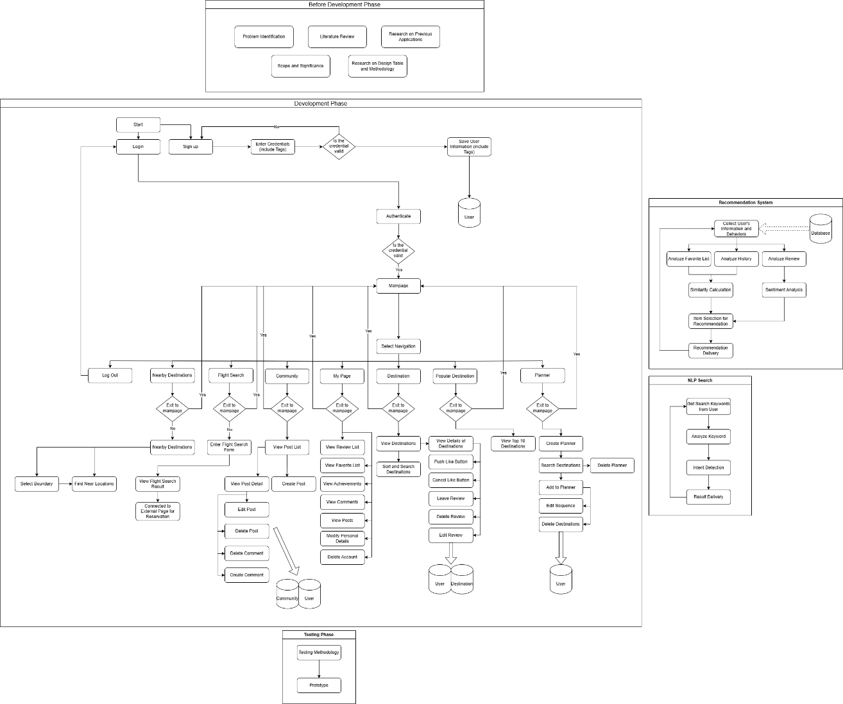
Figure 1. Conceptual Framework

Literature Review

2-1. Overview
워드에 양쪽맟춤!!!

2-2. Knowledge Domain

2-2-1. Current Travel Information Platform
Current travel information platforms, such as TripAdvisor, Google Travel, Lonely Planet, and Nomadic Matt, provide travelers with valuable resources for planning and researching trips. These platforms offer a range of tools that allow users to explore destinations, read reviews, view photos, and receive personalized recommendations. Meanwhile, platforms like Lonely Planet and Nomadic Matt focus more on in-depth travel advice, budget-friendly tips, and cultural insights, appealing to travelers seeking authentic experiences and practical advice. Collectively, these platforms empower users to plan their trips efficiently and explore destinations through a blend of community-driven content and expert guidance. At this point, especially, Tripadvisor is the most ideal model which balance between those platforms. Tripadvisor is an online platform that gathers millions of reviews for various tourism-related businesses, including hotels, restaurants and attractions. The tourism industry now relies heavily on digital word of mouth—the feedback and opinions customers share about their experiences. In this regard, Tripadvisor stands as a major presence on the internet, with data that speaks volumes about its influence. (Perusim, 2022) In conclusion, Tripadvisor balance between travel information exploration and user communication.

2-2-2. Comprehensive travel search engine system
A comprehensive travel search engine system integrates multiple data sources and employs advanced algorithms to provide users with seamless access to travel information. Modern architectures often utilize microservices, enabling independent deployment and scaling of components, which enhances system agility and performance (AWS, n.d.). For instance, International Travel Services (ITS) transitioned from a monolithic application to a microservices architecture using Amazon Elastic Container Service and Amazon ElastiCache, resulting in faster search responses and improved scalability (AWS, n.d.). Additionally, such systems may implement federated search techniques, allowing simultaneous querying across various databases and consolidating results into a unified interface (Wikipedia, n.d.). This approach ensures comprehensive coverage of travel options, including flights, hotels, and car rentals, thereby enhancing the user experience. By combining these architectural strategies, travel search engines can efficiently process vast amounts of data, delivering accurate and timely information to users.

2-2-3. Definition of Personalized System
Personalization is managed by the system in use, where developers configure it to recognize users and provide content, experiences, or features aligned with each user's role. This personalization can be tailored to individual users or applied more broadly at the group or audience level. (Amy Schade, 2016)
The primary aim of personalization is to deliver content and features tailored to specific user needs or preferences, without requiring any effort from the users themselves. The system generates a profile for each user and modifies the interface based on that profile. This personalization may highlight relevant information, control access to particular tools, or streamline processes by retaining user-specific data.
For instance, on a travel website, a user might see promotions or deals for destinations they've previously visited or searched for. In an intranet, personalization might restrict access to tools available only to certain employees. Similarly, an app may save past searches, allowing quick access to information the user may want to revisit. In all these cases, the user doesn’t need to initiate any action; the system adapts automatically based on user identity. (Amy Schade, 2016)
Basically, personalization can be divided into 2 types.
- Role-based personalization: Users are grouped based on predefined characteristics, typically using known data rather than inferred behavior. Common on intranets, it allows specific content, such as retirement plan details, to be shown only to relevant employees.
- Individualized personalization: Here, the system models each user individually, providing unique content tailored to personal behavior. For example, based on recent searches or purchases, the system might infer and adjust content, such as suggesting pregnancy-related items.

2-3. Technical Domain

2-3-1. Tools, frameworks, and technologies

2-3-1-1. Laravel
Laravel is a popular open-source PHP framework designed to simplify and accelerate web application development. Created by Taylor Otwell in 2011, Laravel is known for its elegant syntax, making it user-friendly and developer-centric. It follows the Model-View-Controller (MVC) architectural pattern, ensuring a clean separation of concerns and promoting organized code. Laravel comes with a robust set of built-in tools and features such as routing, middleware, authentication, database migration, and an expressive ORM called Eloquent, which facilitates database interactions. Its seamless integration with third-party packages and support for RESTful APIs make it a versatile framework for building complex applications, while its Blade templating engine enables efficient and dynamic front-end development.

2-3-1-2. Xampp
XAMPP is an open-source, cross-platform web server solution package developed by Apache Friends. It stands for Cross-platform (X), Apache (A), MySQL/MariaDB (M), PHP (P), and Perl (P). XAMPP is designed to make it easy for developers to create local web servers for testing and development purposes. It includes Apache HTTP Server, MariaDB (or MySQL), and interpreters for scripts written in PHP and Perl. With its user-friendly interface and pre-configured setup, XAMPP simplifies the installation and management of web server components, making it a popular choice for developers who need to quickly set up a development environment on their local machines.

2-3-1-3. React.js
React.js is an open-source JavaScript library developed by Facebook for building user interfaces, specifically for single-page applications where a fast and interactive user experience is crucial. Launched in 2013, React allows developers to create reusable UI components that manage their own state, making complex UIs easier to develop and maintain. Its component-based architecture promotes modularity and code reusability, enhancing development efficiency and scalability. React employs a virtual DOM (Document Object Model) that optimizes rendering by updating only the necessary parts of the UI, leading to better performance. React's declarative syntax ensures that code is predictable and easier to debug, while features such as hooks allow for state and lifecycle management in functional components. Widely adopted in the tech industry, React has an active community and a rich ecosystem of tools and libraries, enabling developers to build sophisticated, responsive web applications with ease.

2-3-1-4. Bootstrap
Bootstrap is a popular, open-source front-end framework used for designing responsive and mobile-first websites quickly and efficiently. Originally developed by Twitter, Bootstrap provides a collection of HTML, CSS, and JavaScript components, such as navigation bars, buttons, forms, modals, and carousels, that can be easily customized and integrated into web projects. It features a powerful grid system that allows developers to create layouts that adapt seamlessly to different screen sizes, making it ideal for building responsive web designs. Bootstrap also includes pre-designed themes, icons, and utilities, which significantly speeds up the development process. With extensive documentation and strong community support, Bootstrap remains a go-to framework for both beginners and experienced developers looking to create visually appealing, consistent, and user-friendly interfaces.

2-3-1-5. MariaDB
MariaDB is an open-source relational database management system (RDBMS) that is a fork of MySQL, created by the original developers of MySQL to ensure continued open-source availability. It is designed to offer high performance, stability, and a rich feature set while maintaining compatibility with MySQL, making it a popular choice for organizations looking to migrate from MySQL. MariaDB supports standard SQL and provides advanced features such as JSON support, temporal data handling, and virtual columns. It also includes enhancements like the Aria and XtraDB storage engines for improved performance and scalability. With robust security features, seamless integration with various programming languages, and compatibility with major cloud platforms, MariaDB is widely used for applications requiring reliable and scalable database solutions, from small web applications to large-scale enterprise systems.

2-3-1-6. Django
Django is a high-level Python web framework that allows developers to build robust, scalable, and secure web applications quickly. It follows the "Don't Repeat Yourself" (DRY) principle and emphasizes the use of reusable components, making development more efficient. Django provides built-in tools for common web development tasks, such as authentication, database management, URL routing, and templating, which allow developers to focus more on application logic rather than low-level implementation details. With its strong security features and a vibrant community, Django is widely used for building everything from simple websites to complex web platforms.
For building APIs, Django integrates seamlessly with Django REST Framework (DRF), a powerful and flexible toolkit for developing Web APIs. DRF simplifies the process of creating RESTful APIs by providing features such as serialization, authentication, permissions, and view classes. It adheres to Django's principles and enhances code reusability and modularity, enabling developers to expose application data as RESTful endpoints with minimal configuration. Thanks to its browsable API interface and strong integration with Django's ORM and authentication system, DRF is widely adopted for developing both standalone APIs and APIs that complement Django-based web applications.

2-3-1-7. Spring
Spring is a comprehensive framework for building Java-based enterprise applications, known for its flexibility and scalability. It provides a wide range of features, including dependency injection, aspect-oriented programming, and transaction management, which simplify the development of complex, loosely coupled systems. Spring also supports various modules like Spring Boot (for rapid application development), Spring Security (for authentication and authorization), and Spring Data (for database management), making it a powerful tool for building microservices, web applications, and large-scale enterprise solutions. Its widespread adoption and strong community support make it a go-to choice for Java developers.

2-3-1-8. Vue.js
Vue.js is a progressive JavaScript framework used for building user interfaces and single-page applications (SPAs). Designed to be incrementally adoptable, Vue.js is versatile and can function as a simple library for enhancing existing web pages or as a comprehensive framework for complex applications. Its core features include a reactive data binding system, a component-based architecture, and an intuitive template syntax that makes it easy to bind data to the DOM. Vue.js also provides tools for state management, routing, and animation, making it a robust option for modern web development. With its lightweight structure, extensive documentation, and active community support, Vue.js is popular among developers for creating fast, scalable, and maintainable front-end applications.

2-3-1-9. Supervised Learning / Unsupervised Learning / Hybrid Learning
Supervised learning involves training a model on labeled data, where each input is paired with a known output, allowing the model to learn the relationship between them for tasks like classification and regression. Unsupervised learning, on the other hand, works with unlabeled data and focuses on finding hidden patterns or structures in the data, such as clustering similar data points or reducing dimensions. Hybrid learning combines both approaches, using unsupervised methods for data preprocessing or pattern discovery, followed by supervised learning for prediction, or leveraging semi-supervised and self-supervised techniques where labeled data is scarce. Each approach is selected based on the nature of the data and the problem to be solved.
2-1-1-10. Python Libraries for Machine Learning
Python libraries for machine learning include a range of powerful tools for both supervised and unsupervised learning. Scikit-learn is one of the most widely used libraries, offering efficient tools for classification, regression, clustering, and dimensionality reduction. TensorFlow and Keras are popular for deep learning, providing support for building neural networks and complex models. PyTorch is another deep learning framework known for its flexibility and dynamic computation graph, often used in research and production. H2O.ai offers automated machine learning (AutoML) solutions for building and deploying machine learning models, while XGBoost is highly effective for gradient boosting and ensemble learning, particularly in structured data tasks. These libraries are essential for building a wide variety of machine learning models across different domains.

2-4-2. API

2-4-2-1. Google Map API
Google Maps API is a location-based service API provided by Google that allows developers to easily integrate features like maps, directions, distance calculations, and location search into websites or mobile applications. Through Google Maps API, developers can embed interactive maps, real-time traffic information, satellite imagery, and street view within their applications. It also supports advanced functionalities such as place search, location autocomplete, and distance and time calculations. Additionally, it integrates with services like Google Places, providing access to nearby place recommendations and user reviews, making it widely used across various fields, including travel, logistics, and real estate. Leveraging Google Maps API's accuracy and extensive data, developers can create powerful location-based features to enhance user experience.

2-4-2-2. Skyscanner API
The Skyscanner API provides developers with powerful tools to access Skyscanner's travel data, including flights, hotels, and car rental options, allowing for integration of comprehensive travel search functionality within applications. With Skyscanner API, developers can offer users real-time search results for flight pricing, availability, routes, and booking options from multiple airlines and travel agencies. It also supports hotel and car rental information, making it a versatile solution for creating end-to-end travel planning features. By using Skyscanner API, developers can incorporate filtering options, such as flexible dates or specific airlines, helping users to find the best travel deals and make informed booking decisions. This API is popular among travel platforms and apps that aim to offer users a seamless and informed travel planning experience.

2-4-2-3. Booking.com API
The Booking.com API allows developers to integrate Booking.com's vast database of accommodation options, including hotels, vacation rentals, and other lodging types, into their own applications or websites. With this API, developers can provide real-time availability, pricing, and booking functionality, allowing users to search for and reserve accommodations directly within the app or website. The Booking.com API also includes details on properties such as amenities, location, guest reviews, and images, helping users make well-informed choices. Additionally, the API supports features like filtering by property type, price range, and location, enhancing the user experience. It is widely used by travel platforms, apps, and agencies looking to offer a seamless and comprehensive accommodation booking service.

2-4-2-4. Google Cloud Translation API
The Google Cloud Translation API is a powerful tool that enables developers to integrate language translation capabilities into applications, allowing for real-time translation of text in over 100 languages. This API supports both simple text and HTML content, making it versatile for various use cases, such as translating user-generated content, documents, or website text. With two main versions—Basic, for straightforward translation tasks, and Advanced, which includes additional features like custom glossaries and auto language detection—the API can be tailored to specific needs. It is commonly used in apps, websites, and services that serve a global audience, as it helps bridge language barriers and improve accessibility. Additionally, its neural machine translation model ensures high-quality, contextually accurate translations.

2-5. Software Development Methodologies

2-5-1. Agile Model
The Agile Model is a flexible, iterative, and incremental approach to software development, emphasizing collaboration, customer feedback, and adaptability throughout the project lifecycle (GeeksforGeeks, 2024). Unlike traditional models, Agile breaks the project into smaller iterations or sprints, allowing teams to respond to changes and deliver working software more frequently. This methodology fosters better communication among stakeholders and ensures that the end product aligns closely with user requirements (GeeksforGeeks, 2024).
Pros of Agile Methodology (Indeed, 2024):
- Improved flexibility allows teams to adapt to changes quickly during the development process.
- Emphasis on customer collaboration ensures that the final product aligns closely with user expectations.
- The iterative approach leads to faster delivery of functional software, enabling quicker feedback and adjustments.
Cons of Agile Methodology (Indeed, 2024):
- Potential for scope creep due to its open-ended and evolving nature.
- Significant time and resource commitment required from team members and stakeholders, which can be challenging for some organizations.
- Lack of detailed documentation may lead to confusion or miscommunication in long-term projects.

2-5-2. Waterfall Model
The Waterfall Model is a linear and sequential approach to software development where each phase, such as requirements, design, implementation, testing, deployment, and maintenance, must be completed before moving to the next (GeeksforGeeks, 2024). This model emphasizes thorough documentation and planning, making it suitable for projects with well-defined and stable requirements. While the Waterfall Model is easy to manage due to its structured nature, it lacks flexibility to adapt to changes once the development process has started (GeeksforGeeks, 2024).
Pros of Waterfall Methodology (Lucidchart, n.d.):
- The Waterfall methodology is straightforward and easy to understand, making it ideal for teams and stakeholders who prefer a structured approach.
- It provides clear project milestones and deliverables, ensuring transparency and ease of tracking progress.
- Thorough documentation ensures that all aspects of the project are well-documented, which can be useful for future reference or team transitions.
Cons of Waterfall Methodology (Lucidchart, n.d.):
- The rigid structure makes it challenging to accommodate changes once a phase is completed, which can lead to inflexibility.
- It assumes all requirements are well-known at the beginning, which can be problematic for projects with evolving needs.
- Testing occurs late in the process, making it difficult to identify and address issues early, potentially increasing costs and delays.

2-5-3. Spiral Model
The Spiral Model is a risk-driven software development approach that combines elements of iterative and waterfall models, emphasizing risk analysis and progressive refinement (GeeksforGeeks, 2024). Each iteration, or "spiral," includes four main phases: planning, risk analysis, engineering, and evaluation, allowing for continuous improvements and risk mitigation throughout the development process. This model is particularly suited for large and complex projects where risks are significant, as it incorporates user feedback and incremental deliverables (GeeksforGeeks, 2024).
Pros of Spiral Model (One Beyond, 2017):
- The Spiral Model is highly flexible, making it suitable for complex and evolving projects by allowing for changes and iterations throughout the development process.
- Its emphasis on risk management helps identify and mitigate potential risks early in the project lifecycle.
- User feedback is integrated at each stage, ensuring that the final product aligns closely with user requirements and expectations.
Cons of Spiral Model (One Beyond, 2017):
- The model can be costly and time-consuming due to its emphasis on risk analysis and iterative phases.
- It requires expertise in risk assessment, which may not be readily available in all teams.
- The flexible nature and iterative structure may make the project difficult to manage and track, especially for smaller teams.

2-5-4. V-Model
The V-Model, or Verification and Validation Model, is a software development approach that emphasizes a parallel relationship between the development and testing phases, forming a V-shaped structure (Javatpoint, n.d.). Each development stage has a corresponding testing phase, ensuring that verification (are we building it right?) and validation (are we building the right thing?) occur simultaneously. This model is highly structured and suitable for projects with well-defined requirements, as it facilitates early defect detection and thorough documentation (Javatpoint, n.d.). However, like the Waterfall Model, it lacks flexibility to accommodate changes once the process begins (Javatpoint, n.d.).
Pros of V-Model (A Plus Topper, 2023):
- The V-Model ensures rigorous testing at every development stage, resulting in higher quality and more reliable software.
- It provides a clear structure and well-defined phases, making it easy to understand and implement, especially for teams working on smaller projects with stable requirements.
- Early detection of defects reduces overall costs by addressing issues in the corresponding stages of development.
Cons of V-Model (A Plus Topper, 2023):
- The rigid structure makes the V-Model unsuitable for projects with frequently changing requirements, as changes can disrupt the entire process.
- It assumes that all requirements are known at the beginning, which can lead to challenges in accommodating unforeseen needs.
- The model's focus on strict phases may delay the delivery of a functional product, as testing is heavily reliant on the completion of corresponding development stages.

2-4-5. Prototyping Model
The Prototyping Model is a software development methodology that focuses on creating an early working prototype of the system to gather user feedback and refine requirements before full-scale development begins (GeeksforGeeks, 2024). This approach helps in understanding unclear or incomplete requirements by iteratively refining the prototype based on user inputs. It is especially beneficial for projects where user involvement is critical and requirements are not well-defined. However, it may lead to higher costs and time consumption if prototypes are not efficiently managed (GeeksforGeeks, 2024).
Pros of Prototype Model (Biplus, n.d.):
- The Prototype Model helps clarify and refine user requirements by providing a visual representation of the final product early in the development process.
- It improves communication between developers and stakeholders, ensuring a better understanding of expectations and reducing misunderstandings.
- The iterative process allows for early detection and resolution of design and functionality issues, saving time and costs in the later stages.
Cons of Prototype Model (Biplus, n.d.):
- The constant refinement of prototypes can lead to higher development costs and extended timelines if not managed effectively.
- Over-reliance on prototypes may result in poorly documented requirements, creating challenges for future maintenance and scalability.
- Users may develop unrealistic expectations based on the prototype, leading to dissatisfaction if the final product does not match their perceptions.

2-6. Research Instruments

2-6-1. Questionnaire
A questionnaire is a research instrument consisting of a set of structured or unstructured questions designed to collect data from respondents about specific topics (Cint, 2022). It is widely used in research for its efficiency in gathering large amounts of information from diverse populations within a short timeframe. Questionnaires can be administered in various formats, including online, paper-based, or through interviews, and are particularly effective for obtaining quantitative data for statistical analysis. However, their effectiveness depends on careful question design to minimize bias and ensure reliability (Cint, 2022).
Pros of Questionnaires (Educba, 2023):
- Questionnaires are cost-effective and efficient, allowing researchers to collect data from a large audience with minimal resources.
- They provide respondents with anonymity, encouraging honest and unbiased answers.
- The standardized format ensures consistency in data collection, making it easier to analyze and compare responses.
Cons of Questionnaires (Educba, 2023):
- Poorly designed questions can lead to misinterpretation or biased responses, affecting the validity of the data.
- Questionnaires often lack the flexibility to probe deeper into responses, limiting the depth of insights.
- Low response rates or incomplete answers can skew the data and reduce the reliability of findings.

2-6-1-1. Krejcie and Morgan Table

Figure 2. Krejcie and Morgan Table
The Krejcie and Morgan table is a statistical tool used to determine the appropriate sample size for a study based on a given population size. Developed in 1970, it provides researchers with a standardized method to calculate a representative sample while ensuring reliability and precision in research findings. The table considers factors such as confidence levels (typically 95%) and margin of error (usually 5%) to guide sample size selection, making it a widely-used reference in various research disciplines. By using this table, researchers can efficiently plan their studies without the need for complex calculations, ensuring that the sample size is neither too small to be unreliable nor unnecessarily large, saving time and resources (Kenpro, 2022).

2-6-2. Interview
An interview is a qualitative research method used to gather in-depth information directly from participants through structured, semi-structured, or unstructured formats (Scribbr, 2022). This method allows researchers to explore complex topics, capture detailed personal experiences, and clarify responses in real time. Interviews can be conducted face-to-face, over the phone, or via video conferencing, offering flexibility in reaching diverse populations. While interviews provide rich, nuanced data, they can be time-consuming and resource-intensive to organize, conduct, and analyze (Scribbr, 2022).
Pros of Interviews (Indeed, 2024):
- Interviews allow for a deeper understanding of the respondent's thoughts, as the interviewer can ask follow-up questions and clarify answers in real-time.
- They provide personal interaction, which can help build rapport and encourage more detailed and honest responses.
- Interviews can uncover non-verbal cues, such as body language, which can add context to the responses.
Cons of Interviews (Indeed, 2024):

- They can be time-consuming and expensive, especially when conducted face-to-face or with large sample sizes.
- The presence of an interviewer may lead to biased responses, as participants might answer in ways they think are expected.
- Data analysis can be challenging and time-intensive due to the qualitative nature of interview responses.

2-6-3. Observation
Observation is a qualitative research method used to collect data by systematically watching and recording behaviors, actions, and events in their natural settings (Insight7, n.d.). This method provides researchers with firsthand insights into the context, interactions, and dynamics of the subject being studied, making it particularly useful for understanding complex phenomena. Observations can be structured, semi-structured, or unstructured, depending on the research objectives, and they often complement other data collection methods for richer analysis. However, the effectiveness of observation relies heavily on the researcher’s skill and objectivity, and it can be time-intensive to conduct and analyze (Insight7, n.d.).
Pros of Observation Method (Javatpoint, n.d.):
- The observation method allows researchers to gather real-time data in a natural setting, ensuring authenticity and accuracy.
- It enables the study of non-verbal behavior and interactions, offering insights that may not be captured through other methods like questionnaires.
- Observation is a straightforward and easy-to-implement method that does not rely on respondents’ self-reports, reducing bias.
Cons of Observation Method:
- It can be time-consuming and expensive, especially when observing for long durations or in multiple locations.
- The presence of the observer may influence the behavior of the subjects, potentially skewing the data.
- Data collected through observation is often subjective and difficult to quantify, making analysis and comparison challenging.

2-6-4. Experiment
An experiment is a research instrument designed to test hypotheses by manipulating one or more variables and observing the effects on other variables under controlled conditions (Professional Writing Bay, n.d.). This method is widely used in scientific research to establish cause-and-effect relationships and is particularly effective in isolating variables to understand their specific impact. Experiments can be conducted in laboratories or natural settings and typically involve control and experimental groups for comparison. While experiments provide highly reliable and valid results, they can be resource-intensive and may sometimes lack generalizability to real-world scenarios (Professional Writing Bay, 2023).
Pros of Experimental Research (Indeed, 2024):
- Experimental research establishes clear cause-and-effect relationships by controlling variables and isolating their impacts.
- It allows for a high level of control, ensuring that extraneous factors do not influence the results, leading to more reliable findings.
- The results of experiments are often replicable, enabling validation and consistency in research outcomes.
Cons of Experimental Research (Indeed, 2024):
- Experimental research can be time-consuming and expensive, requiring significant resources to set up and conduct.
- The controlled environment of experiments may not reflect real-world conditions, reducing the generalizability of the findings.
- Ethical concerns can arise, especially when involving human or animal subjects, as experiments may impact their well-being.

2-7. Research Design

2-7-1. Qualitative Research
Qualitative research is a method of inquiry focused on understanding concepts, experiences, and phenomena through non-numerical data, such as words, images, or observations (Scribbr, 2020). It aims to explore the depth and complexity of human behavior, emotions, and interactions by gathering detailed insights through interviews, focus groups, observations, and text analysis. This approach is particularly useful for exploring new ideas, developing theories, and understanding contexts that are difficult to quantify. However, qualitative research often involves subjective interpretations, making it less suitable for generalization and requiring careful data analysis to ensure credibility (Scribbr, 2020).
Pros of Qualitative Research (Poppulo, 2021):
- Qualitative research provides in-depth insights by exploring participants' thoughts, feelings, and motivations in detail.
- It is flexible and allows for the adjustment of research questions as new data emerges, making it suitable for dynamic studies.
- The method is effective for understanding complex phenomena that are difficult to quantify, such as cultural or social dynamics.
- It encourages open-ended responses, enabling the discovery of unexpected findings.
- Qualitative research fosters direct interaction with participants, building trust and enhancing the depth of collected data.
Cons of Qualitative Research (Poppulo, 2021):
- The data collection and analysis process can be time-consuming and resource-intensive.
- Results are often subjective, as they rely on the researcher’s interpretation, which may introduce bias.
- Findings from qualitative research are less generalizable due to smaller sample sizes and context-specific insights.
- Lack of standardized methods can make it difficult to replicate studies and verify results.
- Qualitative research may struggle to provide measurable or definitive answers, limiting its utility for certain objectives.

2-7-2. Quantitative Research
Quantitative research is a systematic investigation that focuses on collecting and analyzing numerical data to understand patterns, relationships, or trends (Scribbr, 2023). It employs structured tools such as surveys, experiments, and statistical analyses to generate objective and replicable results. This method is particularly useful for testing hypotheses, making predictions, and generalizing findings across larger populations. While quantitative research provides high reliability and precision, it may not fully capture the depth or context of complex phenomena, which can limit its applicability in exploring subjective or nuanced topics (Scribbr, 2023).
Pros of Quantitative Research (Helpfull, 2024):
- Quantitative research provides objective and measurable data, ensuring accuracy and reliability in results.
- It is highly structured, enabling researchers to analyze data statistically and draw precise conclusions.
- The method allows for larger sample sizes, increasing the generalizability of findings to broader populations.
- Standardized data collection techniques make it easier to replicate studies and verify findings.
- Quantitative research is efficient and can collect large amounts of data in a relatively short time.
Cons of Quantitative Research (Helpfull, 2024):
- It often lacks context and depth, as it focuses on numerical data rather than detailed insights.
- The rigid structure may prevent exploration of new or unexpected phenomena during the study.
- It requires well-defined hypotheses and variables, making it less suitable for exploratory research.
- Quantitative methods can oversimplify complex issues, reducing the richness of understanding.
- The reliance on standardized instruments may introduce bias or limit the scope of the study.

2-7-3. Mixed Method Research
Mixed methods research is an approach that combines both qualitative and quantitative research methodologies to provide a more comprehensive understanding of a research problem (Scribbr, 2023). By integrating numerical data with detailed contextual insights, this method leverages the strengths of both approaches, allowing researchers to explore complex phenomena more holistically. Mixed methods are particularly useful for addressing multifaceted questions, validating findings through triangulation, and offering both depth and generalizability. However, this approach can be time-intensive and requires expertise in both qualitative and quantitative techniques, as well as careful integration of the two data types (Scribbr, 2023).
Pros of Mixed Methodology Research (TKW Research, 2023):
- Comprehensive Insights: Combining qualitative and quantitative data provides both detailed, contextualized insights and generalized, externally valid findings, allowing researchers to leverage the strengths of each approach to mitigate the other's weaknesses.
- Methodological Flexibility: Researchers can design studies more flexibly, integrating aspects from various methodologies to derive the most informative results and eliminate potential biases inherent in a single method.
- Enhanced Demographic Reach: Utilizing multiple data collection methods enables access to diverse demographics, overcoming limitations associated with relying solely on one approach, such as online surveys that may exclude less tech-savvy populations.
Cons of Mixed Methodology Research (TKW Research, 2023):
- Increased Labor Intensity: Collecting, analyzing, and integrating both qualitative and quantitative data demands significant time and effort, making mixed methods research more labor-intensive.
- Potential for Conflicting Results: Discrepancies between qualitative and quantitative findings can complicate interpretation, posing challenges in systematically comparing and reconciling divergent data.
- Complexity in Execution: The inherent complexity of mixed methodology studies requires careful planning and expertise to effectively manage and integrate diverse data collection and analysis processes.

2-8. Existing Systems
Website | What they focus | Specific Features
TripAdvisor | Share Experiences & Recommendation & Reservation | - User-generated reviews and ratings for hotels, attractions, and restaurants  - Forum and Q&A sections for travelers  - Users can share photos (Forum)  - Recommendations for attractions, restaurants and activities (Location, seasonal, popularity… base)  - Flight Booking & Car Rent Service
Nomadic Matt | Share Experiences (Blog based) & Recommendation | - Personal travel blog and guides  - Tips for budget travel and affordable travel information  - Detailed sharing of travel experiences  - Suggested itineraries and routes
Lonely Planet | Share Experiences (Blog based) & Recommendation | - Destination-specific guidebooks and online guides  - In-depth travel information with cultural and historical insights  - Tips and recommended routes for travelers  - User reviews and photo sharing
Kayak | Reservation | - Price comparison and booking functionality for flights, hotels, and car rentals  - Search engine to easily find various travel options  - Price alert feature  - Trip management and analysis tools
Expedia | Reservation | - Booking functionality for flights, hotels, car rentals, and vacation packages  - Customized search with various filters and sorting options  - Recommendations for trips and package deals  - User review and rating system

2-9. Hardware & Software Specifications
Hardware | Description
Laptop | Environment for development and testing on pc environment

Software | Description
Visual Studio Code | Development Environment
Google Chrome | Research Tool
Microsoft Word | Report Tool
Microsoft PowerPoint | Presentation Tool
DB Browser (Sqlite) | Database Management Tool

Research Methodology

3-1. Overview

3-2. Design science research methodology (DSRM)
Phase | Details of Activities
Phase 1 | Problem identification and motivation  - From the literature, several problems, issues and points that need to be addressed are clearly identified such as poor user experience and issues of information structure and flow.  - Based on research of both literature review and existing systems I could identify the availability of application for this travel information website to solve the stated problems
Phase 2 | Define objectives of a solution  - Investigation of project objectives and expected components of the travel information website system  - Several technologies and components composed of features options and personalized recommendation system are proposed as solutions  - Project scope and outcomes are defined based on all needed elements with building and designing conceptual framework diagram.
Phase 3 | Design and development  - Design the architecture and technical specifications for the travel information website based on user requirements and research instruments  - Develop the prototype of the travel information website with proper dataset, designed interface and machine learning models that would be used for recommendation system  - Based on the environment of Django, React and Python, the system would be constructed with several testing
Phase 4 | Demonstration  - Perform presentation for stakeholders with working prototype of travel information website.  - Organize demonstration to highlight the system's capabilities and key functions.  - Collect feedback from stakeholders and prospective users to pinpoint areas that may need improvement.
Phase 5 | Evaluation  - Conduct evaluation of travel information website’s from overall performance to detailed components with the quality of user experience through various testing and feedbacks  - Conduct measurement the effectiveness of the system in terms of addressing the issues
Phase 6 | Communication  Prepare for FYP 2 Documentation  Prepare for poster presentation

3-3. Research Design Table
Research Question | Project Objective | Method | Expected Outcome
What proper technologies could be applied to enhance user experience, usability and availability of travel information website? | To investigate existing systems and technologies of travel information website to enhance user experience, availability and usability | Literature Review  Study Existing Systems | Identification of both constraints and benefits of travel information website in enhancing user experience, usability and availability.
How to design and develop the website and personalized recommendation system for travel information website to enable users to meet with highly refined user experience? | To design and develop the website and personalized recommendation system for travel information website that enable users to meet with highly refined user experience. | Questionnaire  Agile Model | A user-friendly interface website that includes well-structed database of numerous information, recommendation system and various functions that meets the needs of all kinds of users.
Can travel information website effectively address the issue of ensuring the quality of overall performance of website and highly refined user experience? | To validate the functionality and accuracy of travel information and travelers website to ensure the overall quality of website and well-qualified user experience | Experimental  User Acceptance Testing | Identification of potential issues and inconvenience raised by users in terms of operating travel information website. Evaluation of overall components and reliability by user feedback and analysis

3-4. Evaluation Table
Travel Information Website
Participants | All Travelers
Task | - Login and Logout  - Registration  - Travel Information Exploration Page  - Flight Search Engine  - Popular Destination Page  - Recommendation Page  - Travel Planning Page  - Manage Review and Favorite  - Personal Page  - User Forum  - Find Near Destinations
Technique | - Personalized Recommendation Algorithm  - Questionnaire  - User Acceptance Testing (UAT)  - Study existing system
Measurement | - User Registration Success Rate  - User Login Success Rate  - Identity verification accuracy and time taken  - User Satisfaction of overall view, design and contents variation of website  - User Engagement with all pages  - Accuracy and availability of personalized recommendation system  - Availability of Utilization for external APIs  - Accuracy and availability of planner page  - Accuracy and availability of fetching near destinations  - Task Completion Time  - Error Rate  - Bounce Rate / Drop-off Points
Outline | - Thoroughly describe the evaluation's purpose and objectives.  - Present the prototype to the participants for a demonstration.  - Conduct questionnaires with the participants.  - Analyze the data collected from the questionnaires and use it to enhance the system.

3-5. Overall Research Design Table
Phase | Input | Process | Outcome
Phase 1 | - Problem identification and motivation | - Identify current issues in travel information websites  - Recognize research motivation and significance | - Clear problem statement
Phase 2 | - Clear problem statement | - Investigate existing current travel information web services  - Propose solution for current travel information web services | - Conceptual Framework of travel information website system
Phase 3 | - Conceptual Framework of travel information website system | - Design the artefacts of the travel information website  - Develop the artefacts of the travel information website | - Artefact Design  - Hierarchical Task Analysis
Phase 4 | - Artefact Design  - Hierarchical Task Analysis | - Application and demonstration of artefacts | - Validated Working Prototype
Phase 5 | - Validated Working Prototype | - Measurement and assessment of performance of travel information website | - Validated Artefact
Phase 6 | - Validated Artefact | - Documentation and compilation | - FYP Documentation

3-6. Research Instrument
In this study, data was collected through a questionnaire distributed to respondents. The primary goal of the questionnaire was to capture public opinions on different aspects of the proposed travel information website. The questions were crafted to explore the usage patterns of travel information websites, evaluate users’ perceptions of the current information interface, and gauge their awareness of personalized recommendation systems. The responses provide valuable insights for analyzing public sentiment and evaluating the feasibility of implementing personalized recommendation systems and advanced information structures to improve the user experience of the website. The questionnaire utilized the following types of questions:
1. Closed-ended Questions
This questionnaire predominantly features closed-ended questions, requiring respondents to select their answers from predefined options. This format ensures consistent data collection and is easy to analyze, covering topics such as travel frequency, preferences, and behaviors.
2. Demographic Questions
The survey begins with demographic questions to gather essential background information, such as age and gender. These questions help segment the audience and understand the characteristics of the respondents relevant to the travel website project.
3. Single-answer Multiple Choice Questions
Single-answer multiple choice questions are used for straightforward inquiries, such as age and gender, where respondents select one option that best represents them. This format simplifies data analysis and provides clear insights.
4. Rating Scale Questions
The survey employs rating scale questions to measure the frequency or intensity of behaviors and preferences, such as interest in travel or the amount of research conducted before traveling. These questions use a numerical scale (e.g., 1–5), facilitating the quantification of subjective opinions.
5. Likert Scale Questions
Likert scale questions capture respondents' levels of agreement or disagreement with various statements, such as their comfort with personalized recommendations or their opinions on using travel information websites. The scale typically ranges from “Strongly Disagree” to “Strongly Agree.”
6. Behavioral Questions
Behavioral questions explore respondents' travel habits, such as how often they travel, whether they prefer solo trips, and their experience with researching travel options. These questions aim to understand user behavior and preferences in travel-related contexts.
7. Opinion-based Questions
The survey also includes opinion-based questions to gauge respondents' feelings about personalized recommendations, travel information websites, and algorithms that suggest content. These questions provide valuable insights into user satisfaction and concerns.
8. Awareness Questions
Awareness questions assess respondents' familiarity with concepts like "Recommendation Algorithm" or their experience navigating travel information websites. These questions evaluate how informed the users are about digital travel tools.
9. Acceptance and Willingness Questions
The survey explores the respondents’ acceptance of sharing personal information and their willingness to utilize personalized travel recommendations. Questions like comfort with algorithms and openness to sharing preferences aim to understand user attitudes toward personalization.

3-7. Software Development Life Cycle (SDLC)
The Software Development Life Cycle (SDLC) is a structured framework used to design, develop, test, and deploy software with high quality and efficiency. It involves several stages: planning, defining requirements, designing, building, testing, deployment, and maintenance. Each stage plays a critical role in ensuring the software meets user needs while minimizing risks and optimizing resources. By providing a clear roadmap for the development process, SDLC enhances project management, ensures better control, and enables the delivery of reliable software solutions (Guru99, 2024).
The Agile methodology is well-suited for this research project as it emphasizes adaptability, continuous feedback, and collaboration—essential elements for creating a travel website tailored to user preferences and evolving requirements. Agile is built on iterative development cycles called sprints, allowing the project team to deliver functional components of the software incrementally and refine them based on user feedback and testing. This aligns with the project’s goal of integrating advanced personalization algorithms and user-centric functionalities, as Agile ensures close collaboration between developers and stakeholders to address dynamic user needs effectively. Additionally, Agile’s focus on prioritizing working software over extensive documentation facilitates quicker responses to issues and incorporates future modifications seamlessly, ensuring the delivery of a high-quality platform within tight deadlines (Agile Alliance, n.d.; Scrum.org, 2023).

3-7-1. Proposed Agile Model
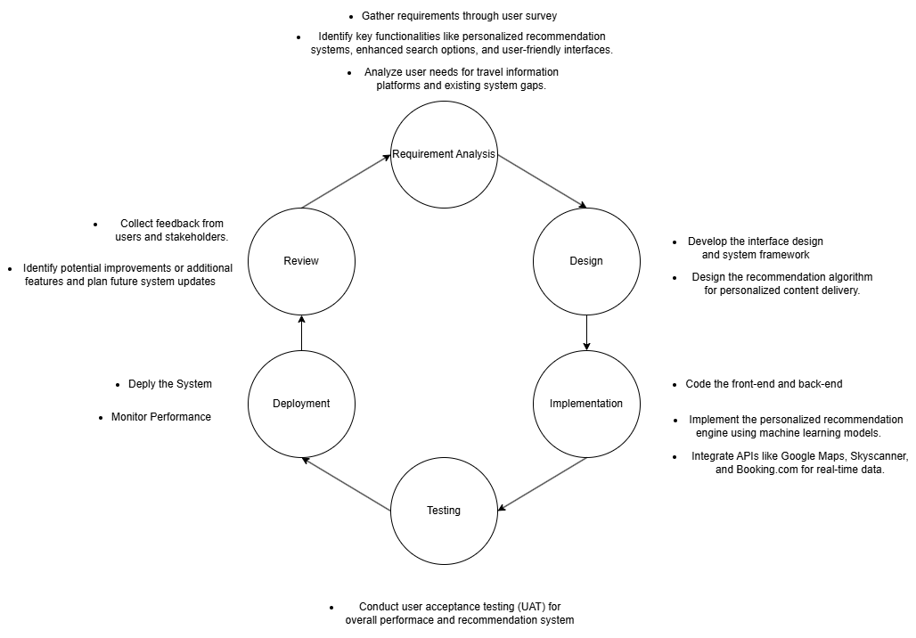
Figure 3. Agile Model

Analysis

4-1. Overview
d

4-2. Questionnaire Objectives
4-2-1. Objective?
Section 1. Demographic
Questions | Purpose
How interested are you in travelling? | To understand users' interest in travelling
How often do you travel? | To understand users' interest in travelling in different way
Do you prefer to travel alone? | To identify the proportion of single travelers and explore users' preferences for personalized recommendation algorithms
How much research do you do before travelling? | To investigate travelers’ willingness to collect information about their travels

Section 2. Awareness
Questions | Purpose
Have you experience of using Travel information websites? | To study travelers’ use of travel-related websites
Do you usually look for travel information on those sites? | To determine whether the Website is used more or less than other means to collect travel-related information.
Have you ever felt frustrated navigating travel information websites (such as Expedia or Klook) to find information about a destination? | To identify and understand users' perception of current travel information websites
How much do you understand about "Recommendation Algorithm"? | To understand how familiar travelers are with the term “Recommendation Algorithm”

Section 3. Acceptance/Preference
Questions | Purpose
Do you feel comfortable finding travel information and making bookings on travel information websites? | To understand travelers’ preferences for travel-related websites
Do you agree to provide your travel preferences to help improve the recommendation system of our travel website? | To understand whether travelers are uncomfortable with providing personal information
Do you agree to share your past travel experiences and preferences to help us personalize your experience on the travel website? | To understand whether travelers are uncomfortable with providing personal information
Do you agree to utilize your personal information to offer recommendations on the travel website? | To understand whether travelers are uncomfortable with providing personal information
Do you feel comfortable to system (like the YouTube algorithm) that recommends contents based on users' personal information and history? | To understand whether travelers are uncomfortable with services that is applied with recommendation algorithm system

Section 4. Willingness
Questions | Purpose
Would you like to be suggested travel-related content based on a personalized recommendation system? | To identify the willingness of users to use future web service
Are you positive about web services that focus on the efficient and optimized provision of information about your destination? | To identify the willingness of users to use future web service

4-3. Questionnaires
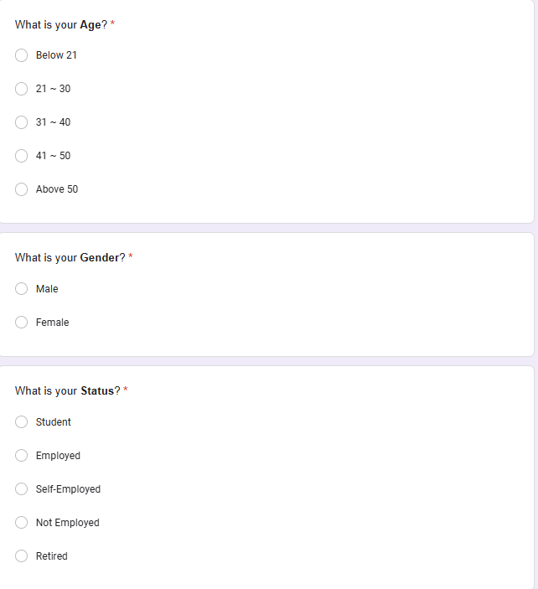
Figure 4. Section 1
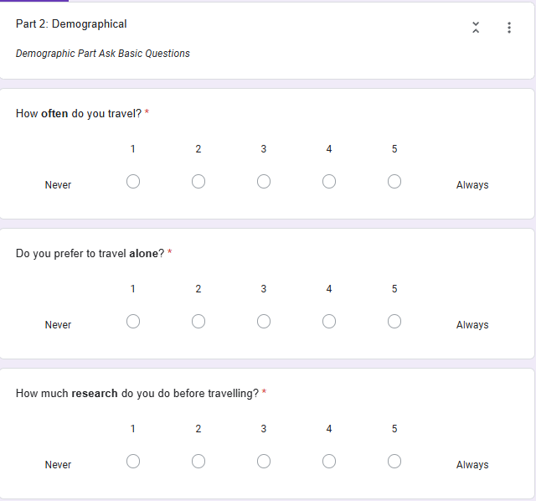
Figure 5. Section 2
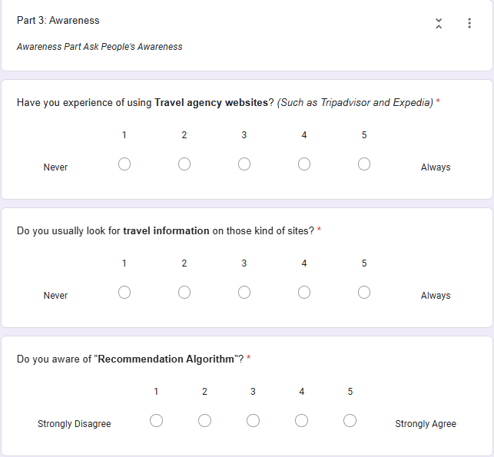
Figure 6. Section 3
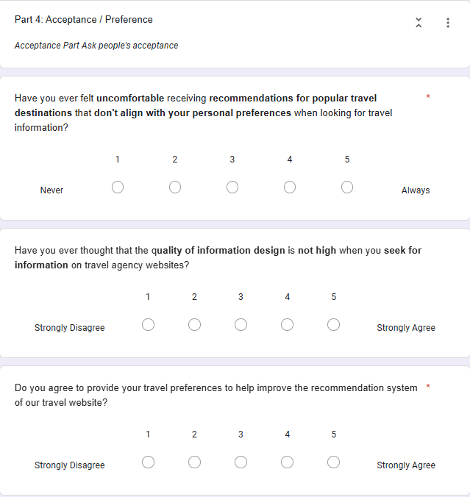
Figure 7. Section 4-1
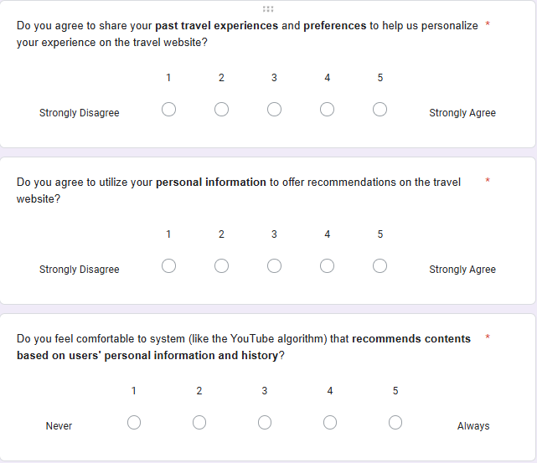
Figure 8. Section 4-2
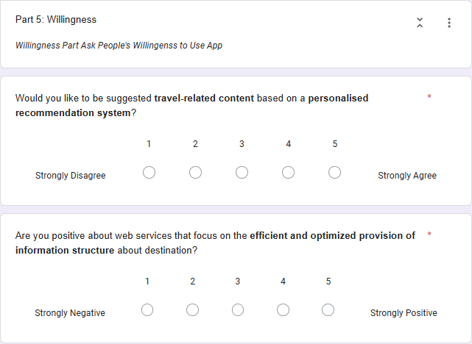
Figure 9. Section 5

4-3-1. Result Analysis
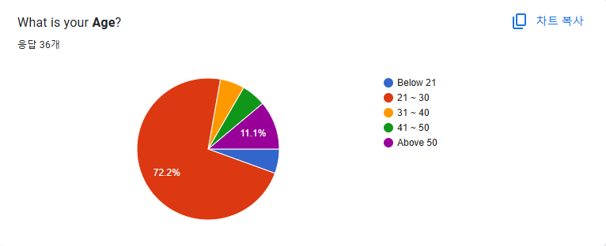
Figure 10. Age Group
Age Distribution: The majority of survey respondents, 72.2%, fall within the 21-30 age group, indicating that the survey primarily targeted young adults. Smaller proportions belong to the below 21 (11.1%) and other age groups, demonstrating limited representation of older demographics.
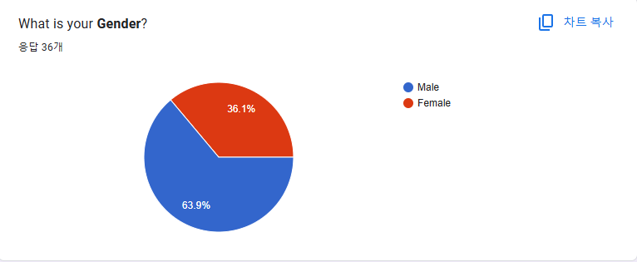
Figure 11. Gender Group
Gender Distribution: Among the respondents, 63.9% identified as male, and 36.1% identified as female. This shows a significant male dominance in the participant demographic.
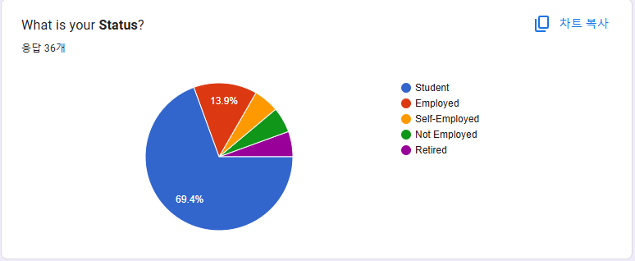
Figure 12. Employment Status
Employment Status: Most respondents, 69.4%, are students, indicating a heavy focus on individuals in educational institutions. A smaller percentage, 13.9%, are employed, with minor representation from self-employed, unemployed, and retired individuals.
Demographic Part
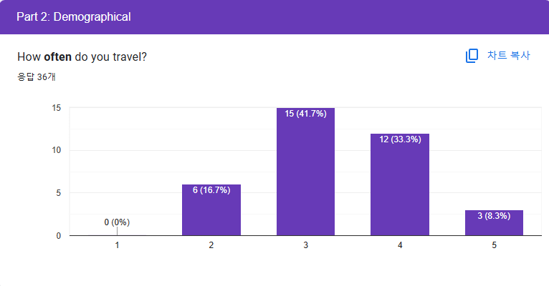
Figure 13. Demographic 1
How often do you travel?: The majority of respondents (41.7%) travel occasionally, represented by a middle score of 3. A significant portion (33.3%) travels frequently, with a score of 4, while only a small percentage (8.3%) indicates very frequent travel with a score of 5. This suggests that most participants travel moderately to often.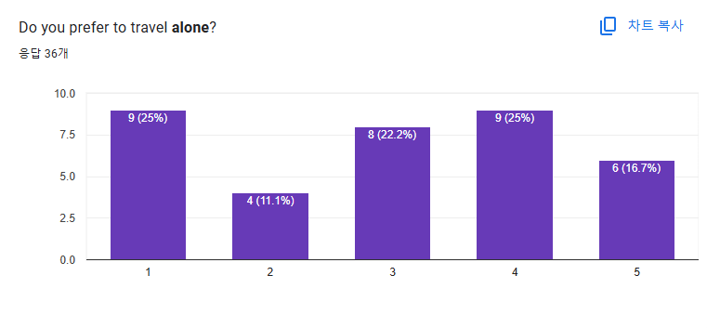
Figure 14. Demographic 2
Do you prefer to travel alone?: The preference for solo travel is evenly split. About 25% of participants each selected 1 (strongly disagree) and 4 (agree somewhat), while 16.7% chose 5 (strongly agree). This indicates varied opinions, with a slight leaning toward disfavoring solo travel.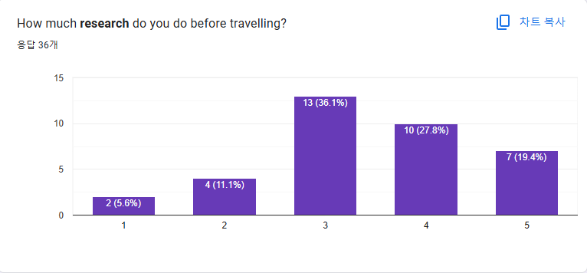
Figure 15. Demographic 3
How much research do you do before traveling?: A substantial portion of respondents (36.1%) conduct a moderate level of research (score 3), while 27.8% and 19.4% lean toward conducting more detailed research (scores 4 and 5). This highlights that preparation is a key aspect for the majority of travelers surveyed.

Awareness Part
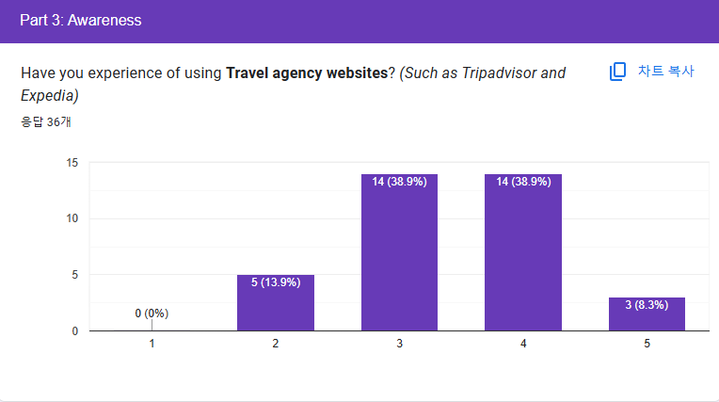
Figure 16. Awareness 1
Experience with Travel agency Websites: A significant portion of respondents (38.9%) rated their experience using travel agency websites (Nowadays usually called as Travel Agency Website) like Tripadvisor and Expedia as moderate (score 3) or somewhat frequent (score 4). Only a small group (8.3%) expressed a high level of familiarity, indicating room for increased awareness or usage.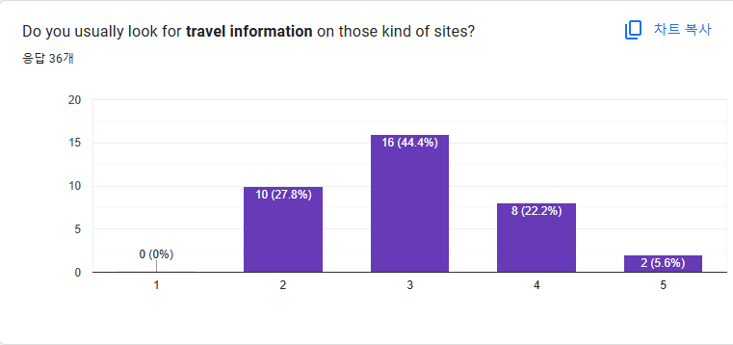
Figure 17. Awareness 2
Looking for Travel Information on Such Websites: Nearly half of the respondents (44.4%) occasionally search for travel information on these websites, represented by a score of 3. A smaller but notable percentage (22.2%) searches more frequently (score 4), while 5.6% regularly utilize these platforms, suggesting a general but varied interest in travel-related content.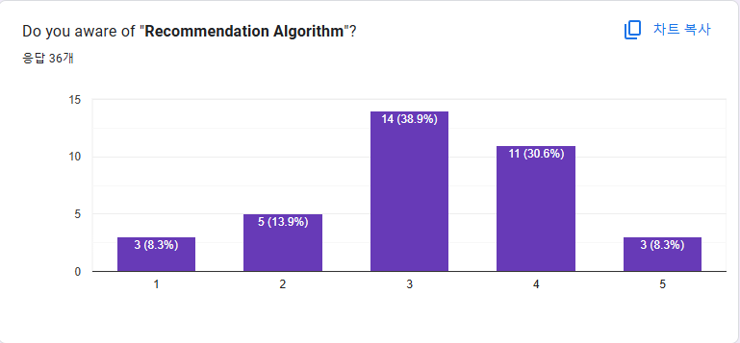
Figure 18. Awareness 3
Awareness of Recommendation Algorithms: A majority of respondents show moderate to high awareness of recommendation algorithms, with 38.9% selecting score 3 and 30.6% selecting score 4. However, 22.2% of participants indicated little to no knowledge (scores 1 and 2), highlighting an opportunity to educate users about these technologies.

Acceptance / Preference
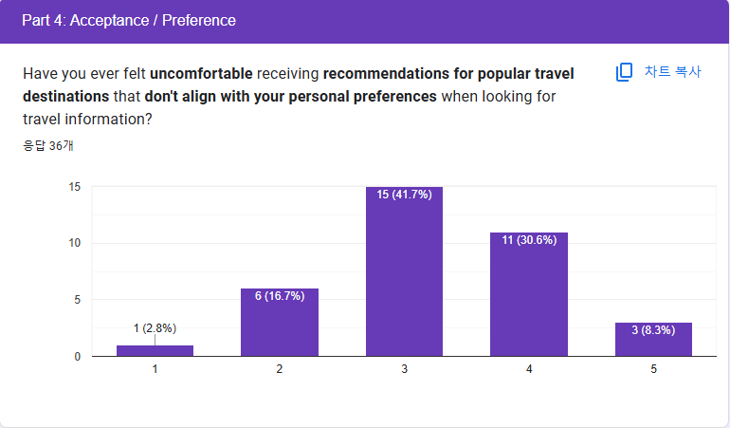
Figure 19. Acceptance/Preference 1
Uncomfortable with Misaligned Recommendations: Most respondents (41.7%) felt moderately uncomfortable when receiving travel recommendations that do not align with their preferences (score 3), while 30.6% leaned toward higher discomfort (score 4). A smaller group (8.3%) expressed strong discomfort, showing a concern for tailored recommendations.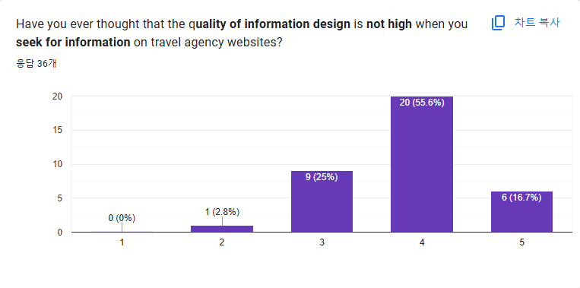
Figure 20. Acceptance/Preference 2
Quality of Information Design: A significant majority (55.6%) somewhat agreed (score 4) that the quality of information design on travel information websites is not high. This suggests a potential gap in user satisfaction with the design and usability of these websites.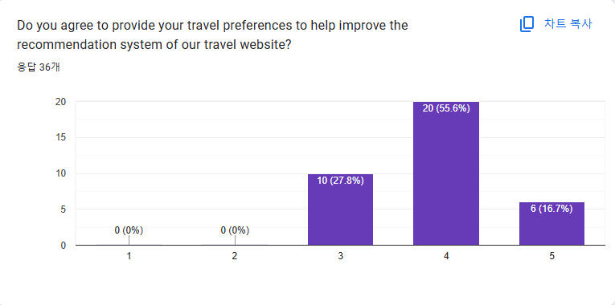
Figure 21. Acceptance/Preference 3
Willingness to Provide Travel Preferences: More than half of the respondents (55.6%) are willing (score 4) to provide their travel preferences to improve recommendation systems, showing a positive inclination toward enhancing personalization on travel websites.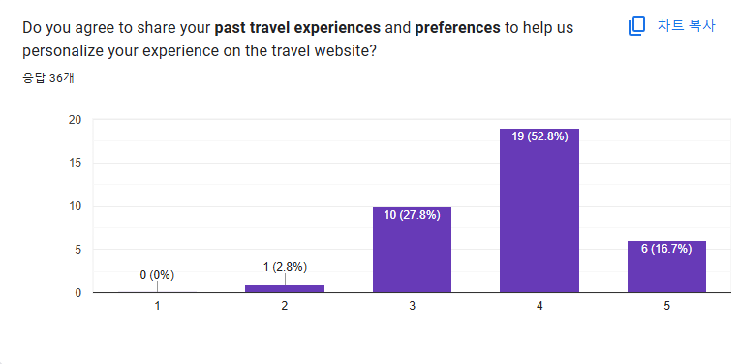
Figure 22. Acceptance/Preference 4
Sharing Past Travel Experiences: Similar to preferences, 52.8% of participants agreed (score 4) to share past travel experiences for better personalization, with an additional 16.7% strongly agreeing (score 5), indicating openness to data sharing for improved user experience.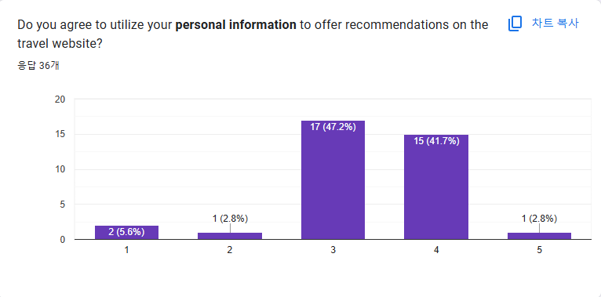
Figure 23. Acceptance/Preference 5
Using Personal Information for Recommendations: Most participants (47.2%) expressed moderate agreement (score 3), while 41.7% leaned further toward willingness (score 4) to share personal information for recommendations. However, a small fraction (5.6%) expressed discomfort (score 1).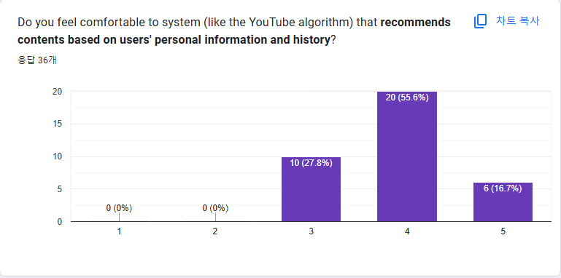
Figure 24. Acceptance/Preference 6
Comfort with Recommendation Systems Using Personal Data: A majority (55.6%) felt comfortable (score 4) with systems like YouTube algorithms that recommend based on personal data, while 16.7% were very comfortable (score 5). This indicates general acceptance of personalized recommendation systems.

Willingness Part
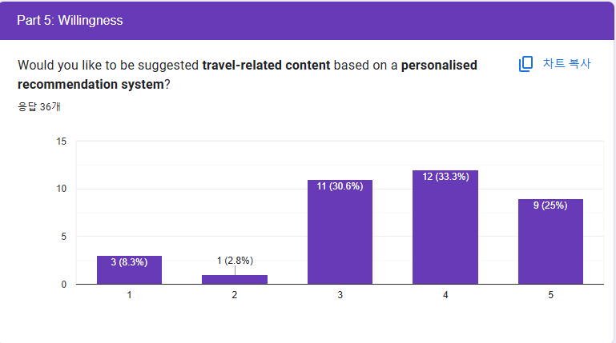
Figure 25. Willingness 1
Willingness to Receive Personalized Travel Suggestions: The majority of respondents expressed a positive attitude towards personalized recommendations, with 33.3% agreeing (score 4) and 25% strongly agreeing (score 5). A smaller group (30.6%) showed moderate interest (score 3), highlighting a general preference for tailored travel content.
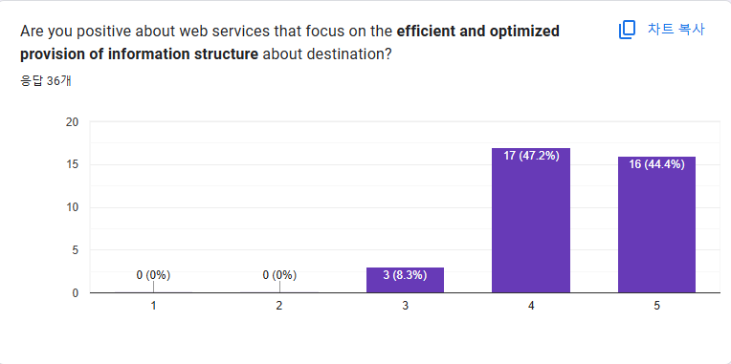
Figure 26. Willingness 2
Optimized Information Structure: Most participants (47.2% and 44.4%) strongly agreed (scores 4 and 5) that they are positive about web services focusing on efficient and optimized destination information. This indicates a strong demand for well-structured and streamlined information delivery systems.

Conclusion of Result
Section 1: Demographics
The survey respondents are predominantly young adults aged 21-30, with a significant majority identifying as students. Male participants slightly outnumber females. This demographic profile suggests that the survey results primarily represent the views and preferences of younger, educated individuals who are likely engaged in academic or early professional stages of life.
Section 2: Travel Habits
Respondents generally travel occasionally, with a mix of preferences regarding traveling alone. Most participants conduct moderate to significant amounts of research before traveling, indicating a well-prepared approach to travel planning. This suggests a balanced pattern of travel frequency and behavior, with a focus on informed decision-making.
Section 3: Awareness
The survey reveals moderate familiarity with travel information websites and recommendation algorithms. While respondents occasionally seek travel information online, a significant number are not highly engaged with these platforms. There is room for improvement in promoting awareness and usage of online travel services and tools.
Section 4: Acceptance/Preferences
Most respondents express moderate to high discomfort with misaligned recommendations and perceive a need for improved information design on travel websites. However, they show willingness to share personal and travel preferences to enhance personalization. This indicates a demand for better-aligned and user-friendly travel recommendation systems.
Section 5: Willingness
Respondents are generally positive about receiving personalized travel recommendations and support efficient, optimized information structures. This highlights an openness to technological solutions that improve user experience, emphasizing the importance of personalization and structured content in travel platforms.
Noticeable Points
Data Sharing and Personalization:
Strong correlations exist between questions about sharing travel preferences, personal information, and past travel experiences:
"Do you agree to provide your travel preferences?" correlates with "Do you agree to share your past travel experiences?" (0.89).
This indicates that participants willing to share their travel preferences are also highly likely to share their past travel experiences.

Personalization and Recommendation System:
"Would you like to be suggested travel-related content based on a personalized recommendation system?" correlates with:
"Do you agree to utilize your personal information?" (0.69).
"Do you feel comfortable with systems recommending based on personal information?" (0.75).
This shows that people comfortable with personalized recommendations are also willing to share personal information to improve such systems.

Comfort with Systems and Awareness of Algorithms:
"Do you feel comfortable with systems recommending based on personal information?" correlates with "Do you aware of 'Recommendation Algorithm'?" (0.59).
Participants who are familiar with algorithms tend to feel more comfortable with systems using their data for recommendations.

User Frustrations with Recommendations:
"Have you ever felt uncomfortable with misaligned recommendations?" correlates strongly with "Would you like to be suggested travel-related content based on a personalized recommendation system?" (0.75).
This highlights a direct link between dissatisfaction with current recommendations and a demand for improved personalization.

4-4. Product Features

4-4-1. Account Features
Feature ID | Feature | Description | Accessible Role
F001 | Register | To allow users to create a new account to access the website. | User
F002 | Login | To allow users to log into the system using their credentials. | User
F003 | Logout | To allow users to log out of the system and end their session. | User
F004 | Delete Account | To allow users to delete their account | User
F005 | Manage Personal Details | To allow users to update and manage their personal information within personal page. | User

4-4-2. My Page Features
F006 | View My Favorite List | To allow users to manage and view their list of favorite destinations. | User
F007 | View My Review and Feedback | To allow users to manage and view their list of reviews | User
F008 | View My Post | To allow users to manage and view their post. | User
F009 | View My Comment | To allow users to manage and view their comment. | User
F010 | View Achievement | To allow users to view their achievements | User

4-4-3. Destination Features
F011 | View Destinations | To allow users to view travel destinations. | User
F012 | Search Destinations | To allow users to browse and explore available travel destinations. | User
F013 | View Destination Details | To allow users to view details of destination | User
F014 | Recommendation Page | To allow users to get travel recommendations based on their preferences | User
F015 | Like Destination | To allow users to remain like and save to favorite list. | User
F016 | Unlike Destination | To allow users to delete liked destination from favorite list | User
F017 | Leave Feedback and Review | To allow users to leave feedback and reviews for destinations or services they've experienced with choosing number of stars. | User
F018 | Delete Feedback and Review | To allow users to delete feedback and reviews that they made | User
F019 | Edit Feedback and Review | To allow users to edit feedback and reviews that they made | User
F020 | Popular Destinations | To allow users to view Most-loved destinations | User
F021 | Nearby Destinations | To allow users to find destinations near to their place. | User

4-4-4. Community Features
F022 | View Post List | To allow users to view other people’s post. | User
F023 | View Post Detail | To allow users to view post content detail. | User
F024 | Search Post | To allow users to search posts | User
F025 | Create Post | To allow users to create new posts for sharing information or experiences. | User
F026 | Edit Post | To allow users to edit the post that he/she created. | User
F027 | Delete Post | To allow users to delete the post that he/she created. | User
F028 | Create Comment | To allow users to leave comments on posts. | User
F029 | Delete Comment | To allow users to delete comments on posts. | User
F030 | View Profile | To allow users to view another user’s profile | User

4-4-5. Flight Feature
F031 | Flight Search | To allow users to search for flights | User
F032 | Flight Details | To allow users to view detailed information for any flight | User
F033 | Reservation Web Connection | To allow users to be connected to external website to make reservation for flight | User

4-4-6. Planner Features
F034 | Create Planner | To allow users to create and build a plan | User
F035 | Delete Planner | To allow users to delete existing plan. | User
F036 | Edit Component Sequence | To allow users to save the sequence of destinations in a plan list. | User

4-5. Architectural Style
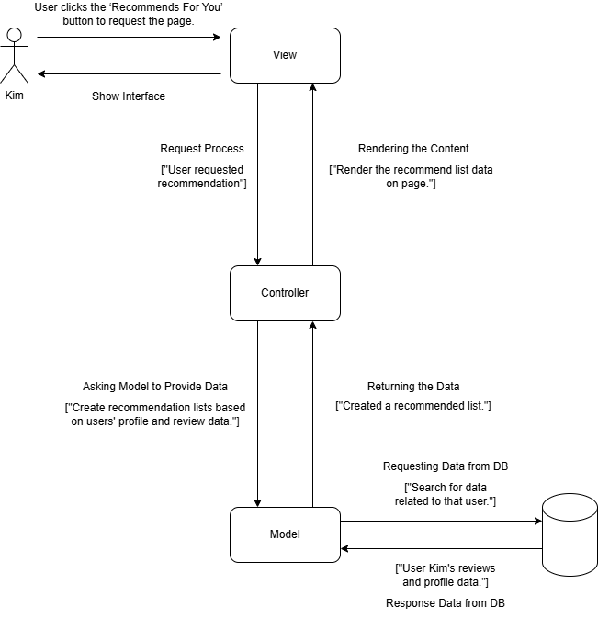
Figure 27. MVC Diagram

4-6. Use Case Diagram
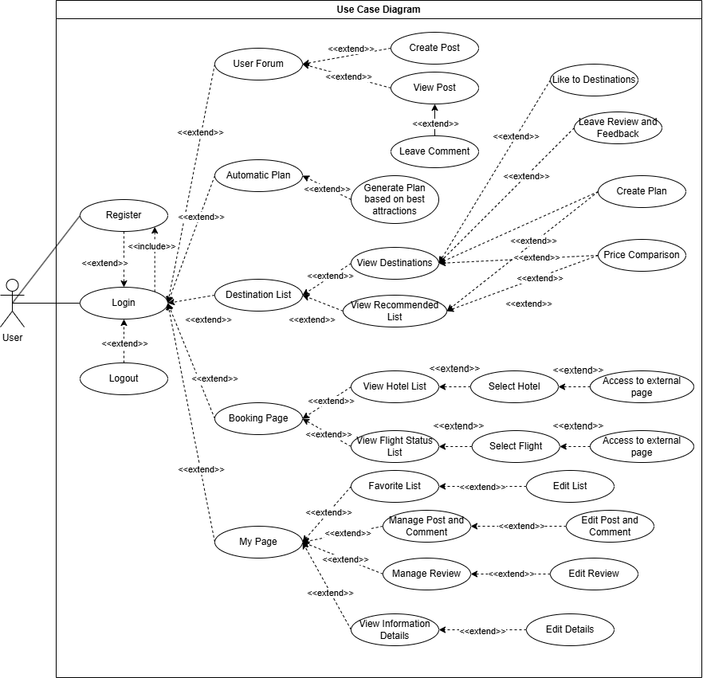
Figure 28. Use Case Diagram

4-7. Use Case Table

4-7-1. Register
Use Case ID | UC001 | Version | 1.0
Feature | F001. Register
Purpose | To allow user to create account
Actor | User
Trigger | User clicks “Register” button. (Login Page, Main Page or Navigation Bar)
Precondition | - User does not have an account.  - User is not logged in.
Scenario Name | Step | Action
Main Flow | 1 | User clicks "Register" button
Main Flow | 2 | System directs User to registration page
Main Flow | 3 | User enters Username, Email, Nickname, Password, Gender, Age Group and Tags.
Main Flow | 4 | User selects "Create Account" button
Main Flow | 5 | System validates user credentials
Main Flow | 6 | System searches user credentials in the database
Main Flow | 7 | System confirms that user credentials don’t exist
Main Flow | 8 | System records user credentials into database
Main Flow | 9 | System directs user to login page
Alternative Flow  Invalid user credentials | 5.1 | System searches user credentials in the database
Alternative Flow  Invalid user credentials | 5.2 | System confirms that user credentials are invalid
Alternative Flow  Invalid user credentials | 5.3 | System pops up error message based on types of invalidation
Alternative Flow  Invalid user credentials | 5.4 | Repeat step 3
Rules | - Entered credential must be valid  - All credentials must be entered
Author | Kim Booil

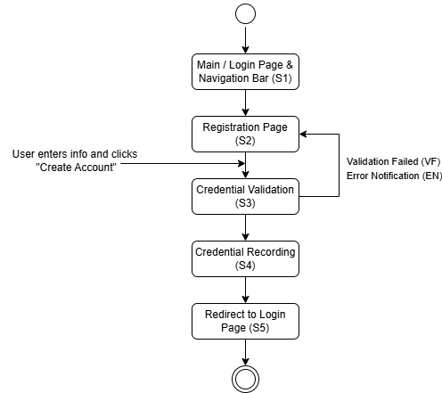
Figure ?.

4-7-2. Login
Use Case ID | UC002 | Version | 1.0
Feature | F002. Login
Purpose | To allow user to login to the website
Actor | User
Trigger | User clicks "Login" button. (Main Page or Navigation Bar)
Precondition | - User has an account.  - User is not logged in.
Scenario Name | Step | Action
Main Flow | 1 | User clicks "Login" button
Main Flow | 2 | System directs User to login page
Main Flow | 3 | User enters ID and password
Main Flow | 4 | User selects "Sign in" button
Main Flow | 5 | System validates user credentials
Main Flow | 6 | System directs user to logged in Main page
Alternative Flow  Invalid user credentials | 3.1 | User enters invalid ID or password
Alternative Flow  Invalid user credentials | 3.2 | System validates entered credentials
Alternative Flow  Invalid user credentials | 3.3 | System pops up message of “Invalid username or password. Please try again.”
Alternative Flow  Invalid user credentials | 3.4 | Repeat step 3
Rules | - User must have account
Author | Kim Booil

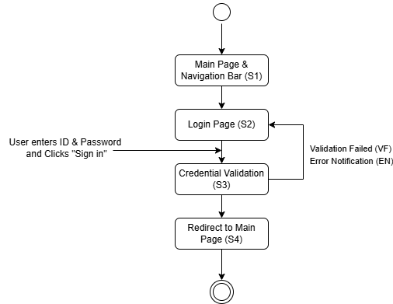
Figure ?.

4-7-3. Logout
Use Case ID | UC003 | Version | 1.0
Feature | F003. Logout
Purpose | To allow user to logout from website
Actor | User
Trigger | User clicks "Logout” button (Navigation Bar)
Precondition | - User is logged in.
Scenario Name | Step | Action
Main Flow | 1 | User clicks "Logout” button
Main Flow | 2 | System validates user’s request
Main Flow | 3 | System pop up message of “Successfully logged out”
Main Flow | 4 | System directs user to Login Page
Rules | - User must be logged in
Author | Kim Booil

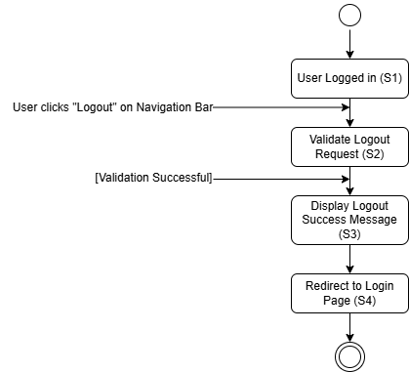
Figure ?.

4-7-4. Delete Account
Use Case ID | UC004 | Version | 1.0
Feature | F004. Delete Account
Purpose | To allow user to delete the account
Actor | User
Trigger | User clicks "Delete Account” button
Precondition | - User is logged in.  - User is at Personal Page (My Page)
Scenario Name | Step | Action
Main Flow | 1 | User clicks "Delete Account” button
Main Flow | 2 | System pop up warning interface for deleting accounts with requiring reconfirmation of deleting account
Main Flow | 3 | User confirm deleting account
Main Flow | 4 | System delete account in database
Main Flow | 5 | System pop up message of “Successfully deleted”
Main Flow | 6 | System directs user to Login Page
Alternative Flow – Cancel button clicked | 3.1 | User clicks “Cancel” Button
Alternative Flow – Cancel button clicked | 3.2 | System close warning interface
Rules | - User must be logged in
Author | Kim Booil

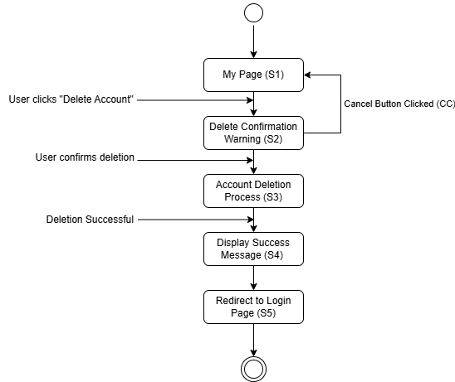
Figure ?.

4-7-5. Manage Personal Details
Use Case ID | UC005 | Version | 1.0
Feature | F005. Manage Personal Details
Purpose | To allow user to manage and modify the details
Actor | User
Trigger | User clicks "Modify Profile”
Precondition | - User is at My Page  - User is logged in
Scenario Name | Step | Action
Main Flow | 1 | User clicks “Modify Profile” Button.
Main Flow | 2 | System shows modify form to user.
Main Flow | 3 | User modify introduction, nickname, personal information and profile image.
Main Flow | 4 | User clicks "Save” button.
Main Flow | 5 | System updates view and save in database.
Alternative Flow  Click Cancel Button | 3.1 | User clicks “Cancel” Button .
Alternative Flow  Click Cancel Button | 3.2 | Modify form interface is removed.
Rules | - User must be logged in
Author | Kim Booil

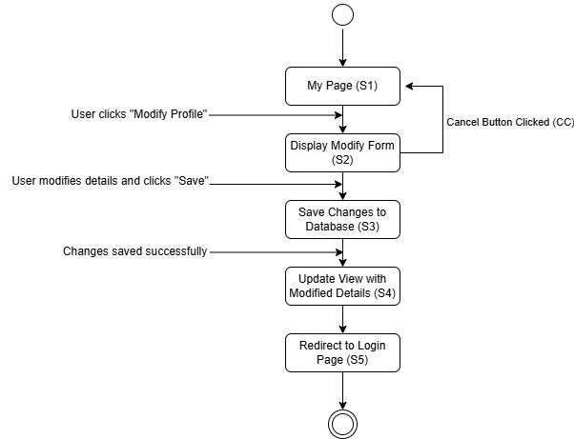
Figure ?.

4-7-6. View My Favorite List
Use Case ID | UC006 | Version | 1.0
Feature | F006. View My Favorite List
Purpose | To allow user to view his/her favorite list
Actor | User
Trigger | User clicks “Liked Destinations”
Precondition | - User is logged in  - User is at My Page
Scenario Name | Step | Action
Main Flow | 1 | User clicks “Liked Destinations”.
Main Flow | 2 | System shows list of destinations that user pushed like button.
Rules | - User must be logged in
Author | Kim Booil

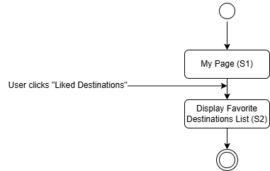
Figure ?.

4-7-7. View My Review and Feedback
Use Case ID | UC007 | Version | 1.0
Feature | F007. View My Review and Feedback
Purpose | To allow user to view his/her review list
Actor | User
Trigger | User clicks “Your Reviews”
Precondition | - User is logged in  - User is at My Page
Scenario Name | Step | Action
Main Flow | 1 | User clicks “Your Reviews”.
Main Flow | 2 | System shows list of reviews that user remained.
Rules | - User must be logged in
Author | Kim Booil

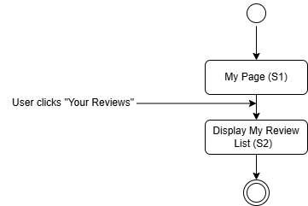
Figure ?.

4-7-8. View My Post
Use Case ID | UC007 | Version | 1.0
Feature | F008. View My Post
Purpose | To allow user to view post that he/she made
Actor | User
Trigger | User clicks “Your Posts”
Precondition | - User is logged in  - User is at My Page
Scenario Name | Step | Action
Main Flow | 1 | User clicks “Liked Destinations”.
Main Flow | 2 | System shows list of posts that user remained.
Rules | - User must be logged in
Author | Kim Booil

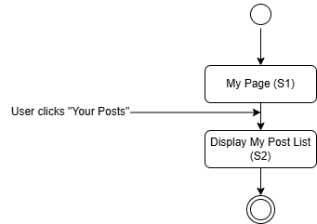
Figure ?.

4-7-9. View My Comment
Use Case ID | UC009 | Version | 1.0
Feature | F009. View My Comment
Purpose | To allow user to view comments that he/she made
Actor | User
Trigger | User clicks “Your Comments”
Precondition | - User is logged in  - User is at My Page
Scenario Name | Step | Action
Main Flow | 1 | User clicks “Your Comments”.
Main Flow | 2 | System shows list of comments that user remained.
Rules | - User must be logged in
Author | Kim Booil

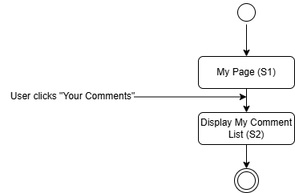
Figure ?.

4-7-10. View Achievement
Use Case ID | UC010 | Version | 1.0
Feature | F010. View Achievement
Purpose | To allow user to view achievements that they completed or not completed
Actor | User
Trigger | User clicks “Your Achievements”
Precondition | - User is logged in  - User is at My Page
Scenario Name | Step | Action
Main Flow | 1 | User clicks “Your Achievements”.
Main Flow | 2 | System shows list of achievements with its progress status of users
Rules | - User must be logged in
Author | Kim Booil

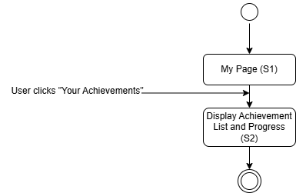

4-7-11. View Destinations
Use Case ID | UC010 | Version | 1.0
Feature | F010. View Destinations
Purpose | To allow user to explore destinations
Actor | User
Trigger | User clicks "Destinations" button (Navigation Bar)
Precondition | - User is logged in
Scenario Name | Step | Action
Main Flow | 1 | User clicks " Destinations" button.
Main Flow | 2 | System directs User to destination list page.
Main Flow | 3 | System displays the lists of destinations with sorting option.
Rules | - User must be logged in
Author | Kim Booil

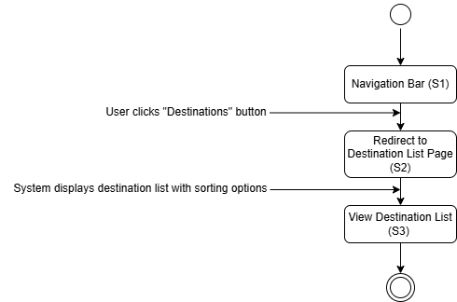
Figure ?.

4-7-12. Search Destinations
Use Case ID | UC011 | Version | 1.0
Feature | F011. Search Destinations
Purpose | To allow user to search destinations
Actor | User
Trigger | User enters keyword and clicks “Search” button (Destinations Page of Add to Planner Page)
Precondition | - User is logged in
Scenario Name | Step | Action
Main Flow | 1 | User enters keyword in the search bar.
Main Flow | 2 | User clicks “Search” button.
Main Flow | 3 | System analyze the credentials and match to database.
Main Flow | 4 | System displays the results of searching.
Rules | - User must be logged in
Author | Kim Booil

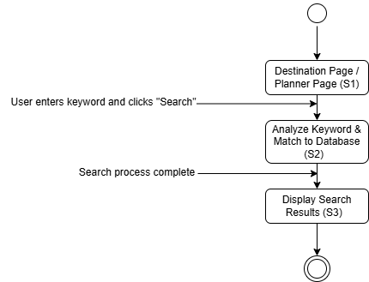
Figure ?.

4-7-13. View Destination Details
Use Case ID | UC012 | Version | 1.0
Feature | F012. View Destination Details
Purpose | To allow user to view details of a destination
Actor | User
Trigger | User clicks any destination (Destination Page or My Page)
Precondition | - User is logged in
Scenario Name | Step | Action
Main Flow | 1 | User clicks any destination.
Main Flow | 2 | System direct user to Destination Detail Page of clicked destination.
Main Flow | 3 | System displays the details of destination (Basic Info, Address Info, Review list and Number of liked)
Rules | - User must be logged in
Author | Kim Booil

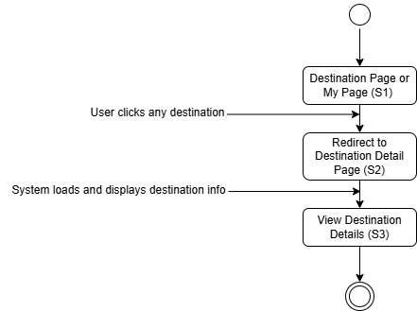
Figure ?.

4-7-14. Recommendation Page
Use Case ID | UC013 | Version | 1.0
Feature | F013. Recommendation Page
Purpose | To allow user to view the recommended destinations
Actor | User
Trigger | User clicks "Recommendations” (Navigation Bar)
Precondition | - User is logged in
Scenario Name | Step | Action
Main Flow | 1 | User clicks "Recommendations”.
Main Flow | 2 | System directs User to recommendation list page.
Main Flow | 3 | System analyzes Favorite, Review and Behavior of user to build recommendation list.
Main Flow | 4 | System gathers and presents the lists of several types of recommended destinations to user.
Rules | - User must be logged in
Author | Kim Booil

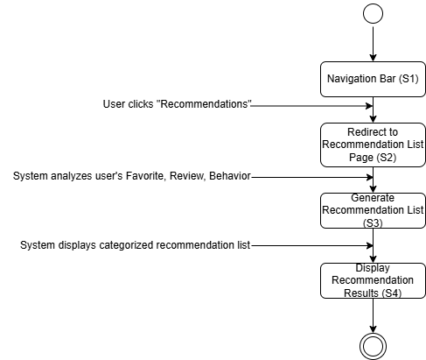
Figure ?.

4-7-15. Like Destination
Use Case ID | UC014 | Version | 1.0
Feature | F014. Like Destinations
Purpose | To allow user to push like button on destination
Actor | User
Trigger | User clicks "Like" button on any destination
Precondition | - User is logged in.  - User is at Destination Detail Page.  - User hasn’t clicked “Like” Button.
Scenario Name | Step | Action
Main Flow | 1 | User click "Like" button.
Main Flow | 2 | System update changes in the database.
Main Flow | 3 | System updates the UI:  • Button turns pink with red border and Heart icon.  • Text changes to “Unlike”.
Rules | - User must be logged in
Author | Kim Booil

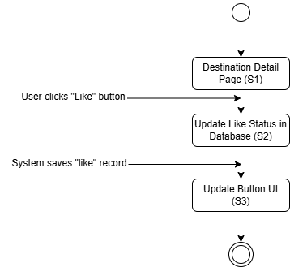
Figure ?.

4-7-16. Unlike Destination
Use Case ID | UC015 | Version | 1.0
Feature | F015. Unlike Destinations
Purpose | To allow user to cancel like button on destination
Actor | User
Trigger | User clicks “Unlike" button on any destination
Precondition | - User is logged in.  - User is at Destination Detail Page.  - User already clicked “Like” Button.
Scenario Name | Step | Action
Main Flow | 1 | User clicks "Unlike" button.
Main Flow | 2 | System update changes in the database.
Main Flow | 3 | System updates the UI:  • Button turns default view  • Text changes to “Like”
Rules | - User must be logged in
Author | Kim Booil

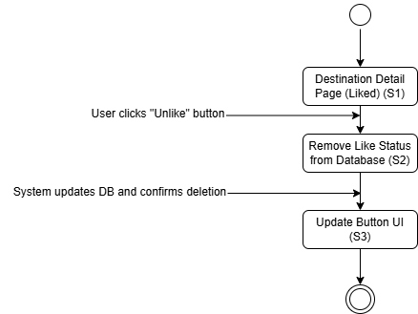
Figure ?.

4-7-17. Leave Feedback and Review
Use Case ID | UC016 | Version | 1.0
Feature | F016. Leave Feedback and Review
Purpose | To allow users to remain review and feedback to any destination
Actor | User
Trigger | User enters content of review, choose rating and clicks “Submit” button.
Precondition | - User is logged in.  - User is at Destination Detail Page.
Scenario Name | Step | Action
Main Flow | 1 | User enters content of review and choose rating 1 - 5
Main Flow | 2 | User clicks “Submit” Button
Main Flow | 3 | System updates change in the database
Main Flow | 4 | System add written review in the review section below.
Rules | - User must be logged in
Author | Kim Booil

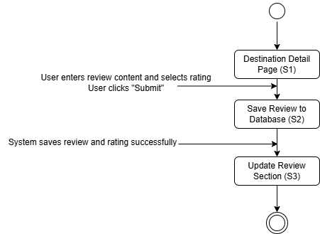
Figure ?.

4-7-18. Delete Feedback and Review
Use Case ID | UC017 | Version | 1.0
Feature | F017. Delete Feedback and Review
Purpose | To allow users to delete review and feedback that he/she remained on any destination.
Actor | User
Trigger | User clicks “Trash Bin” icon on Review.
Precondition | - User is logged in.  - User is at Destination Detail Page.
Scenario Name | Step | Action
Main Flow | 1 | User clicks “Trash Bin” icon on his/her Review.
Main Flow | 2 | System requires reconfirmation of deleting review
Main Flow | 3 | User confirms deletion.
Main Flow | 4 | System saves updates in the database.
Main Flow | 5 | System remove review in the review section below.
Alternative Flow – Cancel Button Clicked | 3.1 | User clicks “Cancel” Button.
Alternative Flow – Cancel Button Clicked | 3.2 | System close confirmation interface.
Rules | - User must be logged in
Author | Kim Booil

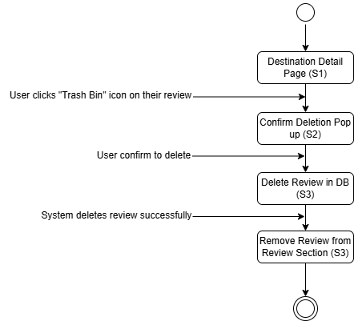
Figure ?.

4-7-19. Edit Feedback and Review
Use Case ID | UC018 | Version | 1.0
Feature | F018. Edit Feedback and Review
Purpose | To allow users to edit review and feedback that he/she remained on any destination.
Actor | User
Trigger | User clicks “Edit” icon on Review.
Precondition | - User is logged in.  - User is at Destination Detail Page.
Scenario Name | Step | Action
Main Flow | 1 | User clicks “Edit” icon on his/her Review.
Main Flow | 2 | System reactivates review form of selected review.
Main Flow | 3 | User modifies rating and content of review.
Main Flow | 4 | User clicks “Update” Button
Main Flow | 5 | System updates change in the database
Main Flow | 6 | System update review in the review section below.
Alternative Flow – Cancel | 3.1 | User clicks “Cancel” Button
Alternative Flow – Cancel | 3.2 | System deactivates review form.
Rules | - User must be logged in
Author | Kim Booil

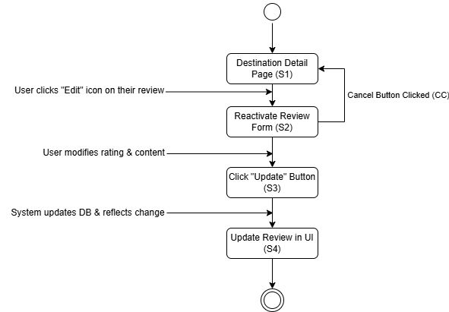
Figure ?.

4-7-20. Popular Destinations
Use Case ID | UC019 | Version | 1.0
Feature | F019. Popular Destinations
Purpose | To allow user to view Most Popular Destinations
Actor | User
Trigger | User clicks "Popular” (Navigation Bar)
Precondition | - User is logged in
Scenario Name | Step | Action
Main Flow | 1 | User clicks "Popular”.
Main Flow | 2 | System directs User to popular destinations list page.
Main Flow | 3 | System displays Top 10 Liked Destinations.
Rules | - User must be logged in
Author | Kim Booil

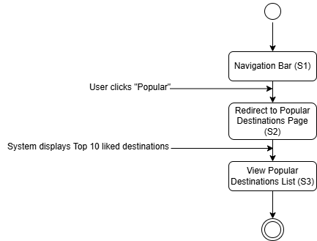
Figure ?.

4-7-21. Nearby Destinations
Use Case ID | UC020 | Version | 1.0
Feature | F020. Nearby Destinations
Purpose | To allow user to view the near destinations from him/she.
Actor | User
Trigger | User clicks "Nearby” (Navigation Bar)
Precondition | - User is logged in
Scenario Name | Step | Action
Main Flow | 1 | User clicks "Nearby”.
Main Flow | 2 | System directs User to Nearby Destinations Page
Main Flow | 3 | User select options of Search Boundary 50km – 200km and clicks “Find My Location” Button.
Main Flow | 4 | System require the authority to collect location information through browser.
Main Flow | 5 | User agrees to collect location information.
Main Flow | 6 | System displays list of near destinations with distance information.
Alternative Flow – Deny Location Collect | 5.1 | User disagree to collect location information
Alternative Flow – Deny Location Collect | 5.2 | System pop up message of “Location Permission Denied”
Rules | - User must be logged in
Author | Kim Booil

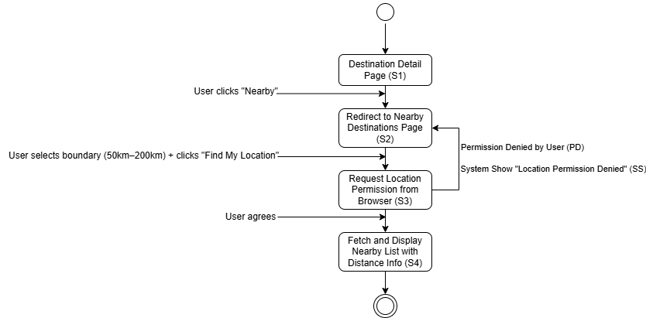
Figure ?.

4-7-22. View Post List
Use Case ID | UC021 | Version | 1.0
Feature | F021. View Post List
Purpose | To allow user to view the list of all posts
Actor | User
Trigger | User clicks "Community” (Navigation Bar)
Precondition | - User is logged in
Scenario Name | Step | Action
Main Flow | 1 | User clicks "Community”.
Main Flow | 2 | System directs User to Post list page.
Main Flow | 3 | System displays list of posts
Rules | - User must be logged in
Author | Kim Booil

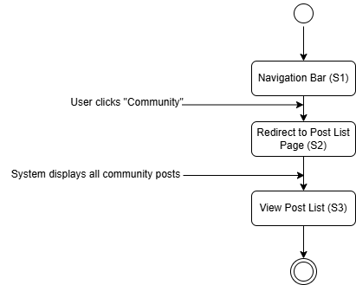
Figure ?.

4-7-23. View Post Detail
Use Case ID | UC022 | Version | 1.0
Feature | F022. View Post Detail
Purpose | To allow user to view the detail(content) of any post.
Actor | User
Trigger | User clicks any post.
Precondition | - User is logged in  - User is at Post list Page
Scenario Name | Step | Action
Main Flow | 1 | User clicks any post.
Main Flow | 2 | System directs User to Post detail Page
Main Flow | 3 | System displays contents (include comments and user profile) of selected post
Rules | - User must be logged in
Author | Kim Booil

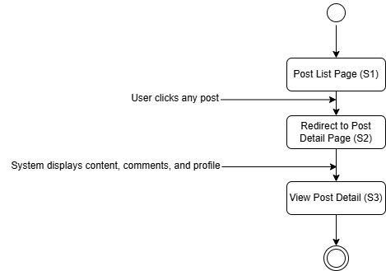
Figure ?.

4-7-24. Search Post
Use Case ID | UC023 | Version | 1.0
Feature | F023. Search Post
Purpose | To allow user to search post
Actor | User
Trigger | User enters keyword, and clicks “Search” button
Precondition | - User is logged in  - User is at Post list Page
Scenario Name | Step | Action
Main Flow | 1 | User enters keyword in the search bar (Default search option is “All”, can be selected title or author).
Main Flow | 2 | User clicks “Search” button.
Main Flow | 3 | System analyze the credentials and match to database.
Main Flow | 4 | System displays the results of searching.
Rules | - User must be logged in
Author | Kim Booil

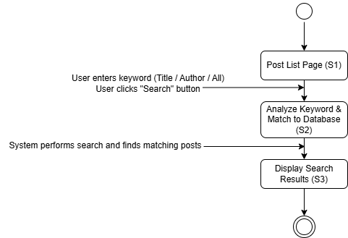
Figure ?.

4-7-25. Create Post
Use Case ID | UC024 | Version | 1.0
Feature | F024. Create Post
Purpose | To allow users to create posts in community
Actor | User
Trigger | User clicks "Create Post" button
Precondition | - User is logged in.  - User is at Post list Page.
Scenario Name | Step | Action
Main Flow | 1 | User clicks "Post" button.
Main Flow | 2 | System directs User to Create post Page.
Main Flow | 3 | User enters Title and Contents.
Main Flow | 4 | User clicks “Upload Post” Button .
Main Flow | 5 | System save updates in the database.
Main Flow | 6 | System add new post in post list and directs user to Post list Page.
Alternative Flow  Back to List | 3.1 | User select “Back to List” button.
Alternative Flow  Back to List | 3.2 | System directs User to Post list Page.
Rules | - User must be logged in
Author | Kim Booil

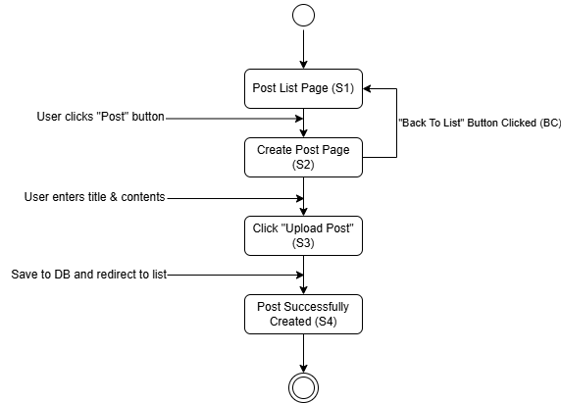
Figure ?.

4-7-26. Edit Post
Use Case ID | UC025 | Version | 1.0
Feature | F025. Edit Post
Purpose | To allow users to edit posts in community
Actor | User
Trigger | User clicks "Modify" Button
Precondition | - User is logged in.  - User is at Post Detail Page.
Scenario Name | Step | Action
Main Flow | 1 | User clicks "Post" button.
Main Flow | 2 | System directs User to Create post Page.
Main Flow | 3 | User enters Title and Contents.
Main Flow | 4 | User clicks “Update” Button .
Main Flow | 5 | System saves updates in the database.
Main Flow | 6 | System adds new post in post list and directs user to Post Detail Page.
Alternative Flow  Cancel Button Clicked | 3.1 | User selects “Cancel” button.
Alternative Flow  Cancel Button Clicked | 3.2 | System directs User to Post Detail Page.
Rules | - User must be logged in
Author | Kim Booil

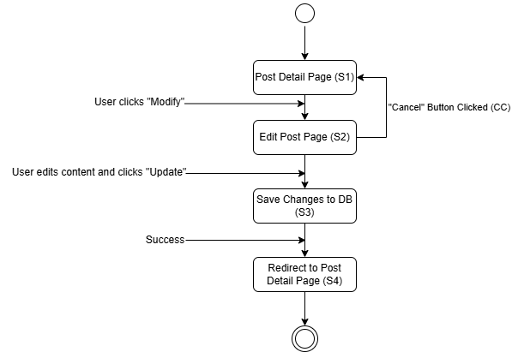
Figure ?.

4-7-27. Delete Post
Use Case ID | UC026 | Version | 1.0
Feature | F026. Delete Post
Purpose | To allow users to delete post
Actor | User
Trigger | User clicks “Delete” Button.
Precondition | - User is logged in.  - User is at his/her Post detail Page.
Scenario Name | Step | Action
Main Flow | 1 | User clicks “Delete” Button.
Main Flow | 2 | System requires reconfirmation of deleting post
Main Flow | 3 | User confirms deletion.
Main Flow | 4 | System pops up message of “Post Successfully Deleted”
Main Flow | 5 | System saves updates in the database.
Main Flow | 6 | System removes post in post list and directs to Post list Page
Alternative Flow – Cancel Button Clicked | 3.1 | User clicks “Cancel” Button.
Alternative Flow – Cancel Button Clicked | 3.2 | System close confirmation interface
Rules | - User must be logged in
Author | Kim Booil

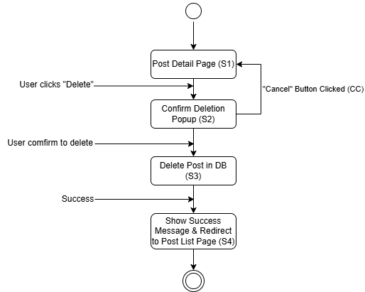
Figure ?.

4-7-28. Create Comment
Use Case ID | UC027 | Version | 1.0
Feature | F027. Create Comment
Purpose | To allow users to leave comments on posts
Actor | User
Trigger | User enter comments and click “Write Comment” Button.
Precondition | - User is logged in.  - User is at any Post detail Page.
Scenario Name | Step | Action
Main Flow | 1 | User enters comments in the comment box below the post details.
Main Flow | 2 | User clicks “Write Comment” button.
Main Flow | 3 | System saves updates in the database.
Main Flow | 4 | System adds new comments to the comment section.
Rules | - User must be logged in
Author | Kim Booil

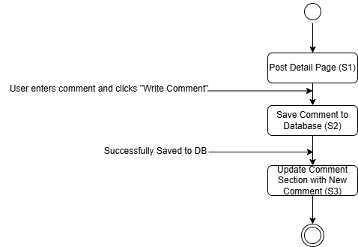
Figure ?.

4-7-29. Delete Comment
Use Case ID | UC028 | Version | 1.0
Feature | F028. Delete Comment
Purpose | To allow users to delete comments on posts
Actor | User
Trigger | User clicks “Trash bin” icon
Precondition | - User is logged in.  - User is at any Post detail Page.  - User left any comments in that Post detail Page.
Scenario Name | Step | Action
Main Flow | 1 | User clicks “Trash bin” icon beside of his/her comment.
Main Flow | 2 | System requires reconfirmation of deleting comment
Main Flow | 3 | User confirms to delete comment.
Main Flow | 4 | System saves updates in the database.
Main Flow | 5 | System removes selected comment in the comment section.
Alternative Flow – Cancel Button Clicked | 3.1 | User clicks “Cancel” Button.
Alternative Flow – Cancel Button Clicked | 3.2 | System close confirm interface
Rules | - User must be logged in
Author | Kim Booil

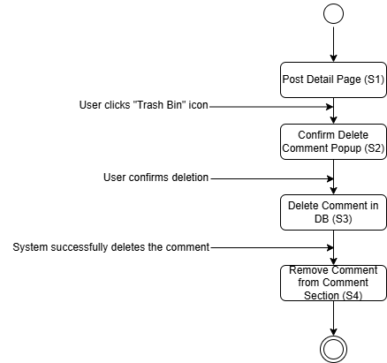
Figure ?.

4-7-30. View Profile
Use Case ID | UC029 | Version | 1.0
Feature | F029. View Profile
Purpose | To allow users to view another user’s profile information
Actor | User
Trigger | User clicks profile image
Precondition | - User is logged in.  - User is at any Post detail Page.
Scenario Name | Step | Action
Main Flow | 1 | User clicks profile image.
Main Flow | 2 | System displays Profile information
Rules | - User must be logged in
Author | Kim Booil

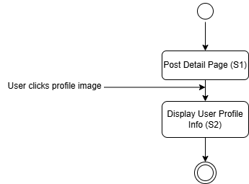
Figure ?.

4-7-31. Flight Search
Use Case ID | UC030 | Version | 1.0
Feature | F030. Flight Search
Purpose | To allow users to search flight.
Actor | User
Trigger | User clicks "Flights" (Navigation Bar)
Precondition | - User is logged in
Scenario Name | Step | Action
Main Flow | 1 | User clicks "Flights".
Main Flow | 2 | System directs User to Flight search Page
Main Flow | 3 | User enters all required credentials for searching flight.
Main Flow | 4 | User clicks “Search Flight” Button.
Main Flow | 5 | System displays list of flights
Alternative Flow  No result exists | 3.1 | User enters credentials that doesn’t contain actual information
Alternative Flow  No result exists | 3.2 | System finds flight results for credentials
Alternative Flow  No result exists | 3.3 | System pops up message of “No search results. Try different search conditions.”
Alternative Flow  No result exists | 3.4 | Repeat step 3
Rules | - User must be logged in
Author | Kim Booil

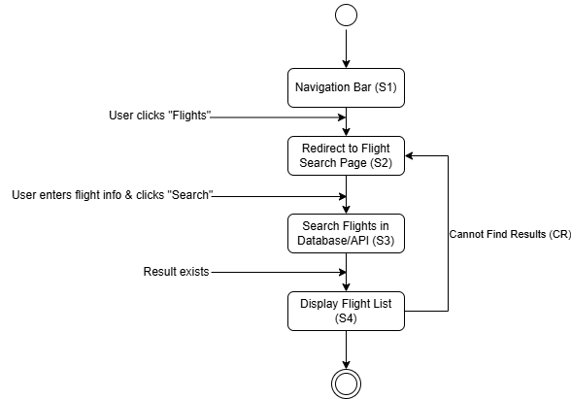
Figure ?.

4-7-32. Flight Details
Use Case ID | UC031 | Version | 1.0
Feature | F031. Flight Details
Purpose | To allow users to view details of any flight.
Actor | User
Trigger | User clicks "Details" Button.
Precondition | - User is logged in  - User is at Flight search Page  - User has searched any flights and watching list of flights
Scenario Name | Step | Action
Main Flow | 1 | User clicks "Details" Button beside of any flight in the list.
Main Flow | 2 | System directs User to Flight detail Page.
Main Flow | 3 | System displays detailed information about selected flight.
Rules | - User must be logged in
Author | Kim Booil

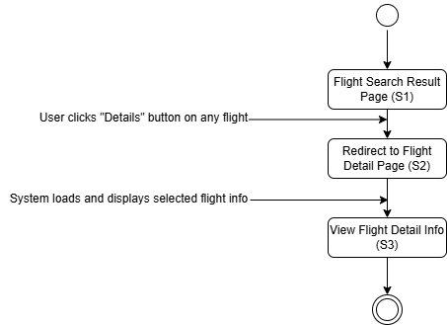
Figure ?.

4-7-33. Reservation Web Connection
Use Case ID | UC032 | Version | 1.0
Feature | F032. Reservation Web Connection
Purpose | To allow users to be connected to external page for actual reservation
Actor | User
Trigger | User clicks "Book Now" Button.
Precondition | - User is logged in.  - User is at any Flight detail Page.
Scenario Name | Step | Action
Main Flow | 1 | User clicks any "Book Now" Button located at external page list section below flight details.
Main Flow | 2 | System directs User to selected external page for reservation.
Rules | - User must be logged in
Author | Kim Booil

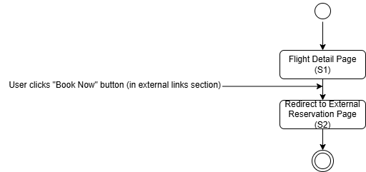
Figure ?.

4-7-34. Create Planner
Use Case ID | UC033 | Version | 1.0
Feature | F033. Create Plan
Purpose | To allow users to create plan as their preference
Actor | User
Trigger | User clicks "Planner" (Navigation Bar)
Precondition | - User is logged in
Scenario Name | Step | Action
Main Flow | 1 | User clicks "Planner".
Main Flow | 2 | System directs User to Planner Page
Main Flow | 3 | System displays New Create Planner form with requiring title and explanation(optional)
Main Flow | 4 | User enters credentials
Main Flow | 5 | User clicks “Create Planner”
Main Flow | 6 | System displays Add to Planner interface and add planner to Your Planner section
Main Flow | 7 | User enters keyword in the search bar
Main Flow | 8 | System automatically displays destinations and country filter option.
Main Flow | 9 | User drags or select any destinations by maximum 10 in one planner as his/her preference.
Alternative Flow – Already Created more than one planner | 3.1 | System displays Add to Planner interface
Alternative Flow – Create Another Planner | 4.1 | User clicks “Create Another Planner” in Add to Planner interface.
Alternative Flow – Create Another Planner | 4.2 | System displays New Create Planner form
Rules | - User must be logged in
Author | Kim Booil

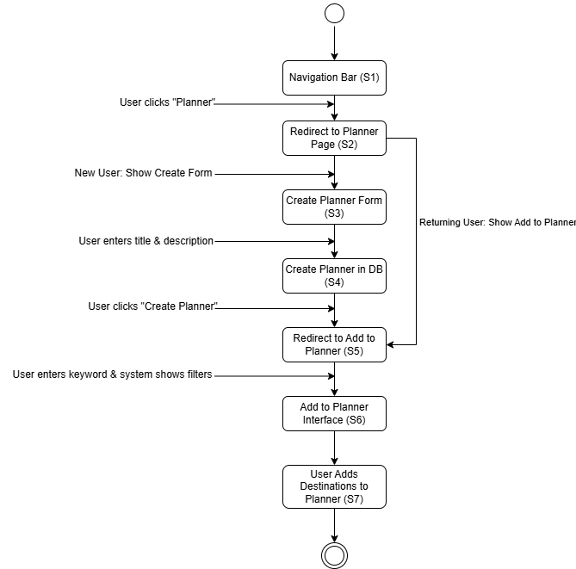
Figure ?.

4-7-35. Delete Planner
Use Case ID | UC034 | Version | 1.0
Feature | F034. Delete Plan
Purpose | To allow users to delete plan.
Actor | User
Trigger | User clicks “Delete Planner” button.
Precondition | - User is logged in.  - User is at Planner Page.  - User is watching Add to Planner interface.
Scenario Name | Step | Action
Main Flow | 1 | User clicks “Delete Planner” button.
Main Flow | 2 | System requires reconfirmation of deleting planner.
Main Flow | 3 | User confirms to delete planner.
Main Flow | 4 | System saves updates in the database.
Main Flow | 5 | System pops up message of “Planner Successfully Deleted”.
Main Flow | 6 | System removes selected planner in the Your Planner section.
Alternative Flow – Cancel Button Clicked | 3.1 | User clicks “Cancel” Button.
Alternative Flow – Cancel Button Clicked | 3.2 | System close confirmation interface
Alternative Flow – Delete All Planner | 3.1 | User confirms to delete planner that left only one.
 | 3.2 | System displays New Create Planner form with requiring title and explanation(optional)
Rules | - User must be logged in
Author | Kim Booil

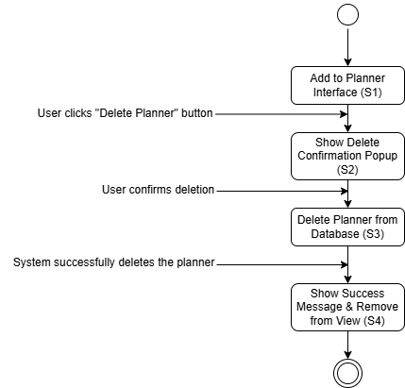
Figure ?.

4-7-36. Edit Component Sequences
Use Case ID | UC035 | Version | 1.0
Feature | F035. Edit Component Sequences
Purpose | To allow users to edit planner.
Actor | User
Trigger | User clicks “Delete Planner” button.
Precondition | - User is logged in.  - User is at Planner Page.  - User is watching Add to Planner interface.
Scenario Name | Step | Action
Main Flow | 1 | User clicks and drags destinations in planner to change sequence.
Main Flow | 2 | User clicks “Save Changes” Button.
Main Flow | 3 | System updates change in the database
Main Flow | 4 | System pops up message of “Planner order has been saved”.
Main Flow | 5 | System pops up message of “Planner Order Saved”.
Main Flow | 6 | System directs to latest planner.
Alternative Flow – Clicks “Save Changes” without adding any destinations | 2.1 | User clicks “Save Changes” Button.
 | 2.2 | System pops up message of “There is no destination to save”.
 | 2.3 | Repeat from 1
Rules | - User must be logged in
Author | Kim Booil

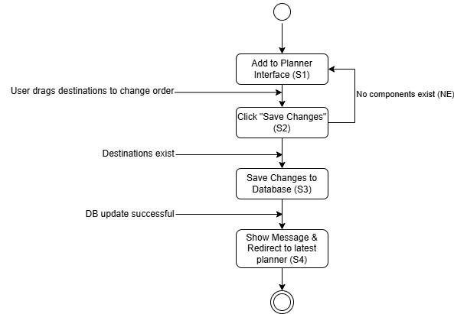
Figure ?.

Here put user persona later

4-8. Functional Requirements
Requirement ID | REQ_F001 | Version | 1.0
Description | The system shall be able to allow users to create a new account to access the website.
Author | Kim Booil

Requirement ID | REQ_F002 | Version | 1.0
Description | The system shall be able to allow users to log into the system using their credentials.
Author | Kim Booil

Requirement ID | REQ_F003 | Version | 1.0
Description | The system shall be able to allow users to log out of the system and end their session.
Author | Kim Booil

Requirement ID | REQ_F004 | Version | 1.0
Description | The system shall be able to allow users to delete their own account.
Author | Kim Booil

Requirement ID | REQ_F005 | Version | 1.0
Description | The system shall be able to allow users to update and manage their personal information.
Author | Kim Booil

Requirement ID | REQ_F006 | Version | 1.0
Description | The system shall be able to allow users to view their favorite list that they made by themselves with clicking like button.
Author | Kim Booil

Requirement ID | REQ_F007 | Version | 1.0
Description | The system shall be able to allow users to view their reviews that they made by themselves.
Author | Kim Booil

Requirement ID | REQ_F008 | Version | 1.0
Description | The system shall be able to allow users to view their posts that they made by themselves.
Author | Kim Booil

Requirement ID | REQ_F009 | Version | 1.0
Description | The system shall be able to allow users to view their comments that they made by themselves.
Author | Kim Booil

Requirement ID | REQ_F010 | Version | 1.0
Description | The system shall be able to allow users to view the list of travel destinations.
Author | Kim Booil

Requirement ID | REQ_F011 | Version | 1.0
Description | The system shall be able to allow users to use search functions when they explore list of destinations.
Author | Kim Booil

Requirement ID | REQ_F012 | Version | 1.0
Description | The system shall be able to allow users to view the detailed information of each destinations.
Author | Kim Booil

Requirement ID | REQ_F013 | Version | 1.0
Description | The system shall be able to allow users to view the list of recommended destinations based on user’s activity and behaviors.
Author | Kim Booil

Requirement ID | REQ_F014 | Version | 1.0
Description | The system shall be able to allow users to add any destinations to their favorite list by clicking like button
Author | Kim Booil

Requirement ID | REQ_F015 | Version | 1.0
Description | The system shall be able to allow users to delete any destinations from their favorite list by clicking like button again.
Author | Kim Booil

Requirement ID | REQ_F016 | Version | 1.0
Description | The system shall be able to allow users to leave their reviews and feedback on destinations they interacted with.
Author | Kim Booil

Requirement ID | REQ_F017 | Version | 1.0
Description | The system shall be able to allow users to delete their reviews and feedback on destinations that they wrote.
Author | Kim Booil

Requirement ID | REQ_F018 | Version | 1.0
Description | The system shall be able to allow users to edit their reviews and feedback on destinations that they wrote.
Author | Kim Booil

Requirement ID | REQ_F019 | Version | 1.0
Description | The system shall be able to allow users to view Top 10 popular destinations based on liked counts.
Author | Kim Booil

Requirement ID | REQ_F020 | Version | 1.0
Description | The system shall be able to allow users to view the near destinations based on GPS information by collecting it from user.
Author | Kim Booil

Requirement ID | REQ_F021 | Version | 1.0
Description | The system shall be able to allow users to view list of all posts.
Author | Kim Booil

Requirement ID | REQ_F022 | Version | 1.0
Description | The system shall be able to allow users to view detailed contents and components in any post.
Author | Kim Booil

Requirement ID | REQ_F023 | Version | 1.0
Description | The system shall be able to allow users to search for post with proper options.
Author | Kim Booil

Requirement ID | REQ_F024 | Version | 1.0
Description | The system shall be able to allow users to create new post.
Author | Kim Booil

Requirement ID | REQ_F025 | Version | 1.0
Description | The system shall be able to allow users to edit the post that they created
Author | Kim Booil

Requirement ID | REQ_F027 | Version | 1.0
Description | The system shall be able to allow users to write comment on any posts
Author | Kim Booil

Requirement ID | REQ_F028 | Version | 1.0
Description | The system shall be able to allow users to delete comment that they wrote
Author | Kim Booil

Requirement ID | REQ_F029 | Version | 1.0
Description | The system shall be able to allow users to another user’s profile information by clicking profile image.
Author | Kim Booil

Requirement ID | REQ_F030 | Version | 1.0
Description | The system shall be able to allow users to search for flights
Author | Kim Booil

Requirement ID | REQ_F031 | Version | 1.0
Description | The system shall be able to allow users to view detailed information of any flights that they search.
Author | Kim Booil

Requirement ID | REQ_F032 | Version | 1.0
Description | The system shall be able to allow users to be connected to external website for actual reservation.
Author | Kim Booil

Requirement ID | REQ_F033 | Version | 1.0
Description | The system shall be able to allow users to create and build planner.
Author | Kim Booil

Requirement ID | REQ_F034 | Version | 1.0
Description | The system shall be able to allow users to delete planner that they created and built.
Author | Kim Booil

Requirement ID | REQ_F035 | Version | 1.0
Description | The system shall be able to allow users to save the sequence of destinations in planner that they set.
Author | Kim Booil

4-9 Non-Functional Requirements

4-9-1. Functionality Application Requirements
ID | Ver | Description | Priority (1-10)
001-001 | 1.0 | Accuracy
001-001-001 | 1.0 | The system shall execute personalized recommendation algorithms with an accuracy rate of at least 95%, ensuring relevant and tailored suggestions for users based on their behaviors and history. | 9
001-001-002 | 1.0 | The system shall display the information from database correctly | 9
001-001-003 | 1.0 | The system shall utilize external APIs within the codes. | 8
001-001-004 | 1.0 | The system shall execute nature language processing to search bar with an accuracy rate of at least 95%, ensuring relevant and tailored search results for users | 9
001-002 | 1.0 | Security
001-002-001 | 1.0 | The system shall require user authentication to access the system | 10
001-002-002 | 1.0 | The system shall encrypt users’ account passwords using a hash algorithm before storing their data on to the database. | 10
001-002-003 | 1.0 | The system shall allow users to delete their profile once it’s no longer needed | 9
001-003 | 1.0 | Suitability
001-003-001 | 1.0 | The system shall provide suitable flight search functionality by integrating Skyscanner API to match user travel needs. | 7
001-003-002 | 1.0 | The system shall provide appropriate and interactive map-based features using Google Maps API to support destination-related tasks. | 7

4-9-2. Reliability System Requirements
ID | Ver | Description | Priority
002-001 | 1.0 | Recoverability
002-001-001 | 1.0 | The system shall save all actions and history of users | 8
002-001-001 | 1.0 | The system shall guide users from error occurred. | 9
002-002 | 1.0 | Reliability
002-002-001 | 1.0 | The system shall provide seamless account access immediately after validating users' login credentials, ensuring no errors or delays. | 9
002-002-002 | 1.0 | The system shall maintain a 99.9% uptime, ensuring uninterrupted access and stable performance for users. | 9
002-002-003 | 1.0 | The system shall manage account information well when account deletion and account creation has occurred. | 10

4-9-3. Usability System Requirements
ID | Ver | Description | Priority
003-001 | 1.0 | Usability
003-001-001 | 1.0 | The system shall provide appropriate and easy interface even first time accessing to allow users to utilize the application without any confusion. | 8
003-002 | 1.0 | Attractiveness
003-002-001 | 1.0 | The system shall have a trendy UI for every components of website. | 7

4-9-4. Efficiency Application Requirements
ID | Ver | Description | Priority
004-001 | 1.0 | Performance
004-001-001 | 1.0 | The system shall be able to display the next page and information details within 3 seconds. | 7
004-001-002 | 1.0 | The system shall direct users to several functions when user chose them within 2 seconds. | 7
004-001-003 | 1.0 | The application shall ensure that users receive the newest information based on real-time update. | 8
004-001-004 | 1.0 | The system shall be able to display recommended list to users with efficient processing of model | 8
004-001-005 | 1.0 | The system shall be able to fetch near destinations of user based on collected GPS information. | 7

Design

5-1. Overview

5-1-1. Entity Relationship Diagram
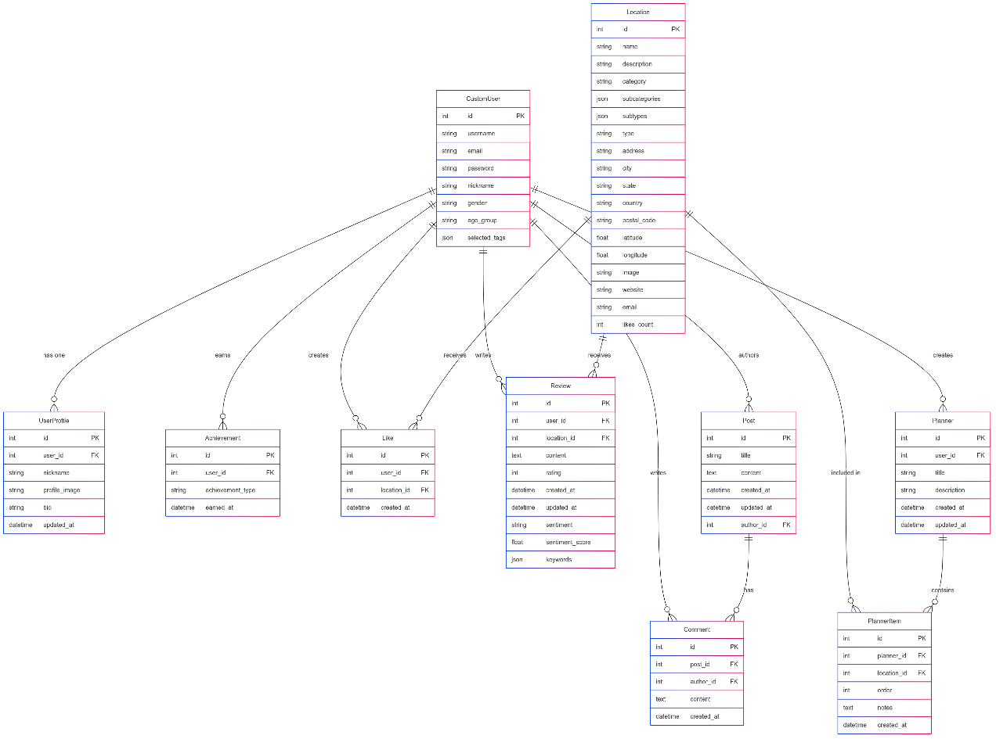
Figure ?. ERD

5-2. Technical Drawings

5-2-1. Context Diagram
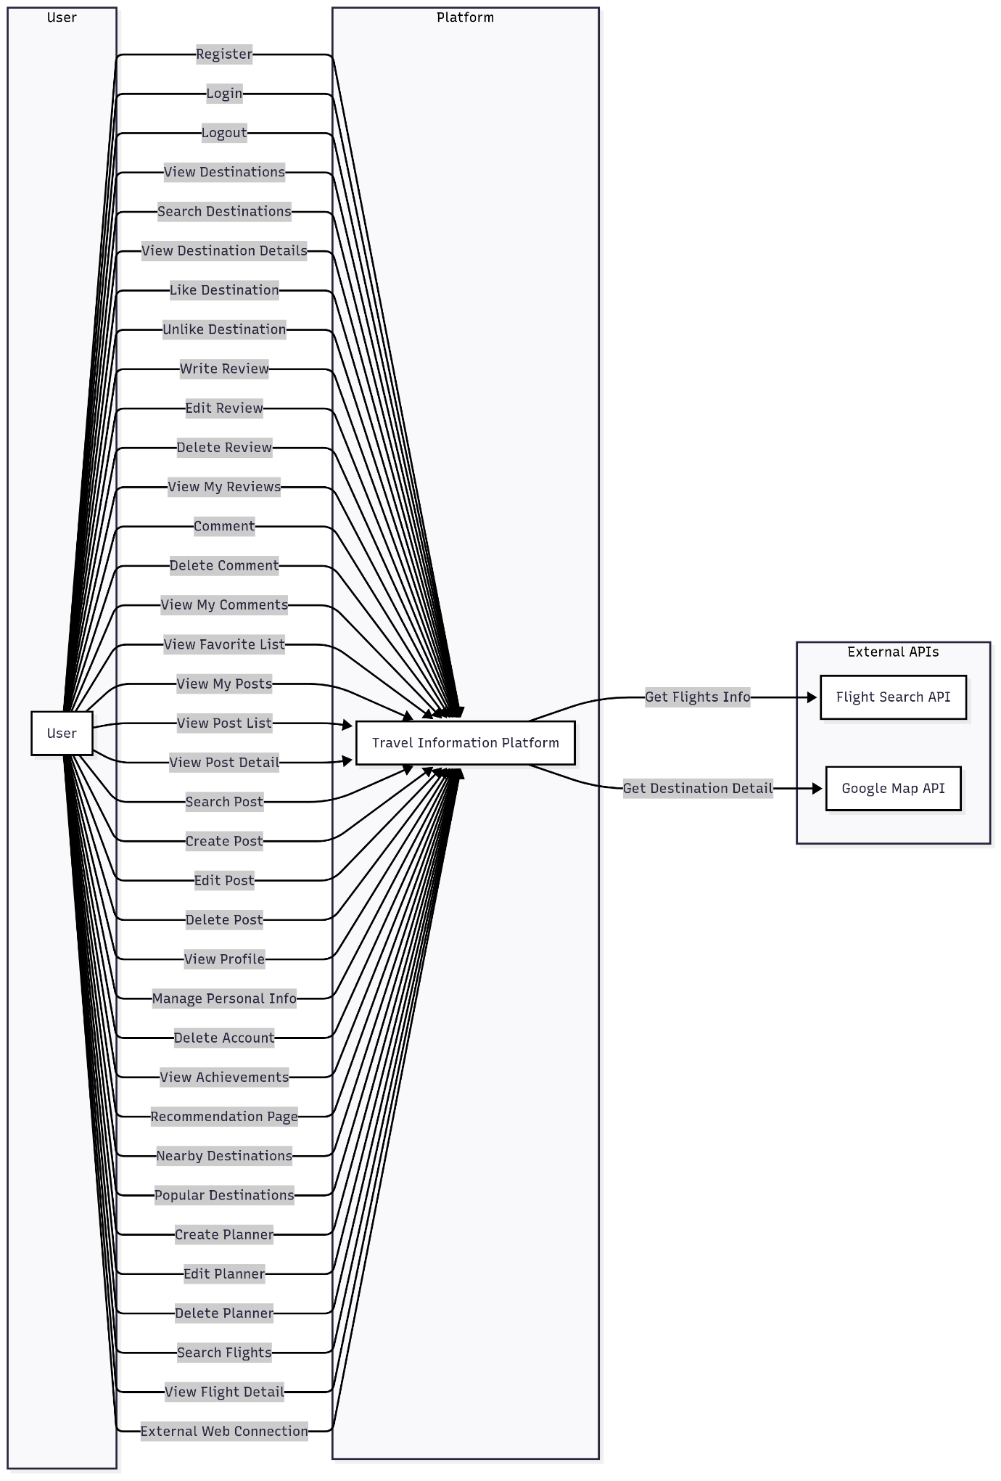
Figure ?.

5-2-3. Sequence Diagram
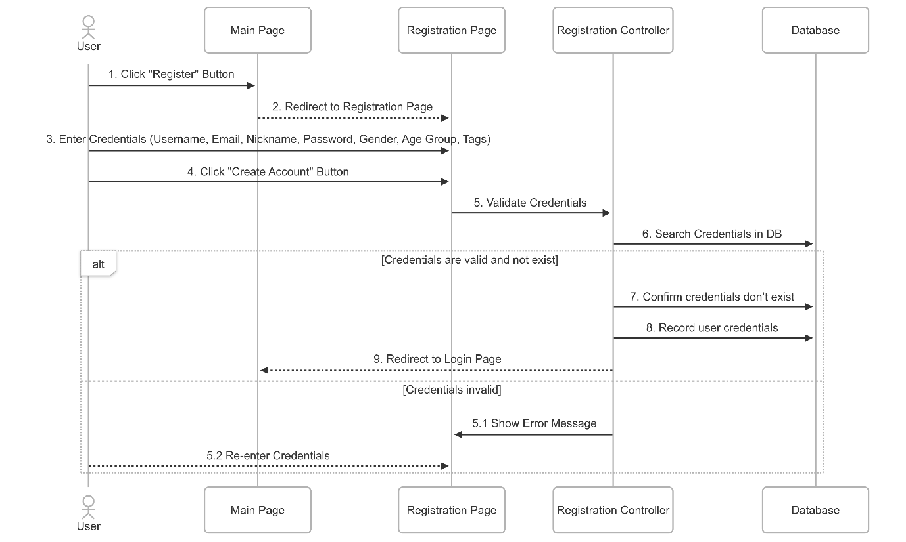
Figure ?. Register
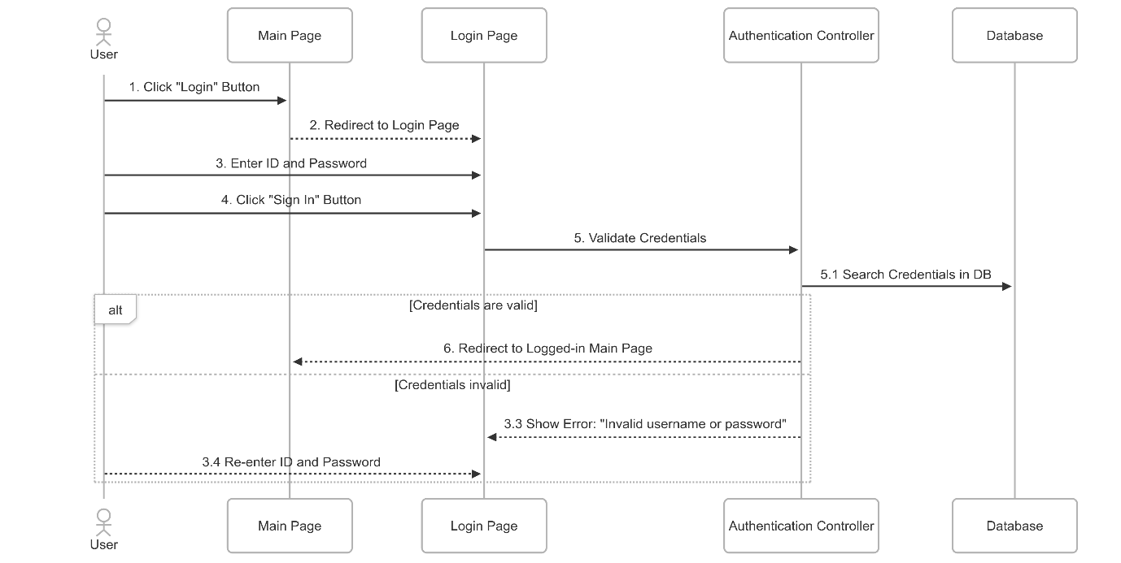
Figure ?. Login
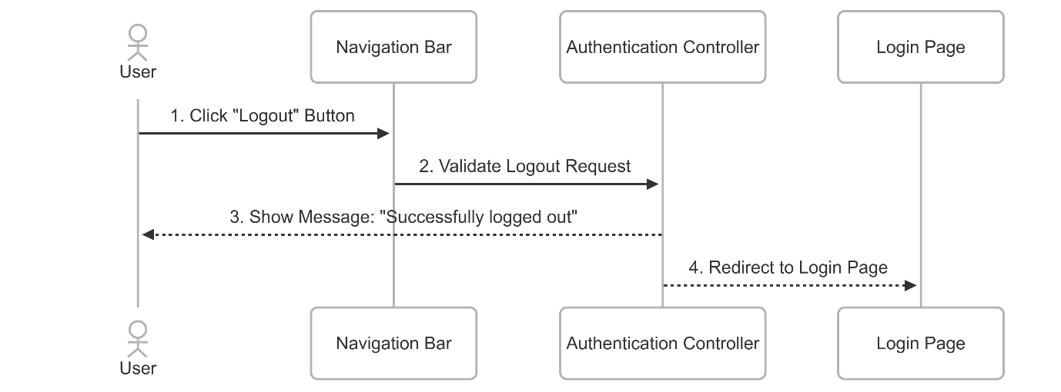
Figure ?. Logout
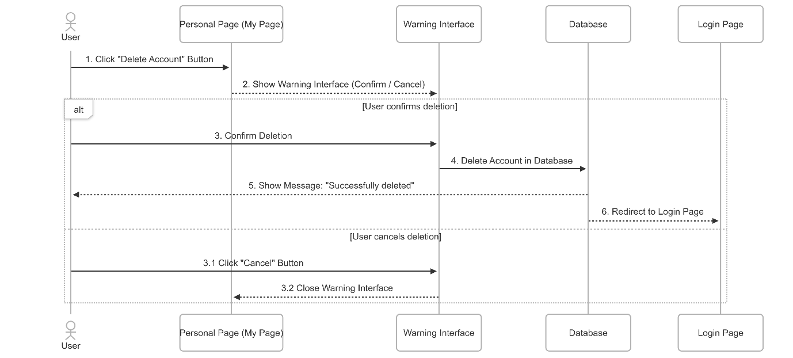
Figure ?. Delete Account
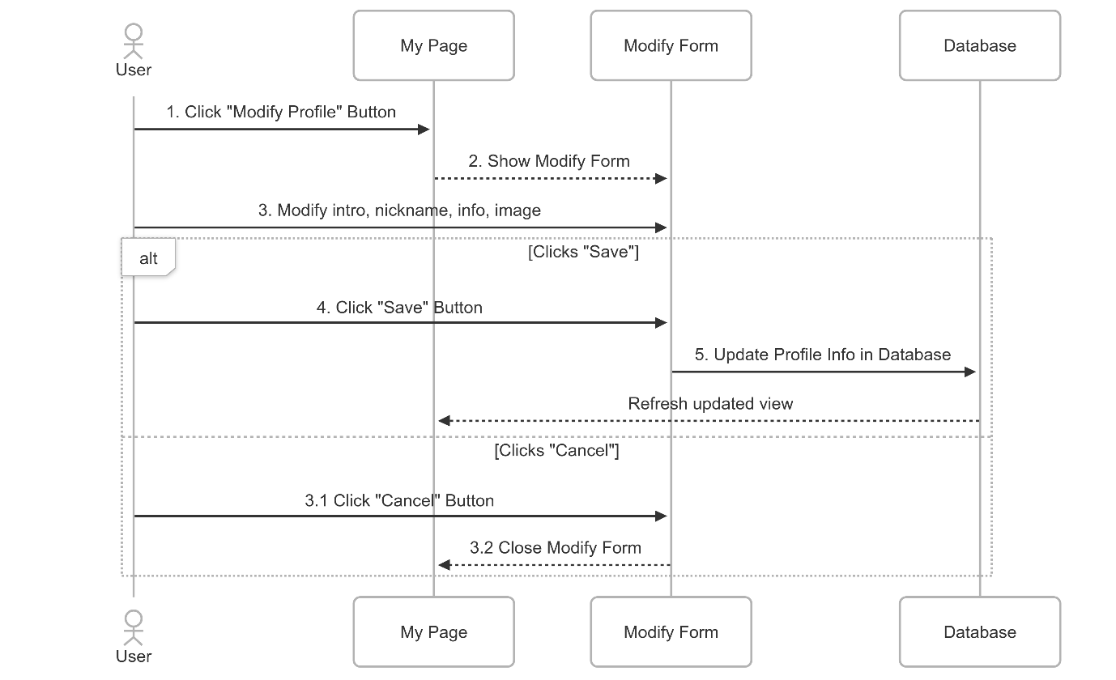
Figure ?. Manage Personal Details
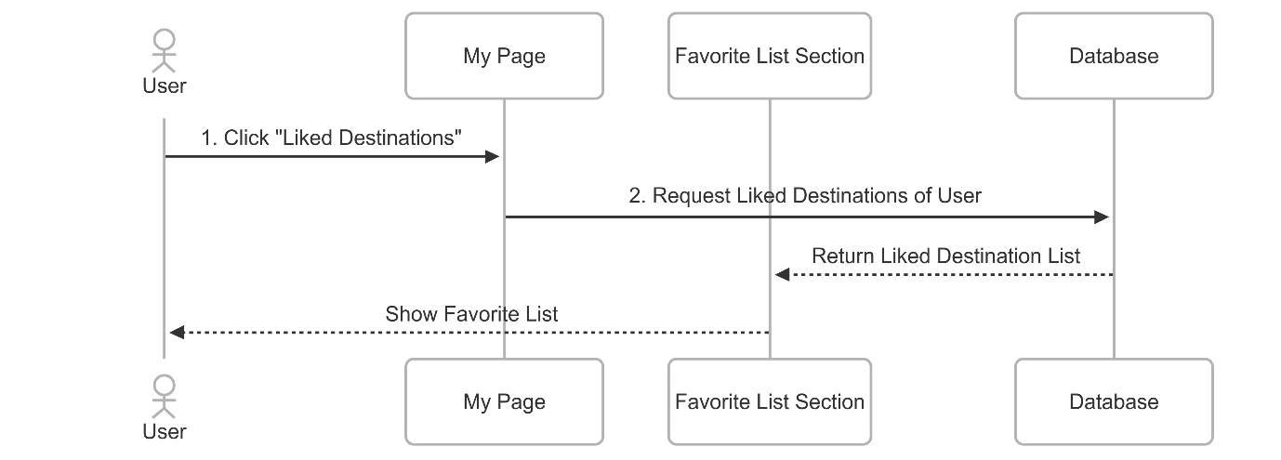
Figure ?. View My Favorite List
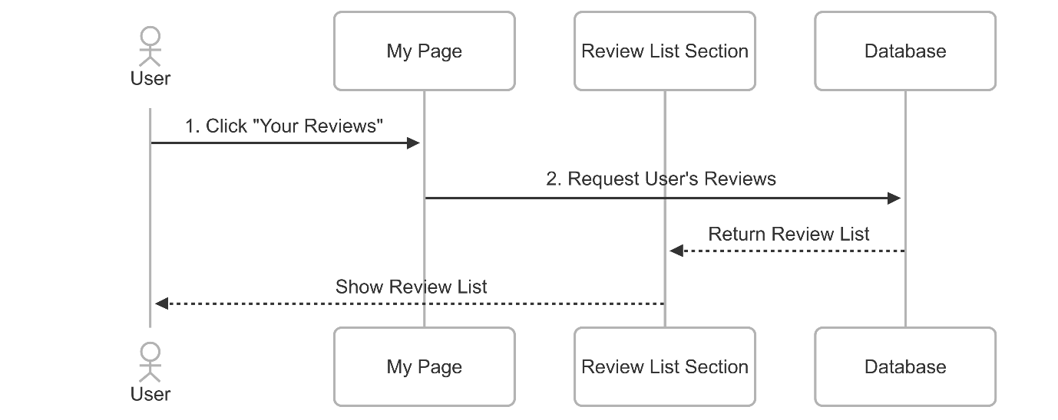
Figure ?. View My Review and Feedback
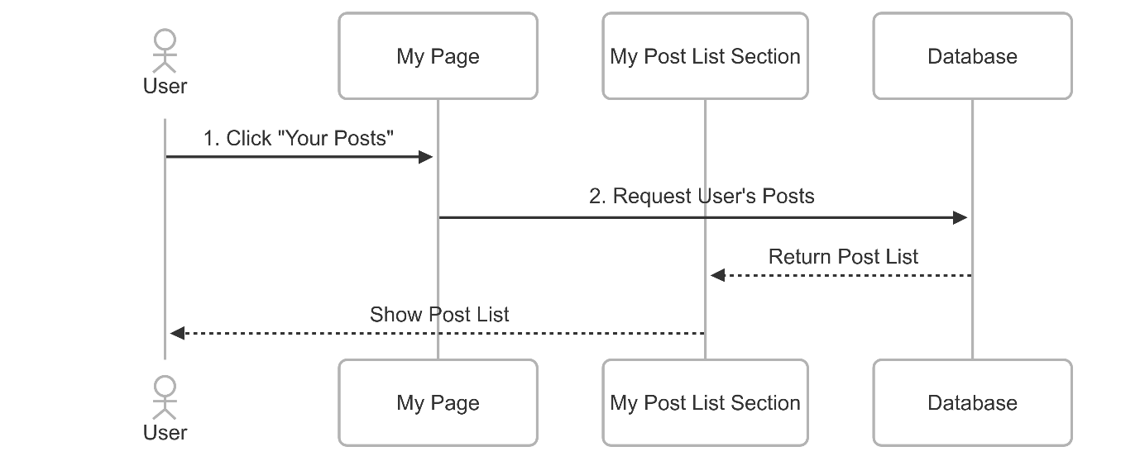
Figure ?. View My Post
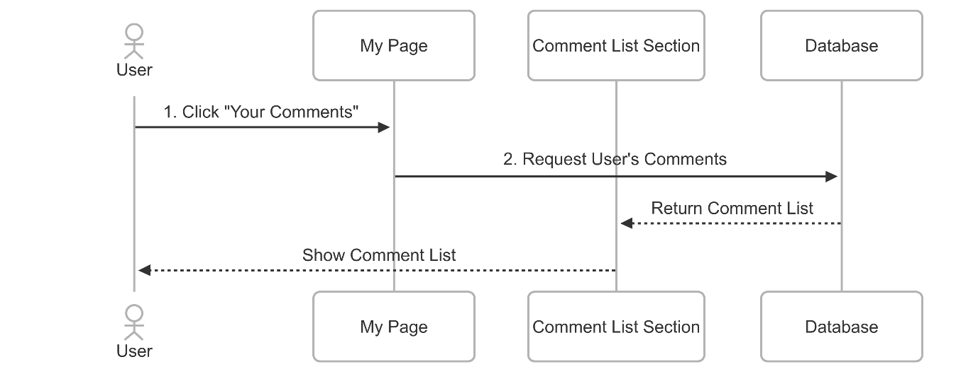
Figure ?. View My Comments
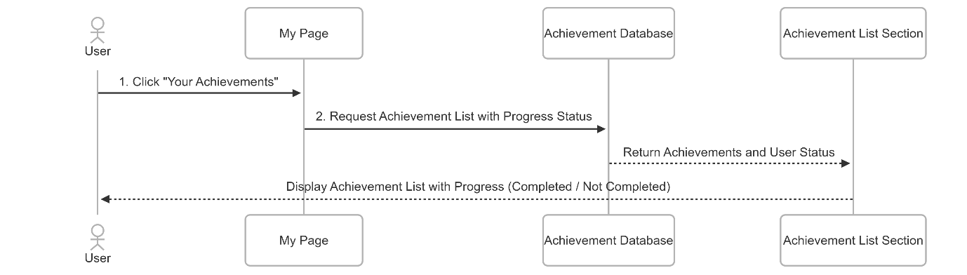
Figure ?. View Achievement
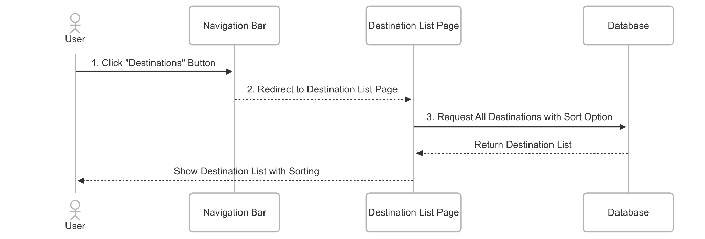
Figure ?. View Destinations
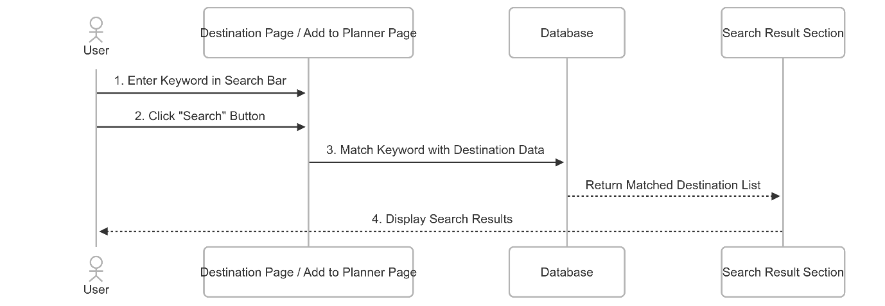
Figure ?. Search Destinations
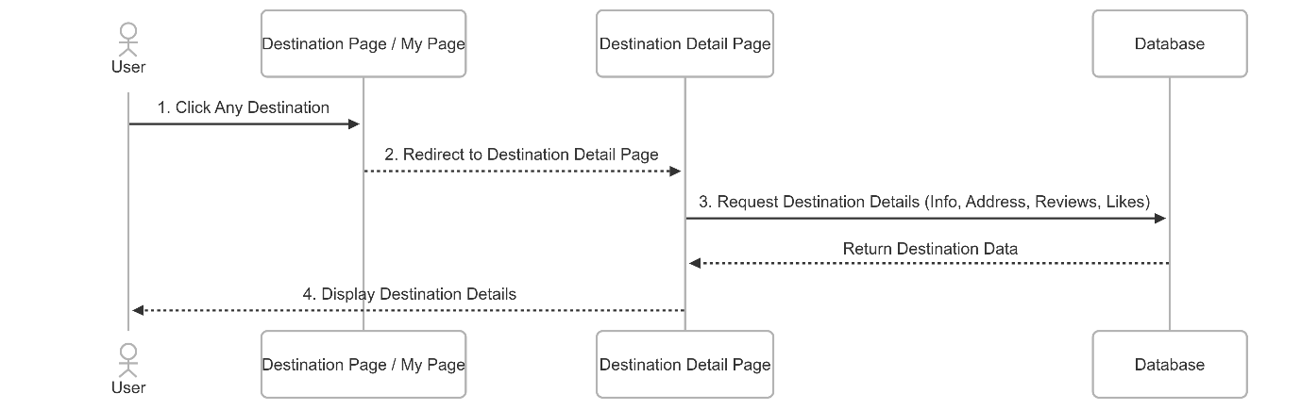
Figure ?. View Destination Details
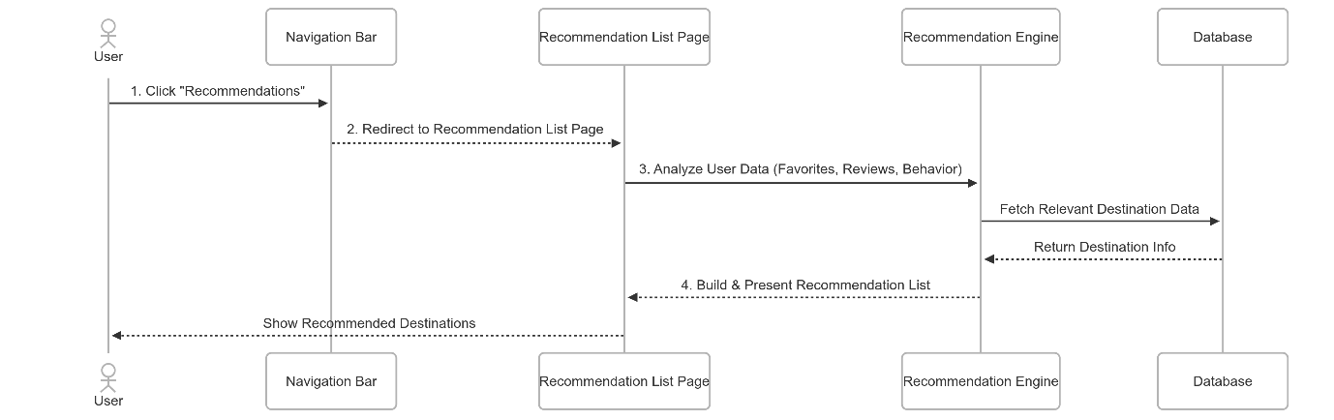
Figure ?. Recommendation Page
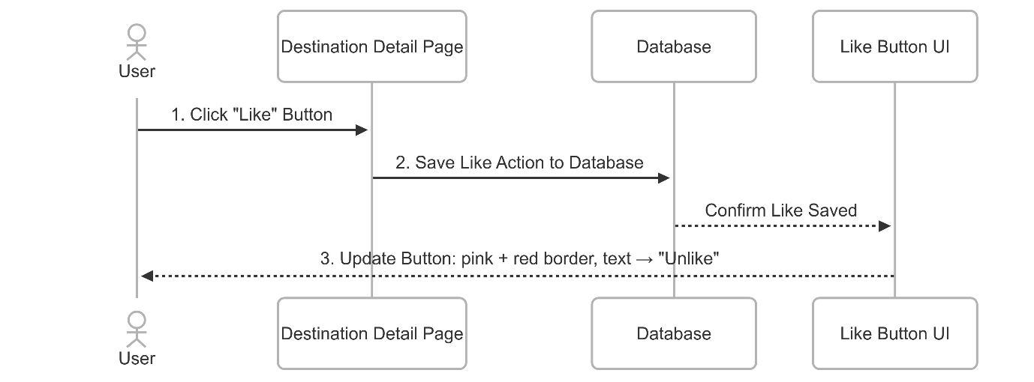
Figure ?. Like Destination
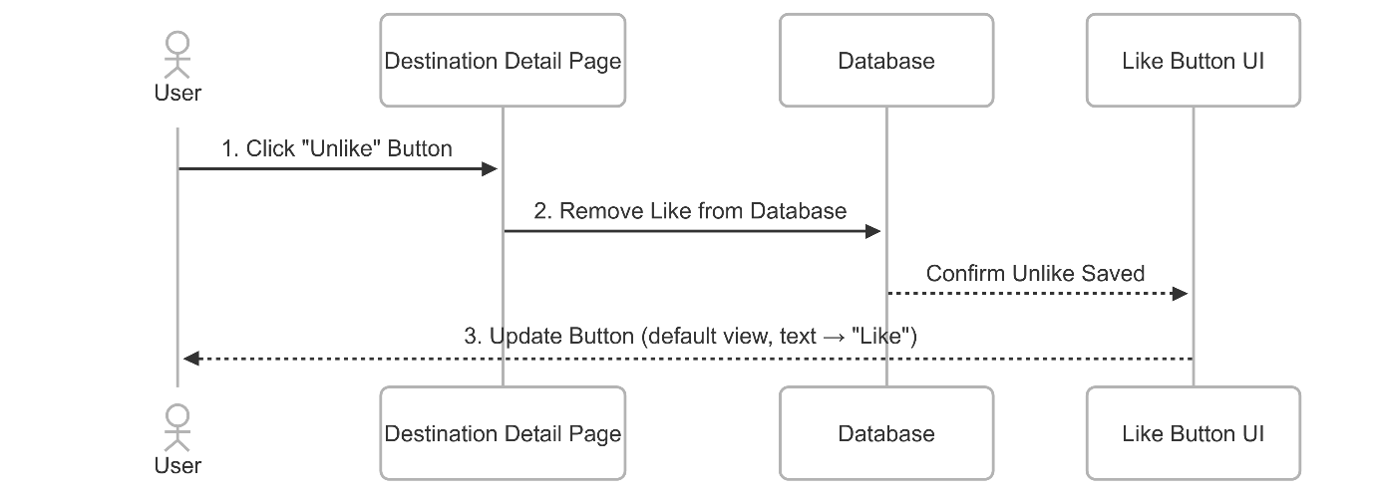
Figure ?. Unlike Destination
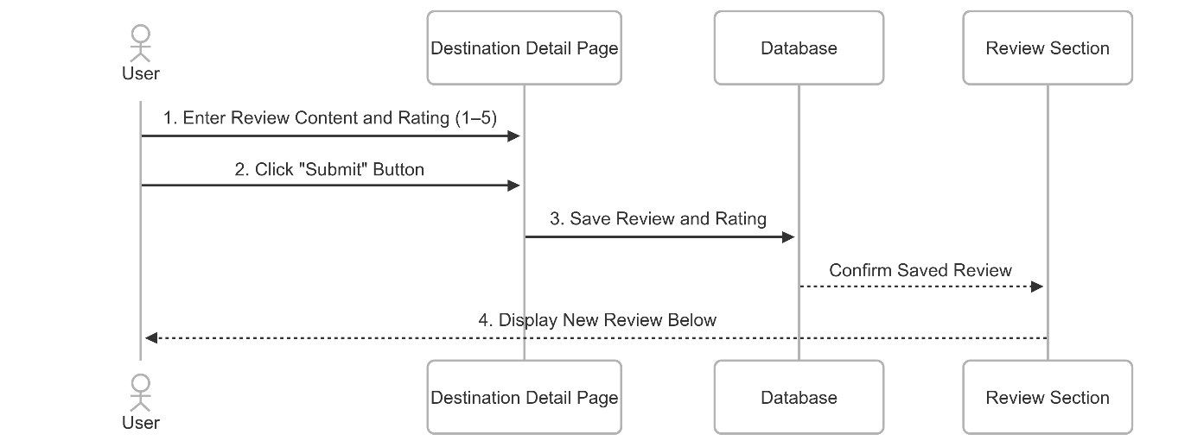
Figure ?. Leave Feedback and Review
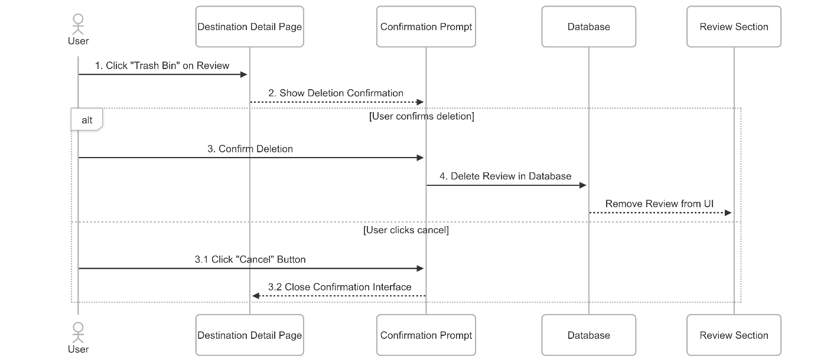
Figure ?. Delete Feedback and Review
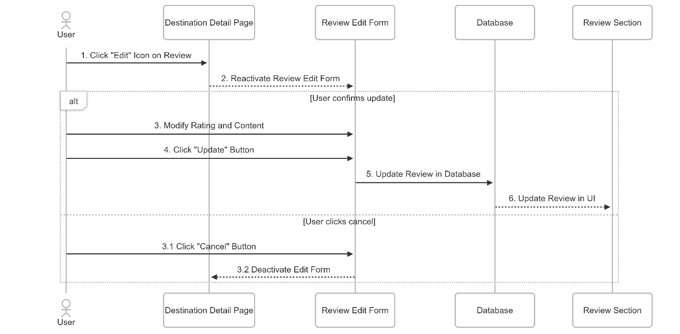
Figure ?. Edit Feedback and Review
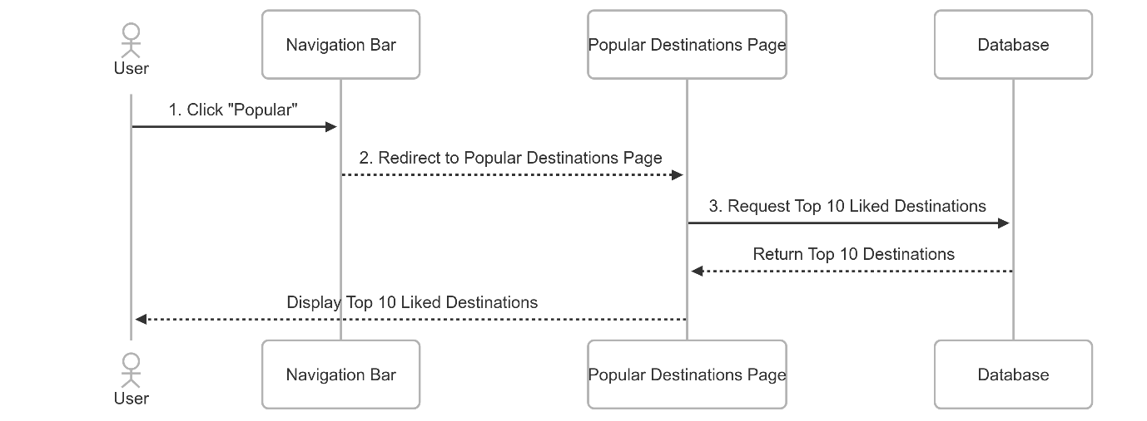
Figure ?. Popular Destination
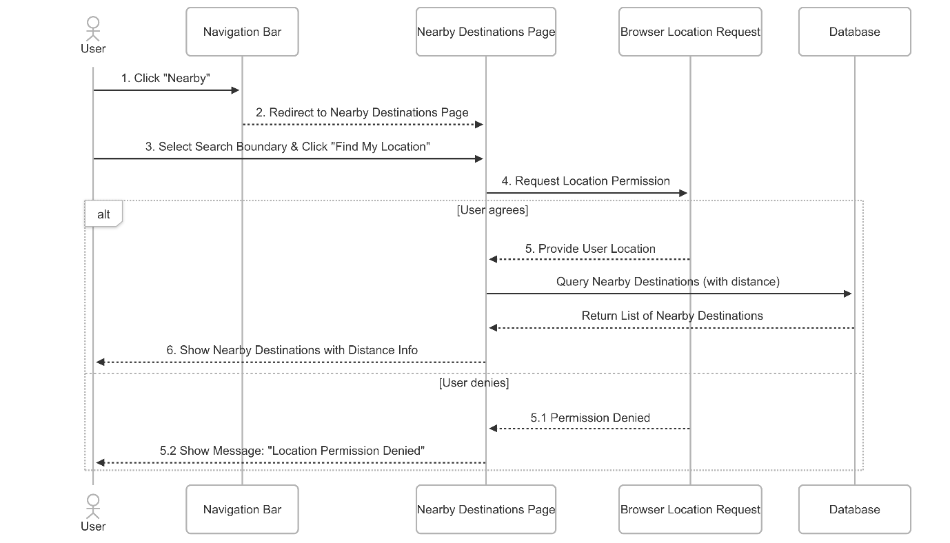
Figure ?. Nearby Destinations
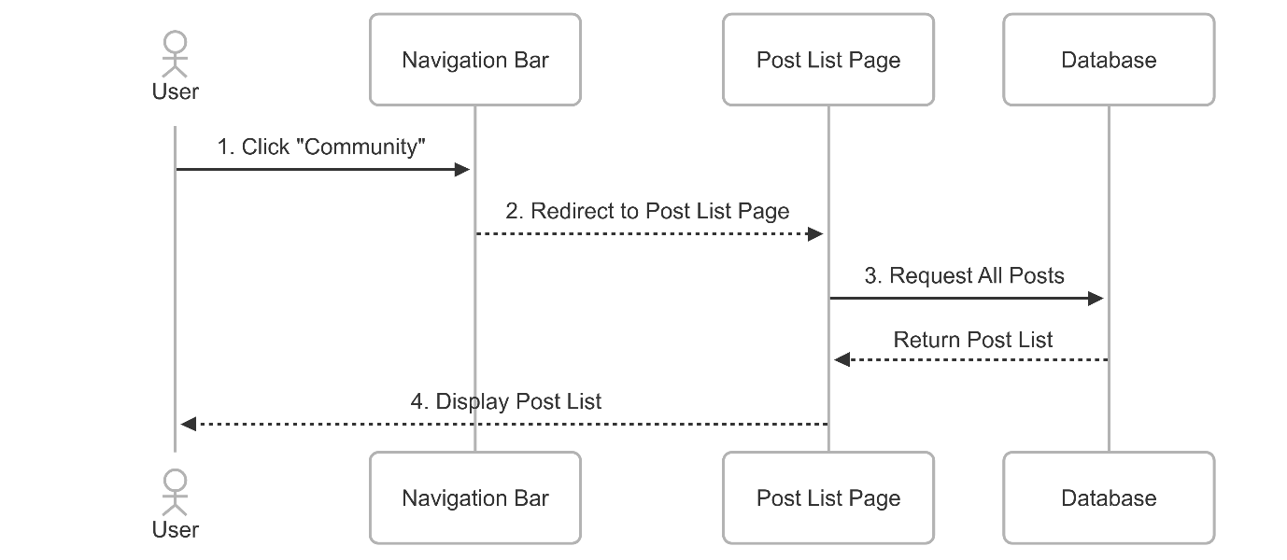
Figure ?. View Post List
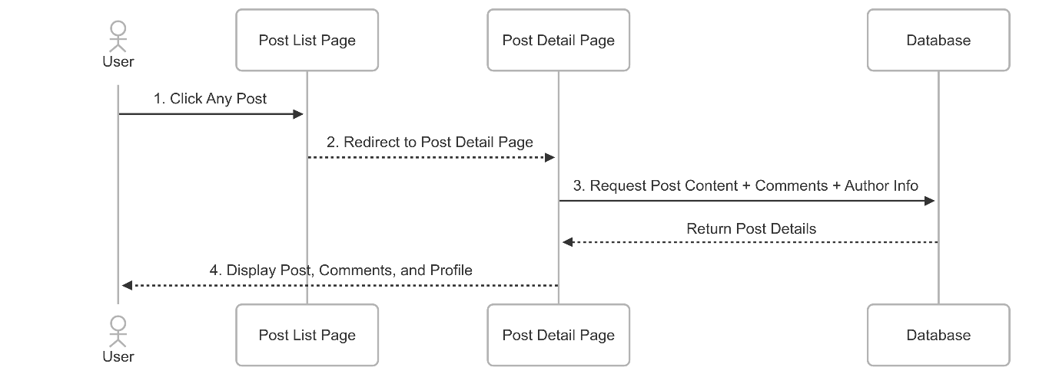
Figure ?. View Post Details
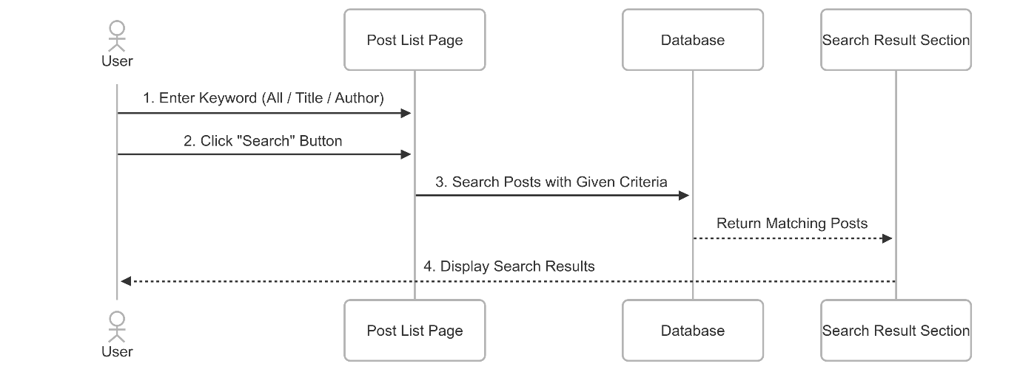
Figure ?. Search Post
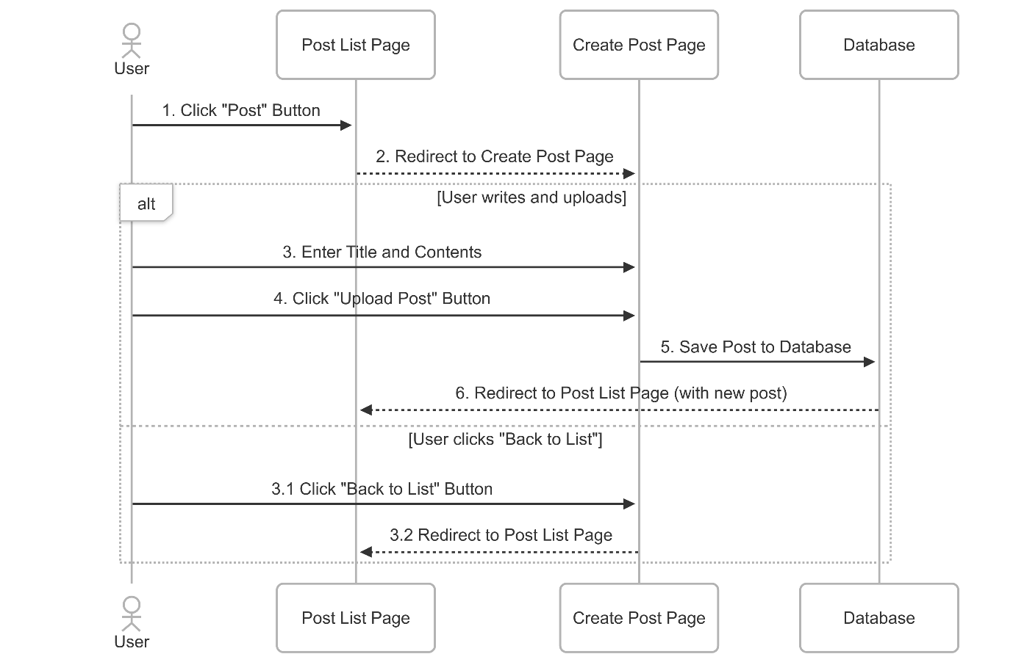
Figure ?. Create Post
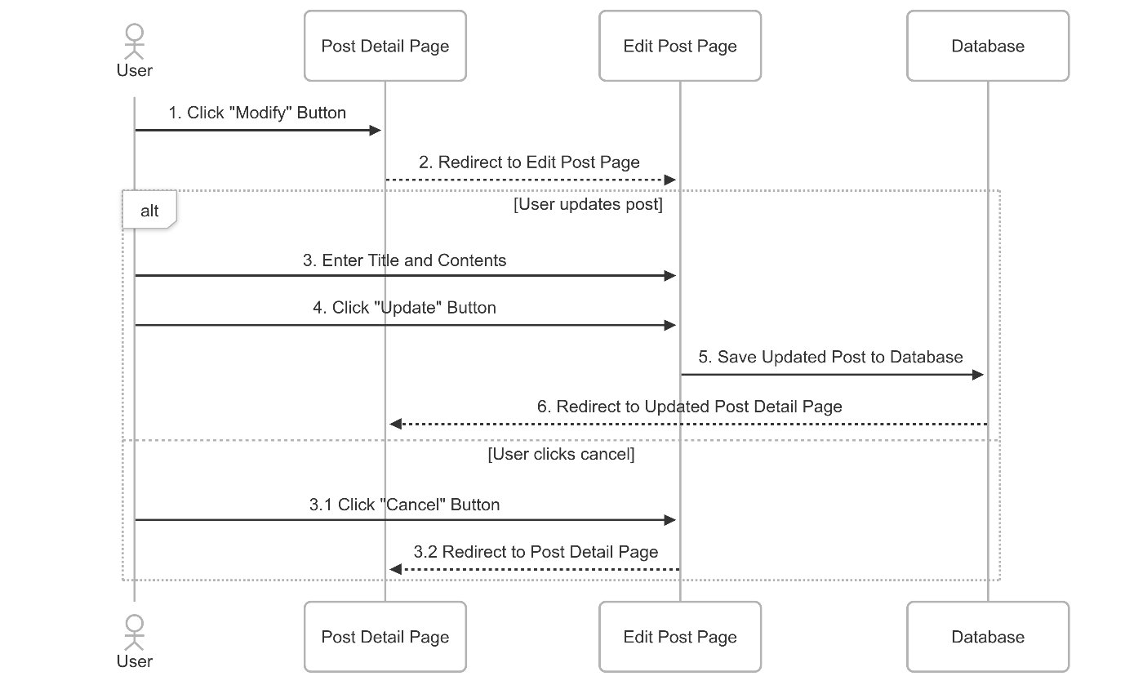
Figure ?. Edit Post
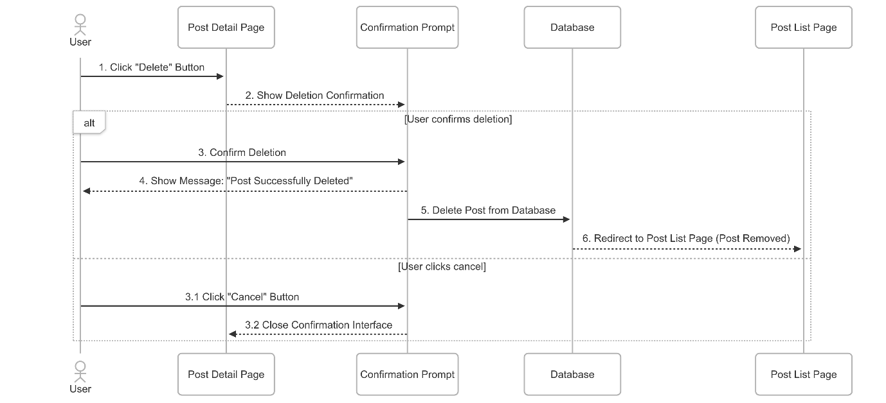
Figure ?. Delete Post
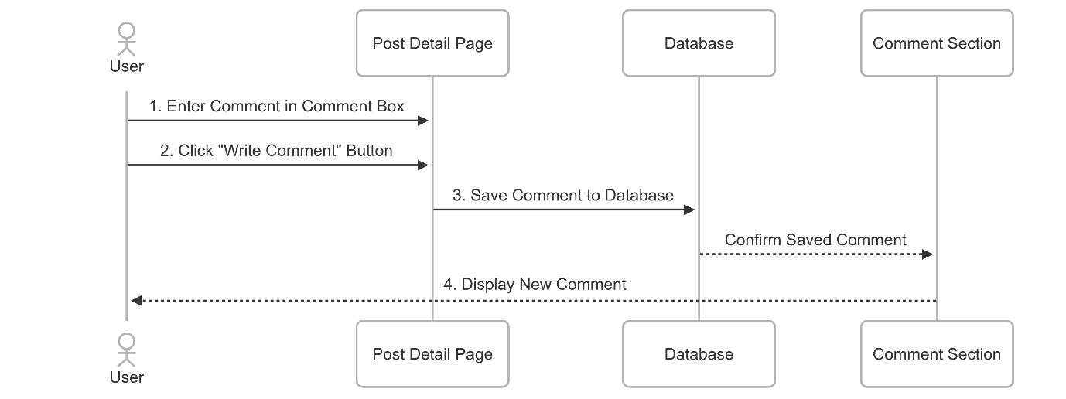
Figure ?. Create Comment
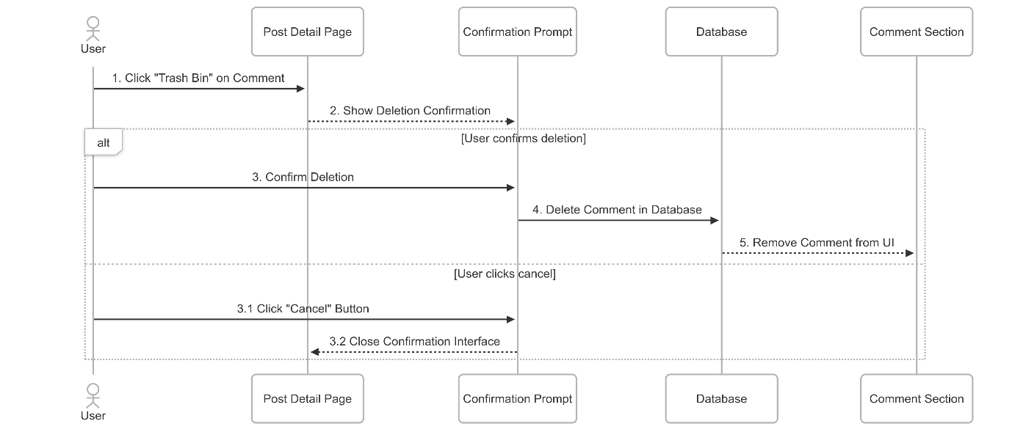
Figure ?. Delete Comment
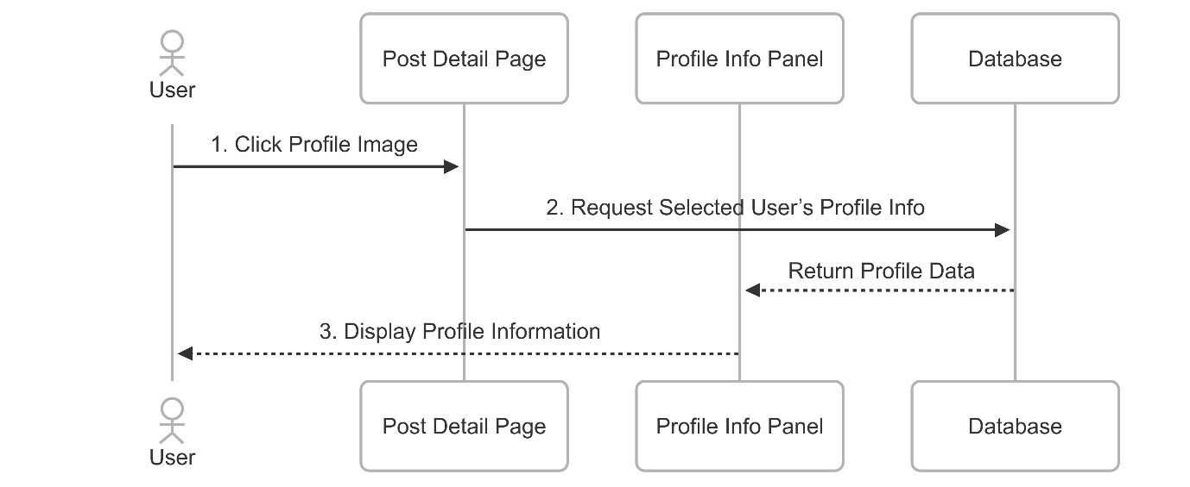
Figure ?. View Profile
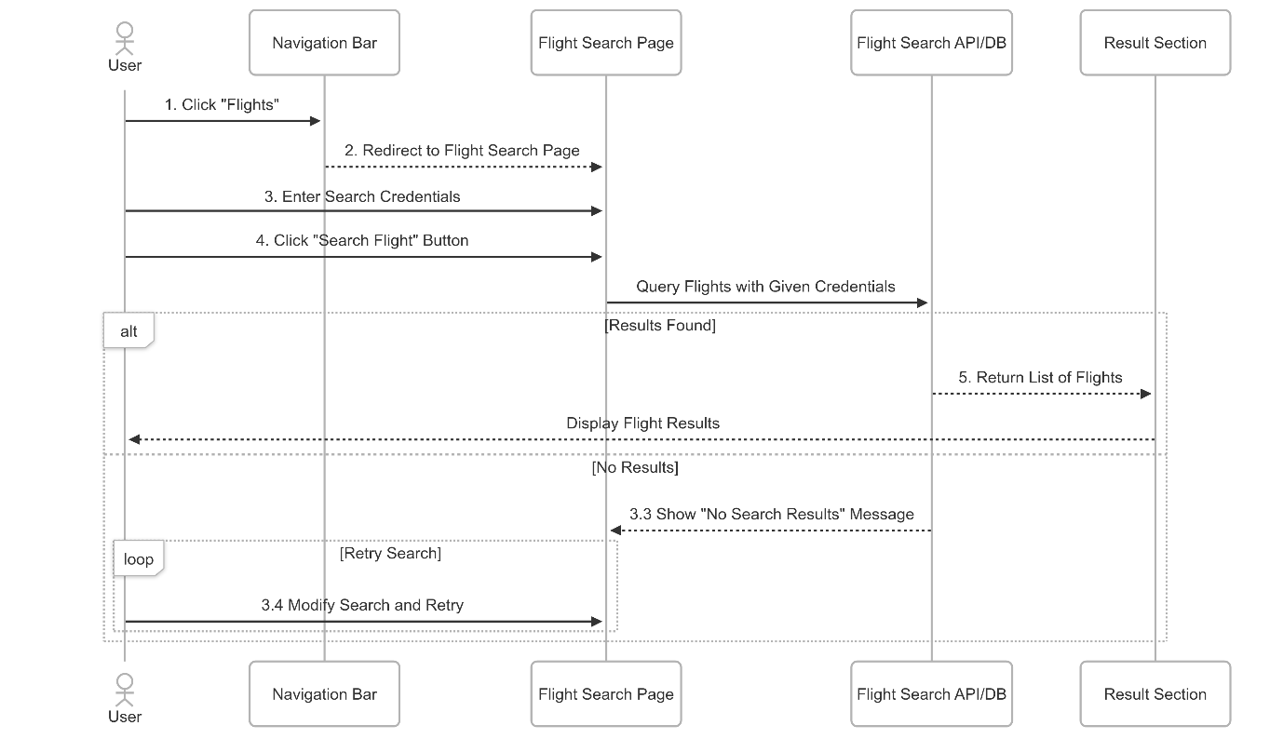
Figure ?. Flight Search
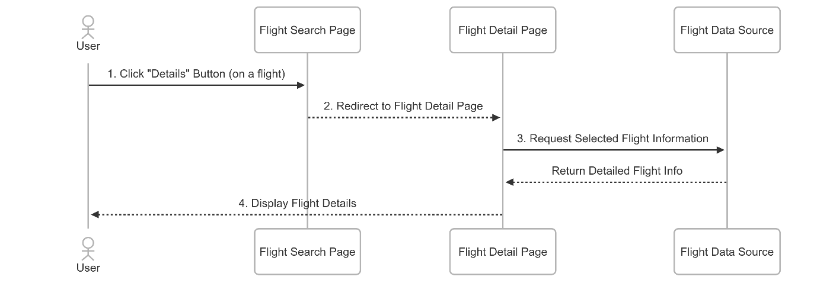
Figure ?. Flight Details
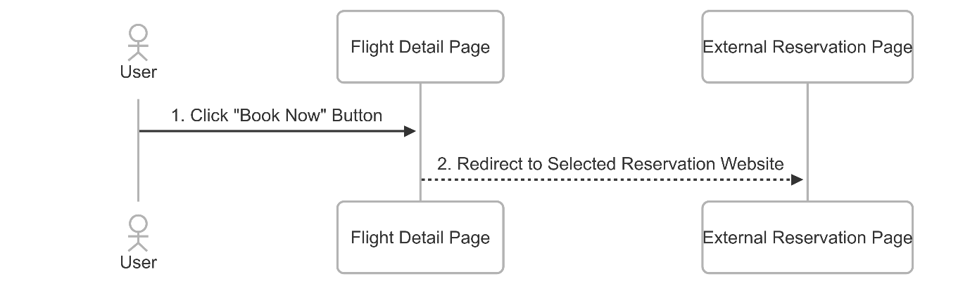
Figure ?. Reservation Web Connection
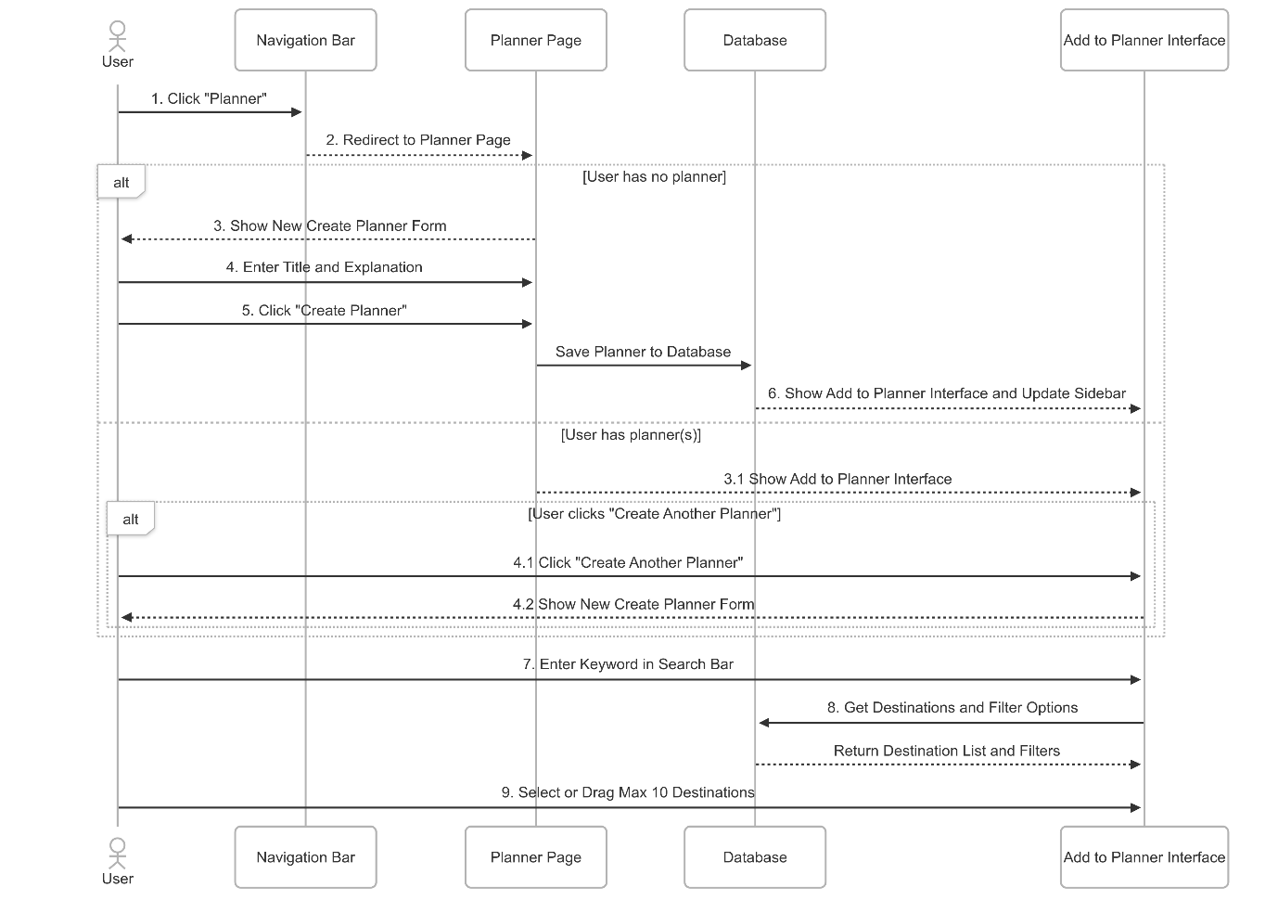
Figure ?. Create Planner
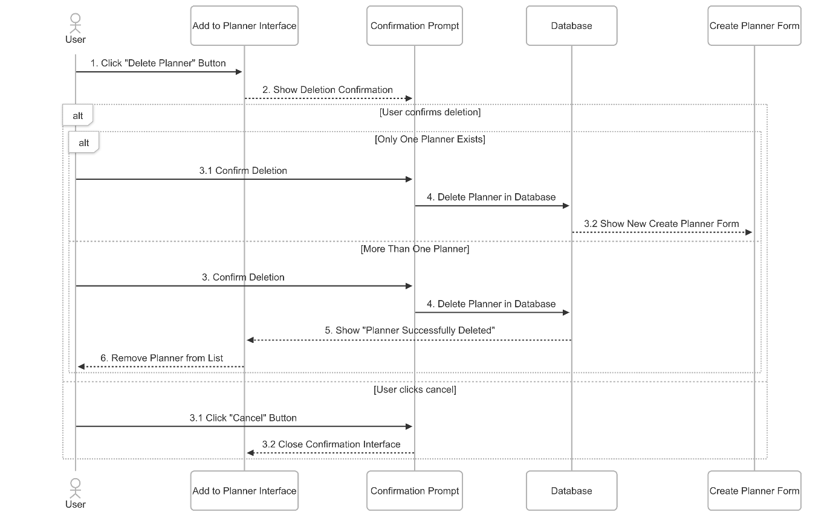
Figure ?. Delete Planner
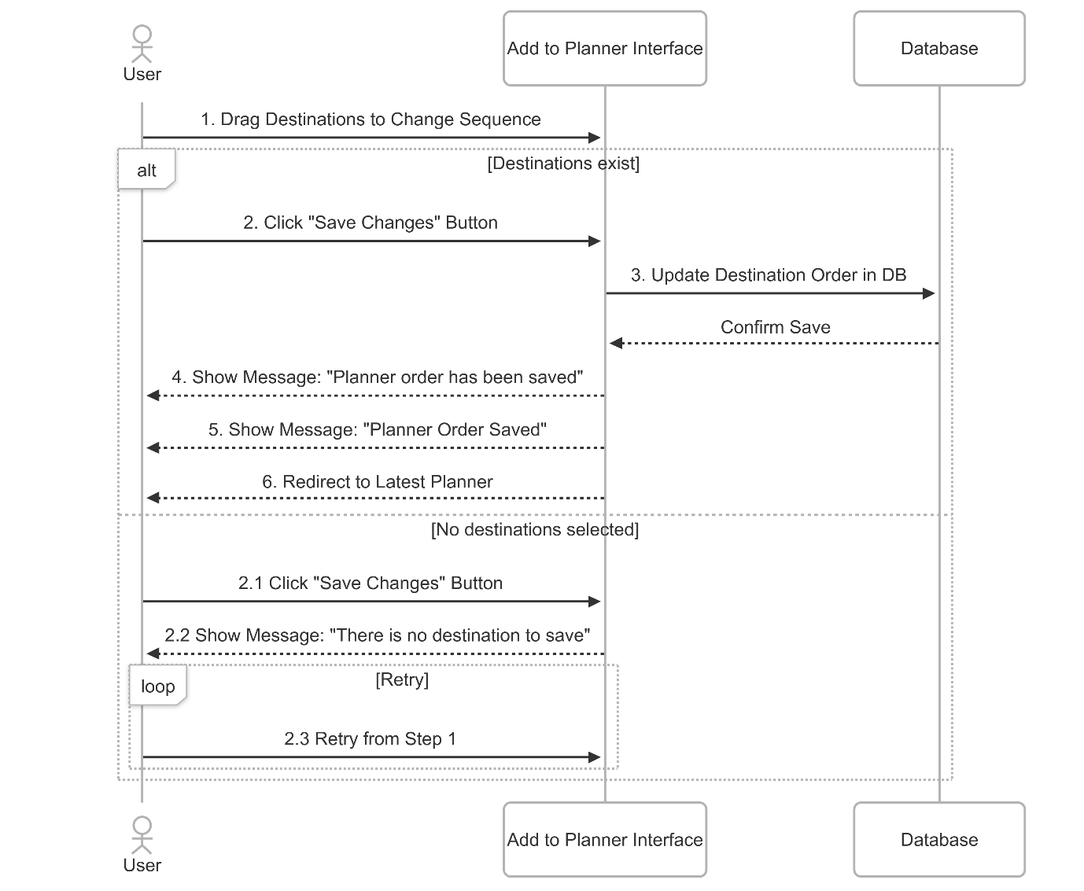
Figure ?. Edit Component Sequences

5-2-3. Class Diagram
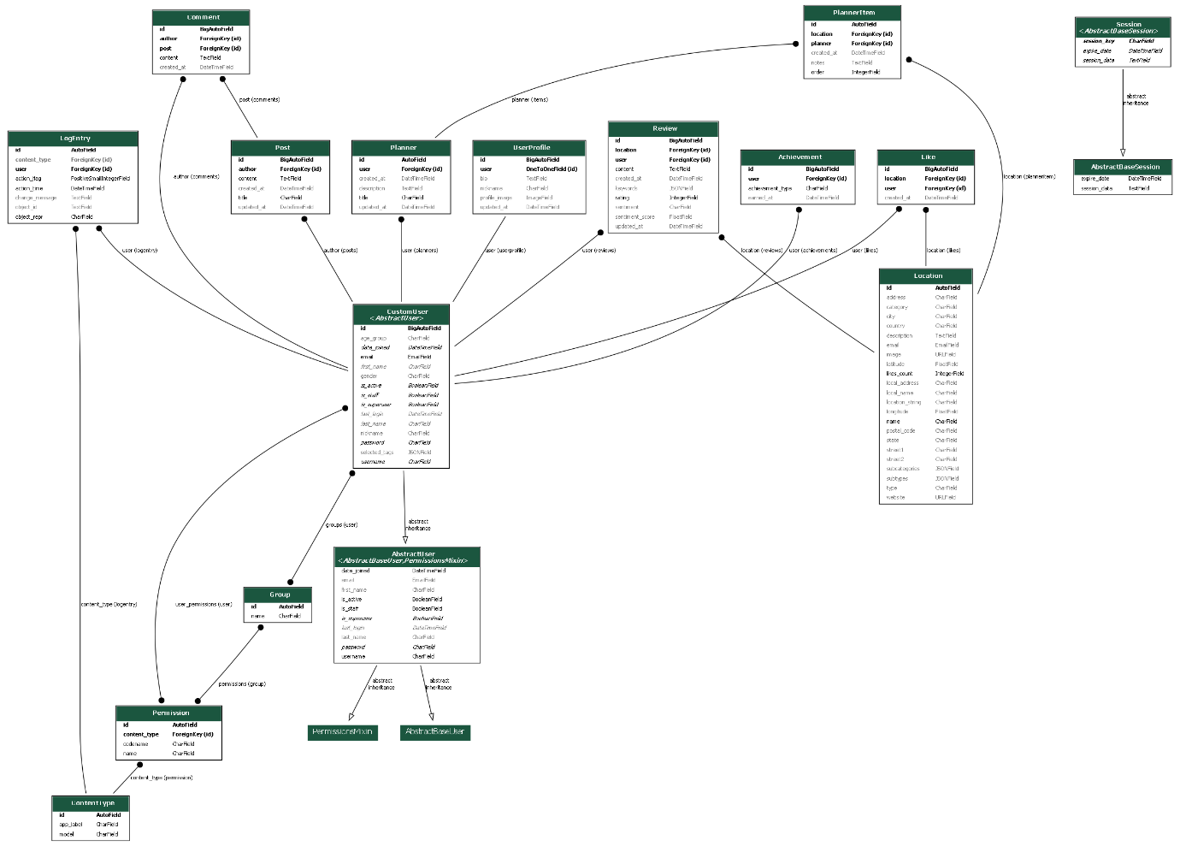

5-2-4. Activity Diagram
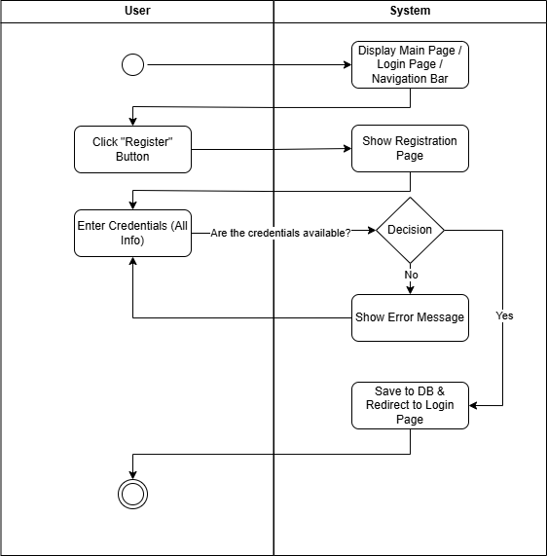
Figure ?. Register
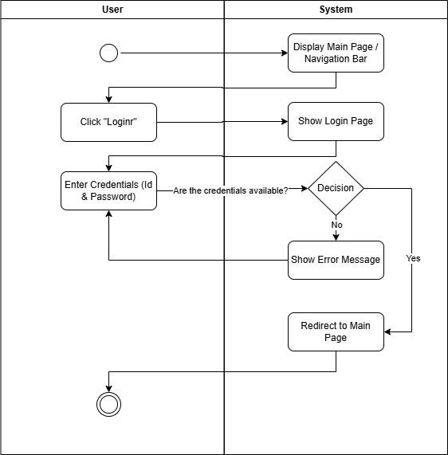
Figure ?. Login
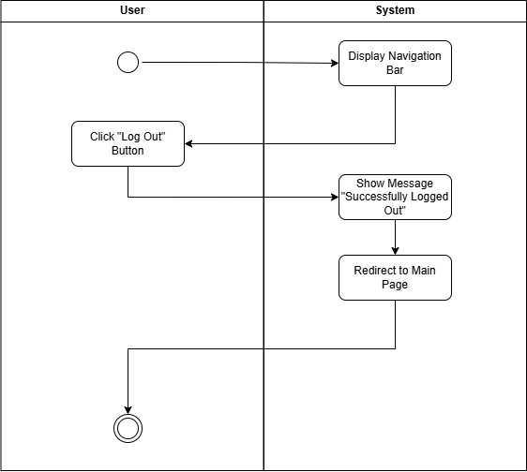
Figure ?. Logout
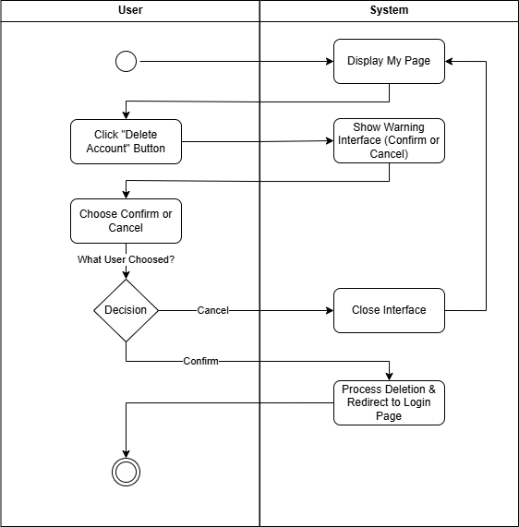
Figure ?. Delete Account
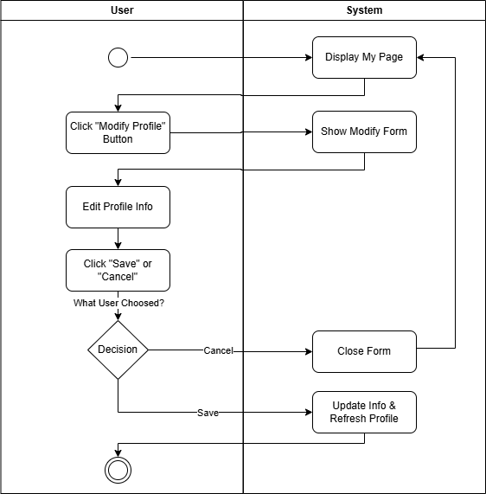
Figure ?. Manage Personal Details
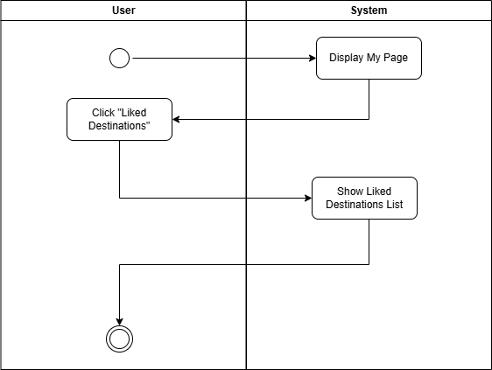
Figure ?. View My Favorite List
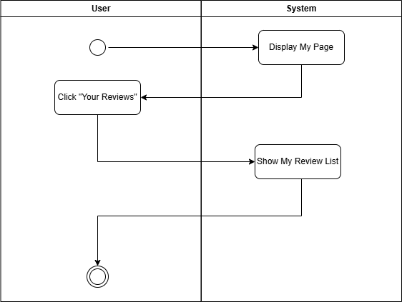
Figure ?. View My Review and Feedback
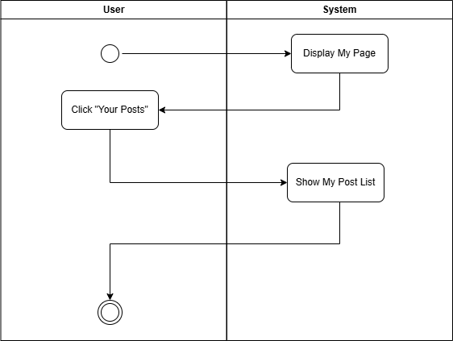
Figure ?. View My Post
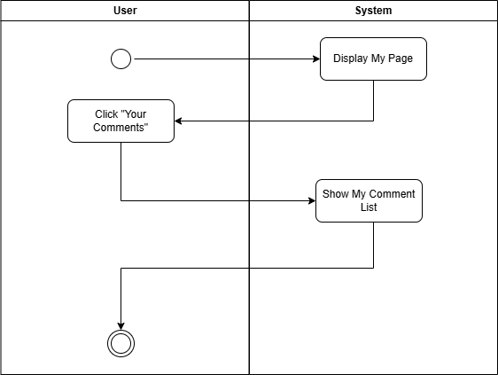
Figure ?. View My Comment

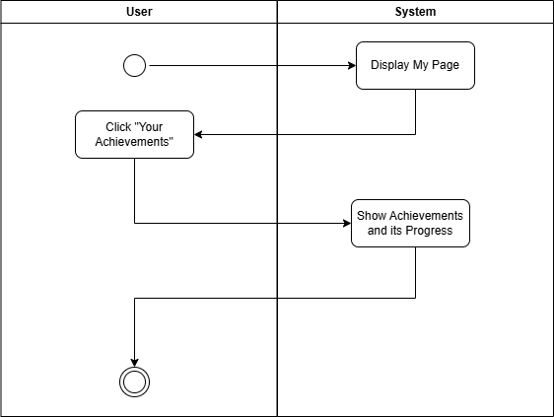
Figure ?. View Achievement
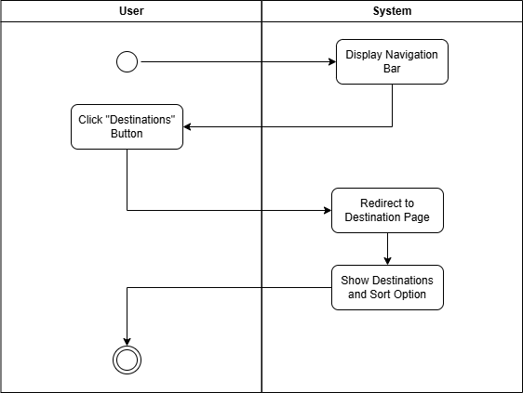
Figure ?. View Destinations
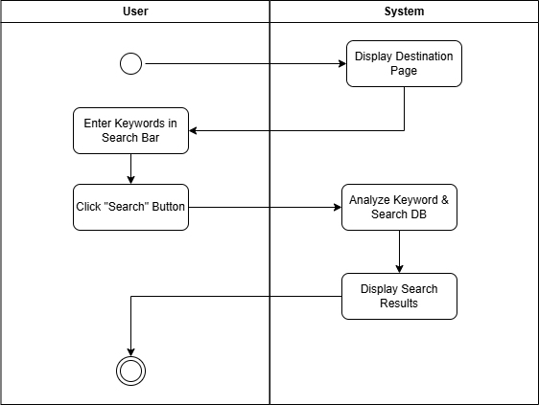
Figure ?. Search Destinations
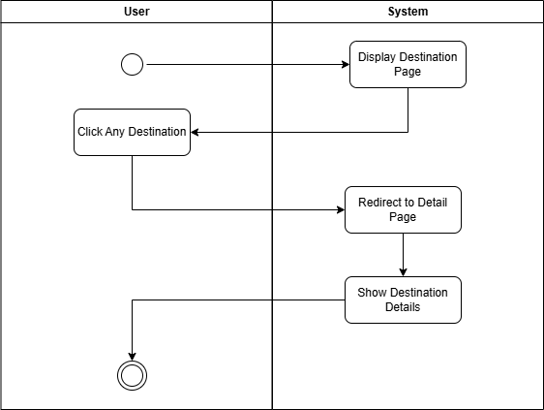
Figure ?. View Destination Details
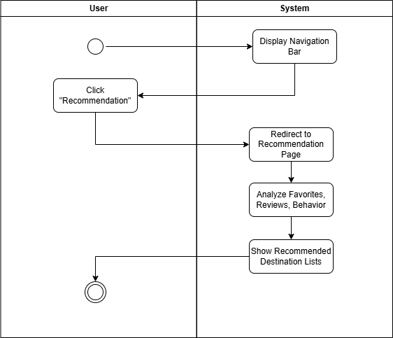
Figure ?. Recommendation Page
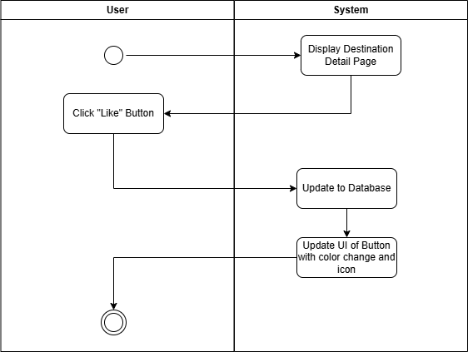
Figure ?. Like Destination
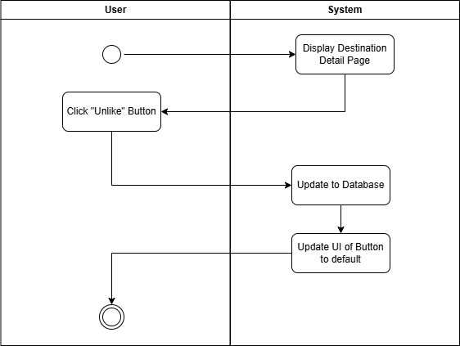
Figure ?. Unlike Destination
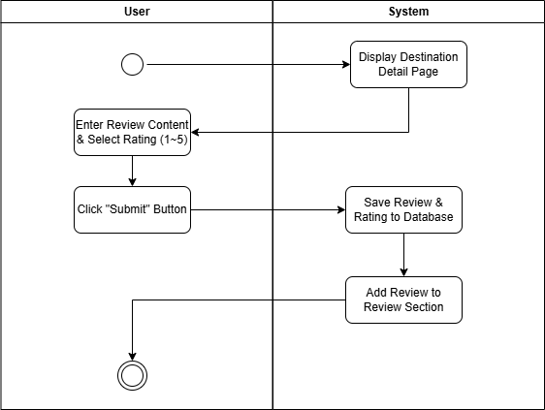
Figure ?. Leave Feedback and Review
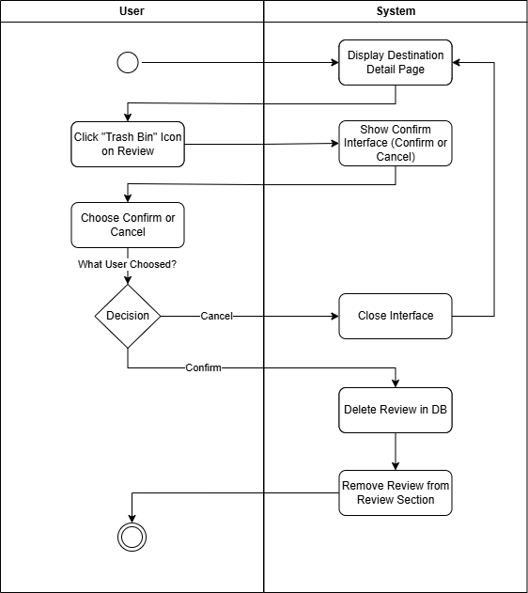
Figure ?. Delete Feedback
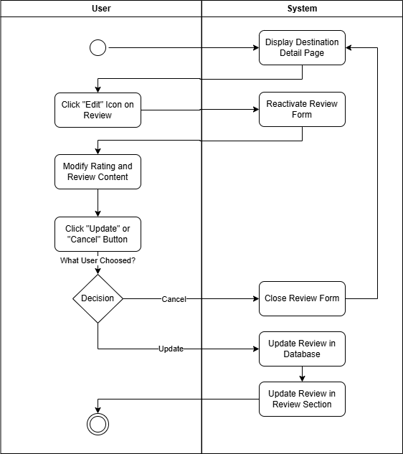
Figure ?. Edit Feedback and Review
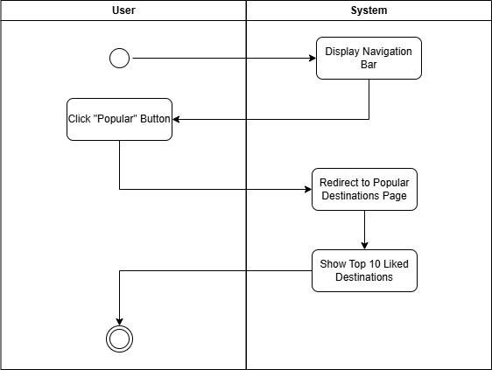
Figure ?. Popular Destinations
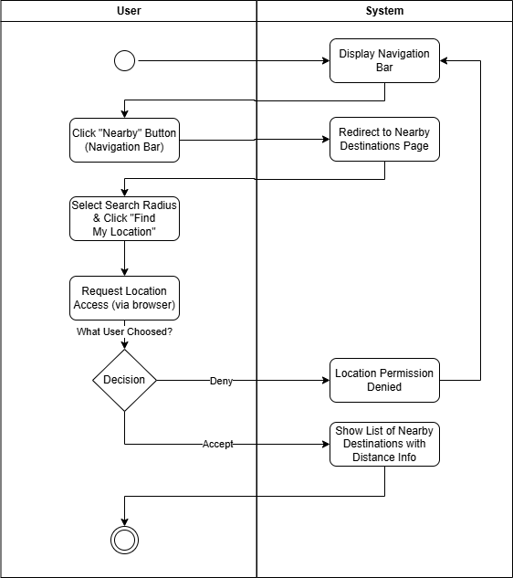
Figure ?. Nearby Destinations
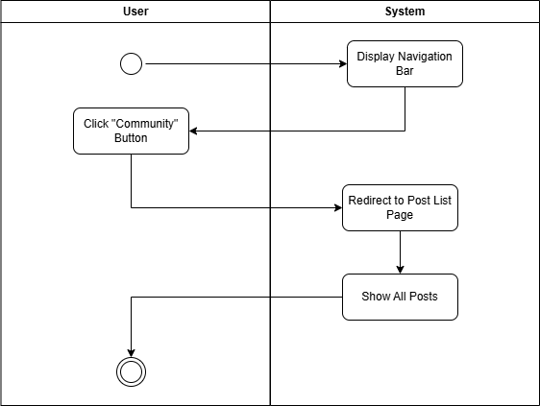
Figure ?. View Post List
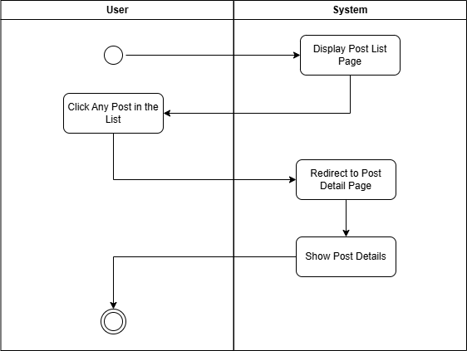
Figure ?. View Post Detail
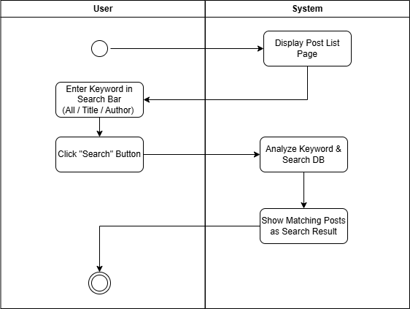
Figure ?. Search Post
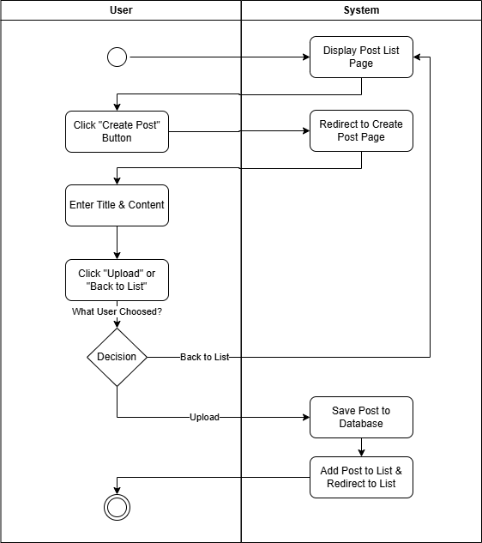
Figure ?. Create Post
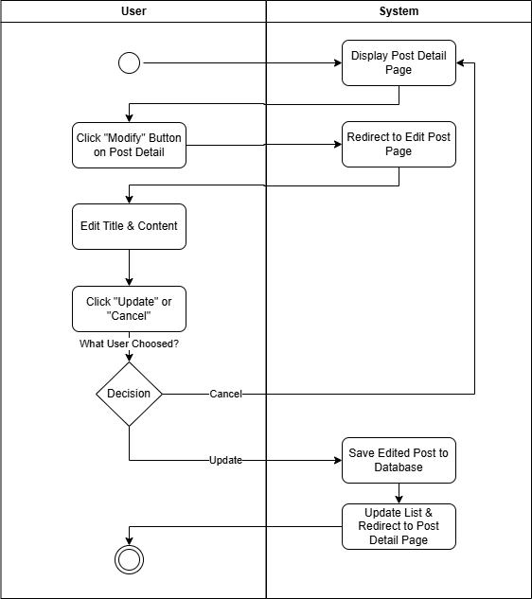
Figure ?. Edit Post
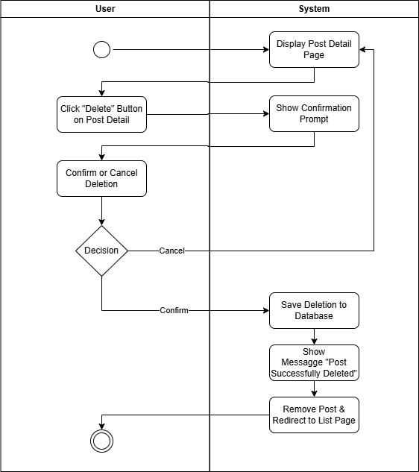
Figure ?. Delete Post
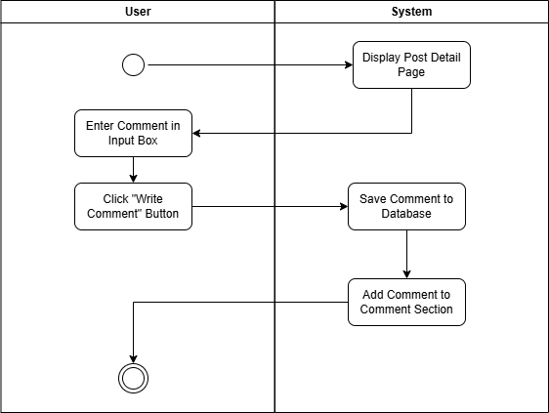
Figure ?. Create Comment
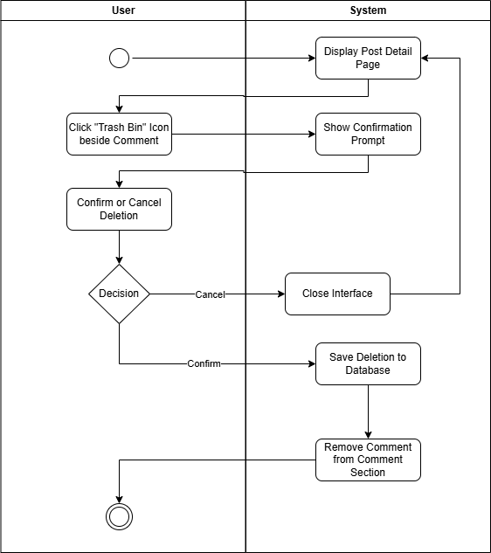
Figure ?. Delete Comment
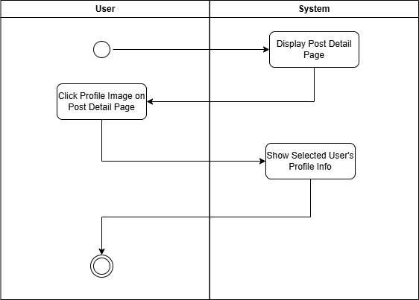
Figure ?. View Profile
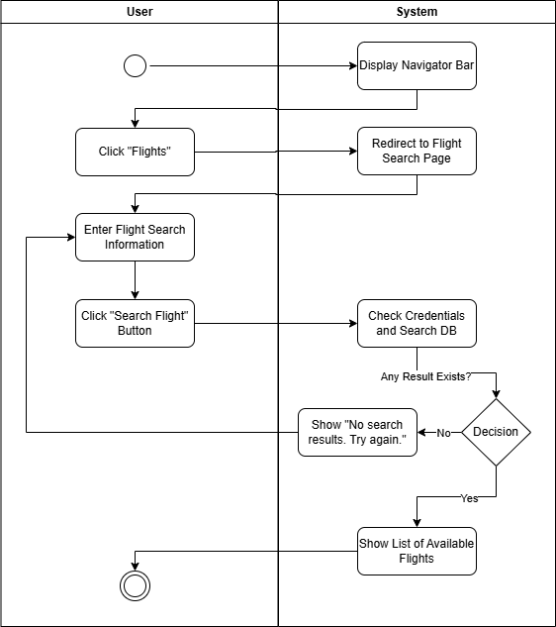
Figure ?. Flight Search
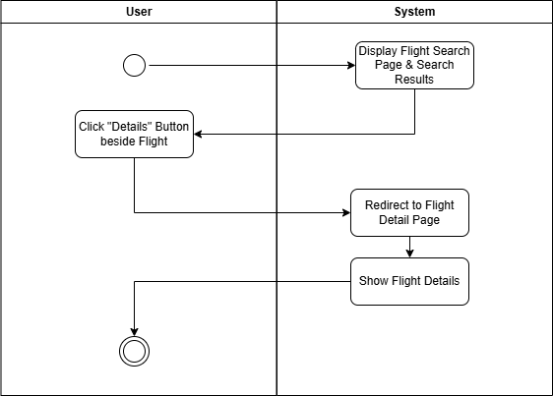
Figure ?. Flight Details
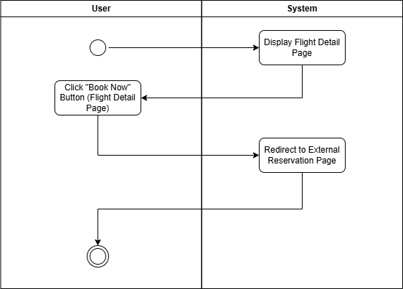
Figure ?. Reservation Web Connection
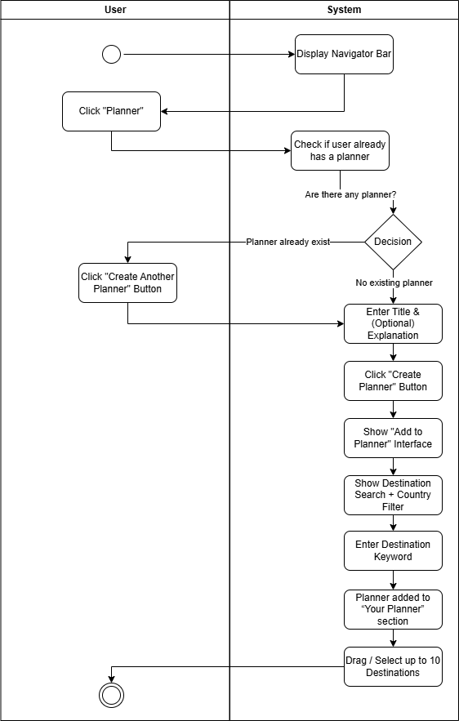
Figure ?. Create Planner
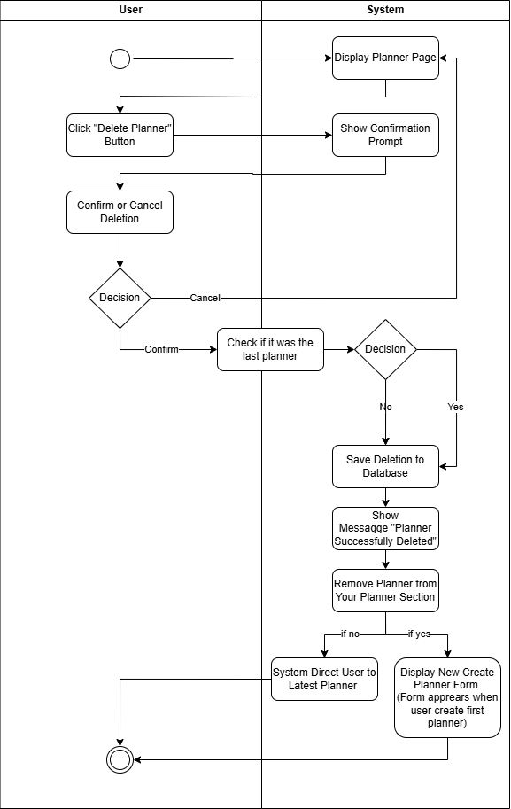
Figure ?. Delete Planner
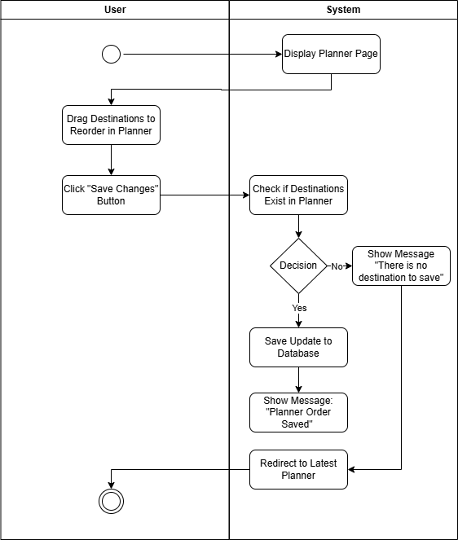
Figure ?. Edit Component Sequences

5-3. Architectural Style
Figure ?. MVC Diagram

5-4. Design Principles

5-4-1. Visibility
Visibility refers to how easily users can see and understand the options available to them in an interface. According to Educative, a well-designed system ensures that relevant functions and actions are visible to users so they can comprehend what is possible just by looking. This is particularly important in mobile interfaces where space is limited. For example, on a login page, only login or sign-up buttons should be visible so users are not overwhelmed or distracted by unnecessary elements.
The principle emphasizes that users should not need to rely heavily on memory to figure out how to interact with the interface. If key features or functions are hidden, users may not even realize that certain actions are available. Visibility helps bridge the gap between what users want to do and what the system offers (Educative, n.d.).
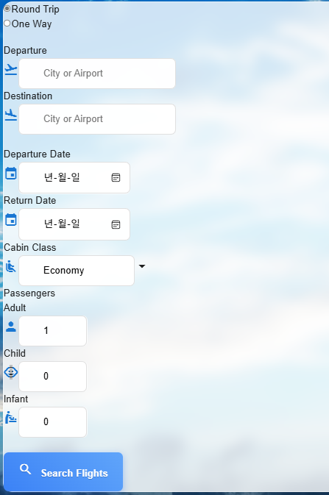
Figure ?. Flight search form
Inside of the travel platform, one of the examples of this principle could be flight search page with its clear guidance and visual resources such as icons that allow users to utilize flight search functionality without confusing.

5-4-2. Feedback
Feedback ensures users are kept informed about what is happening after an action is performed. Educative states that a system should provide immediate and informative feedback so users know their actions are recognized. A common example is when users click a button and a loading spinner appears, confirming the system is processing their request.
This principle is vital for maintaining user trust and preventing confusion. If users don't receive feedback, they might repeat actions unnecessarily or assume the system is broken. Effective feedback can come in many forms, such as visual indicators, sounds, or status messages (Educative, n.d.).
This button gives the user appropriate feedback (like has been successfully completed) with color (red) and heart icons that match the user's click behavior.
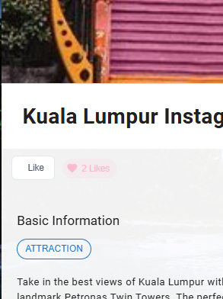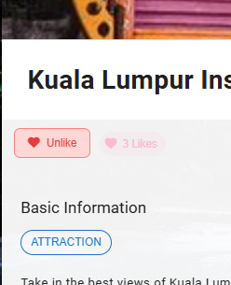
Figure ?. Like button clicking process
Moreover, the pop-up messages that appear when the users perform specific tasks also remind users to the tasks are successfully conducted.
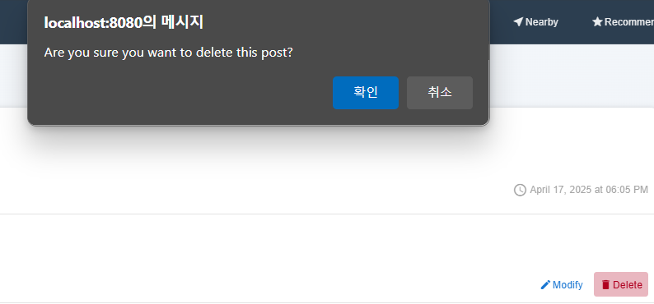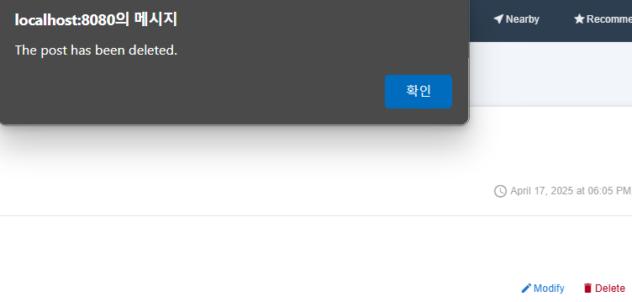
Figure ?. Process of deleting post

5-4-3. Constraints
Constraints are limitations that guide user behavior and prevent incorrect actions. According to Educative, constraints can be physical, logical, or cultural, and are used to simplify interactions and reduce errors. A good example is a form that only allows numbers to be entered into a phone number field.
These limitations help users understand what is allowed within the system. By clearly restricting certain inputs or interactions, designers reduce the chance of user error and streamline the experience. Constraints serve as gentle nudges toward correct behavior without requiring additional explanation (Educative, n.d.).
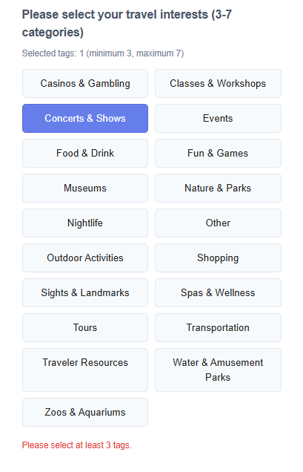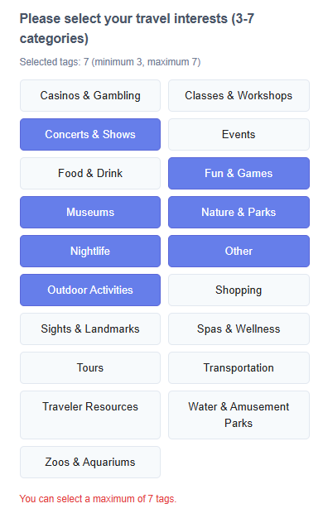
Figure ?. Tag Choose section of Registration Page
In the project, several constraint mechanisms have been implemented, each of which helps guide users to use the system correctly and prevents runtime exceptions. One of the examples of constraint could be tag-choosing section inside of registration page. Basically, system is limiting the number of tags can be choose. This part may effectively avoid situations in which too few tags are obtained to make the performance of the recommendation system insufficient or too many are acquired to increase resources and cause confusion to users.
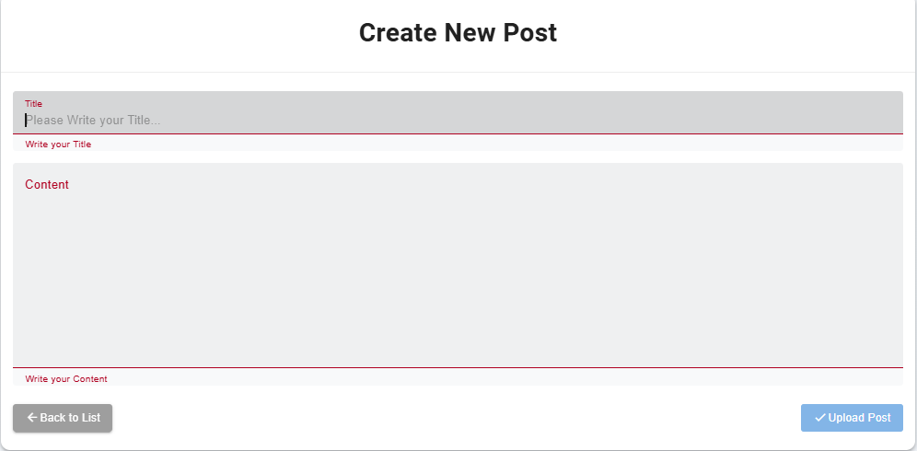
Figure ?. Creating New Post Page
Also, constraint can prevent empty data such as locking submit or upload button before completing tasks that need to be.

5-4-4. Mapping
Mapping describes the relationship between controls and their effects. As mentioned in the Educative article, a well-designed system ensures a logical connection between the interface control and its result. For instance, turning a steering wheel left moves a car left, or moving a scrollbar down causes content to move up.
Good mapping simplifies learning and usage because users can predict outcomes based on how controls are arranged. Poor mapping, on the other hand, increases cognitive load and may lead to mistakes. Designers should aim to create interfaces where the layout of controls naturally aligns with user expectations (Educative, n.d.).
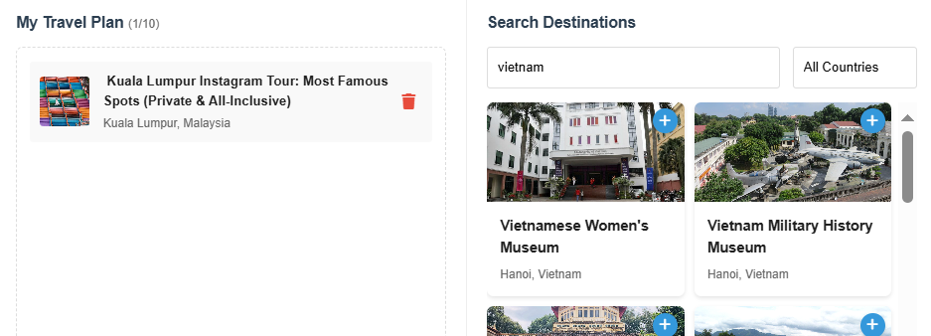
Figure ?. Travel planner page

Figure ?. Date selecting in flight search form
As the principle of mapping, users can view proper icons that can expect its result. With the picture above, icons of trash bin, plus and calendar, users can utilize those functionalities without additional explanation.

5-4-5. Consistency
Consistency involves keeping interface elements uniform across different parts of the system. Educative notes that when a product maintains consistency—such as using the same color, icon style, or layout—users can more easily recognize patterns and predict how to interact with it.
A consistent interface reduces the amount of learning required and makes users feel more confident in navigating the system. It also supports usability by ensuring that similar actions produce similar results, thereby creating a cohesive and intuitive user experience (Educative, n.d.).

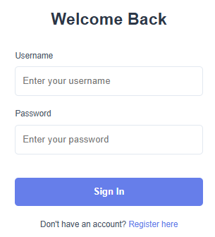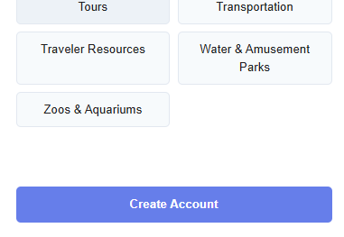
Figure ?. Login & Registration page
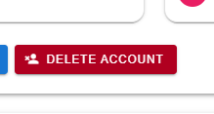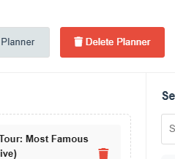
Figure ?. Delete account & Delete Planner
As the principle of consistency, the color of buttons related to such as create and submit are type of blue. In contrast, the buttons related to delete has red type color.

5-4-6. Affordance
Affordance refers to the properties of an object that indicate how it should be used. Educative explains that users should be able to intuitively understand an element’s functionality based on its appearance. For example, a button that looks like it can be pressed encourages interaction, just as a coffee cup handle suggests how it should be held.
This design principle helps reduce the learning curve for users. By designing elements with clear affordances, users can interact with new interfaces without requiring instructions. Effective affordances lead to a more natural and instinctive user experience (Educative, n.d.).
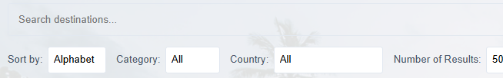
Figure ?. Destination search bar
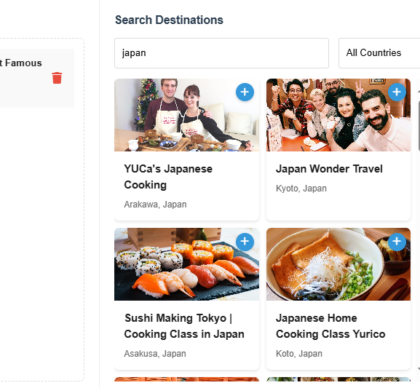
Figure ?. Planner page
In both search bar of Destination Page and Planner Page, user can assume what activities could be done. In the search bar portion, the system may self-estimate and find functions available to users through labels. Also, the hovering effect on destination cards in planner search section can trigger the idea of being able to drag a card to users.

5-5. Mockup (Walkthrough)
D

5-6. Design Pattern
​The Gang of Four (GoF) design patterns, introduced in the 1994 book Design Patterns: Elements of Reusable Object-Oriented Software, offer a structured approach to solving common software design challenges. These 23 patterns are categorized into creational, structural, and behavioral types, each addressing specific aspects of object-oriented design. Creational patterns focus on object instantiation mechanisms, structural patterns deal with object composition, and behavioral patterns concentrate on communication between objects. By applying these patterns, developers can create more flexible, reusable, and maintainable code structures, which remain relevant in modern software development practices (Williams O, 2022). In this project, several design patterns has used in each applications that compose the backend of the project.

5-6-1. Template Method Pattern
Template Method is a behavioral design pattern that encapsulates the fixed structure of an algorithm in a superclass, delegating the implementation of variable steps to its subclasses, ensuring consistency while allowing flexibility (Refactoring Guru, 2014). Django, which is the backend framework for this project, has DRF (Django REST Framework) and it is a Django-based toolkit that makes it easier to build RESTful APIs by providing essential components like serialization, authentication, and view sets (Jagdishprajapati, 2024). Especially, in the project, every applications are actively utilizing serializer functionality with validating and converting between Python and Json data.
Inside of the serializers.py of “Accounts” Application, which manage functionalities such as registration and login, there is RegisterSerializer() that include information of registration.
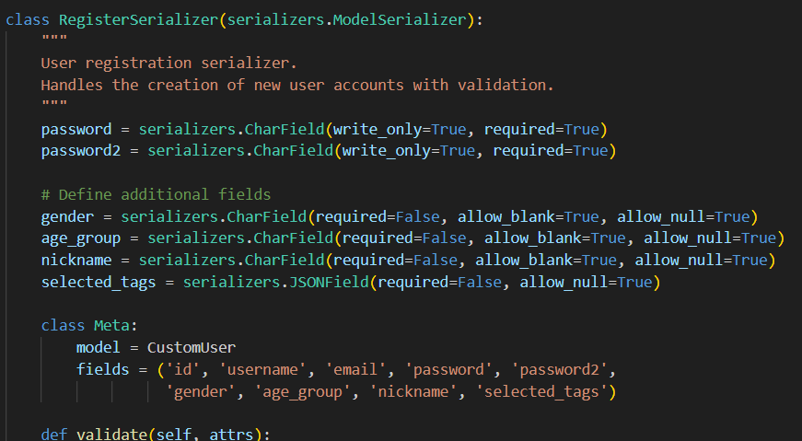
Figure
In detail, we can find create() function in the middle of RegisterSerializer().
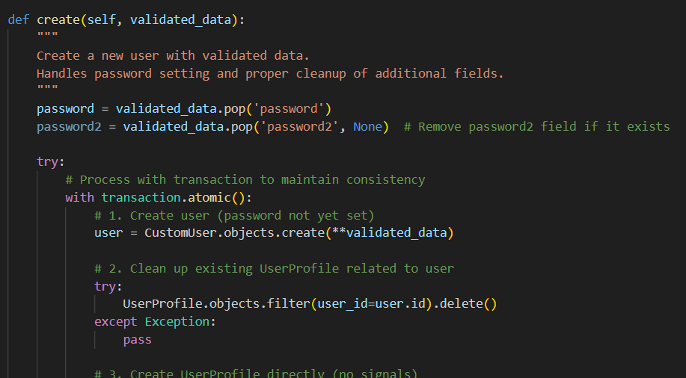
Figure
And this create() function is originally based on BaseSerializer() that is embedded in DRF itself.
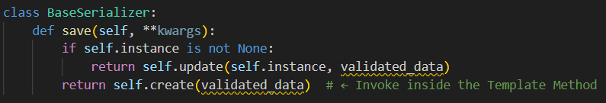
Figure
At this case, DRF provides a template method called save() and Internal logic flow is fixed to remain unchanged. So Users can modify the step-by-step behavior by overriding only create() or update(). To summarize, It follows the template method structure of the Model Serializer, which is based on BaseSerializer(), provided by the Django REST Framework, and uses the create() method as a hooking point.
Overall, the Template Method Pattern is utilized in the code through Django REST Framework’s base classes like ModelSerializer and ViewSet, where core workflows such as save() or dispatch() are predefined in the superclass. The custom classes, like RegisterSerializer, override only specific steps such as create() to inject custom behavior while preserving the overall algorithm structure. This pattern promotes code reuse, enforces consistent behavior across different components, and simplifies extension by allowing developers to customize only what’s necessary. As a result, it provides a stable framework that ensures flexibility without compromising the integrity of the request-handling flow.

5-6-2. Adapter Pattern
Adapter pattern is a structural design solution that enables interaction between objects with mismatched interfaces (Refactoring Guru, 2014). The main elements that make up the adapter pattern are largely Adapter, Adaptee and Target Interface. In this project, each component can be matched like this:
Role | Description
Adaptee | Classes with existing features (e.g., Django models)
Target Interface | Interface expected by the client (e.g., JSON response structure)
Adapter | Classes that connect and relay the two (e.g. Serializer)

In the project, several serializers (such as UserProfileSerializer, PostSerializer, AchievementSerializer etc…) are showing this Adapter Pattern Characteristics.
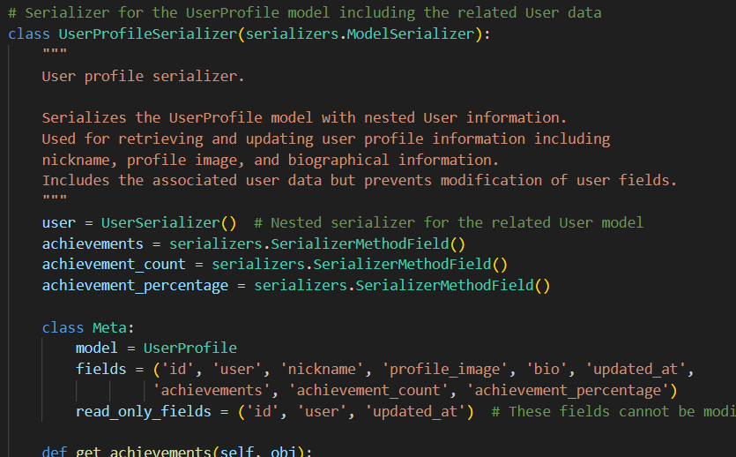
Figure
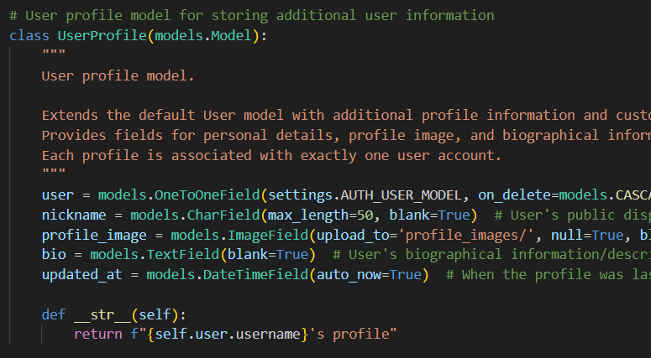
Figure
So for example, in the case of UserProfileSerializer, the role of adapter is taken by UserProfileSerializer while UserProfile in models.py of My Page Application works as adaptee, with the process of UserProfile directly take data from database model and UserProfileSerializer convert the Django model to Json to change to the interface expected from the outside (JSON response client). In result, the code itself cannot be called as the structure of Adapter Pattern, but the serializer itself performs task of Adapter Pattern.
These serializers act as adapters by converting Django ORM model instances into JSON representations that API clients can easily consume. This separation between internal data structures and external API formats ensures flexibility and reusability. It allows the system to evolve internally without breaking the API interface, simplifies data transformation, and enhances maintainability by centralizing the conversion logic. As a result, the pattern enables seamless communication between incompatible interfaces—namely, Django models and external consumers.

5-6-3. Factory Method Pattern
The Factory Method is a creational design pattern that defines a method for object creation in the superclass, while enabling subclasses to decide which specific object to instantiate (Refactoring Guru, 2014).
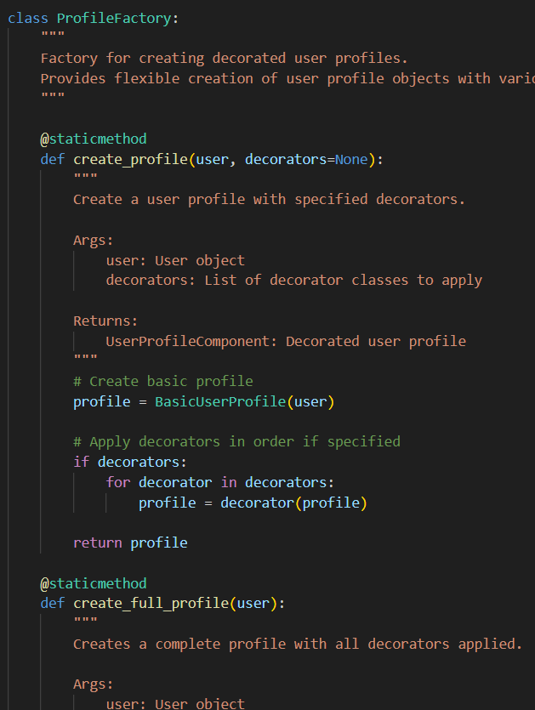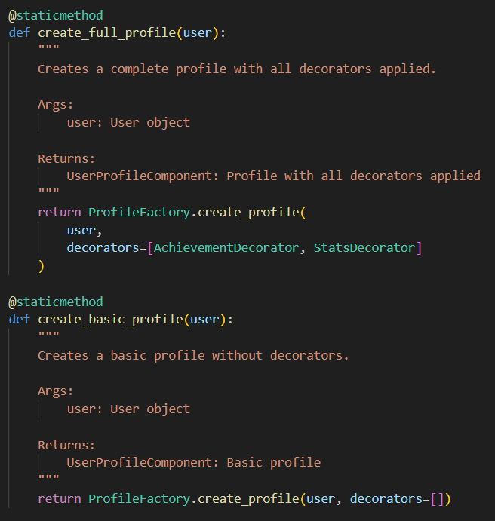
Figure
In this project, Factory Method Pattern collaborates with Decorator Pattern. The responsibility for deciding which Accreditation Decorator (Stats Decorator) to attach to a user profile lies within ProfileFactory, not within the client. So clients only need to call create_profile(...) or create_full_profile(...)
The use of the Factory Method Pattern in this code—specifically through the ProfileFactory class—brings clear structural and maintenance benefits. By encapsulating the logic for assembling different profile configurations (such as basic or achievement-enhanced profiles), it separates object creation from business logic, reducing complexity in the calling code. This approach improves readability, supports the Open/Closed Principle by allowing new profile types without modifying existing logic, and enables flexible combinations of decorators through a single, unified creation interface. Ultimately, it streamlines profile generation and keeps the codebase more modular and scalable.

5-6-4. Facade Pattern
The Facade pattern is a structural design pattern that offers an easy-to-use interface to a complex system, such as a library, framework, or a group of interconnected classes (Refactoring Guru, 2014).
In this project, flight/views.py module exemplifies the Facade Pattern by exposing simple, unified REST endpoints for complex Skyscanner API interactions. Each function consolidates API endpoint selection, parameter formatting, header injection, and error management into a single entry point. The client does not need to understand or manage the underlying API contracts. This results in a clean separation of concerns, easier maintenance, and a significantly simplified external interface — all of which align with the core intentions of the Facade Pattern.
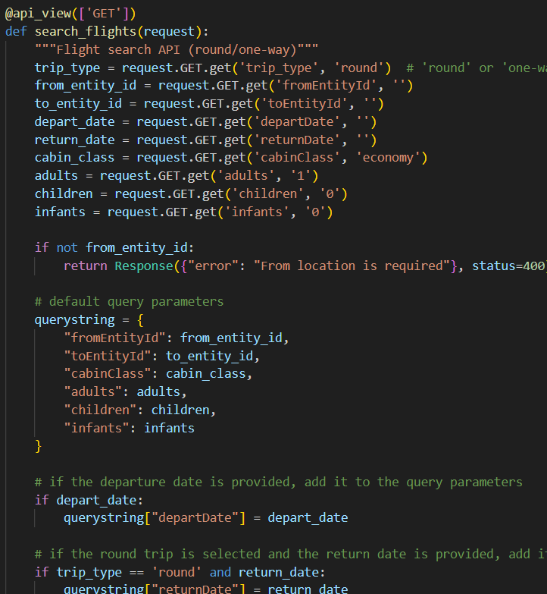
Figure ?.
One of the clearest examples of the Facade Pattern in this project is the search_flights(request) function. It abstracts away the internal complexity of choosing between multiple API endpoints (e.g., roundtrip or one-way), dynamically builds query parameters from user input, formats and sends external requests, handles errors, and presents a single, simplified interface (GET /search_flights) to the client. By encapsulating this complex logic behind a unified entry point, the system becomes easier to use, maintain, and extend.

5-6-5. Decorator Pattern
The Decorator pattern is a structural design pattern that allows you to add additional functionality to objects by wrapping them with special objects that implement the desired behavior (Refactoring Guru, 2014).
In this project, as described above, decorator pattern is deeply working with factory pattern. Several decorators exist in mypage/serializers.py, and those are:
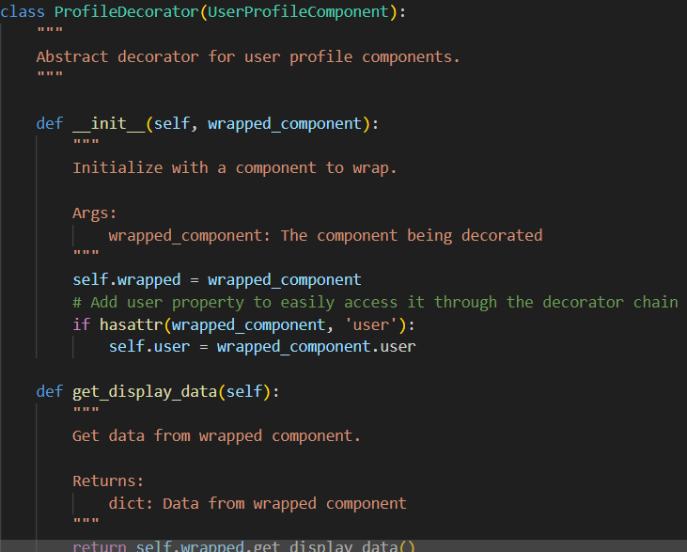
Figure ?.
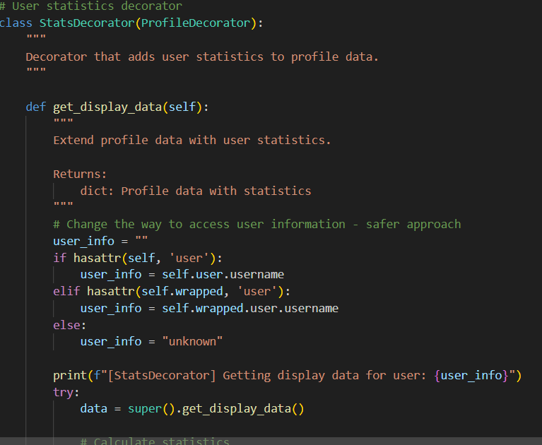
Figure ?.
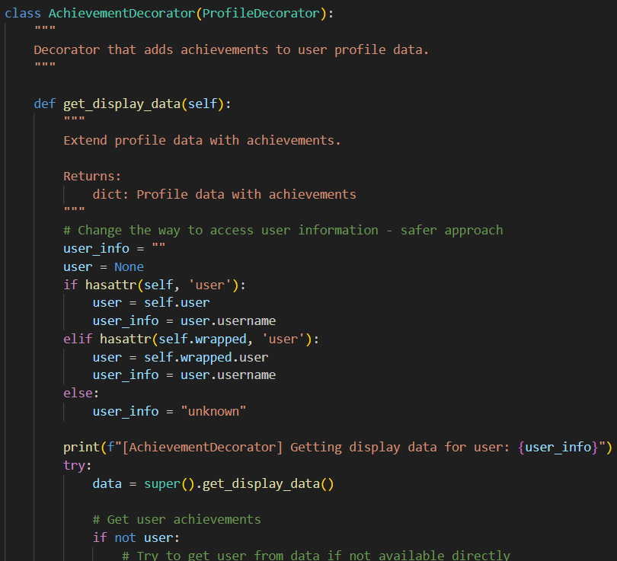
Figure ?.
Firstly, ProfileDecorator acts as an abstract base for all decorators, holding a reference to the wrapped profile object and delegating the get_display_data() method. It doesn't add functionality itself but enables dynamic behavior extension. And, AchievementDecorator extends the base profile by adding achievement-related data such as a list of earned achievements, total count, and completion percentage. It dynamically checks and creates new achievements based on user activity. Finally, StatsDecorator enhances the profile with user activity statistics including post, review, and like counts, as well as recent engagement metrics. It adds analytical insight to the profile in a modular and reusable way.
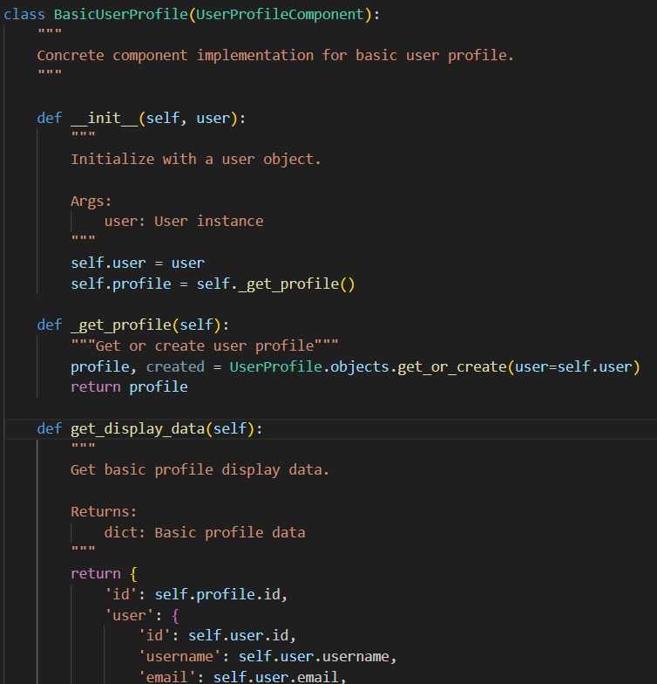
Figure ?.
And this. BasicUserProfile acts as the concrete component in the Decorator Pattern, providing the essential structure and data for a user profile. It implements the UserProfileComponent interface by returning core information such as the user's ID, username, email, nickname, bio, and profile image. As the foundational object, it serves as the base instance that decorators like AchievementDecorator and StatsDecorator wrap to incrementally extend functionality without modifying the original profile logic.
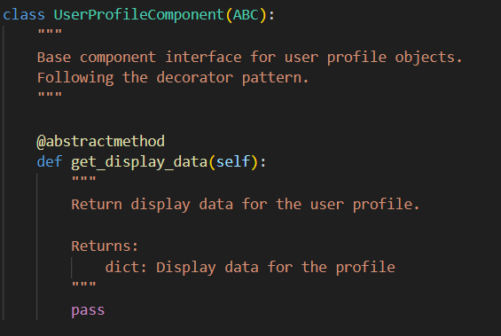
Figure ?.
Among all these decorators, UserProfileComponent serves as the foundational interface in the Decorator Pattern, defining the get_display_data() method that all profile-related classes must implement. Both the concrete component (BasicUserProfile) and all decorators (ProfileDecorator, AchievementDecorator, StatsDecorator) inherit from this interface, ensuring they can be used interchangeably and wrapped in layers. This common contract enables the seamless composition of profile objects with extended behavior, which is the core mechanism of the Decorator Pattern.
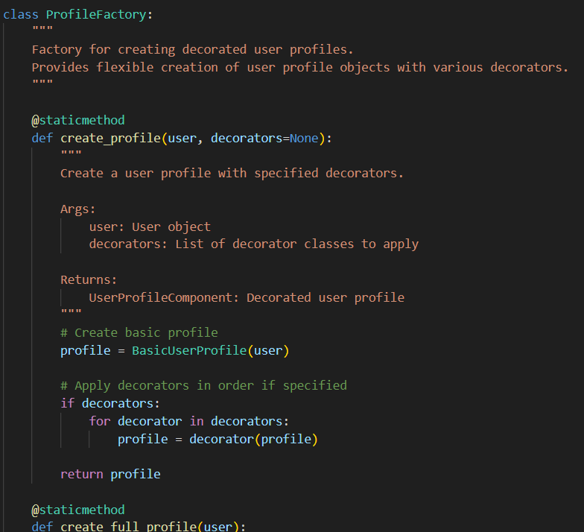
Figure ?.
And finally, this ProfileFactory assembles and creates the entire Decorator structure with deciding which decorator combination to attach to which user and create the final object.

Implementation

6-1. Registration
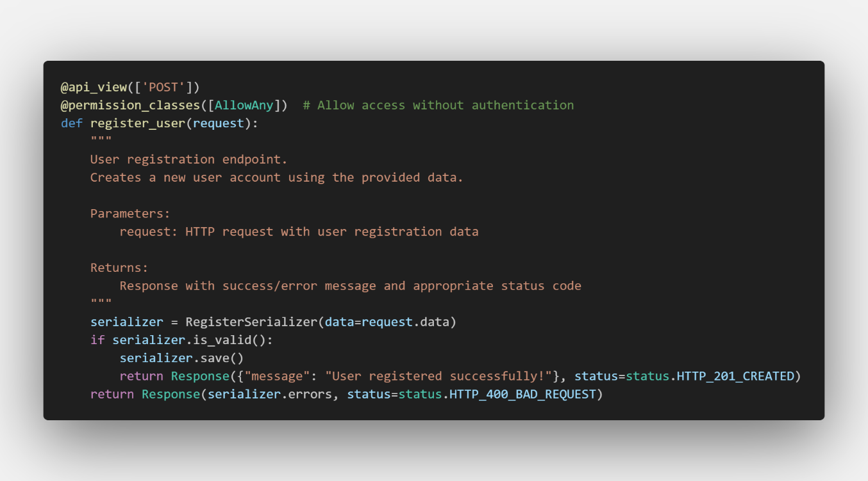
Figure ?.
This function acts as a user registration endpoint that securely creates new user accounts based on data submitted via POST to /api/auth/register/. It uses RegisterSerializer to validate fields such as username, email, and password, enforcing rules like uniqueness and format correctness. If the data is valid, the account is created with encrypted password storage, and a success message with HTTP 201 is returned. If validation fails, it responds with a detailed error and HTTP 400. The endpoint is publicly accessible, requiring no prior authentication, and Django ensures database consistency through automatic transaction management.
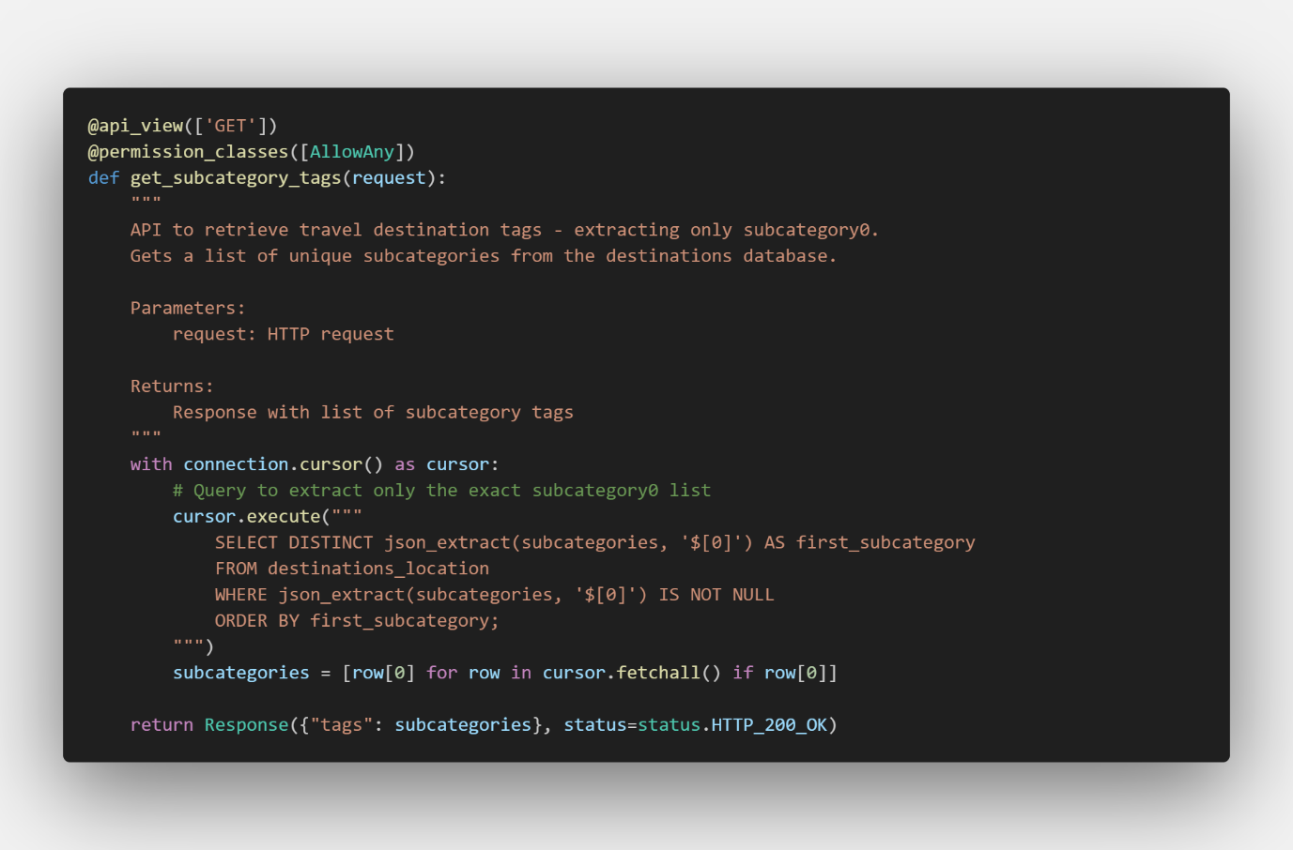
Figure ?.
Additionally, get_subcategory_tags provides a public GET API at /api/auth/tags/ that retrieves a list of unique travel-related subcategory tags from the database. It is mainly used during user registration, allowing the frontend to display tag options for users to select their interests. The function uses raw SQL to extract the first element from a JSON array field, filtering out duplicates, nulls, and empty values. The cleaned tags are sorted alphabetically and returned as a JSON response with HTTP 200 status.
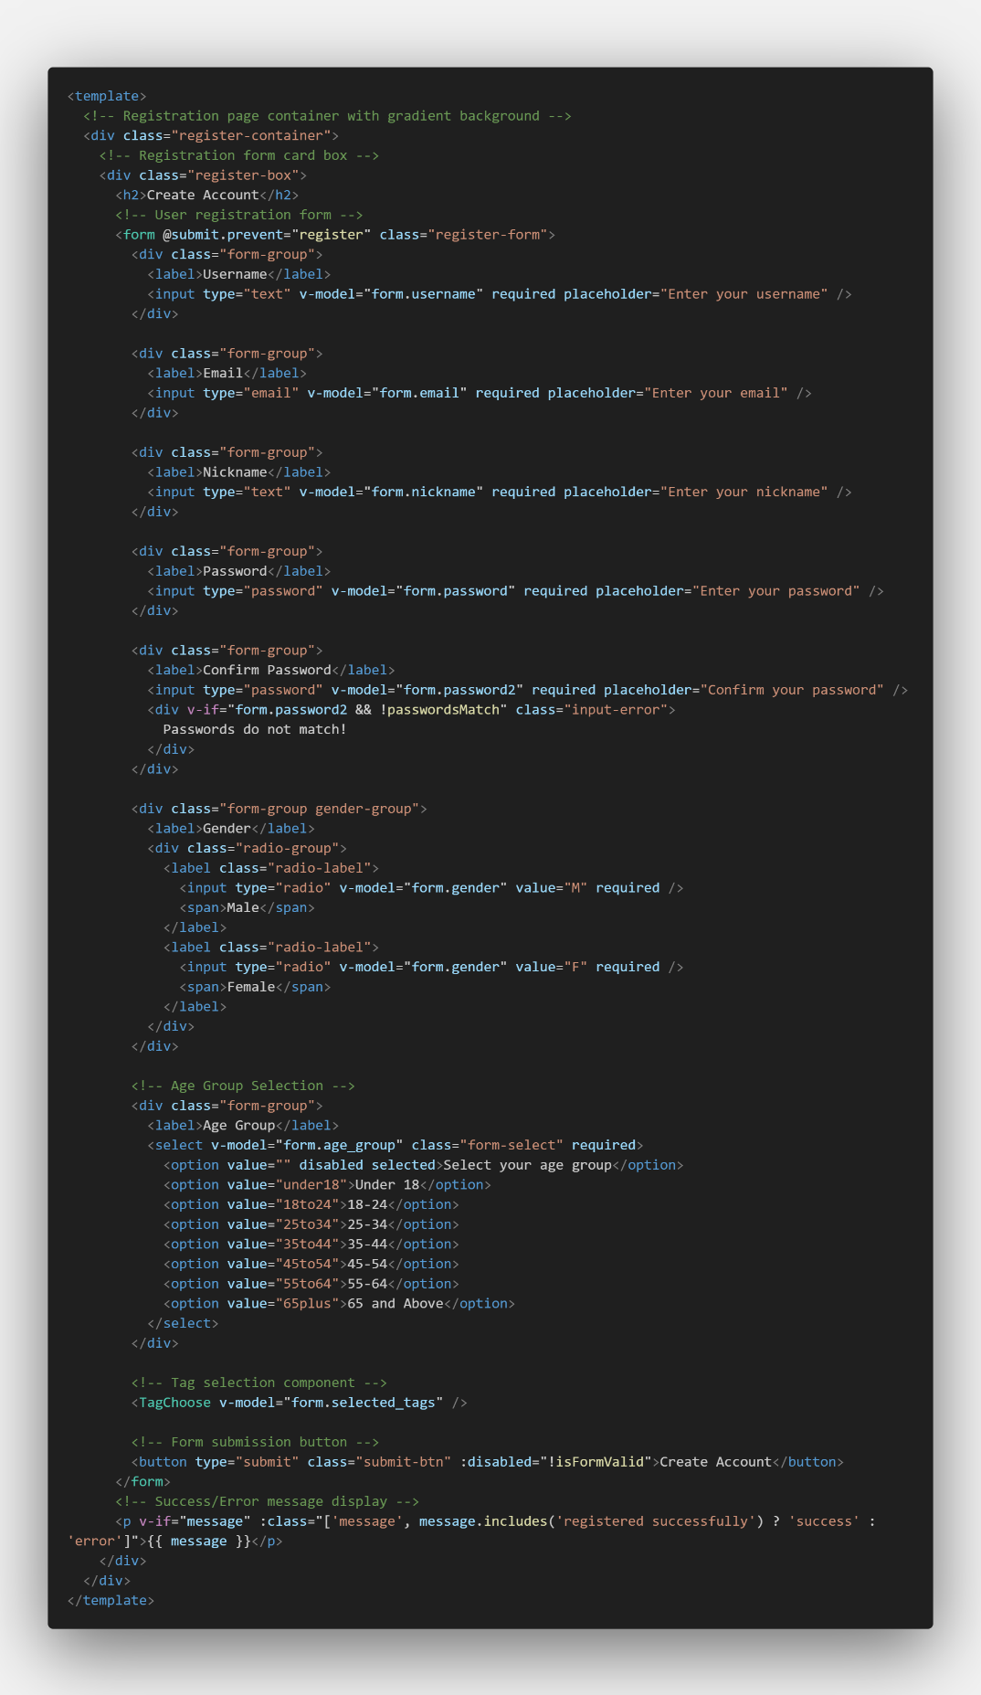
Figure ?.
This is structure of register view and it provides input fields for username, email, nickname, password, gender, and age group, along with a feature that allows users to select their travel interest tags. The user input is stored in a form object, and upon clicking the register button, the register() method is triggered.
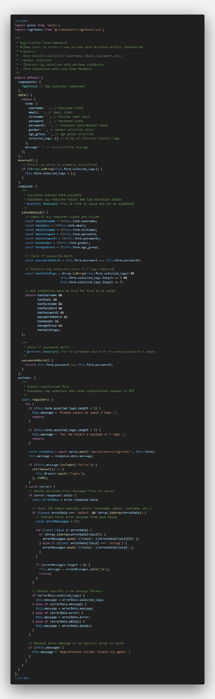
Figure ?.
The registration process is handled in the register() method, where axios.post is used to send the form data to the backend endpoint /api/accounts/register/. This request includes all user input along with the selected tags. Before making the request, the method validates that the number of selected tags is between 3 and 7. If the condition is not met, a warning is shown and the request is blocked. Depending on the server's response, the application displays either a success message or error handling feedback. This tag selection is set at components files separately.
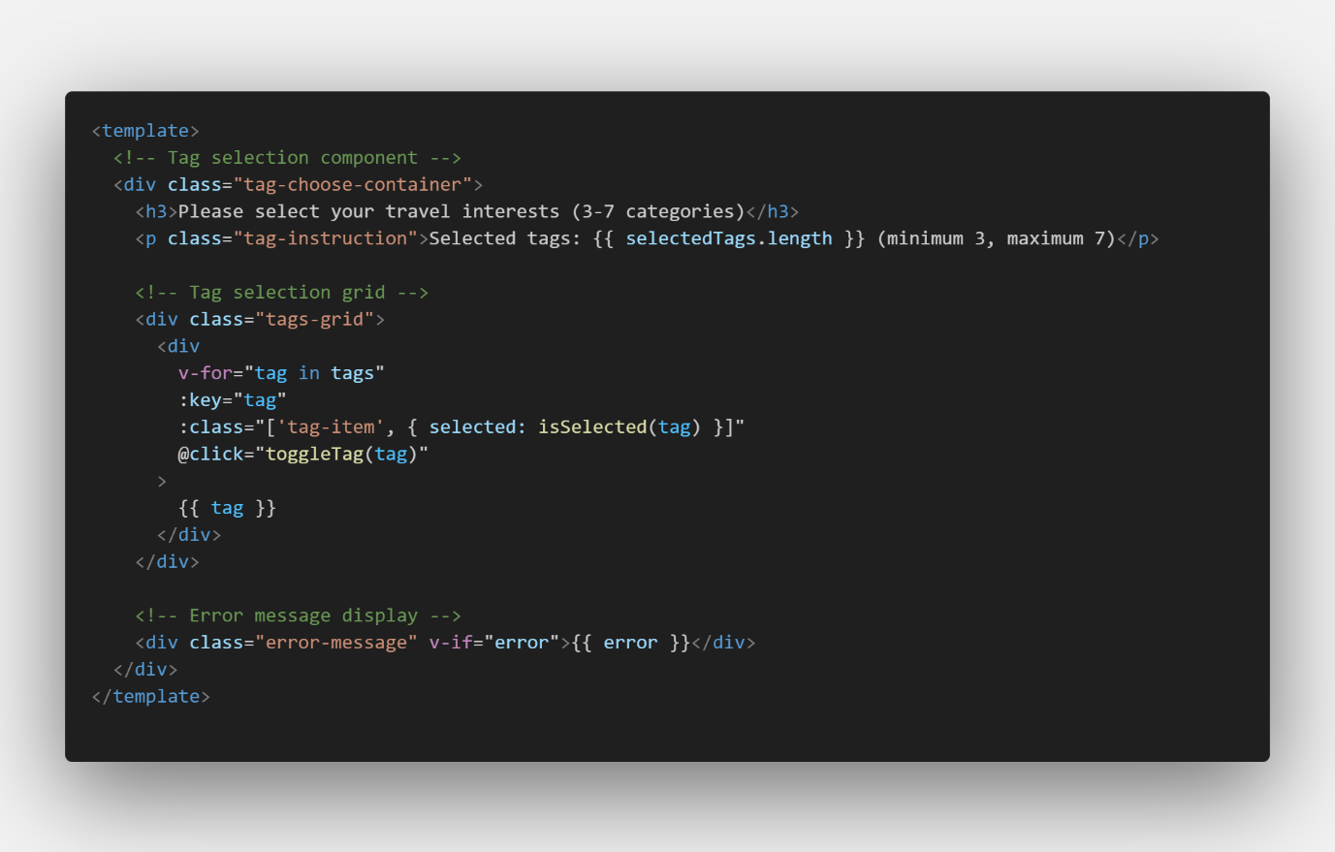
Figure ?.
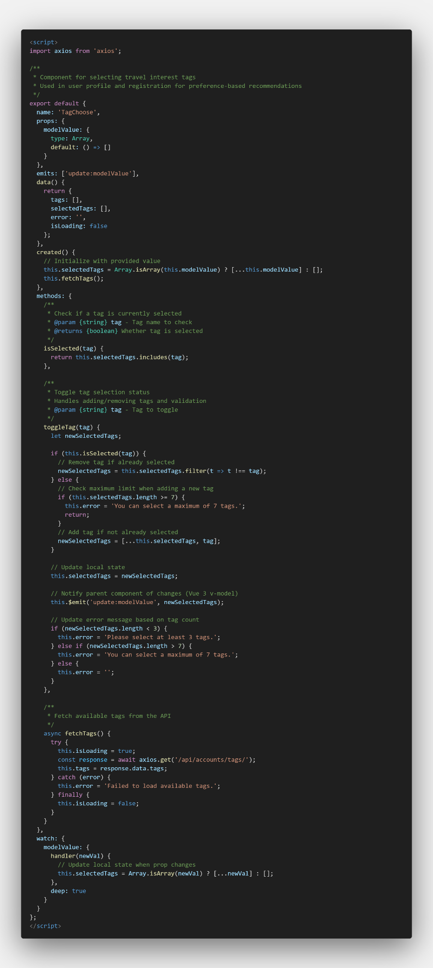
Figure ?.
This component retrieves available travel tags from the backend using axios.get('/api/accounts/tags/'), which calls the get_subcategory_tags function. The retrieved tags are displayed in a grid layout, allowing users to select them by clicking. The selected tags are stored in a selected_tags array, which is included in the form object and submitted during registration.

6-2. Log in & Log out
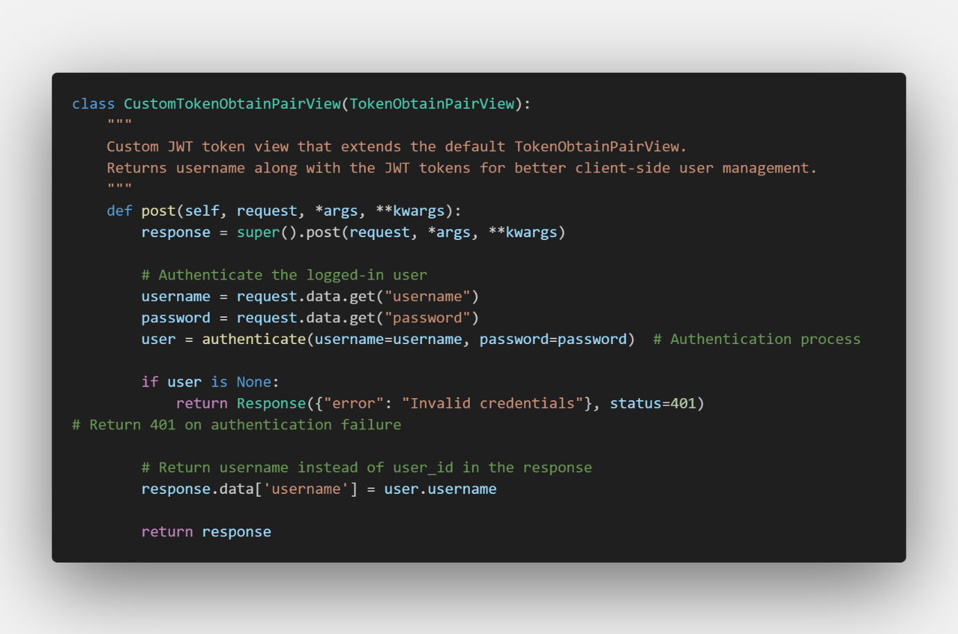
Figure ?. CustomTokenObtainPairView for Login Functionality
CustomTokenObtainPairView is a class-based view that extends Django REST Framework’s TokenObtainPairView to provide a customized JWT login process. It authenticates users by validating the submitted username and password, and if successful, returns a response containing both the standard access and refresh tokens along with the authenticated user's username. This helps the frontend immediately identify the user after login. If the credentials are invalid, the class returns a structured 401 Unauthorized response with an "Invalid credentials" message. Internally, it uses Django’s authenticate() function for validation and modifies the token response accordingly, enhancing both security and user experience without requiring any changes on the client side.
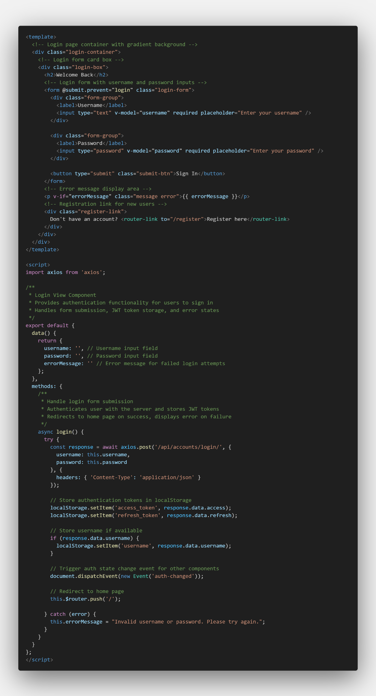
Figure ?. Login View Frontend
Within the login view frontend file, when the user enters their username and password and clicks the login button, the login() method is triggered. This method sends a POST request to the backend endpoint /api/accounts/login/ using axios, with the entered credentials in JSON format. If the login is successful, the backend responds with a JWT access token, a refresh token, and optionally the username. These tokens are stored in the browser's localStorage for future authentication purposes, and an auth-changed event is emitted to notify other components of the login status change. The user is then redirected to the homepage ('/'), providing a seamless transition after login.
On the other hand, if the login fails due to incorrect credentials, an error message such as "Invalid username or password." is displayed to inform the user. From this front-end behavior, it can be inferred that the backend handles the /api/accounts/login/ endpoint by validating the provided credentials and issuing JWT tokens upon success. These tokens are later attached to the Authorization header for protected API requests, allowing the backend to verify the user's identity. This interaction enables a secure and reactive login flow, ensuring both user feedback and system-wide authentication state tracking.
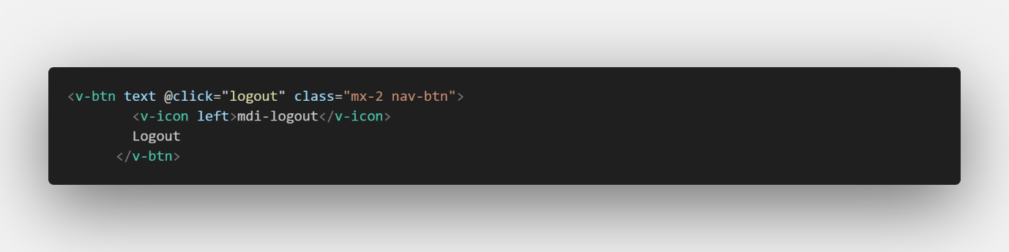
Figure ?. Logout Button inside of Navigation Frontend File
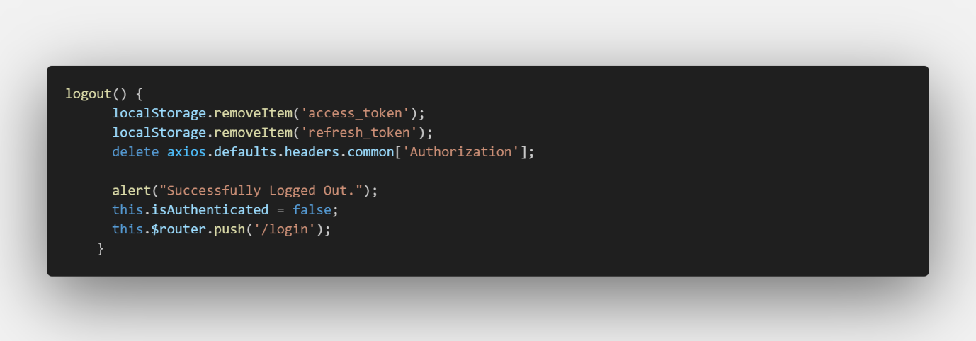
Figure ?. Logout Script
When the user clicks the logout button, the logout() method is called. It removes the tokens from localStorage, deletes the Authorization header from axios, shows a "Successfully Logged Out" message, sets isAuthenticated to false, and redirects the user to the login page. The Navbar also listens for changes in auth status using storage and custom auth-changed events to update the UI in real time.

6-3. User Community
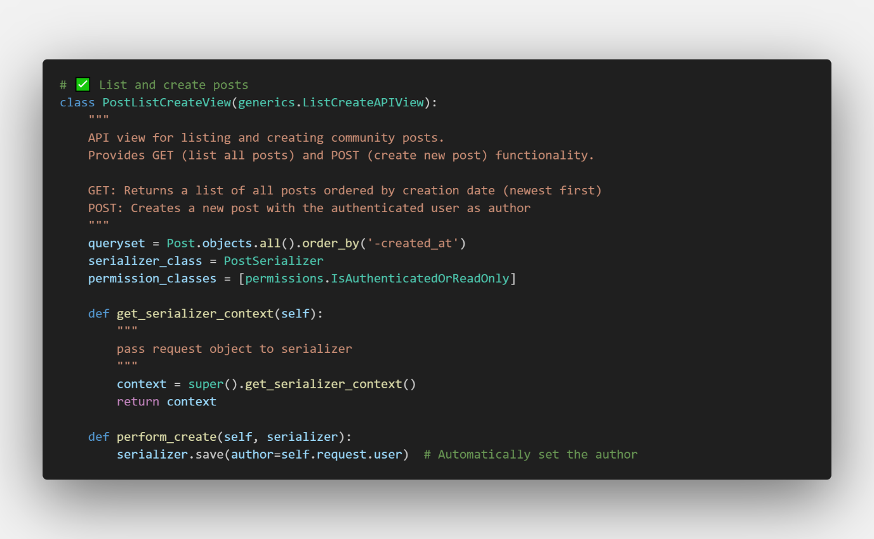
Figure ?.
PostListCreateView is a class-based view that provides functionality for listing all posts and creating new ones. It inherits from generics.ListCreateAPIView, allowing it to handle both GET and POST requests. The view applies the IsAuthenticatedOrReadOnly permission class, which means any user can view posts, but only authenticated users are allowed to create them. It overrides get_serializer_context to pass the request object to the serializer and uses perform_create to automatically assign the currently logged-in user as the author of a new post. Posts are returned in descending order based on their creation time, ensuring the most recent posts appear first.
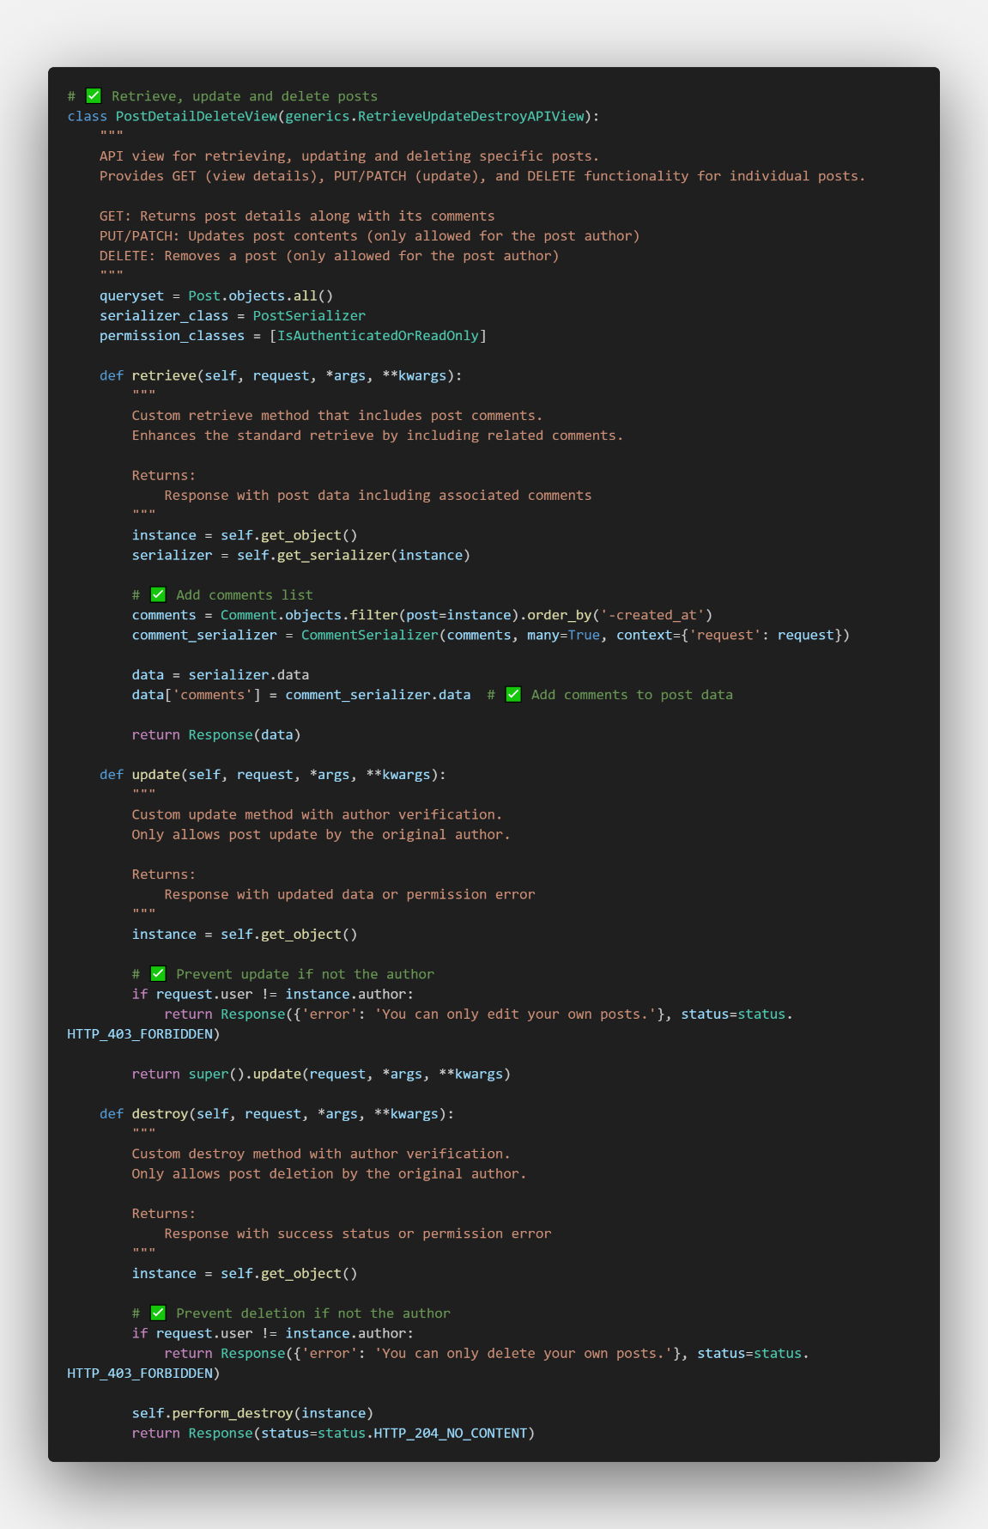
Figure ?.
PostDetailDeleteView is a class-based view that handles retrieving, updating, and deleting a specific post. It inherits from generics.RetrieveUpdateDestroyAPIView and uses the same IsAuthenticatedOrReadOnly permission policy. The retrieve method is customized to return not only the post itself but also its associated comments. The update and destroy methods enforce ownership verification — only the author of a post is allowed to modify or delete it. If a user without permission attempts these actions, the view responds with a 403 Forbidden error, ensuring strong content ownership protection.
Both of these classes perform tasks related to managing post.
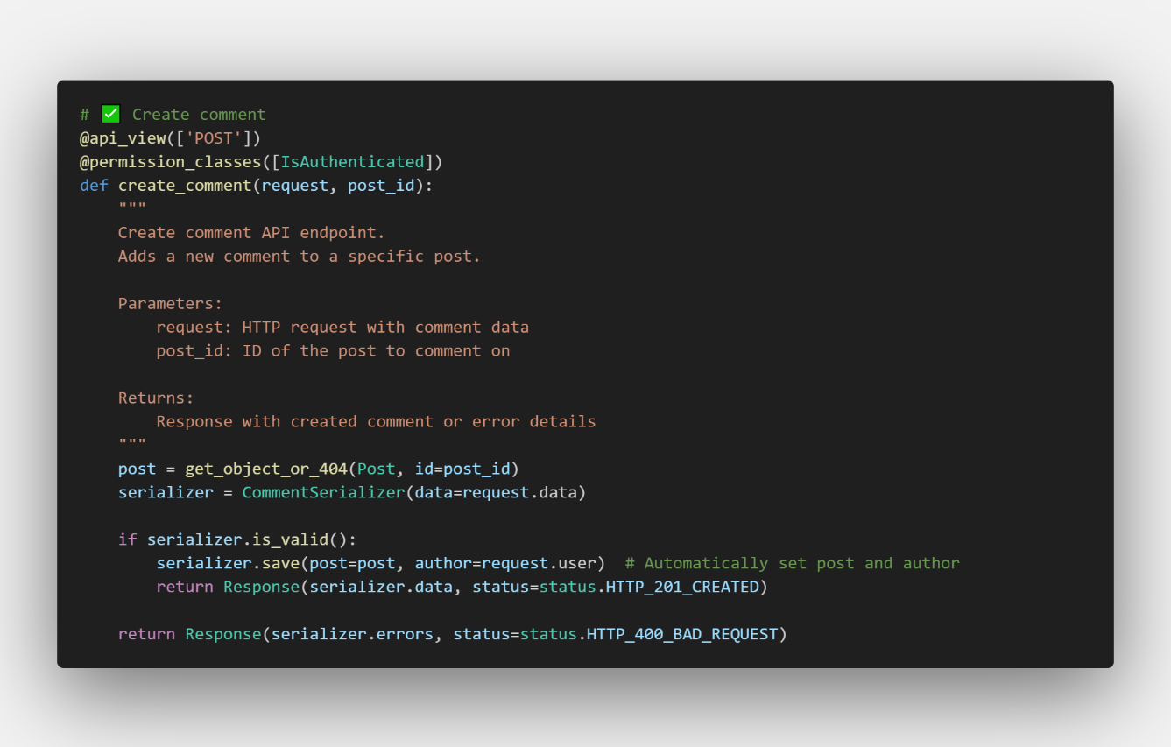
Figure ?.
Method create_comment handles creating a new comment on a specific post via POST request. Only authenticated users can access this view. It validates input, assigns the current user as the author, and links the comment to the target post.
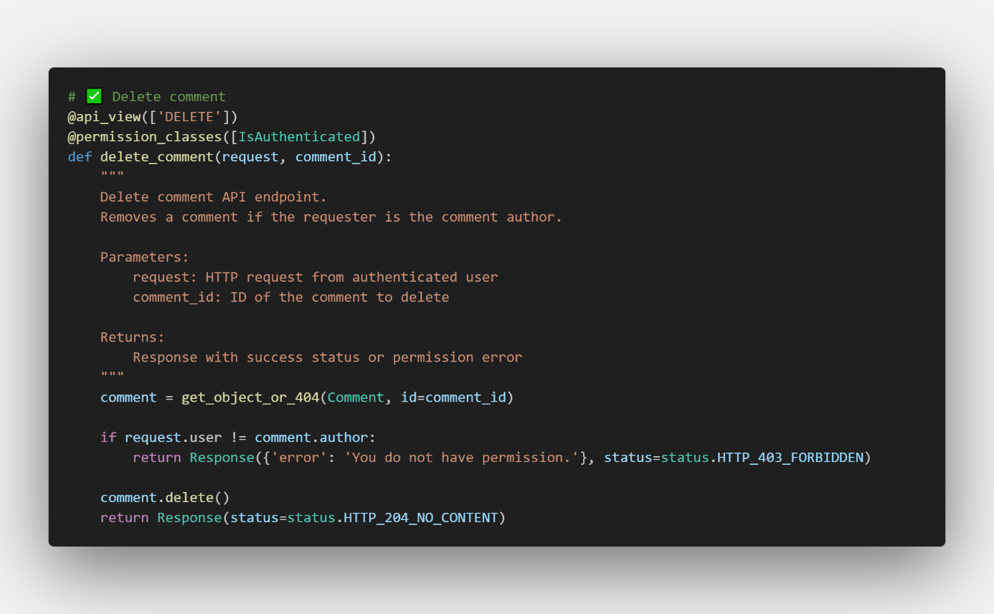
Figure ?.
Method delete_comment allows an authenticated user to delete a specific comment via DELETE request. Only the original author is permitted to perform this action; otherwise, a 403 error is returned.
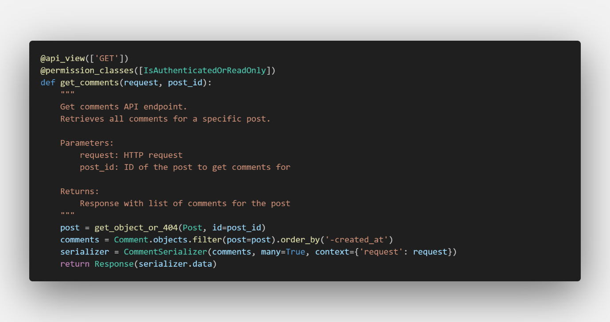
Figure ?.
Method get_comments retrieves all comments for a given post in descending order of creation time. Accessible to all users for reading, but only authenticated users may interact further.
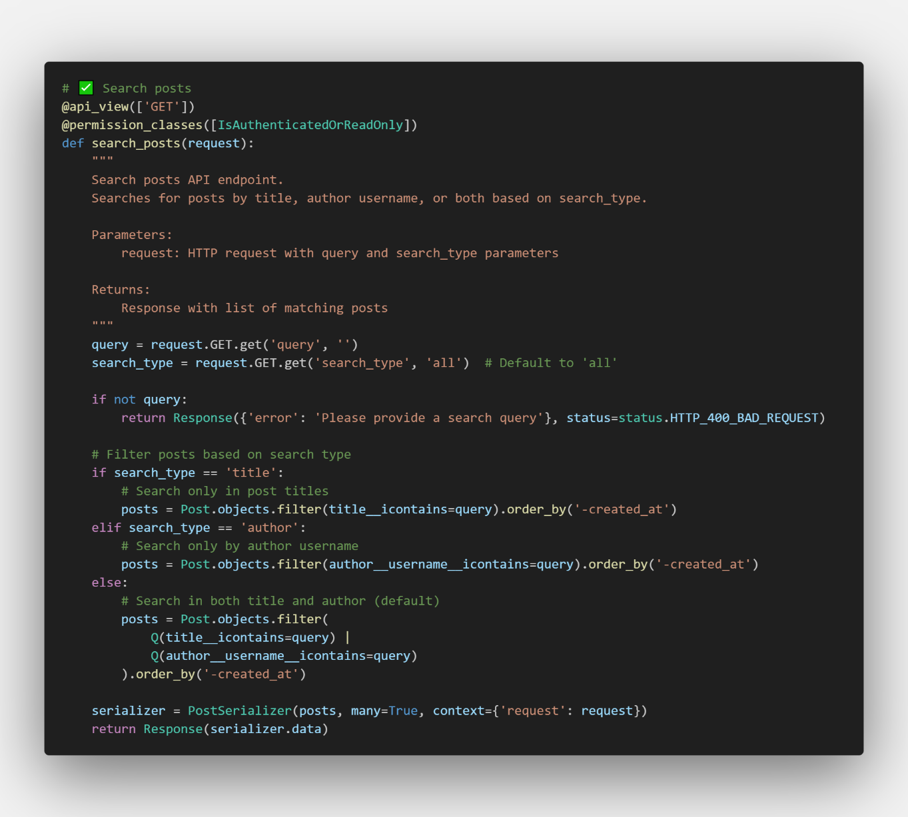
Figure ?.
Method search_posts, as its name, performs a search across posts based on a query and search type (title, author, or all). Returns posts sorted by newest first that match the criteria.
For the part of frontend in community, 4 frontend files for Post list, Post detail, Edit post and New post.
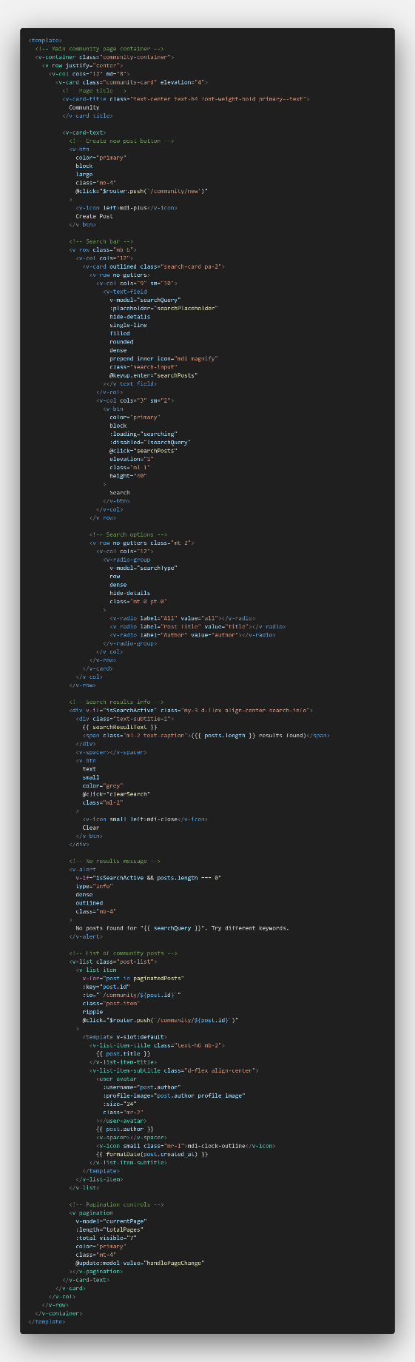
Figure ?.
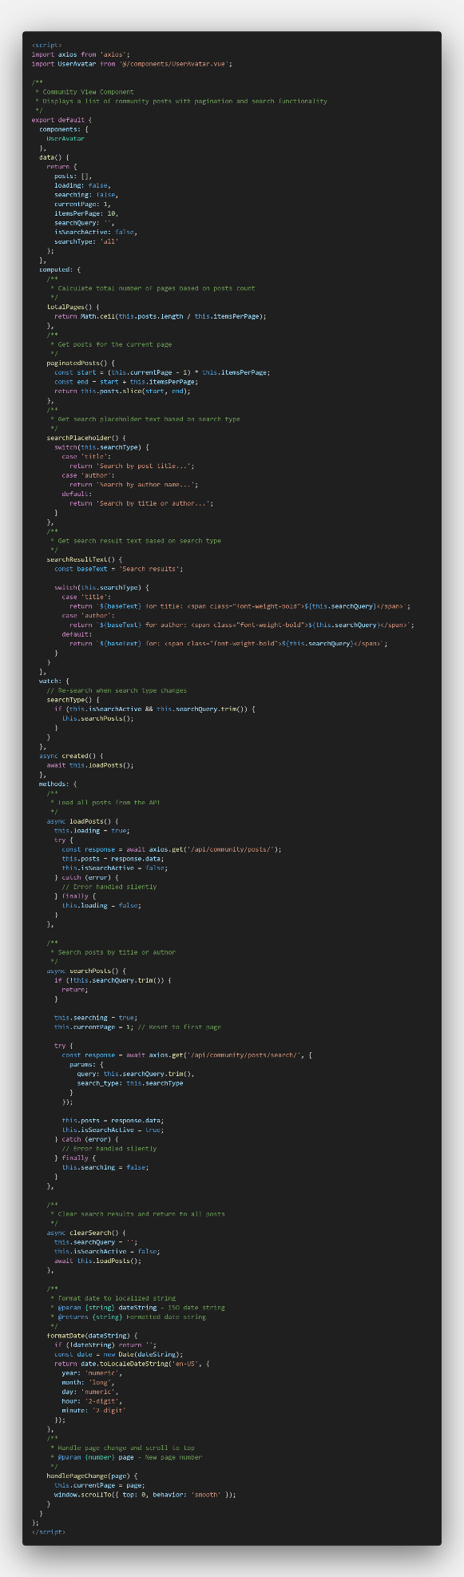
Figure ?.
The CommunityView component implements the main page of the community bulletin board, displaying a list of posts and providing a search function. It communicates with the backend PostListCreateView class and the search_posts function. The loadPosts() method calls axios.get('/api/community/posts/') to retrieve all posts using the GET method from PostListCreateView. The searchPosts() method uses axios.get('/api/community/posts/search/') to search for posts by title or author via the search_posts function. Pagination is handled on the client side to show 10 posts per page.
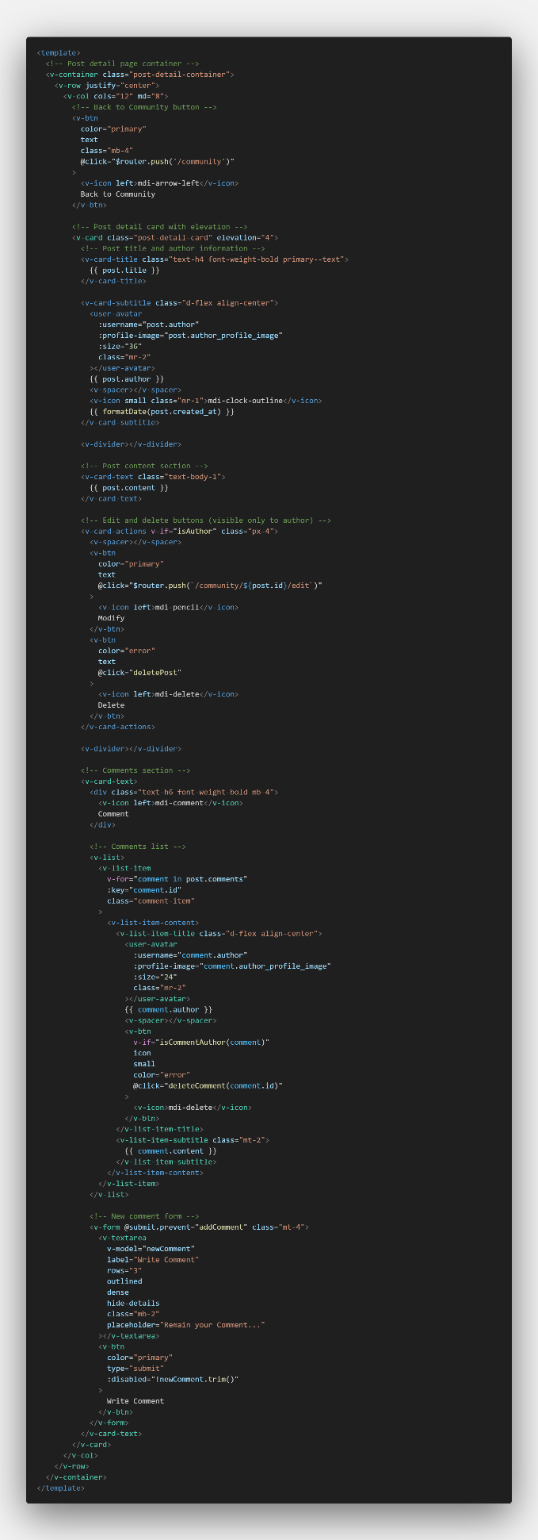
Figure ?.
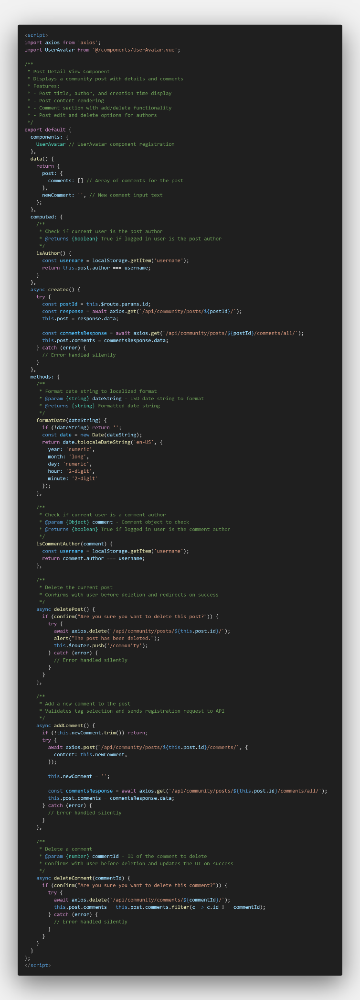
Figure ?.
PostDetailView.vue displays the detailed content of individual posts and their comments, interacting with the backend's PostDetailDeleteView.retrieve, get_comments, create_comment, and delete_comment functions. In the created() hook, it calls axios.get(/api/community/posts/${postId}/) to fetch post information through the PostDetailDeleteView.retrieve method, and axios.get(/api/community/posts/${postId}/comments/all/) to fetch comment listings through the get_comments function. Additionally, the addComment() method calls axios.post(/api/community/posts/${this.post.id}/comments/) using the create_comment function, and the deleteComment() method calls axios.delete(/api/community/comments/${commentId}/) using the delete_comment function to implement comment addition and deletion features respectively.
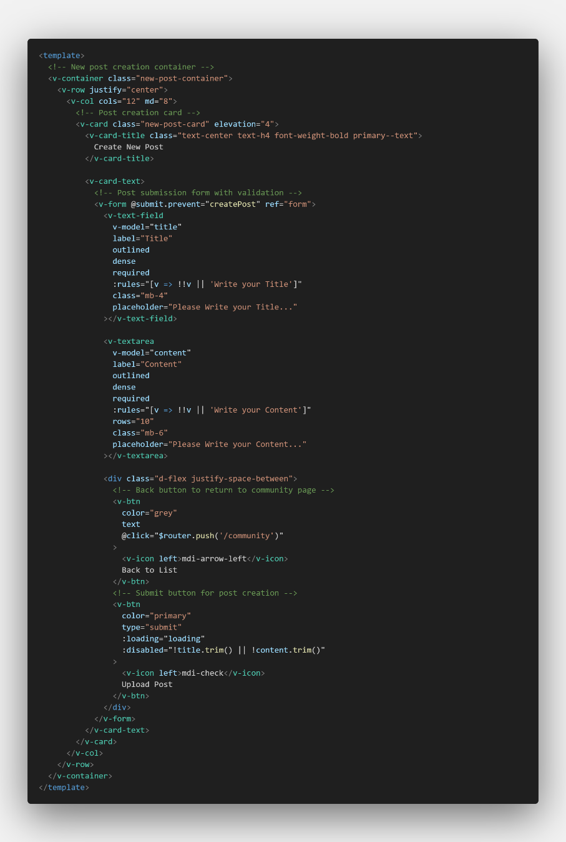
Figure ?.
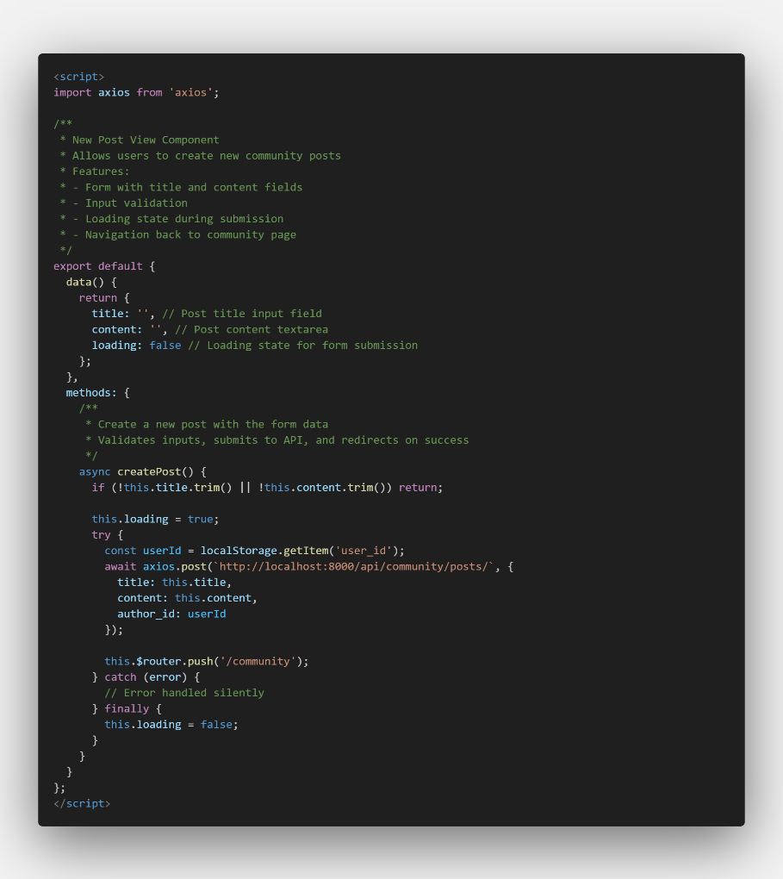
Figure ?.
NewPostView.vue provides a form for creating new posts, interacting with the backend's PostListCreateView.perform_create method. In the createPost() method, it calls axios.post(http://localhost:8000/api/community/posts/) to create new posts through the POST request handler of the PostListCreateView class. During this process, title and content validity are first checked on the client side, and on the server, the currently logged-in user is automatically set as the post author. Once post creation is complete, the user is automatically redirected to the community main page.
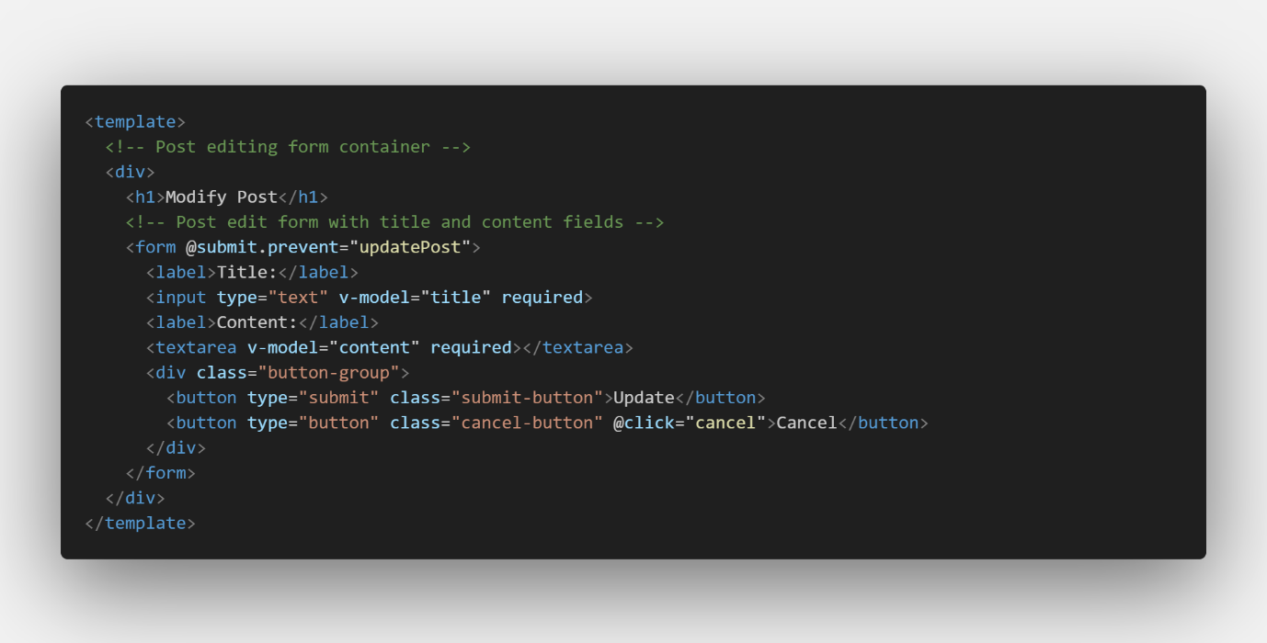
Figure ?.
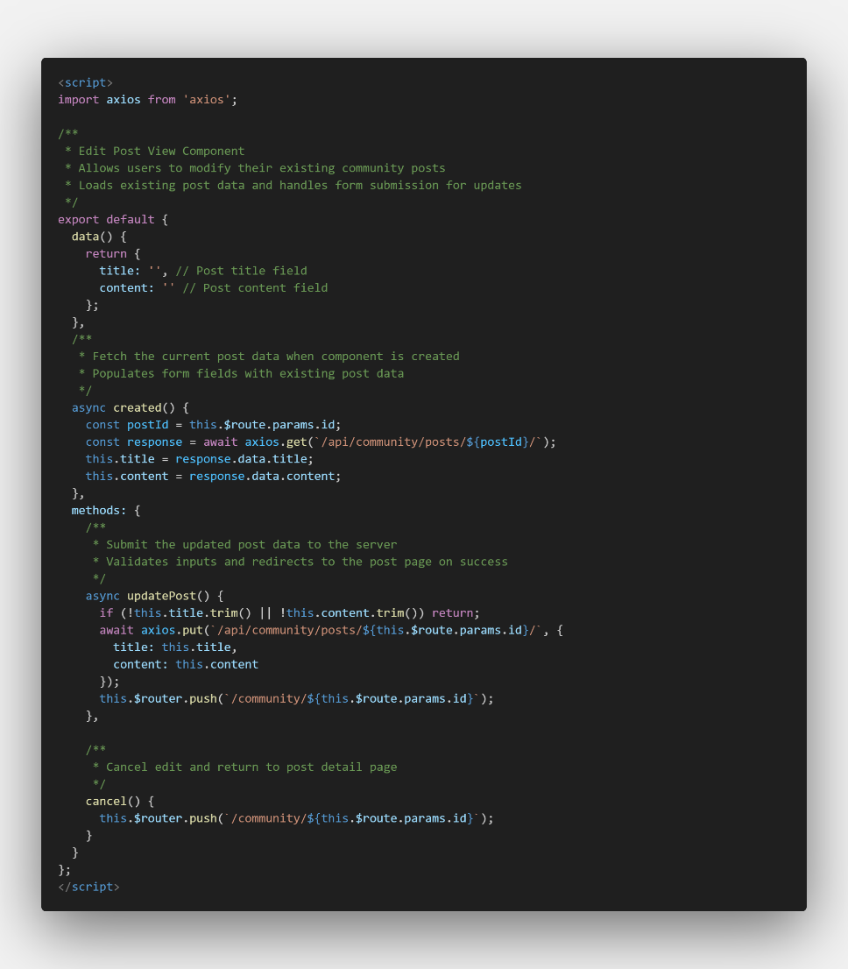
Figure ?.
EditPostView.vue then provides a form for editing existing posts, interacting with the backend's PostDetailDeleteView.retrieve and PostDetailDeleteView.update methods. In the created() hook, it calls axios.get(/api/community/posts/${postId}/) to load existing post content through the PostDetailDeleteView.retrieve method, and in the updatePost() method, it calls axios.put(/api/community/posts/${this.$route.params.id}/) to save the modified post content through the PostDetailDeleteView.update method. Editing is restricted to the original author, with permission checks performed on the server side.
Also, in community, View user profile is performed via post detail page.
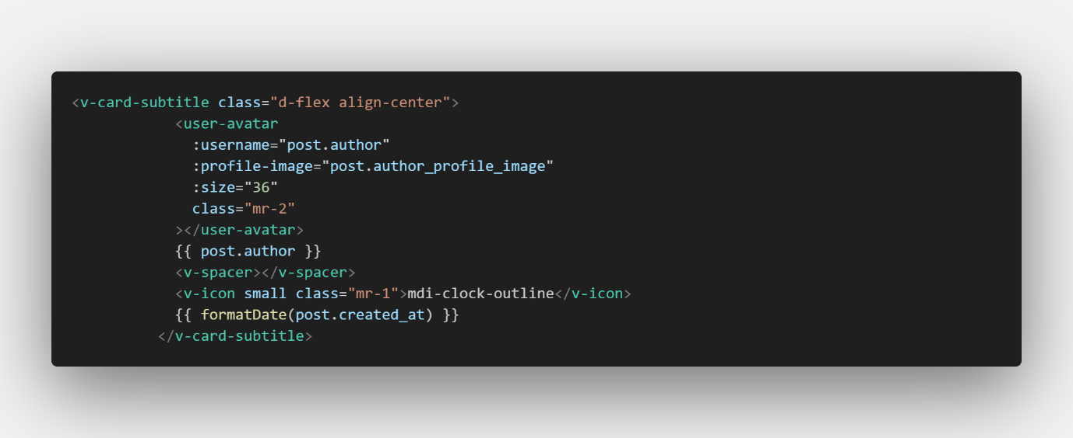
Figure ?.
Inside of the post detail page file, user-avatar component exists and this component is rendered next to usernames for both post authors and commenters. It serves as the entry point for users to access profile information by clicking on an avatar.
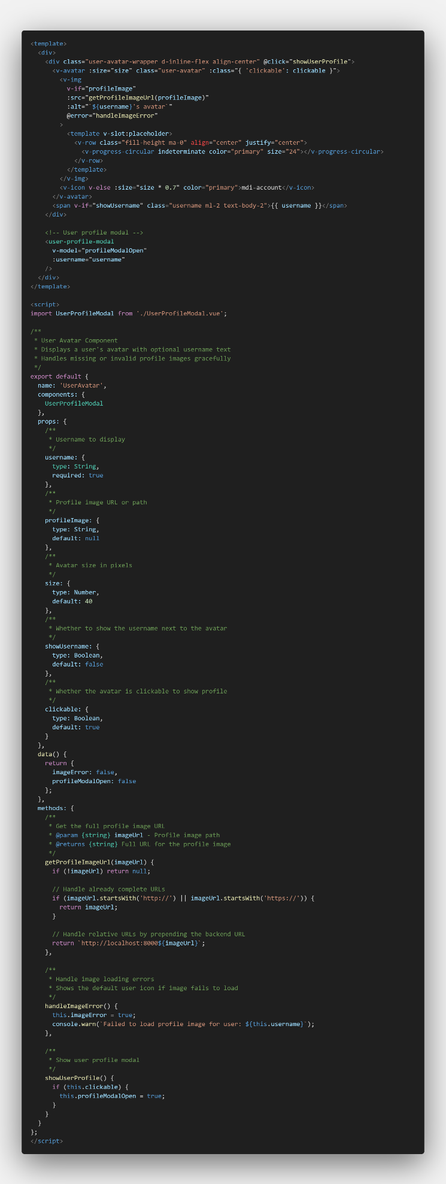
Figure ?.
When the user clicks an avatar, the showUserProfile() method in UserAvatar.vue is triggered. This method sets a local state variable (e.g., profileModalOpen) to true, which opens the user profile modal. The modal component, UserProfileModal.vue, is included in the template and receives username and profileImage as props for identifying the user to be displayed.
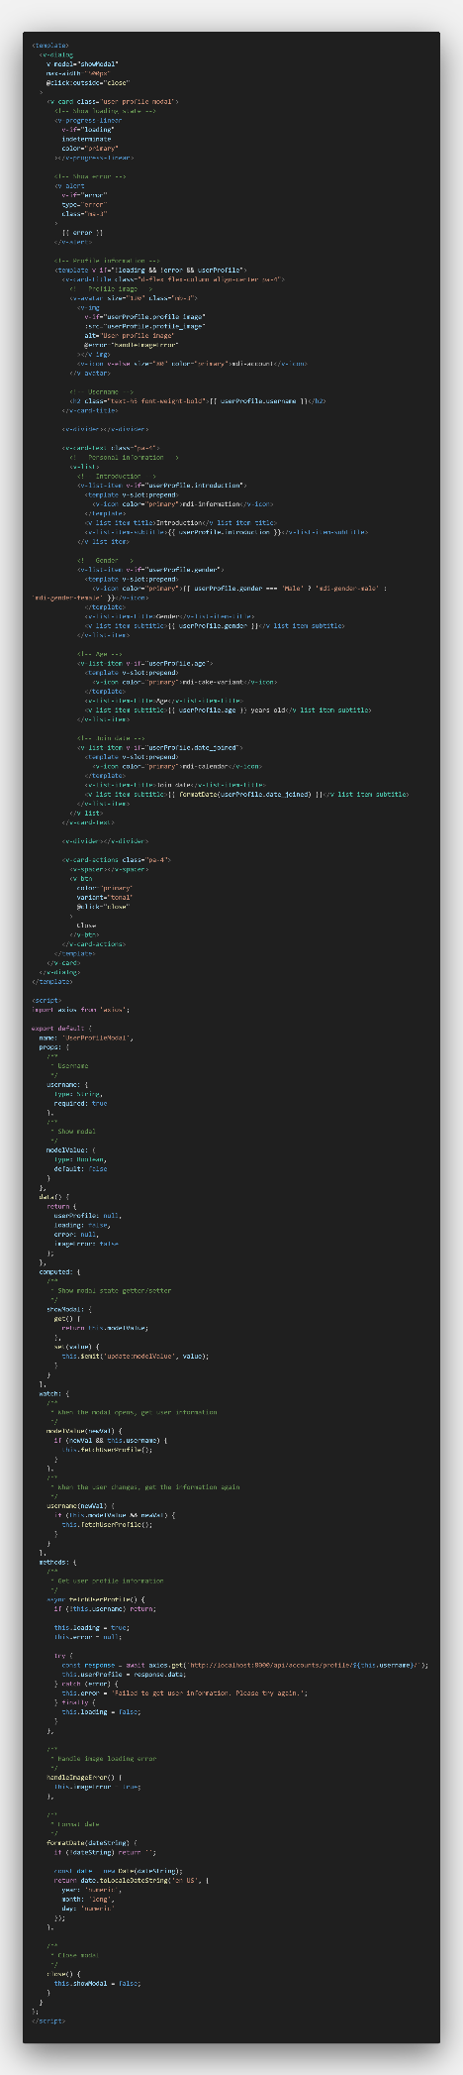
Figure ?.
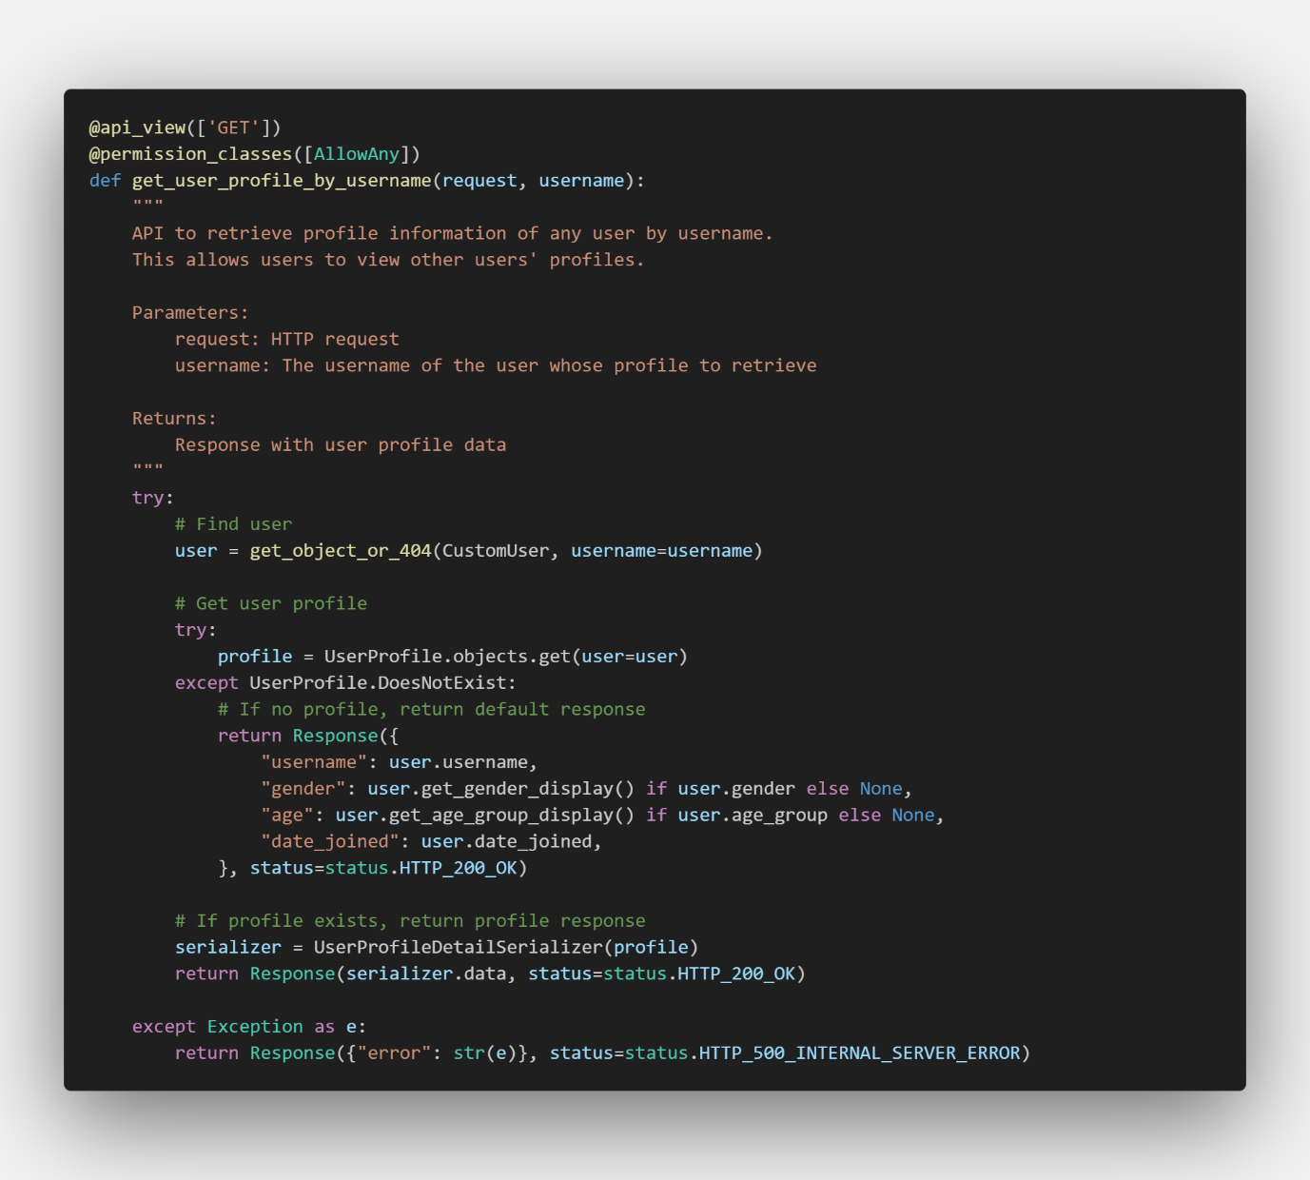Figure ?.
Once the modal opens, a watcher on modelValue detects the change and triggers the fetchUserProfile() method. This method sends a request to the backend via axios.get('/api/accounts/profile/{username}/'). On the server side, the get_user_profile_by_username function in accounts/views.py processes the request and returns the user’s profile data, which is stored in the userProfile variable and used to populate the modal UI. With the user profile data received, UserProfileModal.vue displays the user’s details in a styled modal. Users can view information such as username, profile image, and possibly other metadata. The modal includes a close button that resets profileModalOpen to false, effectively closing the modal. Throughout this process, technologies like two-way v-model binding, prop passing, conditional rendering (e.g., loading states), and error handling for images ensure a smooth user experience.

6-4. My Page
My Page has various functions such as Delete Account, Manage Personal Details, View My Posts, View My Comments, View My Review, View Favorite List and View Achievement.
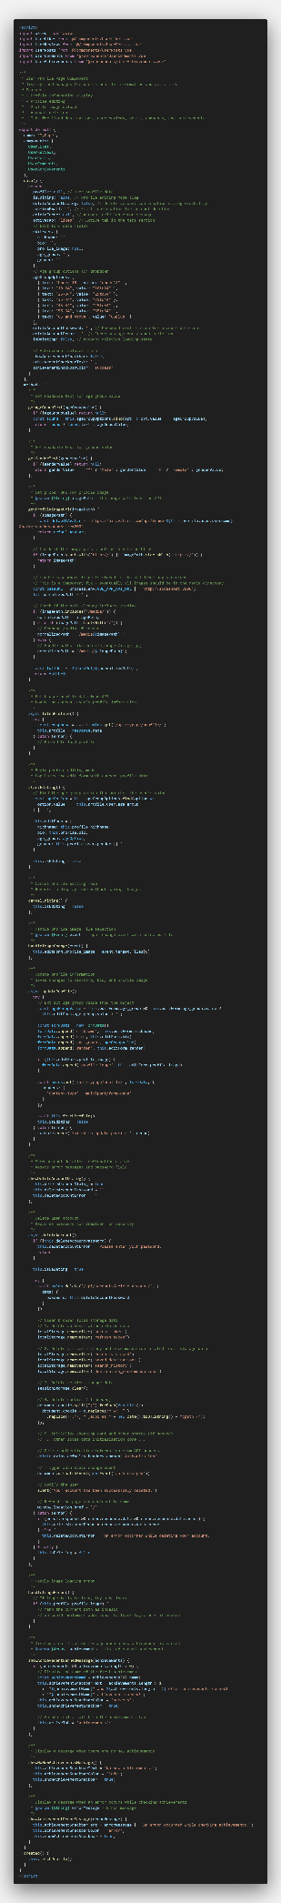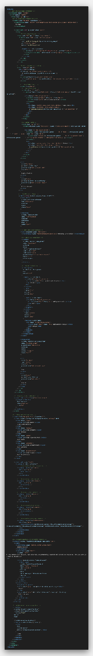 Figure ?.
Since My Page file has various and compulsory kinds of functionalities, it is one of the longest file in this project.
Firstly, delete account is performed via accounts/views.py.
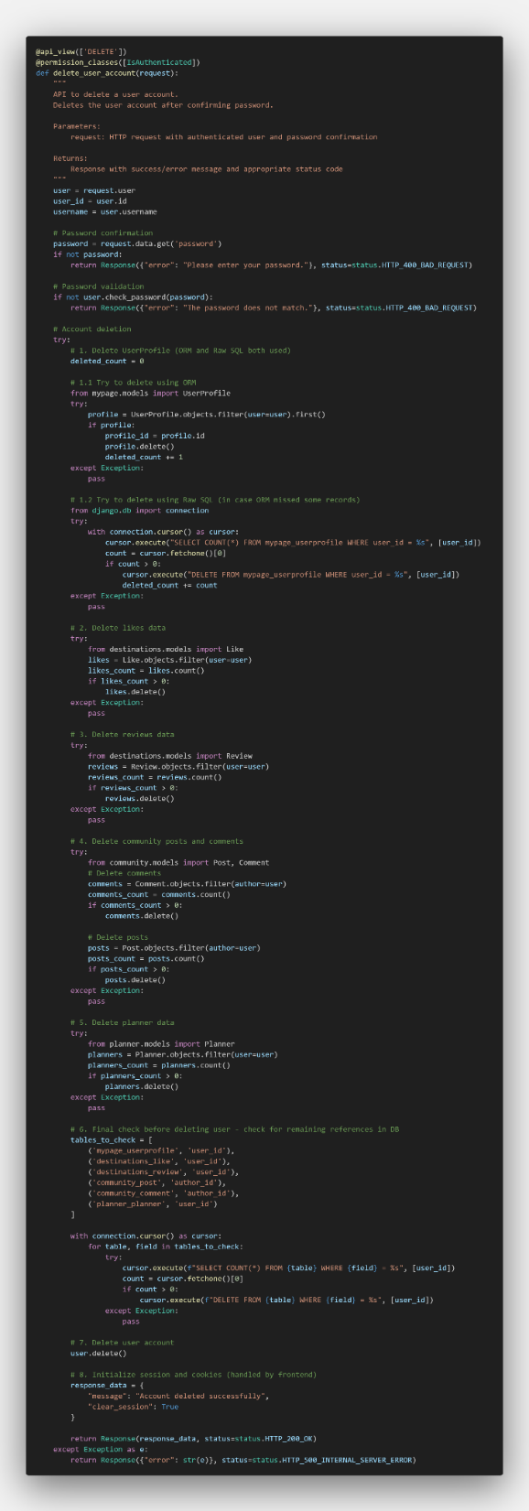
Figure ?.
The account deletion process starts with a password check to ensure security. After that, all user-related data—such as profile, likes, reviews, posts, comments, and travel plans—is deleted step by step using both ORM and raw SQL. Each step is handled separately with try-except, so even if one part fails, the rest can still continue. This prevents errors from stopping the whole process. It also uses secure SQL and handles data across multiple apps. The goal is to delete as much user data as possible safely and completely.
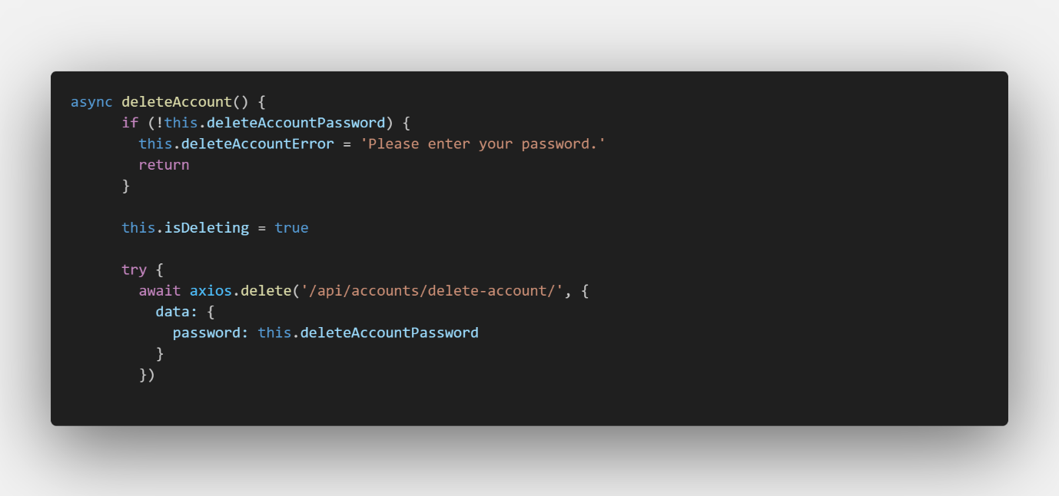
Figure ?.
Inside of the script of MyPage, frontend is connected to backend at this part,
Secondly, manage profile is performed by mypage/views.py.
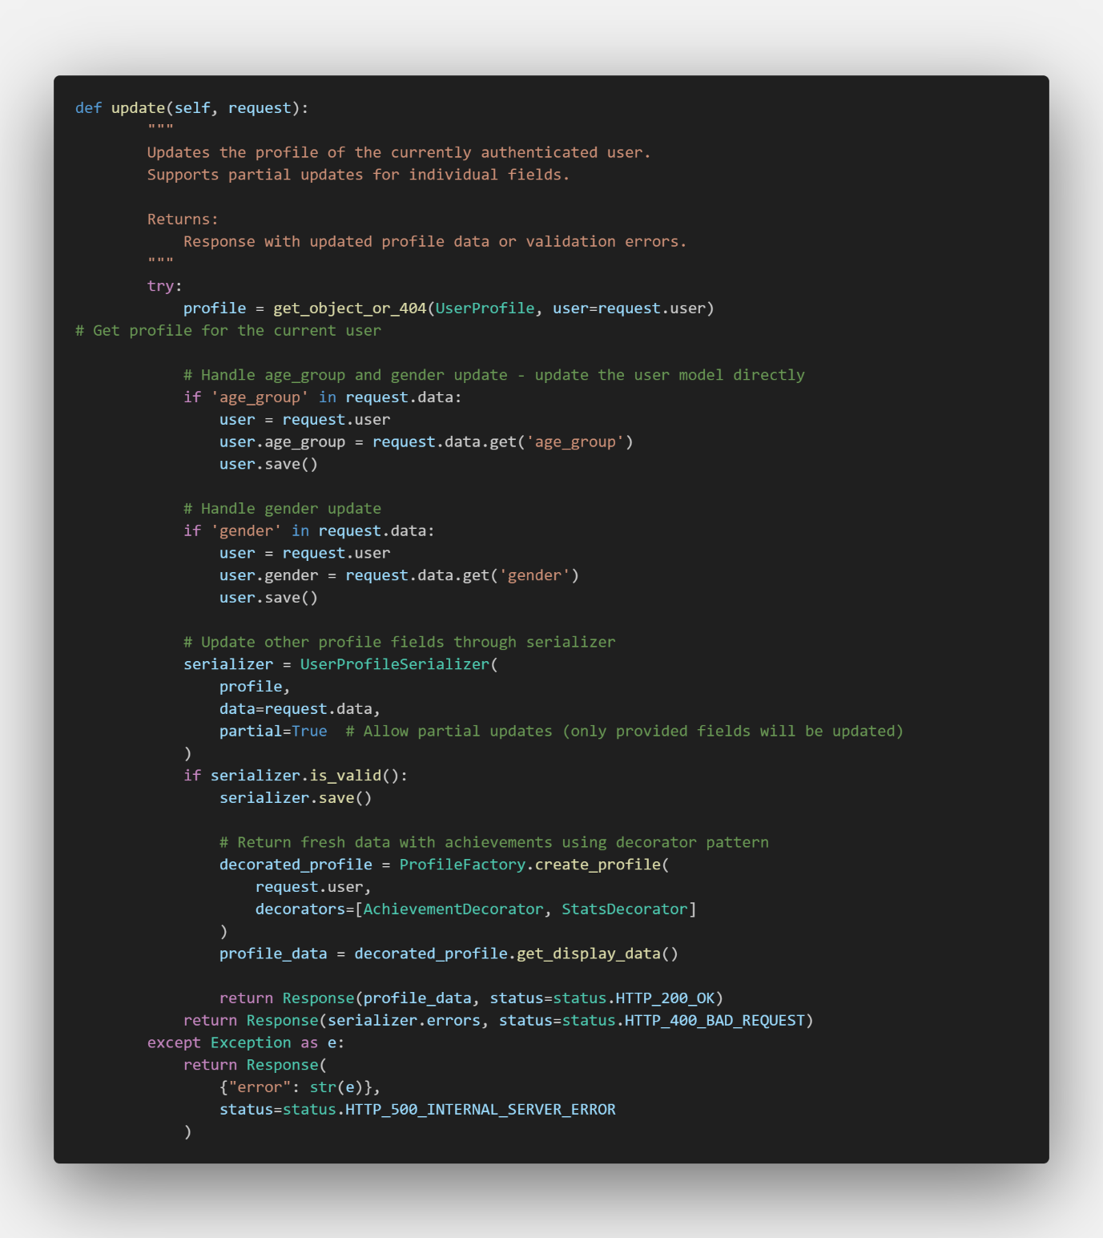
Figure ?.
The profile update process involves locating the UserProfile instance and updating its fields. The age_group and gender fields are directly updated on the user model, while other profile fields such as nickname, bio, and profile_image are handled through the UserProfileSerializer. Only the fields defined in the serializer are updatable, and the use of partial=True allows for partial updates, meaning users can modify specific fields without affecting the others. The response utilizes a decorator pattern to return both the updated profile information and the user’s achievement data together.
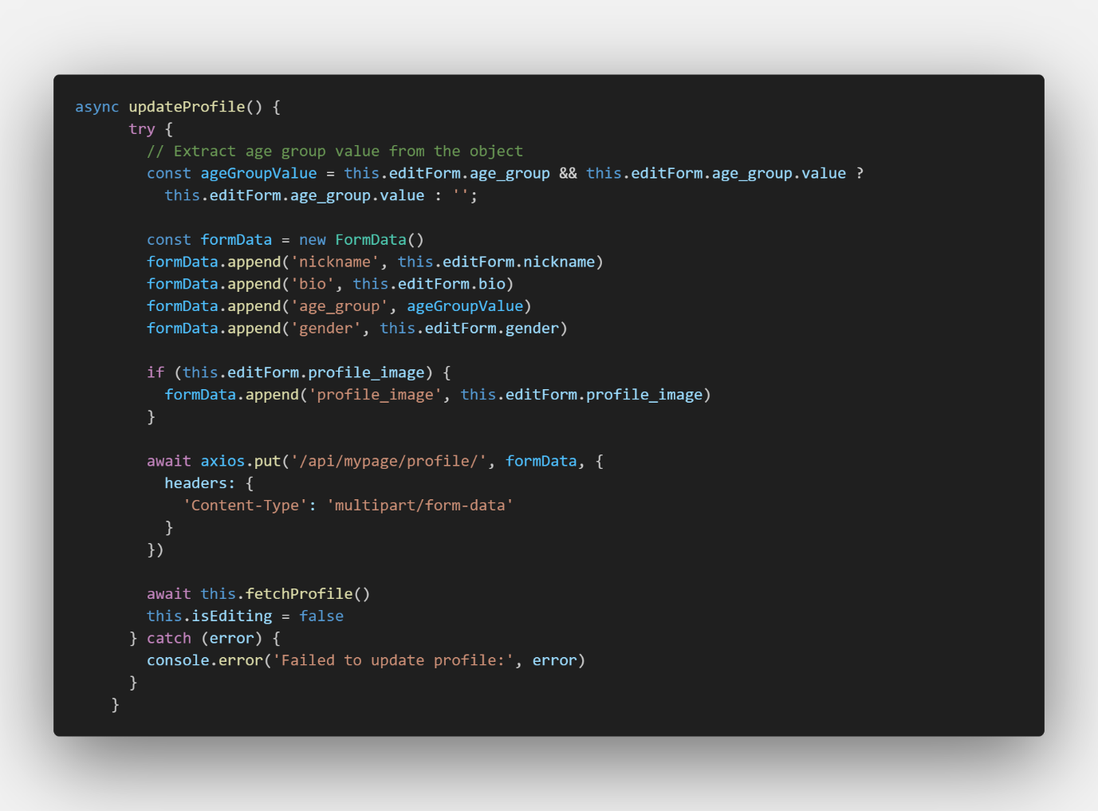
Figure ?.
And the updateProfile method in MyPage.vue calls the API endpoint /api/mypage/profile/ using a PUT request. This API supports updating profile information, including image uploads, by sending the data as multipart form data.
And thirdly, the interface of showing reviews, liked destinations, posts, comments and achievements by users are separately located.
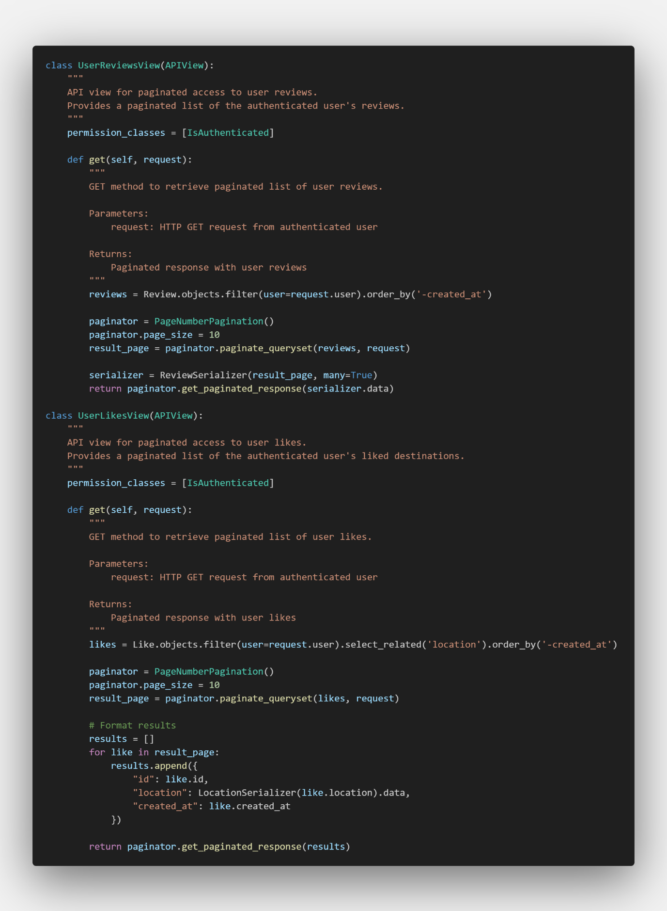
Figure ?.
When a user clicks the like button or submits a review on the destination detail page, the frontend sends a POST request to either /api/destinations/likes/ or /api/destinations/reviews/. These requests are handled by the backend through the LikeViewSet.create or ReviewViewSet.create methods, which create corresponding Like or Review instances in the database and update related statistics.
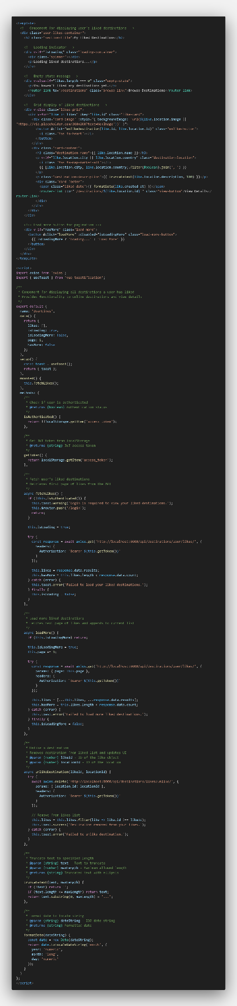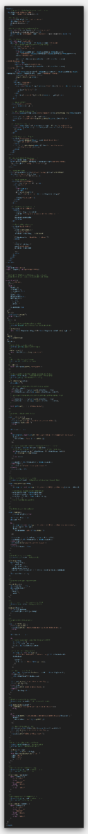
Figure 23. UserLikes.vue & UserReviews.vue
Later, when the user navigates to the "Liked Destinations" or "Your Reviews" tab on their MyPage, the corresponding components (UserLikes.vue or UserReviews.vue) are initialized and send a GET request to /api/destinations/user/likes/ or /api/destinations/user/reviews/. The backend filters the data by user through UserLikesView.get or UserReviewsView.get, and returns only the relevant entries, which the frontend then uses to render the UI.
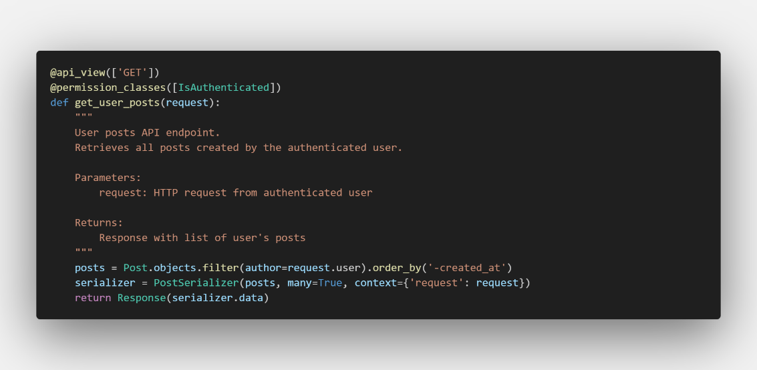
Figure ?.
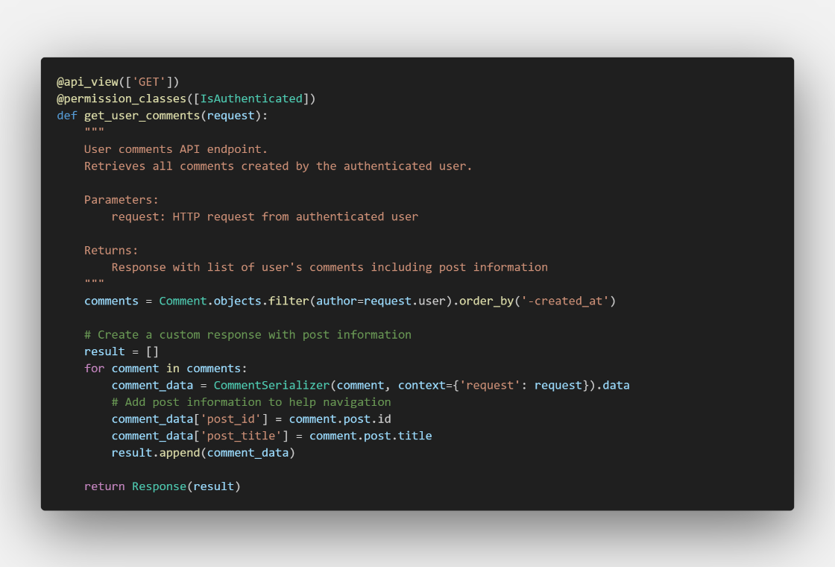
Figure ?.
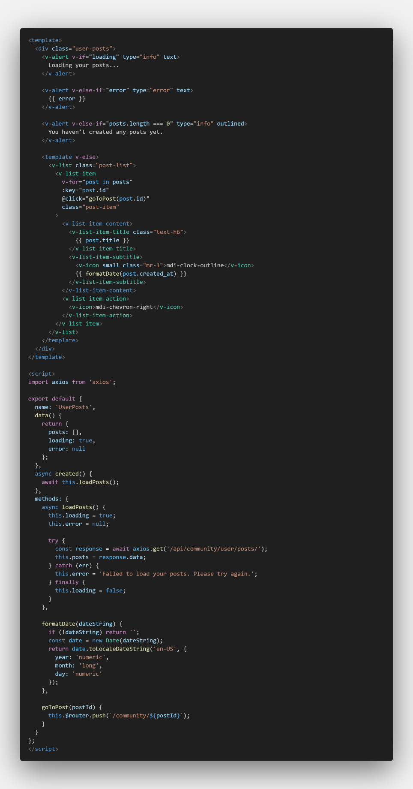
Figure ?.
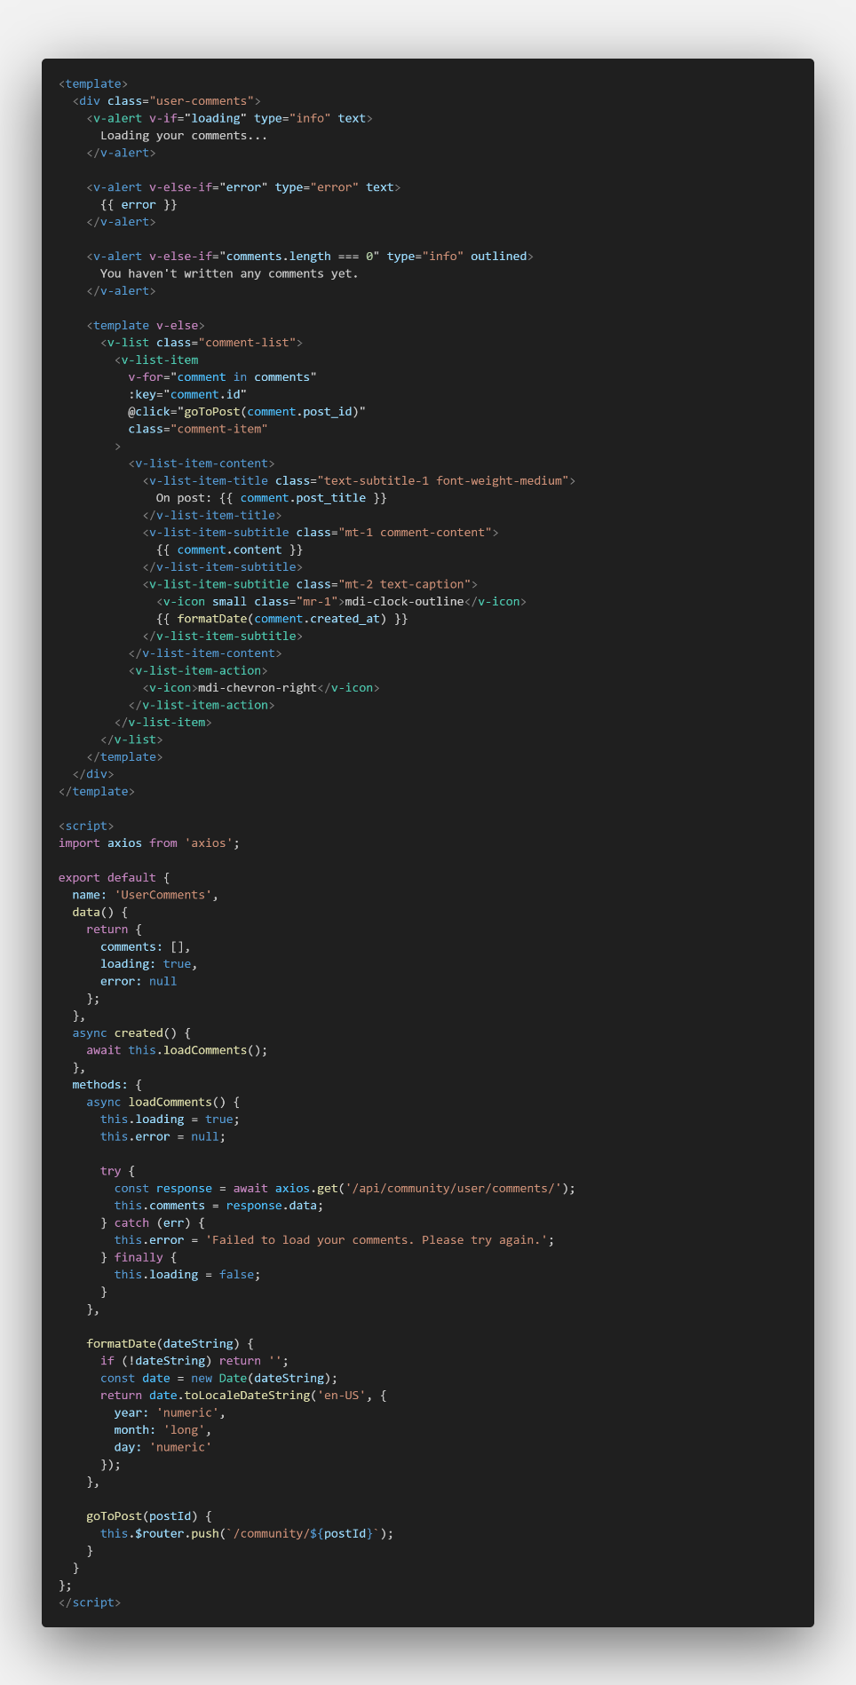
Figure ?.
When the user selects the "Your Posts" tab on their MyPage, the UserPosts.vue component is initialized and sends a GET request to the /api/community/user/posts/ endpoint. The backend handles this request using the get_user_posts function, which filters and returns only the posts created by the currently logged-in user. The frontend then uses the response data to render the list of the user's posts on the page.
Similar to post one, also when the user selects the “Your Comments” tab, UserComments.vue component is loaded and triggers a GET request to the /api/community/user/comments/ endpoint. The backend processes the request through the get_user_comments function, filtering the comments to return only those made by the current user. Additionally, the response includes information about the posts to which each comment belongs. The frontend uses this data to display the user's comments along with their associated post details.
Finally, the achievement tab is located in the last sequence of sections in my page.

6-5. Destination Page
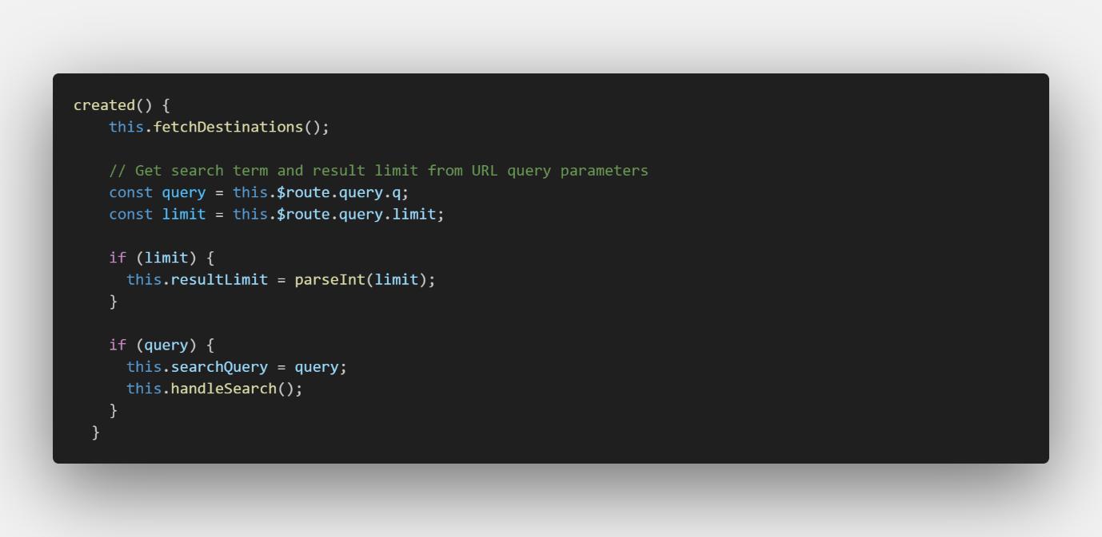
Figure ?.
The created() lifecycle hook in the DestinationList component enables URL-driven search functionality. It first loads all destinations, then extracts any search parameters from the URL query string. If a search query (q) or result limit parameter exists in the URL, it applies these values and automatically triggers the search operation. This feature allows users to navigate directly to specific search results through shareable URLs, supporting use cases like bookmarked searches and deep linking to pre-filtered destination lists.
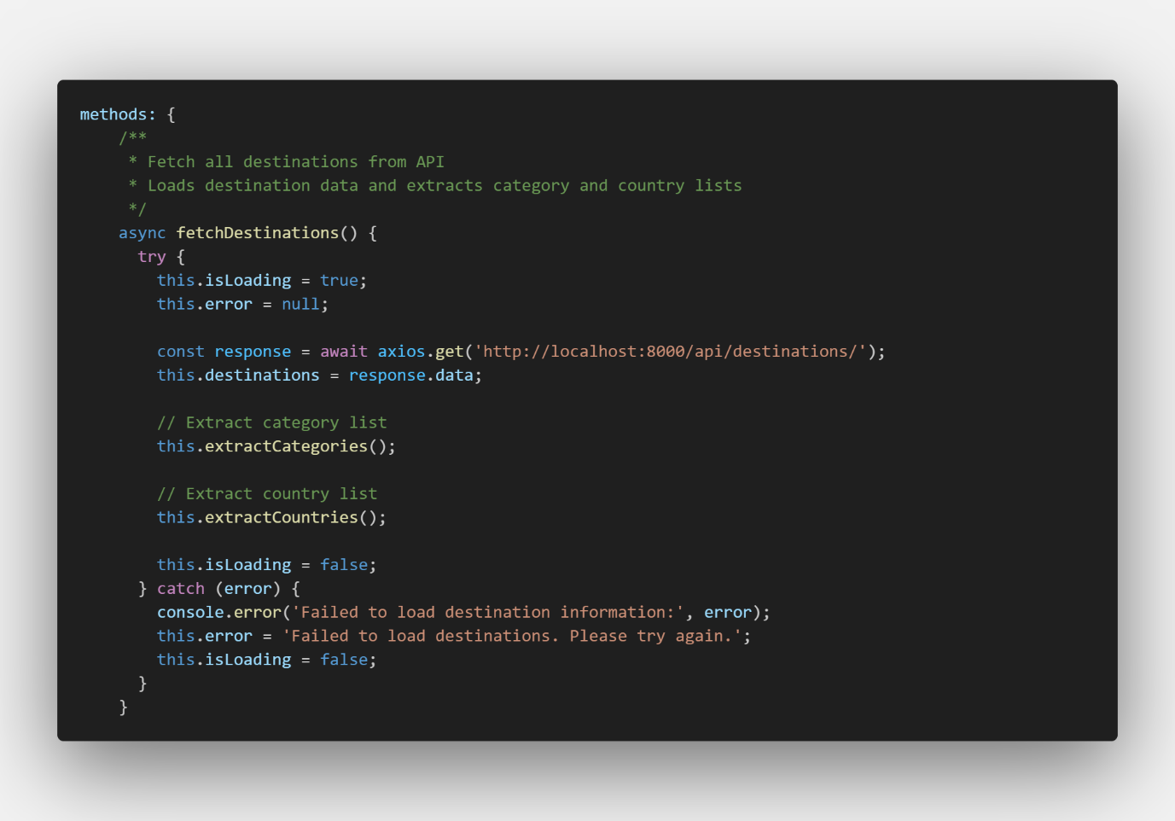
Figure ?.
The DestinationList component initializes when mounted to the DOM. Its lifecycle hooks trigger the fetchDestinations() method, which uses Axios to send an HTTP GET request to the backend. This method manages loading states and handles potential errors to ensure a smooth user experience.
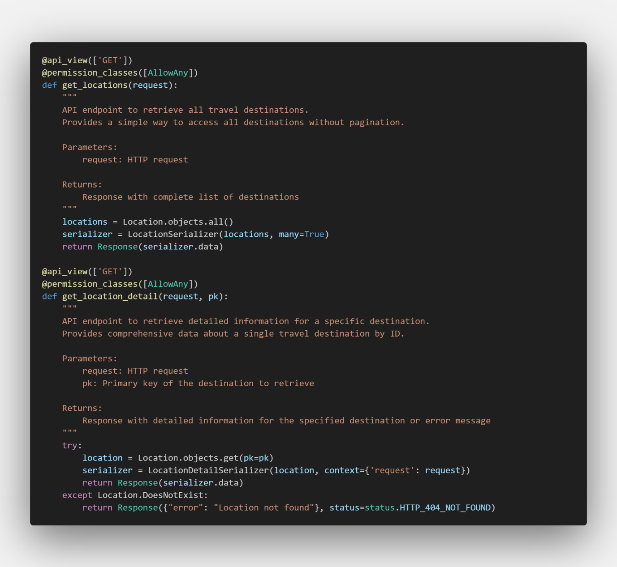
Figure ?.
The get_locations function queries the Location model and serializes the data to JSON format using LocationSerializer. With AllowAny permissions, it makes destination data accessible to all users without authentication requirements, then returns the serialized data as an HTTP response.
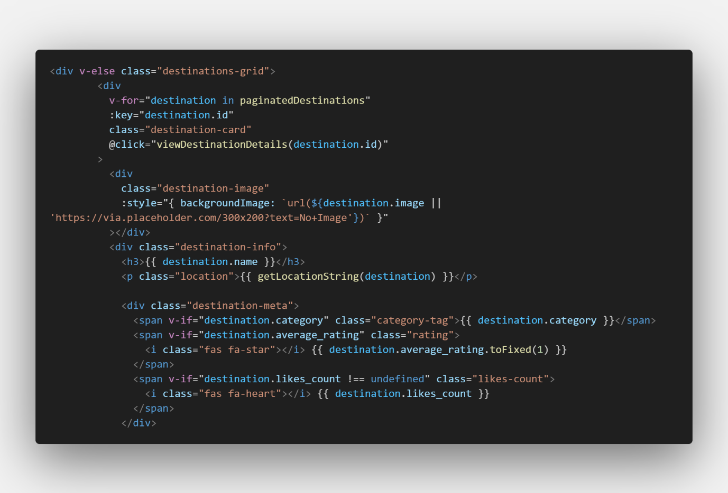
Figure ?.
Vue.js stores the received JSON data in its reactive system and renders it through declarative templates. The v-for directive iterates through destinations, displaying each as a card component. Conditional rendering handles loading states and potential errors to maintain interface responsiveness.
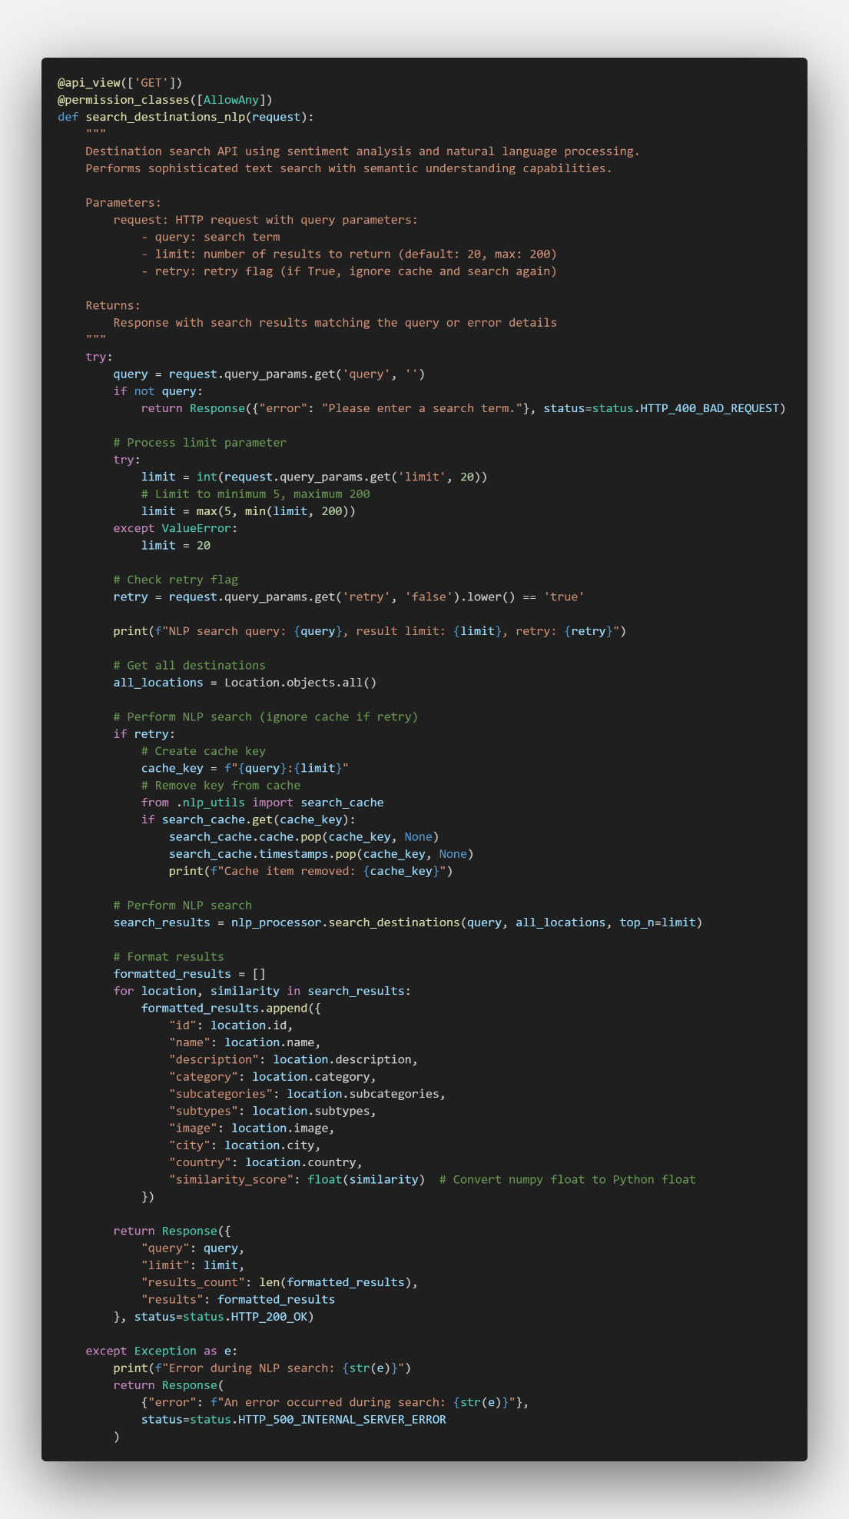
Figure ?.
Through this endpoint, system access nlp_utils.py which actually performs nature language processing.
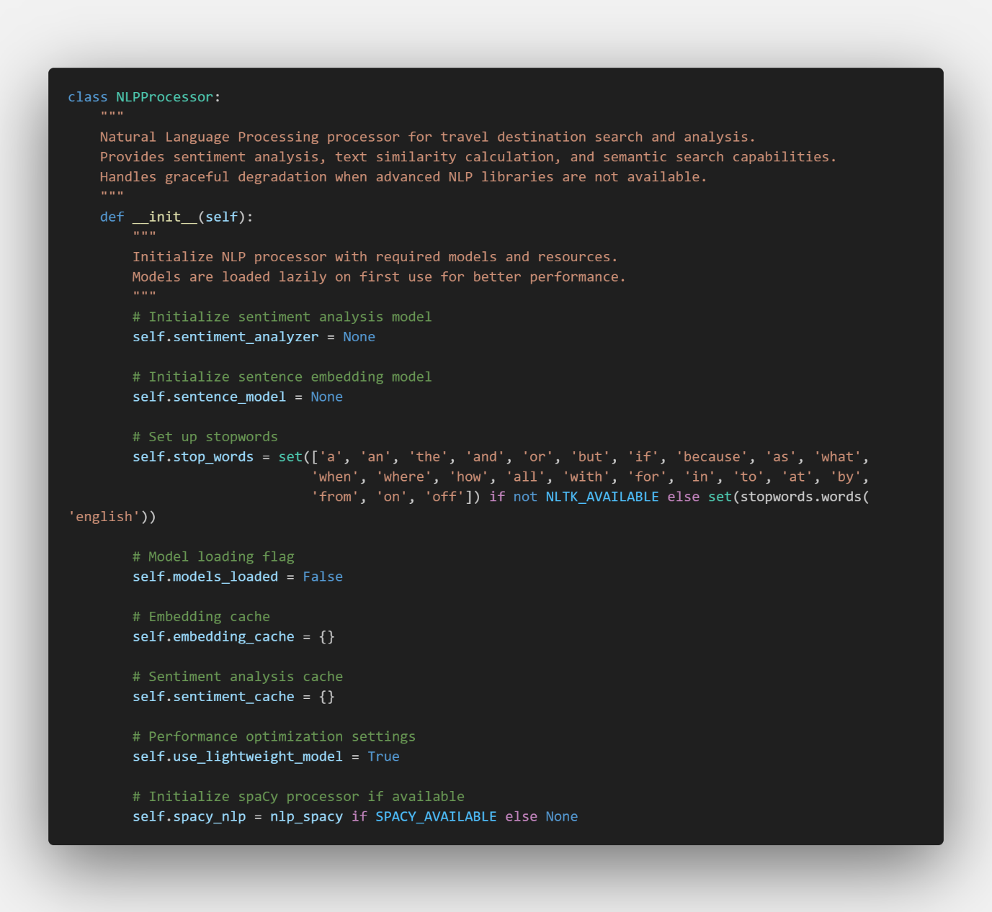
Figure ?.
nlp_utils.py has one of the largest amounts of codes in one class, which performs whole processes of nature language processing search. In detail, this class is responsible for the core logic of natural language processing. During initialization, pre-trained NLP models and vectorizers are loaded to promote performance optimization. The search process is divided into several steps: (1) lowercase transformation, terminology removal, and interpersonal extraction are performed in search word preprocessing; (2) text is transformed into numerical vectors in the vectorization step, and state-of-the-art embedding techniques (Word2Vec, BERT, etc.) can be utilized; (3) the most relevant results are found by calculating the similarity with each destination. The caching mechanism improves system efficiency and reduces response time by preventing iterative computation for the same query.

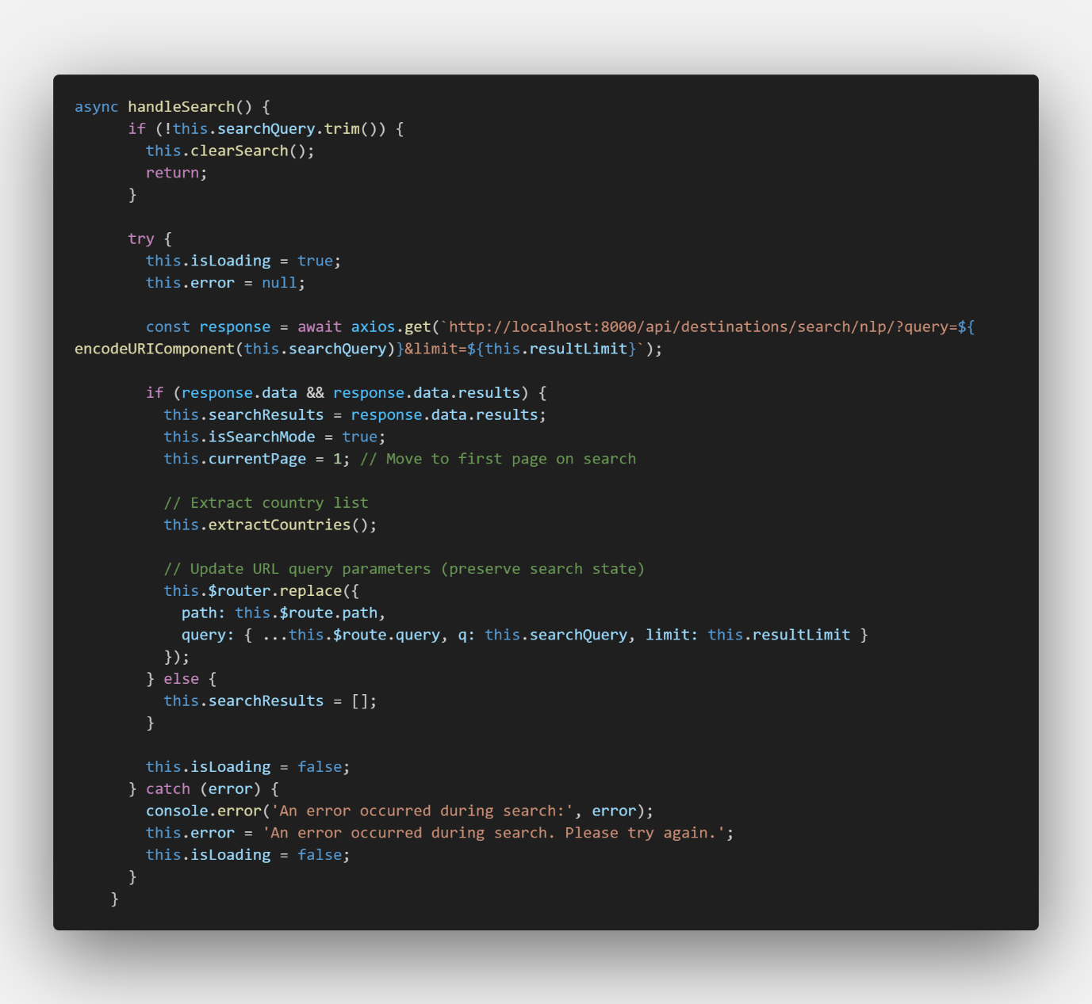
Figure ?.
In this step, component safely handles user inputs and communicates with the backend API. The search terms entered by the user are URL-encoded as codeURIComponent and delivered securely to the API. This function manages the loading status to show the user the progress of the search, and responds to network problems or server errors, including error handling logic. When the search results arrive, they update the status and extract a unique list of countries from the results for country filtering.
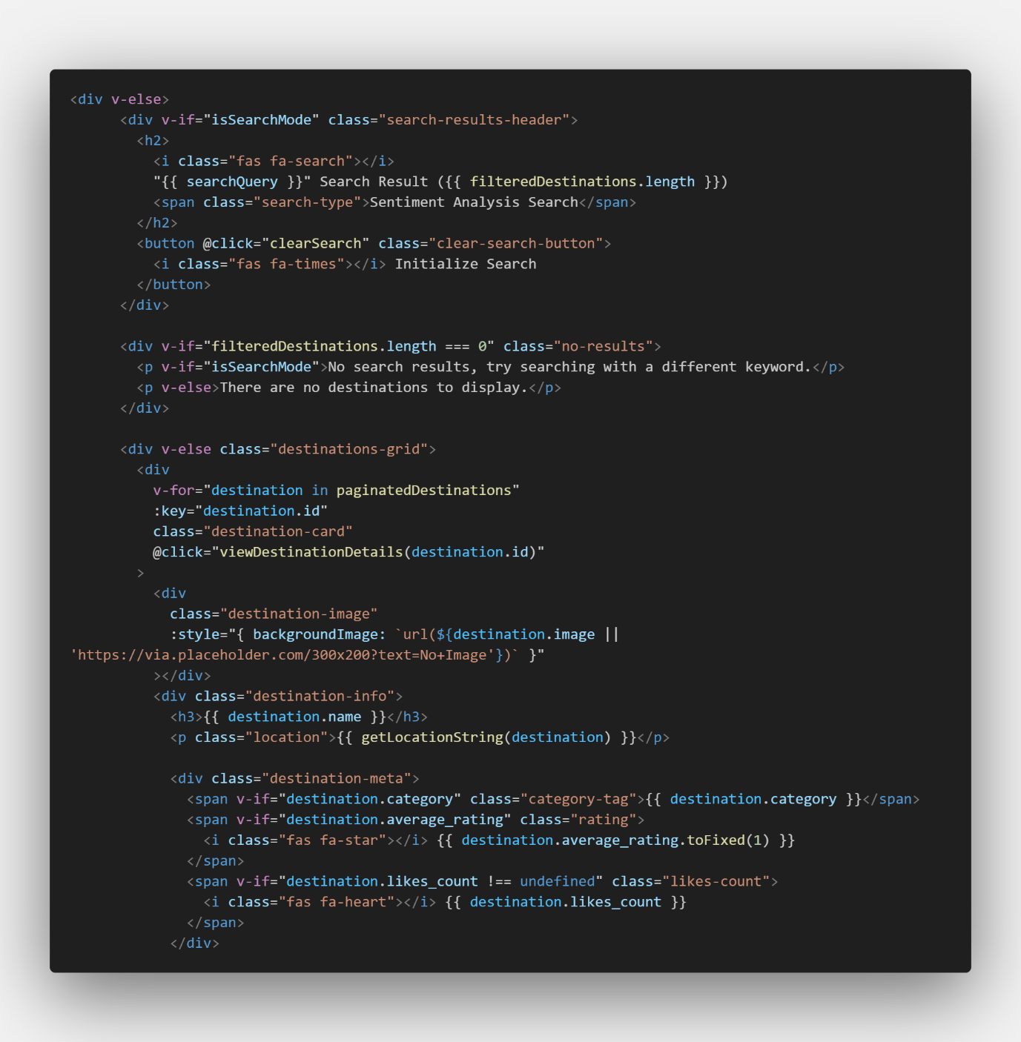
Figure ?.
The user interface utilizes the Vuetify design system to construct a responsive grid layout. Each destination is presented in the form of a card, containing key information such as image, name, country, and description. Of particular note is the "match" chip that displays on each result, which translates the similarity score calculated at the back end into a percentage, allowing the user to intuitively identify the relevance of the results. The text description is a truncateText function that limits its length to maintain a consistent layout, and when the user clicks the "View Details" button, it provides a router link to the detailed page of the destination.

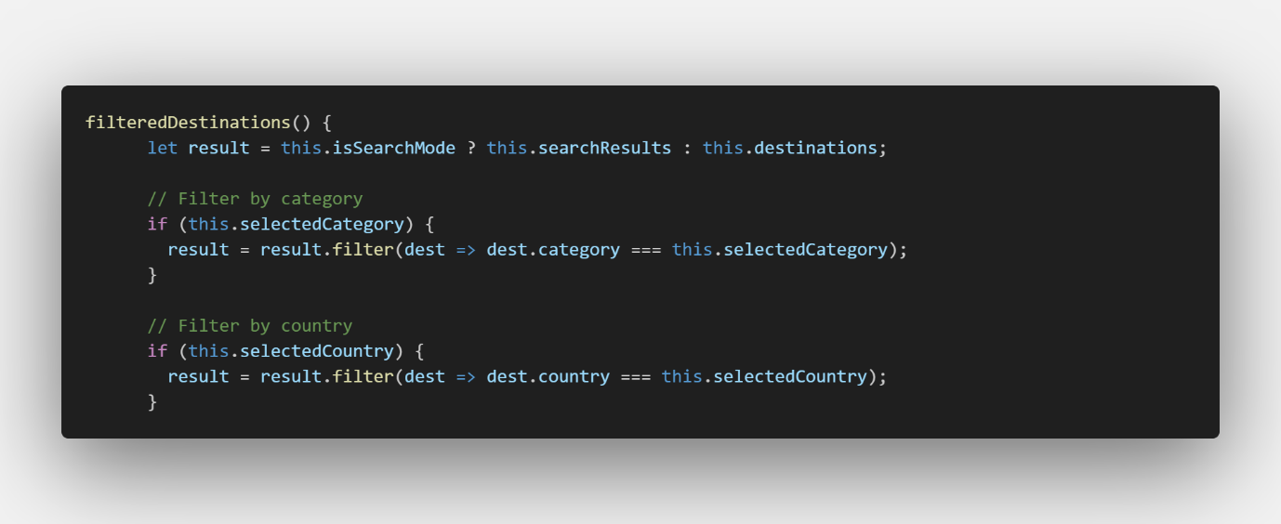
Figure ?.
Computed properties in Vue.js enable client-side filtering and sorting. When users select categories or countries, the filteredDestinations property automatically updates to show matching destinations. This provides immediate UI updates without requiring additional server requests.
Figure ?.
Inside the get_location_detail function, Django attempts to retrieve a single Location object matching the provided ID. The function handles potential errors with a try-except block, returning a 404 error response if the location doesn't exist. For valid locations, it utilizes the LocationDetailSerializer to transform the database model into JSON, passing the request object in the context for user-specific customization.
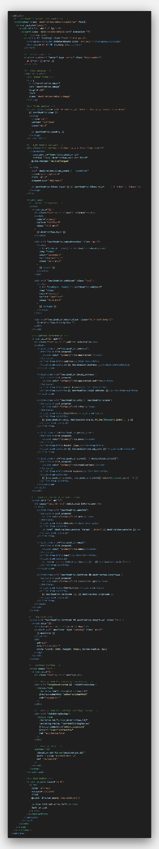
Figure ?.
After receiving the API response, the DestinationDetailView stores the destination data and manages the loading state. The detailed destination information is displayed using Vuetify's card components with conditional rendering for different sections. The template utilizes v-if/v-else directives to handle loading states, errors, and successful data display scenarios. For images, coordinates, and other optional fields, additional conditional checks ensure graceful handling of missing data. The destination detail view offers an interactive experience with features like real-time likes, user reviews, and Google Maps integration. These elements boost engagement and help users plan their trips more effectively.

6-6. Flight Search
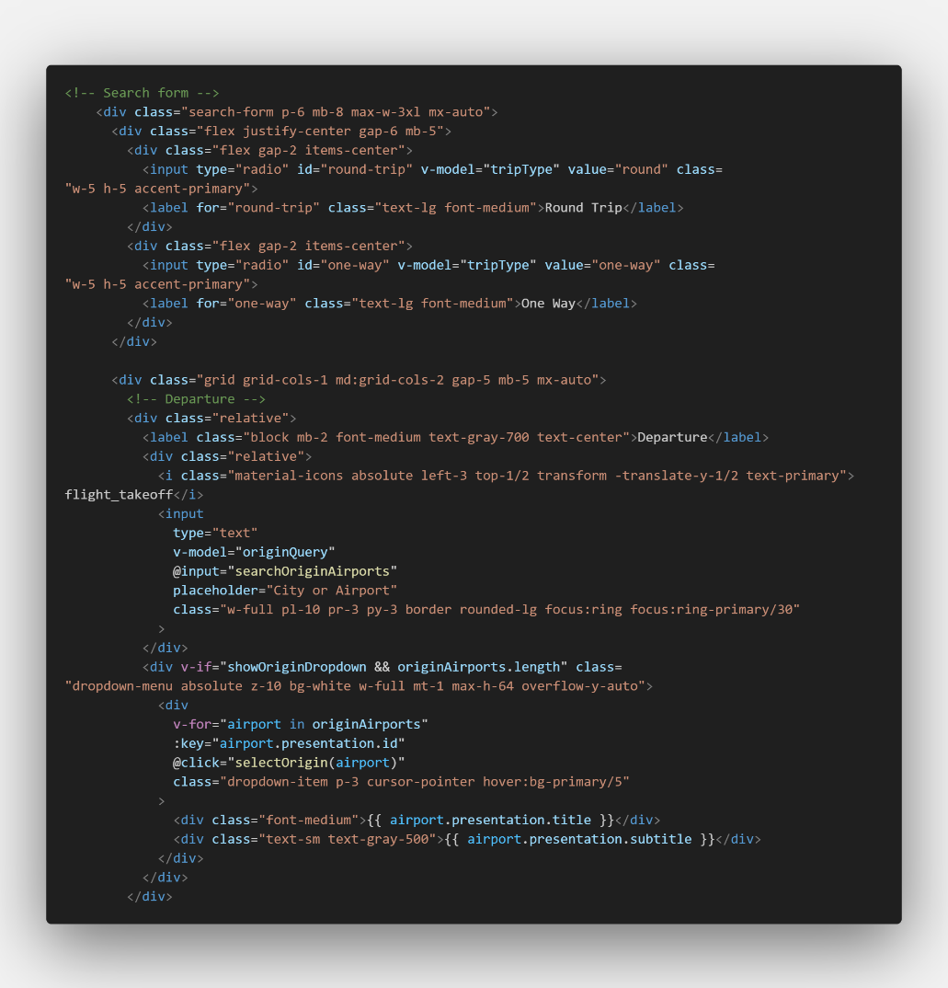
Figure ?.
In the FlightView component, the user enters flight search conditions such as origin, destination, and date. The interface provides intuitive form controls with validation to ensure all required fields are properly completed before submission, enhancing user experience through immediate feedback.
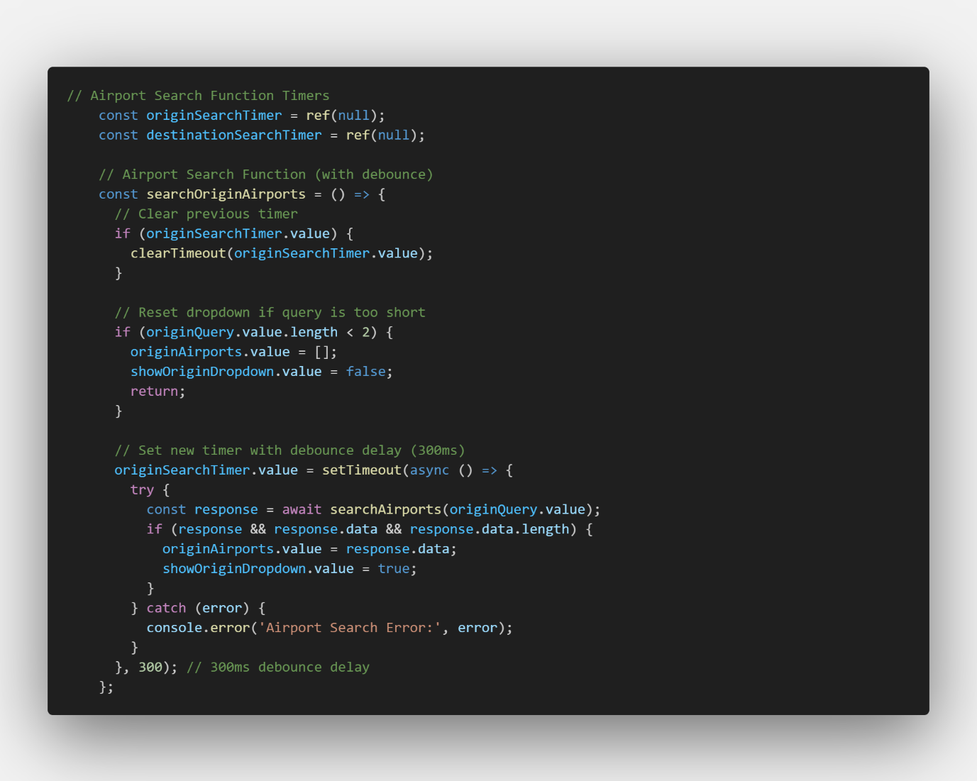
Figure ?.
When the user enters the departure or destination, the airport information is automatically completed through API calls. This feature implements a debounce mechanism to prevent excessive API requests, waiting until the user pauses typing before sending the query, which optimizes performance and reduces server load.
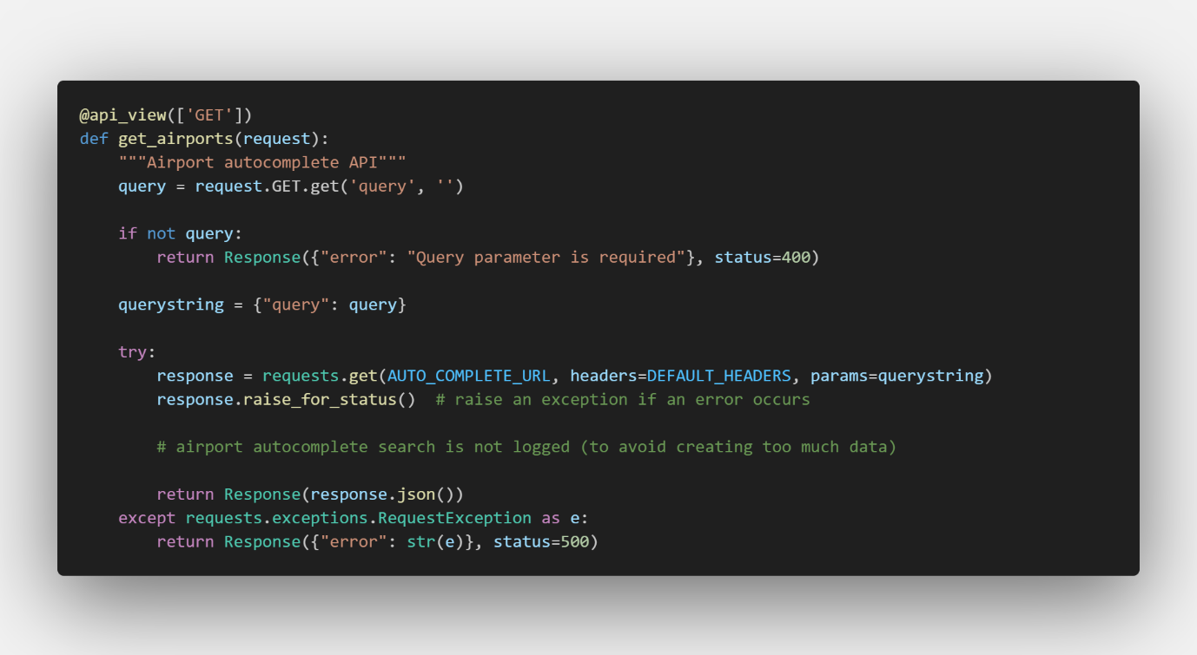
Figure ?.
The request from the front end is forwarded to the back end API, which calls the external Skyscanner API. This middleware approach allows the application to securely manage API credentials and implement consistent error handling without exposing sensitive information to client-side code.
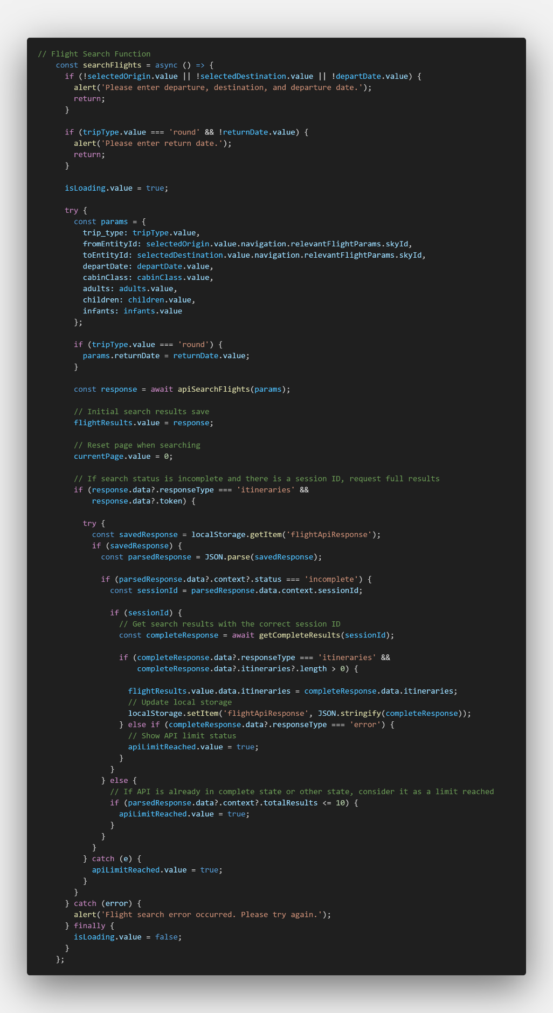
Figure ?.
Search requests at the front end are processed through the back end API. The backend validates all input parameters, constructs the appropriate query based on trip type (one-way or round-trip), and handles potential errors from the external API, providing a standardized response format regardless of the external API's behavior.
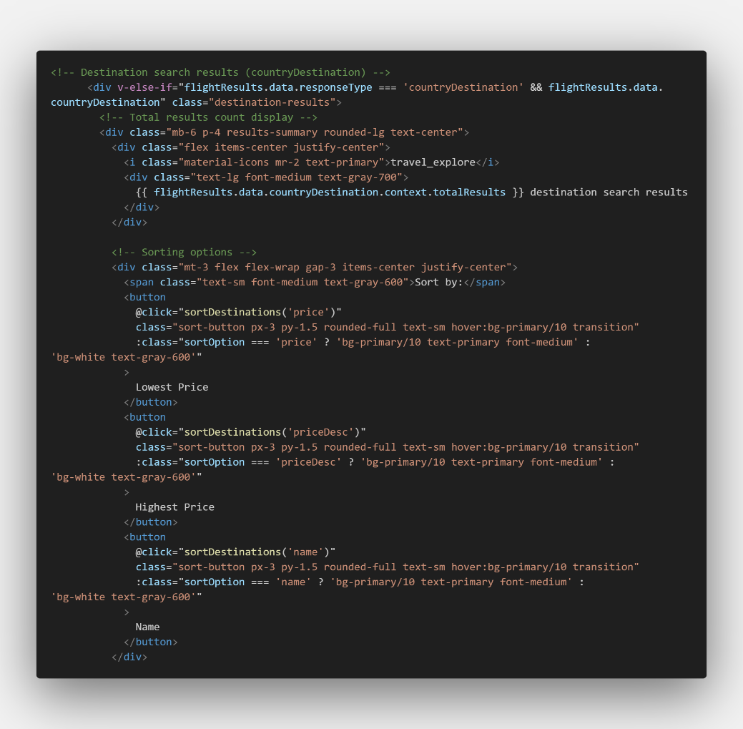
Figure ?.
Displays the flight search results received from the backend to the user. Each flight option is presented in a card format showing critical information such as airline, departure and arrival times, duration, number of stops, and price, with sorting options allowing users to prioritize results based on their preferences.
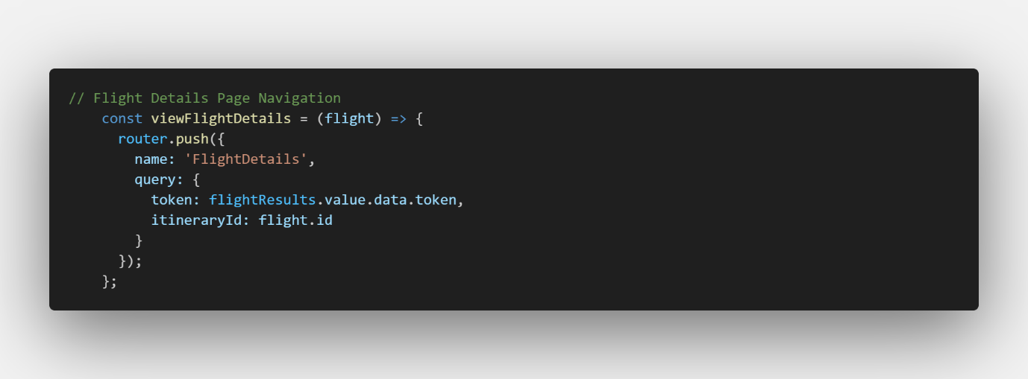
Figure ?.
When the user clicks on the "View Details" button for a particular flight, it goes to the details page for that flight. This navigation utilizes Vue Router to pass the necessary flight identifier and token via URL parameters, maintaining state between views without requiring complex state management solutions.
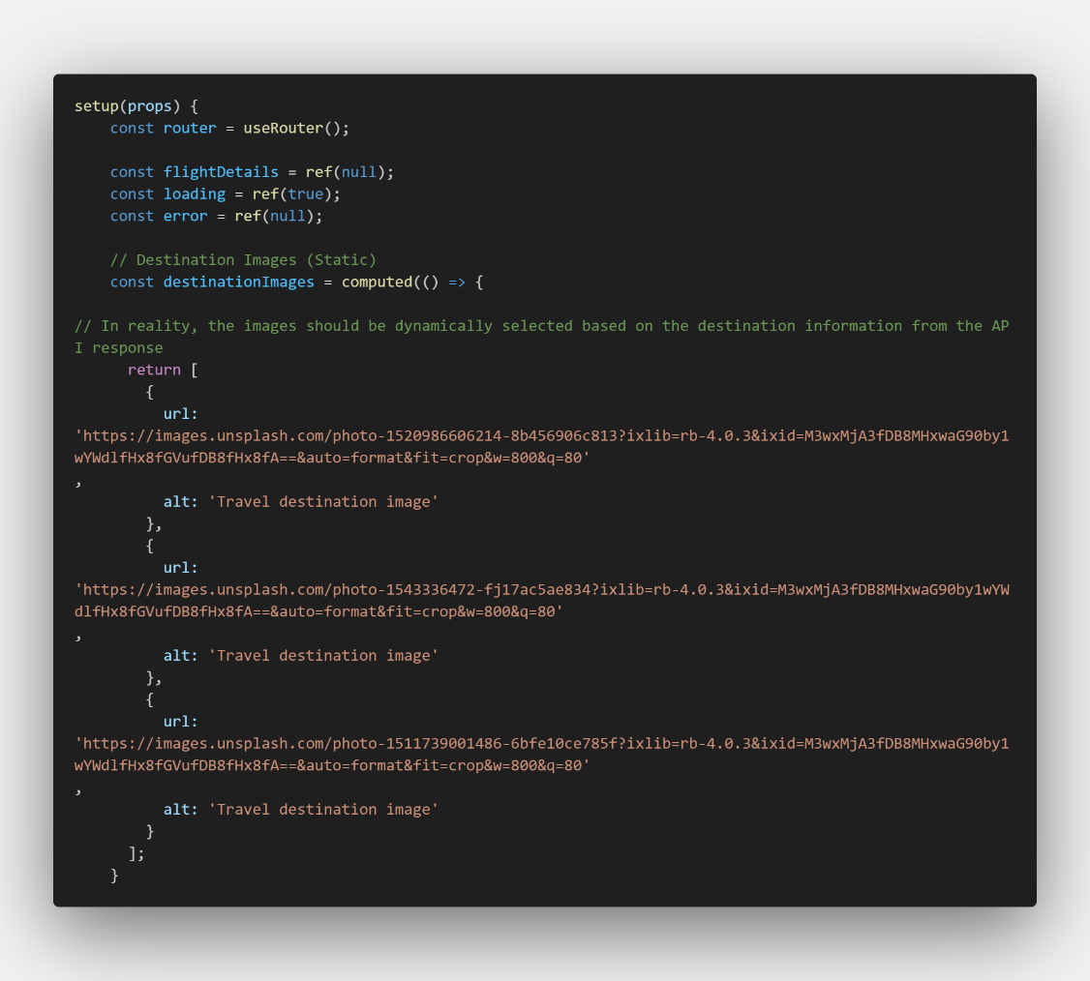
Figure ?.
Once the FlightDetailView component is mounted, it will request further information using the token and flight ID received through the URL query parameter. The component implements error handling for missing or invalid parameters and shows appropriate loading states to keep the user informed throughout the data fetching process.
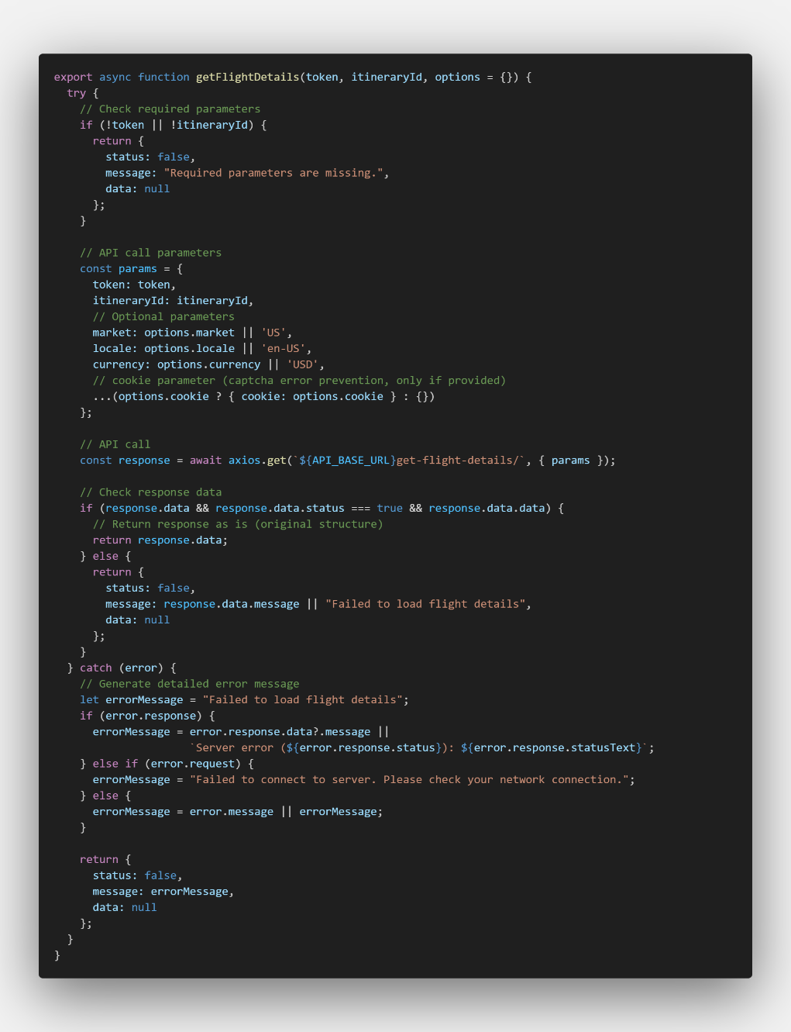
Figure ?.
Flight details requests are processed through the API module. This centralized approach encapsulates all logic for communicating with the backend, handling authentication tokens, and standardizing error messages, which promotes code reusability and simplifies maintenance.
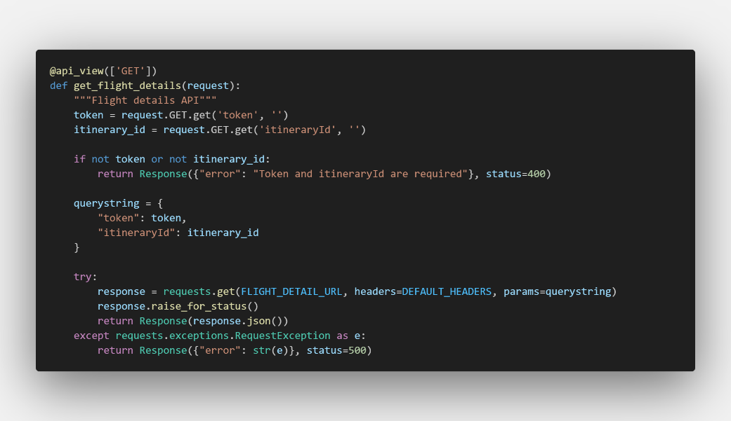
Figure ?.
The request for details on the front end is processed through the backend API. The backend performs additional parameter validation before calling the Skyscanner detailed information endpoint, then transforms the response to ensure consistency in data structure before returning it to the frontend.
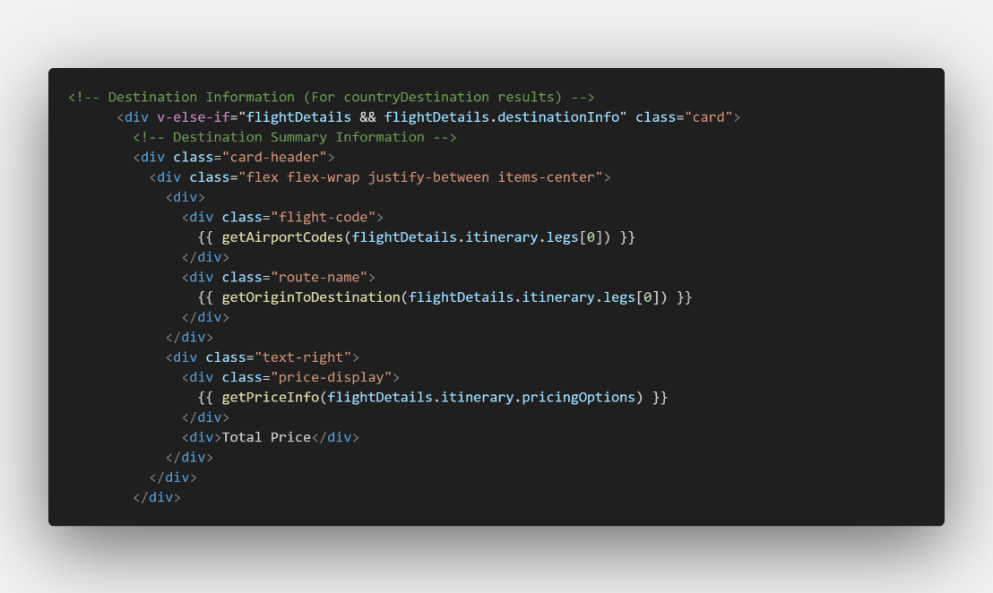
Figure ?.
Flight details received are detailed in the FlightDetailView component. The information is organized into logical sections including flight legs, segments, timing details, and pricing options, with visual elements like airline logos and flight path indicators enhancing comprehension of complex itineraries.

6-7. Travel Planner
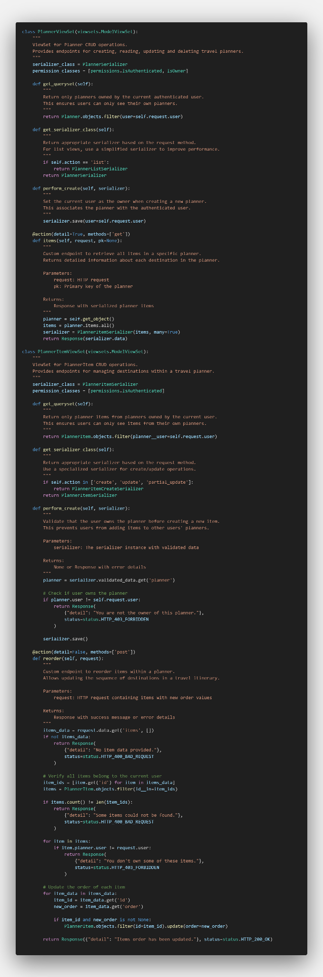
Figure ?.
PlannerViewSet provides per-user planner creation, query, modification, and deletion, and PlannerItemViewSet supports destination item management and reordering within a planner. In particular, the reorder action allows you to save the order of destinations changed to drag and drop, and all APIs are secure with user authentication and ownership verification.
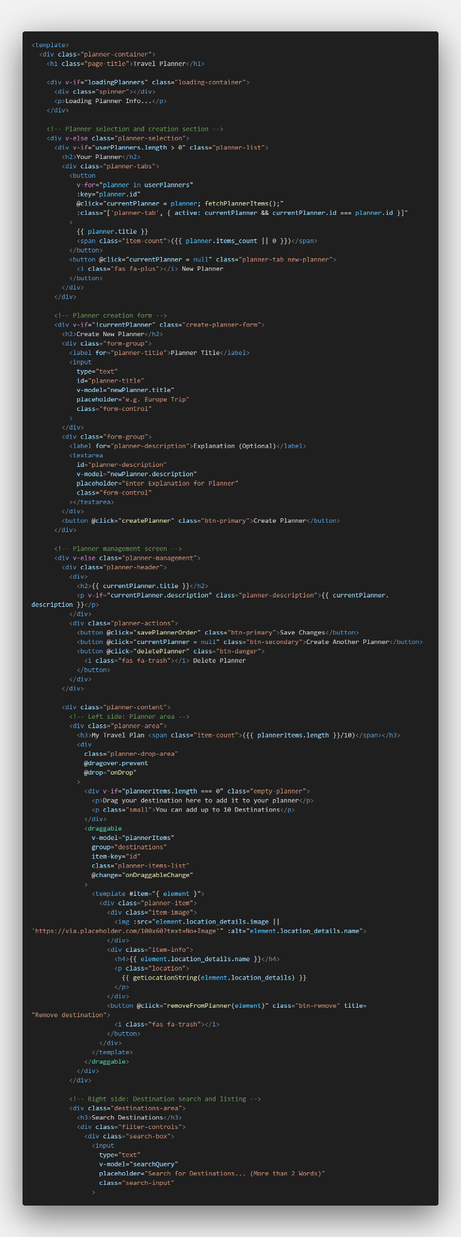
Figure ?.
In CreatePlanner.vue, left side displays a list of destinations user have added, and the right side allows user to find new destinations through a search function. Users can enter search terms to locate destinations through NLP-based searches, add or reorder destinations by dragging and dropping, and each planner is limited to a maximum of 10 destinations. Users can create multiple planners and switch easily through the tab interface. Destinations can be added by drag-and-drop or by clicking on a button, and changes can be saved through the "Save Changes" button after changing the order. Optimizing the user experience by handling loading status, error messages, and empty statuses, and efficiently navigating search results through country-specific filtering. The travel planning process begins with the user creating or selecting a planner. The NLP-based search will then find the relevant destination and add it to the plan by drag and drop. The change in destination order is handled using the vuedraggable library on the client side, and the changed order is saved permanently through the backend API. It also provides an interworking function that allows you to add destinations directly to the planner via URL query parameters on other pages.

6-8. Popular Destination Page
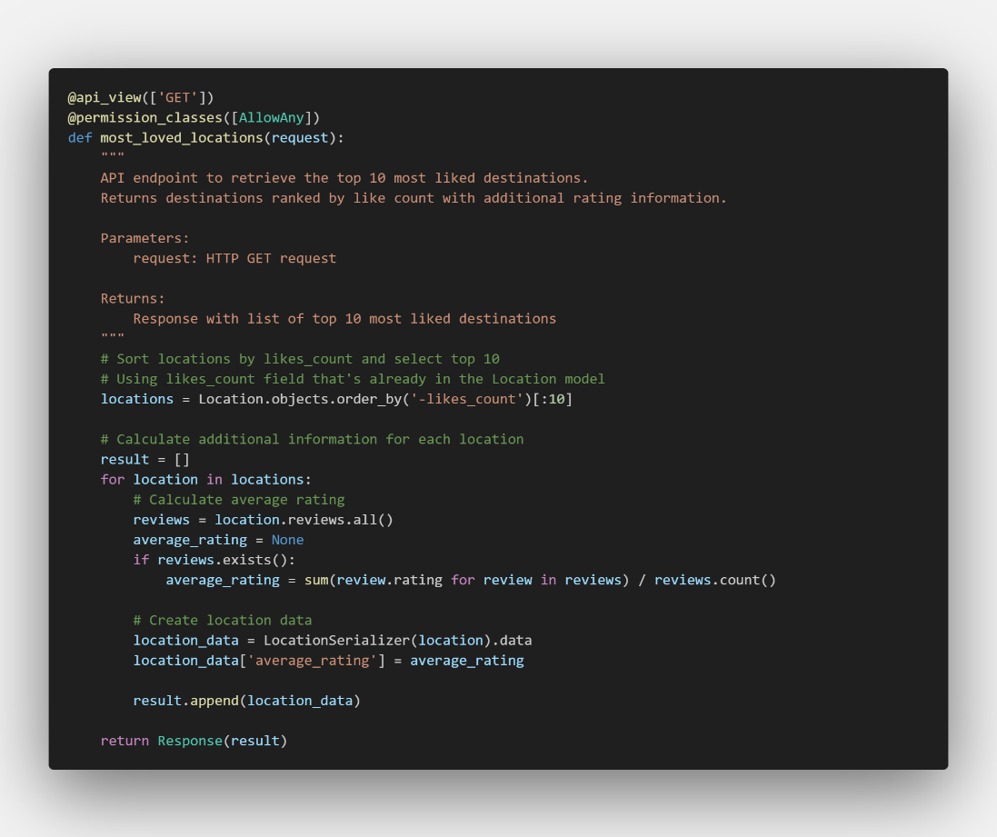
Figure ?.
The most_loved_locations function at the back end inquires and provides the top 10 destinations based on the number of likes_count in the location model. This API responds by including the average rating information calculated by analyzing the review data along with the basic information of each destination, and the AllowAny privilege setting allows anyone to access it without logging in.
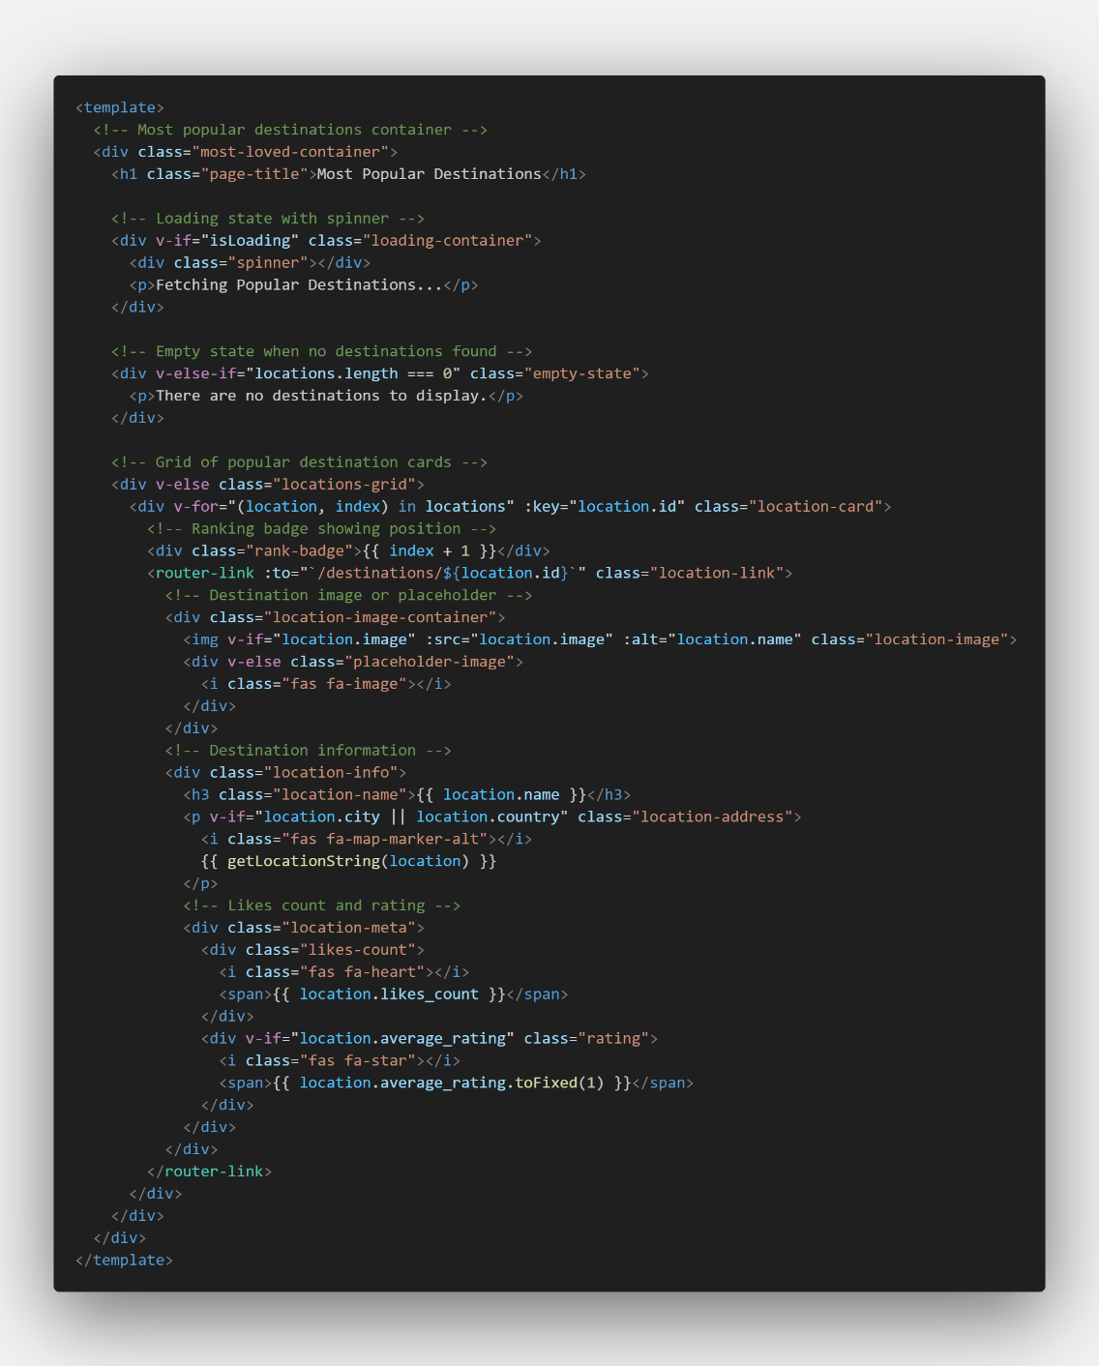
Figure ?.
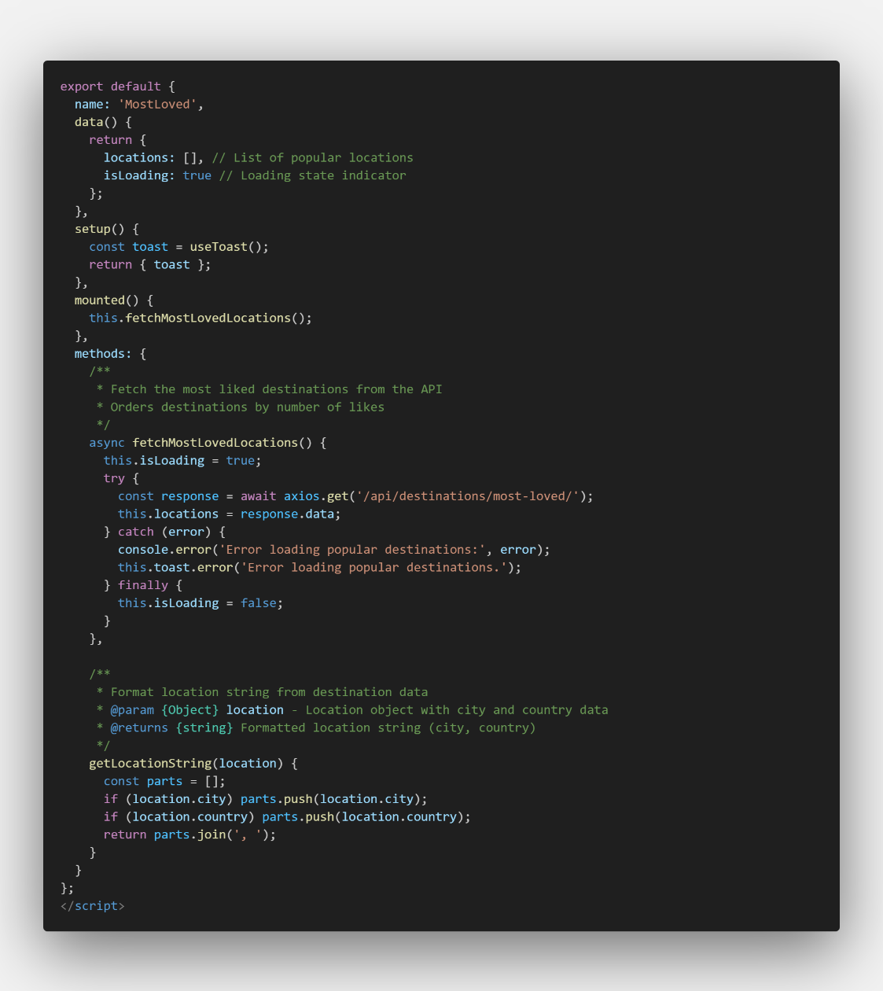
Figure ?.
The MostLoved.vue component automatically fetches popular destination data via the fetchMostLovedLocations method when mounted. It enhances user experience by managing loading and empty-state indicators, and displays results as destination cards. Each card features a ranking badge, destination name, location info, like count, average rating with heart and star icons, and a link to the detailed destination page for intuitive and engaging browsing.

6-9. Recommendation Page
Login / register / community / my page / destinations / flight / planner
Like based (Content based)
Review Sentiment Analysis, Review rate, Review Keyword Extract
Location Based
Search (NLP)
Click based…

6-10 Nearby Locations
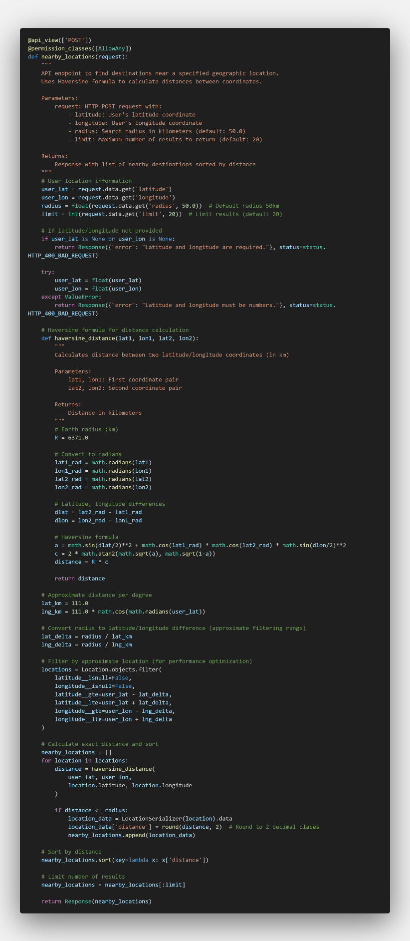
Figure ?.
nearby_locations function finds positions within a specified radius based on the latitude and longitude provided by the user. The function uses the Haversine formula to calculate the distance between two points, and provides parameters to limit the maximum distance and the number of results. It validates the latitude and longitude values, and first optimizes the performance through approximate coordinate filtering and accurate distance calculations.
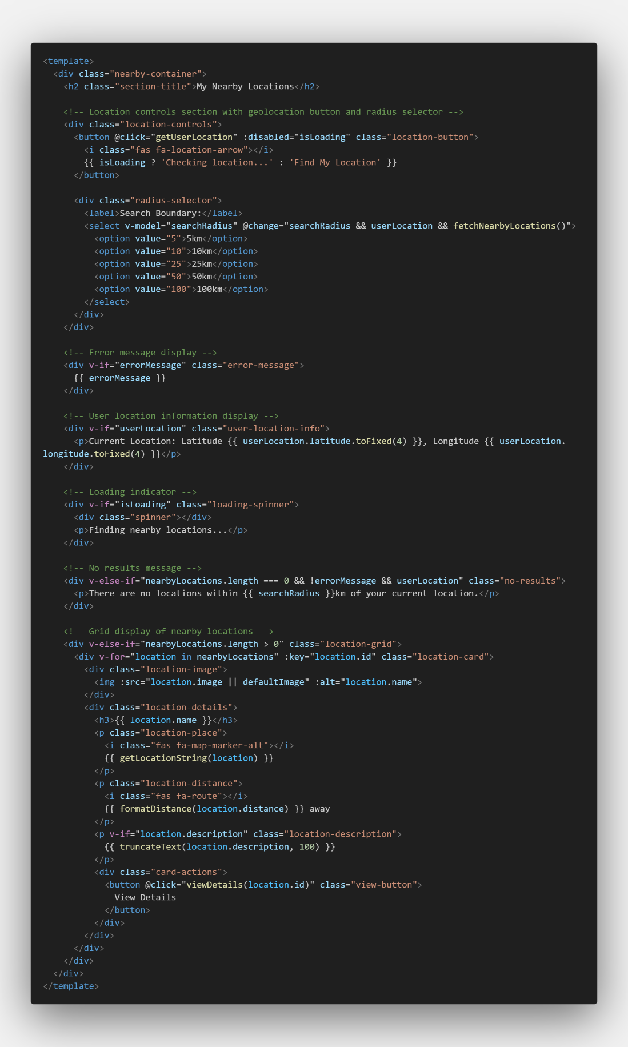
Figure ?.
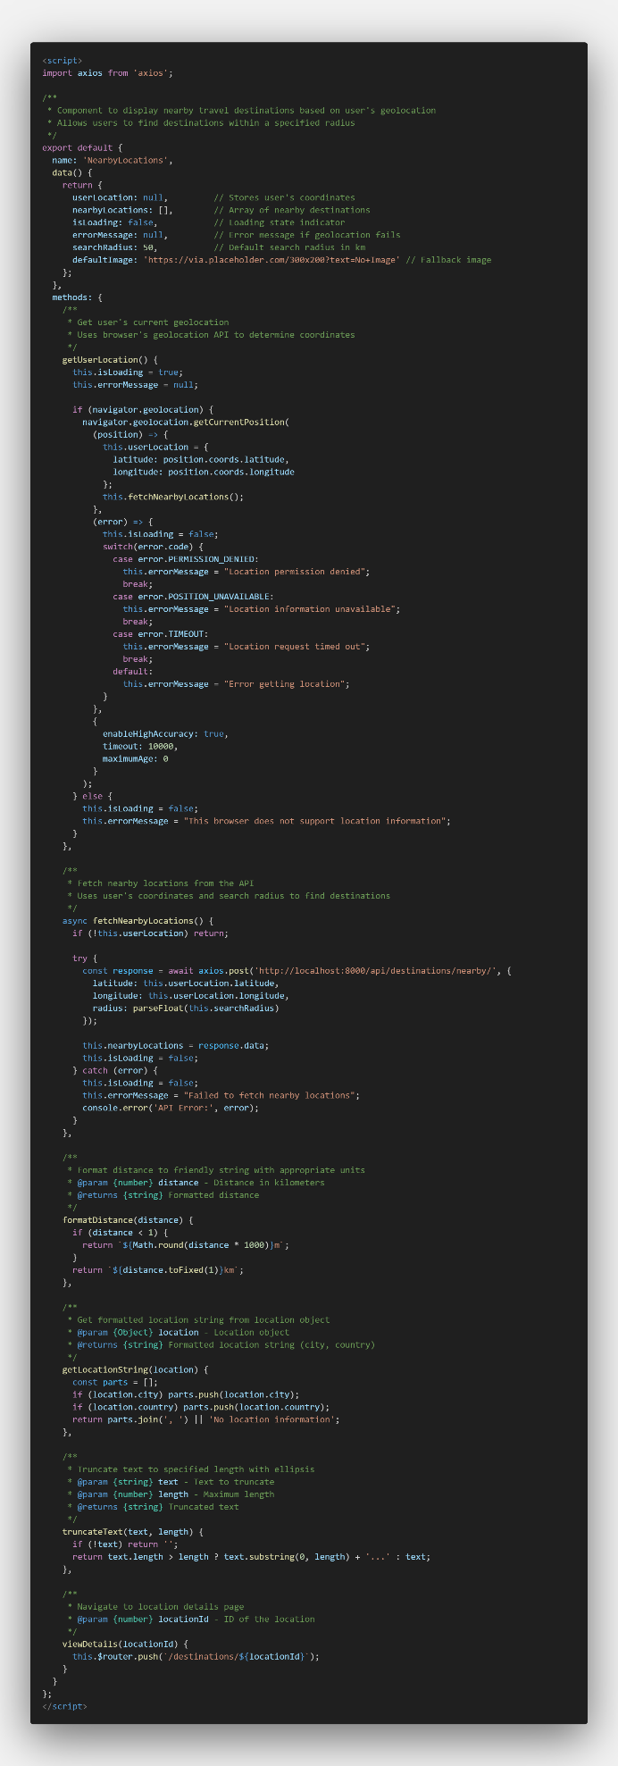
Figure ?.
This nearby frontend component displays nearby travel destinations based on the user's current location and uses the browser's location information API to verify latitude and longitude. The "Find My Location" button prompts the user for access to location information, allows the user to select a range of search radii from 5 km to 100 km, and optimizes the user experience, including settings and error handling to improve location accuracy. After confirming the user's location information, the fetchNearbyLocations method sends a POST request to the backend API and sends the latitude, longitude, and search radius as parameters. The backend uses the Haversine formula to calculate the distance from the user's location and return a list of destinations sorted by this, which the frontend receives and formats the distance of each destination appropriately in kilometers or meters.

Testing
On progress
7-1. Overview

7-2.

Critical Evaluation and Conclusion
D On progress

Reference
• Abhirup, K. (2021). How to develop, test, and deploy smart contracts using Ganache. LogRocket Blog. Available at: https://blog.logrocket.com/develop-test-deploy-smart-contracts-ganache [Accessed 1 Dec. 2024].
• Perusim. (n.d.). What is Tripadvisor? Perusim Blog. Available at: https://perusim.com/blog/what-is-tripadvisor/ [Accessed 1 Dec. 2024].
• ResearchGate. (2018). A personalized hybrid tourism recommender system. ResearchGate. Available at: https://www.researchgate.net/publication/323711026_A_Personalized_Hybrid_Tourism_Recommender_System [Accessed 1 Dec. 2024].
• Red Collar. (n.d.). 5 problems of travel websites: Looking for solutions together with Red Collar. Medium. Available at: https://redcollar.medium.com/5-problems-of-travel-websites-looking-for-solutions-together-with-red-collar-fdcbc0b8e5a5 [Accessed 1 Dec. 2024].
• Traveler. (2023). Top 5 reasons why visitors leave your travel websites forever. Traveler WP Blog. Available at: https://travelerwp.com/5-reasons-why-visitors-leave-your-travel-websites-forever/ [Accessed 1 Dec. 2024].
• Bokun. (n.d.). Rise of solo travellers. Bokun Blog. Available at: https://www.bokun.io/rise-of-solo-travellers [Accessed 1 Dec. 2024].
• UX Heuristics. (n.d.). 9 problems and opportunities on travel sites. UX Heuristics. Available at: https://uxheuristics.net/heuristics/9-problems-and-opportunities-travel-sites [Accessed 1 Dec. 2024].
• Nielsen Norman Group. (n.d.). Customization vs. personalization. NNG Blog. Available at: https://www.nngroup.com/articles/customization-personalization/ [Accessed 1 Dec. 2024].
• McKinsey & Company. (n.d.). What is the future of travel? McKinsey Insights. Available at: https://www.mckinsey.com/featured-insights/mckinsey-explainers/what-is-the-future-of-travel [Accessed 1 Dec. 2024].
• Kenpro. (n.d.). Sample size determination using Krejcie and Morgan table. Kenpro Blog. Available at: https://www.kenpro.org/sample-size-determination-using-krejcie-and-morgan-table/ [Accessed 1 Dec. 2024].
• Guru99. (2024). Software Development Life Cycle (SDLC) tutorial. Guru99. Available at: https://www.guru99.com/ko/software-development-life-cycle-tutorial.html [Accessed 1 Dec. 2024].
• Agile Alliance. (n.d.). What is Agile? Agile Alliance. Available at: https://www.agilealliance.org/agile101/ [Accessed 1 Dec. 2024].
• Scrum.org. (2023). What is Agile? Scrum.org. Available at: https://www.scrum.org/resources/what-is-agile [Accessed 1 Dec. 2024].
• GeeksforGeeks. (n.d.). Software engineering: Agile development models. GeeksforGeeks. Available at: https://www.geeksforgeeks.org/software-engineering-agile-development-models/ [Accessed 1 Dec. 2024].
• Indeed. (n.d.). Pros and cons of Agile methodology. Indeed Career Advice. Available at: https://www.indeed.com/career-advice/career-development/pros-cons-of-agile-methdology [Accessed 1 Dec. 2024].
• GeeksforGeeks. (n.d.). Waterfall model. GeeksforGeeks. Available at: https://www.geeksforgeeks.org/waterfall-model/ [Accessed 1 Dec. 2024].
• Lucidchart. (n.d.). Pros and cons of the Waterfall methodology. Lucidchart Blog. Available at: https://www.lucidchart.com/blog/pros-and-cons-of-waterfall-methodology [Accessed 1 Dec. 2024].
• GeeksforGeeks. (n.d.). Software engineering: Spiral model. GeeksforGeeks. Available at: https://www.geeksforgeeks.org/software-engineering-spiral-model/ [Accessed 1 Dec. 2024].
• One Beyond. (n.d.). Pros and cons of the Spiral model. One Beyond Blog. Available at: https://www.one-beyond.com/pros-cons-spiral-software-development/ [Accessed 1 Dec. 2024].
• Javatpoint. (n.d.). Software engineering: V-Model. Javatpoint. Available at: https://www.javatpoint.com/software-engineering-v-model [Accessed 1 Dec. 2024].
• A Plus Topper. (n.d.). V-Model advantages and disadvantages. A Plus Topper Blog. Available at: https://www.aplustopper.com/v-model-advantages-and-disadvantages/ [Accessed 1 Dec. 2024].
• GeeksforGeeks. (n.d.). Software engineering: Prototyping model. GeeksforGeeks. Available at: https://www.geeksforgeeks.org/software-engineering-prototyping-model/ [Accessed 1 Dec. 2024].
• BiPlus. (n.d.). Prototype model: Advantages and disadvantages. BiPlus Blog. Available at: https://biplus.com.vn/blog/prototype-model-advantages-and-disadvantages [Accessed 1 Dec. 2024].
• Cint. (n.d.). What is a questionnaire and how is it used in research? Cint Blog. Available at: https://www.cint.com/blog/what-is-a-questionnaire-and-how-is-it-used-in-research/ [Accessed 1 Dec. 2024].
• Scribbr. (n.d.). Interviews in research. Scribbr Methodology Blog. Available at: https://www.scribbr.com/methodology/interviews-research/ [Accessed 1 Dec. 2024].
• EDUCBA. (n.d.). Advantages and disadvantages of questionnaires. EDUCBA Blog. Available at: https://www.educba.com/advantages-and-disadvantages-of-questionnaires/ [Accessed 1 Dec. 2024].
• Indeed. (n.d.). Advantages and disadvantages of interviews. Indeed Career Advice. Available at: https://in.indeed.com/career-advice/interviewing/advantages-and-disadvantages-of-interviews [Accessed 1 Dec. 2024].
• Insight7. (n.d.). Observation as a research instrument explained. Insight7 Blog. Available at: https://insight7.io/observation-as-a-research-instrument-explained/ [Accessed 1 Dec. 2024].
• Javatpoint. (n.d.). Advantages and disadvantages of observation method. Javatpoint. Available at: https://www.javatpoint.com/advantages-and-disadvantages-of-observation-method [Accessed 1 Dec. 2024].
• Professional Writing Bay. (n.d.). Examples of research instruments. Professional Writing Bay Blog. Available at: https://www.professionalwritingbay.com/examples-of-research-instruments [Accessed 1 Dec. 2024].
• Scribbr. (n.d.). Qualitative research. Scribbr Methodology Blog. Available at: https://www.scribbr.com/methodology/qualitative-research/ [Accessed 1 Dec. 2024].
• Scribbr. (n.d.). Quantitative research. Scribbr Methodology Blog. Available at: https://www.scribbr.com/methodology/quantitative-research/ [Accessed 1 Dec. 2024].
• Indeed. (n.d.). Experimental research. Indeed Career Advice. Available at: https://au.indeed.com/career-advice/career-development/experimental-research [Accessed 1 Dec. 2024].
• Poppulo. (n.d.). 10 advantages and disadvantages of qualitative research. Poppulo Blog. Available at: https://www.poppulo.com/blog/10-advantages-and-disadvantages-of-qualitative-research [Accessed 1 Dec. 2024].
• Helpfull. (n.d.). 10 advantages and disadvantages of quantitative research. Helpfull Blog. Available at: https://helpfull.com/blog/10-advantages-disadvantages-of-quantitative-research [Accessed 1 Dec. 2024].
• TKW Research. (n.d.). Mixed methodology research: The pros and cons. TKW Knowledge Box. Available at: https://tkwresearch.com.au/knowledge_box/mixed-methodology-research-the-pros-and-cons/ [Accessed 1 Dec. 2024].
• Scribbr. (n.d.). Mixed methods research. Scribbr Methodology Blog. Available at: https://www.scribbr.com/methodology/mixed-methods-research/ [Accessed 1 Dec. 2024].

https://refactoring.guru/design-patterns/template-method
https://buihuycuong.medium.com/the-23-gang-of-four-design-patterns-974ae8d1a957
https://medium.com/@liams_o/gang-of-four-fundamental-design-patterns-41a85a562954
https://principles.design/examples/don-norman-s-principles-of-design
https://www.educative.io/answers/what-are-normans-design-principles

